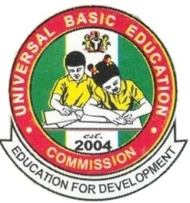

2016 Annual Report

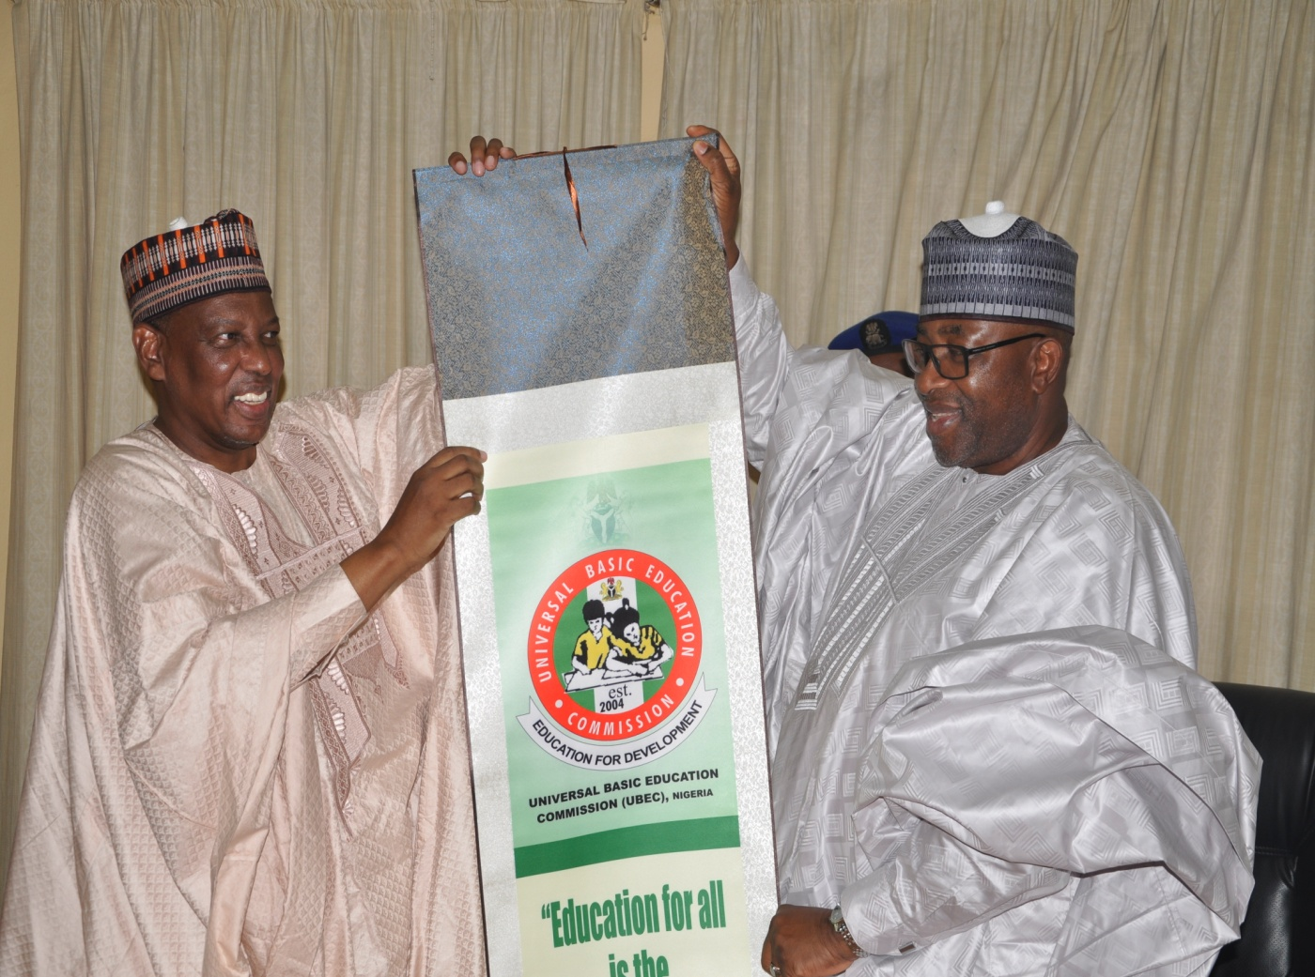

UNIVERSAL BASIC EDUCATION COMMISSION
UBEC
2016
Annual Report

UNIVERSAL BASIC EDUCATION COMMISSION
UBEC Building, No. 7, Gwani Street,
Wuse Zone 4, PMB 5086
Post Code 900284, Abuja – Nigeria
www.ubeconline.com
ubenigeria@yahoo.com

Education for All is the Responsibility of All

Published by

Universal Basic Education Commission
No. 7, Gwani Street, Wuse Zone 4,
Abuja

© UBEC 2016

Except for purely academic purposes, this report may not be reproduced in part or in full or stored in a retrieval system or transmitted in any form or by any means: electronic, mechanical, photocopying, recording or otherwise without the consent of the copyright owner.

ISBN- 978-978-52285-5-7
ISBN- 978-978-52285-6-4
EAN- 9785228564

TABLE OF CONTENTS
Table of Contents…………………………………………………………..……….......................4
Acronyms………………………………………………………………………………………..……………6i
Vision ………………………………………………………………………………..….......................10
Mission ………………………….…………………………………………………..…………..............10
Core Values ……..…………………………………………………………...……………………………10
Foreword ..………………………………………………………………………………………………….12
Organizational Structure……………………………………………………………………………..13
Management Team ..………………………………………………………………………………….14
Zonal Directors ..………………………………………………………………...........................17

SECTION 1:
OFFICE OF THE EXECUTIVE SECRETARY
Office of the Executive Secretary …………………………………………….……………….18
Internal Audit Unit ………………………………………………………….…........................30
Legal Unit ……………………………………………………………………..………………………….32
Procurement Unit …………………………………………………………….………………………35
Public Relations & Protocol Unit ………………………………………….….……………….37
Special Projects Unit …………………………………………………………..……………………40
ServicomUnit ..…………………………………………………………………………………………46
Federal Teachers’ Scheme ……………………………………………………………………….47

SECTION 2:
DEPARTMENTAL REPORTS
Academic Services …………………..………………………………………….. …………………50
Administration and Supplies ….……………………………………………………………….59
Finance and Accounts ……………………………………………………..........................64
Physical Planning …………………………………………………………………………………….72
Planning, Research and Statistics …………………………………………….................76
Quality Assurance ……………………………………………………………........................81
Social Mobilization ………………………………………………………............................86
Special Duties ………………………………………..……………………….. …………………….91
Special Programmes ……………………………………………………….. …………………….94
Tsangaya Education Programme …………………………………………………………….97
UBEC Zonal & State Offices …………………………………………………………………..100

ACRONYMS
AIDS - Acquired Immune Deficiency Syndrome
AIT - African Independence Television
APER - Annual Performance Evaluation Report
BMIS - Book Management Information System
CA - Continuous Assessment
CATI - Community Accountability and Transparency Initiative
CBECC - Community Based Early Childhood-Care Center
CBOs - Community – Based Organizations
CGPs - Civil Society and Government Partners
CIDA - Canadian International Development Agency
CONRAISS - Consolidated Research and Allied Institutions Salary Structure
CRF - Consolidated Revenue Fund
CSACEFA - Civil Society Action Coalition on Education for All
DFID - Department for International Development
DLIs - Disbursement Linked Indicators
DRG - Debt Relief Grants
EAC - Educate A Child
ECAN - Education Correspondence Association of Nigeria
ECD - Early Child Development
ECCDE - Early Childhood Care Development and Education
EDOREN - Education Data, Operational Research and Evaluation in Nigeria
EFA - Education for All
EMIS - Education Management Information System
ESSPIN - Education Sector Support Program in Nigeria
FCT - Federal Capital Territory
FGN - Federal Government of Nigeria
FMBN - Federal Mortgage Bank of Nigeria
FME - Federal Ministry of Education
FMF - Federal Ministry of Finance
FMI - Federal Ministry of Information
FRCN - Federal Radio Corporation of Nigeria
FTS - Federal Teachers’ Scheme
G&C - Guidance and Counseling
GPE - Global Partnership for Education
GTC - Global Training Consulting
ICT - Information and Communication Technology
IDB - Islamic Development Bank
IDPs - International Development Partners/Internally Displaced Persons
IGR - Internally Generated Revenue
IPSAS - International Public Sector Accounting Standard
JCCE - Joint Consultative Committee on Education
JICA - Japan International Cooperation Agency
JSS - Junior Secondary School
KOICA - Korea International Cooperation Agency
KPI - Key Performance Indicator
LAN - Local Area Network
LGEA - Local Government Education Authority
MDGs - Millennium Development Goals
MSAP - Modern Statistical Application Packages
NABTEB - National Business and Technical Examinations Board
NALABE - National Assessment of Learning Achievement in Basic Education
NBTE - National Board for Technical Education
NCCE - National Commission for Colleges of Education
NCE - Nigeria Certificate in Education
NCOA - National Chart of Account
NEI - Northern Education Initiative
NERDC - Nigerian Educational Research and Development Council
NGOs - Non–Governmental Organizations
NHIS - National Health Insurance Scheme
NIEPA - National Institute for Educational Planning and Administration
NIIMP - National Integrated Infrastructure Master Plan
NPoC - National Population Commission
NTA - Nigerian Television Authority
NTI - National Teachers Institute
NYSC - National Youth Service Corp
NUT - National Union of Teachers
PIC - Project Implementation Committees
PSDN - President’s Schools Debate of Nigeria
PTA - Parent/Teachers Associations
SBMC - School Based Management Committee
SEPIP - State Education Programme Investment Project
SERVICOM - Service Compact
SMASE - Strengthening of Mathematics and Science Education
STVEP - Skills Training and Vocational Education Project
SUBEBs - State Universal Basic Education Boards
TAF - The Albino Foundation
TETFund - Tertiary Education Trust Fund
TKT - Teaching Knowledge Test
TPD - Teacher Professional Development
UBE - Universal Basic Education
UNCAP - Unified National Continuous Assessment Programme
UNCPD - United Nations Commission on Population and Development
UNICEF - United Nations Children Education Fund
USAID - United State Agency for International Development
UNESCO - United Nations Educational, Scientific and Cultural Organization

VISION
To be a world class education intervention and
regulatory agency for the promotion of uniform,
qualitative and functional basic education.

MISSION
The Commission shall operate as an intervention, coordinating and monitoring Agency to progressively improve the capacity of States, Local Government Agencies and Communities in the provision of unfettered access to high quality basic education in Nigeria.

CORE VALUES
- Honesty and Accountability
- Integrity and Transparency
- Teamwork with Commitment

FOREWORD
The provision of quality Basic Education to all children of school-going-age children remains the key focus of the Federal Government of Nigeria. It is in pursuit of this objective that the Universal Basic Education (UBE) Programme. The Commission is charged with the responsibility of coordinating and providing support in Basic Education delivery through the State Universal Basic Education Boards (SUBEBs) and Local Government Education Authorities (LGEAs).

In its desire to achieve this, 2% of the Federal Government’s Consolidated Revenue Fund (CRF) is set aside as intervention for the implementation of the UBE Programme across the 36 States and the FCT. The Commission among other things intervenes in the provision of infrastructure, facilities/equipment, instructional materials, capacity building of teachers, education of children with special needs, Girl-Child, Boy-Child, Tsangaya and Vocational Schools.

To achieve its mandate, the Commission developed series of programmes/projects/activities and implements such in conjunction with the SUBEBs and LGEAs. It also collaborates with national and International Development Partners to attract extra funding for basic education.

This Report therefore highlights the activities carried out by the Commission in the year 2016.

Foremost among these activities are:
- UBEC’s partnership with parastatals under the Federal Ministry of Education as well as International Development Partners(IDPs) to come up with innovative approaches aimed at addressing the out-of-school children phenomenon and reducing this challenge to the barest minimum.
- The One-Year Early Child Care Development & Education (ECCDE) made mandatory for all public schools in Nigeria as directed by National Council on Education (NCE) also received priority attention in 2016. The Commission in promoting this policy held meetings with States on fast tracking the implementation of pre-primary Education in the 36 states and the FCT. There was also a re-introduction of the utilization of 5% of the Matching Grant of the 2% CRF to be built into States Action Plans for ECCDE.

The Commission has continued its collaboration with IDPs and other stakeholders on best practices to be used in improving basic education delivery in Nigeria in conjunction with the World Bank, UNICEF, DFID-ESSPIN, UNESCO, etc. These collaborations have led to the development of a seamless Strategic Planning process for UBEC and SUBEBs using a National Medium Term Basic Education Strategic Plan. The World Bank supported Programme for Result (PforR) is a reference point in this direction.

As part of efforts towards improving its service delivery mechanism the Commission undertook a review of the Staff Condition of Service and has received approval from the office of the Head of Service of the Federation . This document will ensure a smooth administrative process, improve the human resource management and staff welfare.

Though the Commission has made a lot of strides through its activities, some of which are highlighted in this annual report, there are still lots to be done in ensuring that every Nigerian child is enrolled, receives and completes a course of quality basic learning in a UBE facility. UBEC advocates and solicits the full support of every Nigerian citizen towards the attainment of this ideal in line with the Commission’s slogan: “Education for All is the Responsibility of All”.

I wish to note that SUBEBs, LGEAs, IDPs, NGOs and other stakeholders have contributed in no small measure to the successes so far recorded in the implementation of our mandate and especially the remarkable achievements recorded in the past year.

To this end therefore, I am delighted to recommend this compendium of the functions, achievements and challenges associated with UBEC’s 2016 operations to all UBE stakeholders, with the belief that we will continue to deploy our best efforts and resources towards ensuring improved UBE service delivery in subsequent years.

Dr. Hamid Bobboyi
Executive Secretary

THE ORGANIZATIONAL STRUCTURE OF UBEC

Servicom

Public Relations & Protocol

Special Projects

Audit

Legal
Procurement

Director, Physical Planning

Director,Tsangaya Educ. Prog.

Director, Quality Assurance

Director, Academic Services

Director, Admin.&Supplies
Director, Special Duties

Director, Fin. &Accts

Director,
P.R.S.

Director, Social Mobilization

Director, Special Prog.

Architecture

Zonal Office Matters

Monitoring & Evaluation

Establishment

Boy-Child

ESSPIN Desk

Social Mobilization

Assessment

Maintenance & Services

Expenditure Control

Engineering

Community Development & Empowerment
Stores & Supplies

FTS/Project Accounts

Quantity Surveying

Training & Welfare

Planning

ICT

EMIS

Final Accounts

Education Support Services

Academic Planning

T. P. D.

Research & Publications

Funds & Budget

State Accounts

MANAGEMENT TEAM

DR HAMID BOBBOYI
EXECUTIVE SECRETARY

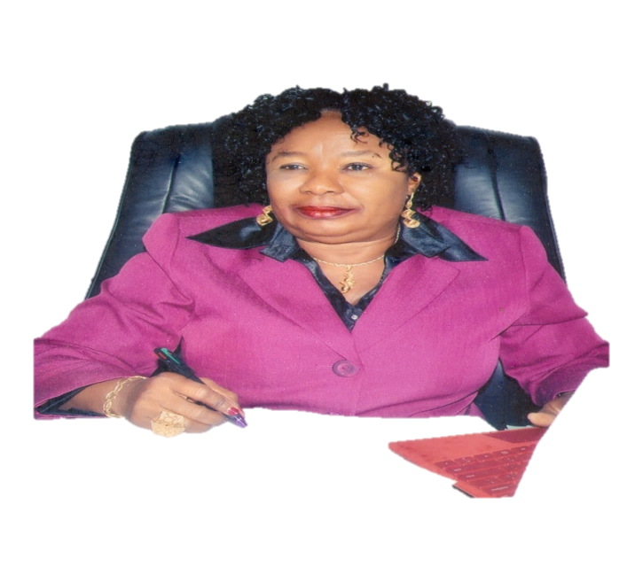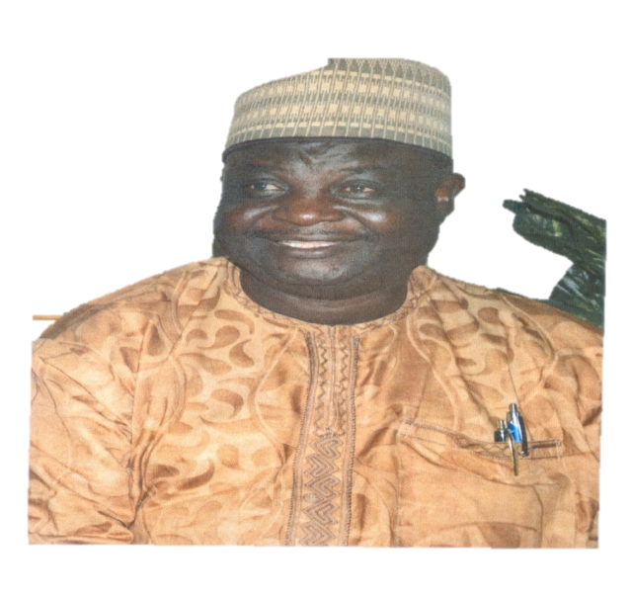
DR. SHARON ‘ROWO ORIERO-OVIEMUNO  DEPUTY EXECUTIVE SECRETARY (TECHNICAL) | DR. YAKUBU GAMBO  DEPUTY EXECUTIVE SECRETARY (SERVICES)
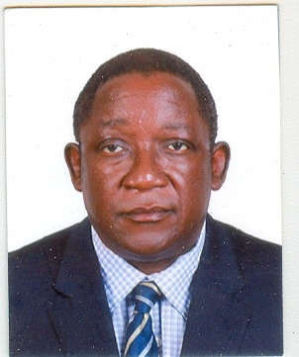 |  | 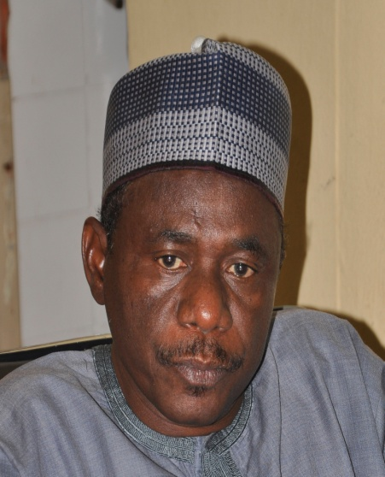
Arch. M.M. Mutfwang  Director, Physical Planning |  | Alhaji Aliyu Musa Kardi  Director, Tsangaya Education Programme
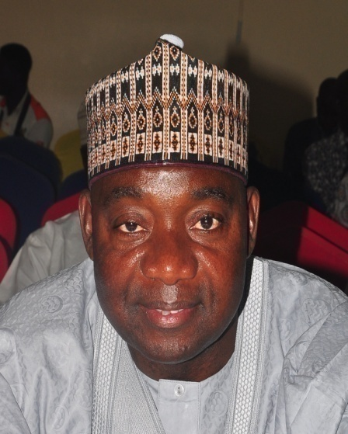 |  | 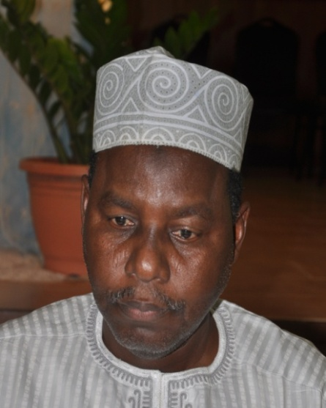
Alhaji Bello Kagara  Director, Social Mobilization |  | Alhaji Mohammed S. Dukku  Director, Finance&Accounts
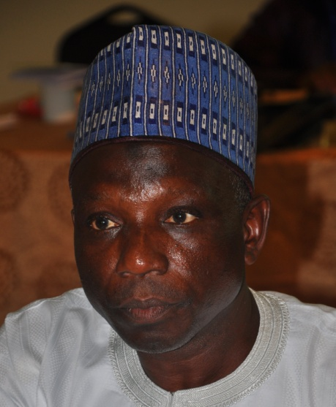 |  | 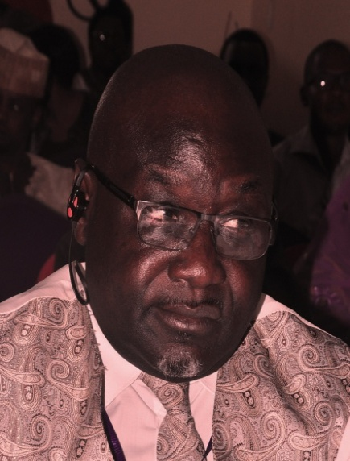
Mallam Jibo Abdullahi  Director, Quality Assurance |  | Bishop Edwin Jarumai  Director, Administration & Supplies
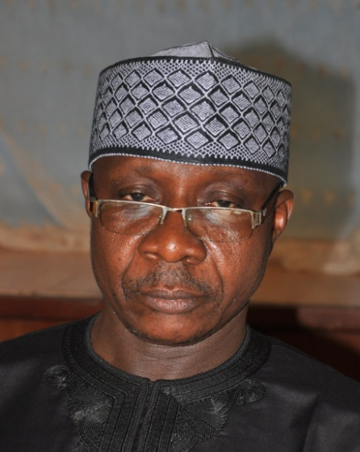 |  | 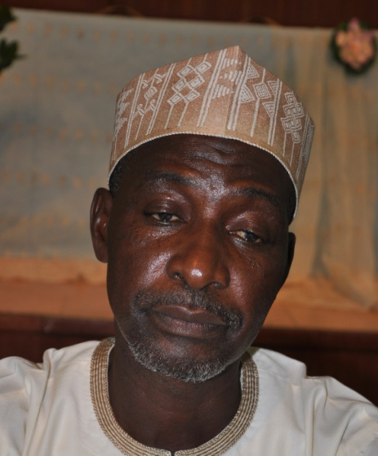
Alhaji Aliyu Usman Kaoje  Director, Field Services |  | Alhaji Dauda Alhassan  Ag. Director, Special Programmes
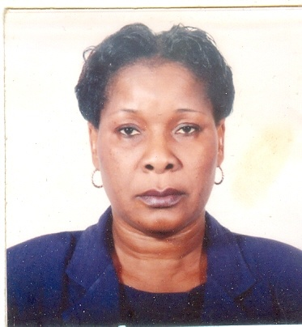 |  | 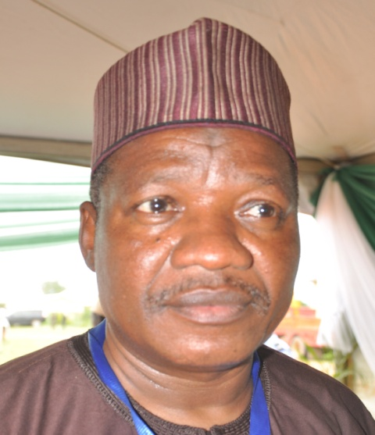

Dr. Tokunbo T. Onosode Mallam Wadatau Madawaki
Ag.Director, Planning, Research &Statistics Ag. Director, Department of Academic Services

ZONAL DIRECTORS

Alhaji Mansu rIdris  Zonal Director, North-West |  | Mr. J. O. Toluju  Acting Zonal Director, South-West
Mallam Hassan D. Umar  Acting. Zonal Director, North-East |  | Mrs. Maureen Obaitan  Acting Zonal Director, South-South
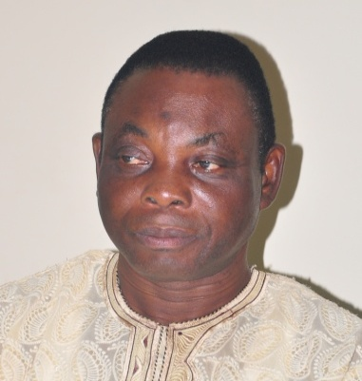  Mr. Sylvester Enyinnaya  Acting Zonal Director, South-East |  | 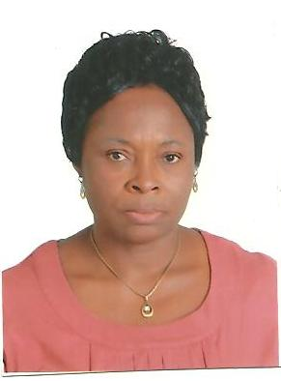  Dr. Ene Adikwu  Ag Zonal Director, North-Central
1.0 OFFICE OF THE EXECUTIVE SECRETARY
1.1 INTRODUCTION
The Executive Secretary is the Chief Executive and Accounting Officer of the Commission who responsible for the day-to-day administration of the Commission and he is answerable to the Board and the Minister of Education. He is assisted by two Deputy Executive Secretaries (Technical and Services).
THE EXECUTIVE SECRETARY
DR HAMID BOBBOYI
EXECUTIVE SECRETARY

 | - THE EXECUTIVE SECRETARY  A.ORIGIN AND EDUCATIONAL ATTAINMENTS  Dr Hamid Bobboyi, who hails from Yola, Adamawa State, Nigeria, was born on July 29, 1957. He had his primary education at the Fufore Primary School, where he obtained the First School Leaving Certificate in 1971. He then proceeded to Government Secondary School, Yola, and obtained the West African School Certificate (WASC)in 1975.  The quest for higher education took him to North East College of Arts and Science (NECAS) Maiduguri, Nigeria and finally Northwestern University, Evanston Illinois, U.S.A., where he obtained a Bachelor of Arts Degree in History in 1982, followed by a Master’s Degree and finally capping it with a Ph.D in History of Educational Institutions in 1992.  B. WORKING EXPERIENCES AND ENGAGEMENTS WITHIN THE ACADEMIC COMMUNITY  Dr. Hamid Bobboyi, having been equipped with a sound educational foundation, began his peregrinations as a Teaching Assistant, Department of History, Northwestern University, Evanston, Illinois in 1984. He further served the University as a Teaching Fellow and Research Assistant. His working career in the US culminated in his appointment as a Research Fellow in the same university up till 1992. In the bid to give back to his country, he returned to Nigeria and took up appointment as a Research Coordinator with Huda Huda Publishing Company Ltd. Zaria, Nigeria. He served in this capacity until 1995.  Between 1995 and 1996, he joined the Ahmadu Bello University, Zaria, as a Visiting Senior Research Fellow and later returned to Huda Huda Publishing Company Ltd., Zaria, as the Managing Director and served in that capacity till 1998.  A significant milestone in Dr. Bobboyi’s professional career was his appointment as Director of Arewa House, Centre for Research and Historical Documentation, Ahmadu Bello University, Kaduna, Nigeria. He served In that  - John F. Kennedy School of Government, Harvard University, Cambridge, Massachusetts. USA, 12-15 December 2002. Conference on Nigeria: Governance, Law and Conflict. Presented a paper on Conflict and Conflict Management in Central Nigeria: The case of the Tiv and the Jukun.  - Programme of African Studies, Northwestern University, Evanston, May-June 2001 as Senior Scholar in Residence. Participated and chaired sessions in two conferences: Transmission of Islamic Learning in Africa and Nigeria’s Economy: The Life and Economic Thoughts of Pius Okigbo.  - Muhammad V. University, Rabat and the Kingdom of Morocco, International Conference 1000 years of Relations between Fez and Sub- Saharan Africa, November, 1993.  - George Mason University, Washington DC in collaboration with National Institute for Policy and Strategic Studies (NIPSS) and National Defence College, Abuja, on Institutional Reforms in Nigeria (under the Chairmanship of Prof. John Paden).  - Afro-Middle East Centre and Wits University, Johannesburg, International Conference on Conceptualizing Power between States and Islamic Movements, held at Pretoria, from 19-20th January 2015. Presented a paper entitled, Islam, Militancy, and Attitude to Political Power and Authority: The Case of Nigeria’s Boko Haram.  D. MAJOR PUBLICATIONS  Dr. Hamid Bobboyi’s academic accomplishments are readily demonstrated through his rich contributions to literature. Some of his major publications include:  - Bobboyi, Hamidu and Yakubu Mahmud, Peace-Building and Conflict Resolution in Northern Nigeria, Kaduna: Arewa House 2005.  - Bobboyi, Hamidu and Alkasum Abba, Adamawa Emirate: A Documentary Source book, Vol. I, (1809-1965), CRID, Abuja, 2009.  - Bobboyi, Hamidu, Principles of Leadership  According to the Founding Fathers of the Sokoto  Caliphate: An Anthology, CRID, Abuja 2011.  F. PEACE BUILDING AND OTHER RELATED PROFESSIONAL ACTIVITIES  Dr. Bobboyi has been at the fore-front of the promotion of national and regional integration and has deployed his professional expertise in initiating and facilitating peace-building efforts at national and regional levels. Some of his major engagements in this respect include:  - Facilitator to the Peace-conference organised by Arewa Consultative Forum (ACF) at Arewa house, Kaduna, to resolve the politico-ethnic crisis between the Tiv and the Jukun in Benue and Taraba States, 2002.  - Chairman, Technical Committee on Northern Nigeria Peace Conference, organised by the Northern States Governors Forum, December 2004.  - Resource person, Inter-Faith Research Roundtable organized by the National Institute of Policy and Strategic Studies (NIPSS), Kuru, Nigeria, the Chairmanship of Prof. John Paden, September 2014. |  | capacity up till 2006 and was responsible for overseeing the administration as well as the general operations of the House, serving as member of and Secretary to the Board of Governors of the House and working with state governments, government agencies and non- governmental organizations in developing sustainable policy in areas of education, culture and the economy.  After a successful tenure at the Arewa House, Dr. Bobboyi was appointed Director–General, Centre for Regional Integration and Development (CRID), Abuja. Focusing on West African Developmental issues, especially Education and socio-economic development, 2007 to 2016, CRID under his leadership, among others, undertook major policy, education and development projects including:  - Collation and editing of the proceedings of Nigeria’s Constitutional Conferences 1946 -1963 for the National Institute of Legislative Studies (an institution under Nigeria’s National Parliament).  - Tsangaya Schools Project, for the Education Trust Fund (ETF), Federal Ministry of Education, Abuja.  - Textbook development, editing and publication for the ETF, Federal Ministry of Education.  - Research and Advocacy Project on Girl-Child Education in Northern States of Nigeria, The Hewlett Packard Foundation, Seattle, USA  As part of his career engagement within the University community between 2004-2006, Dr. Bobboyi also served as Member, Humanities Complex Committee, Member, Committee of Deans and Directors (CDD) of the University; Member of Ahmadu Bello University Senate; Chairman, Committee on the Establishment of a new Ahmadu Bello University College in Kaduna as well as External Examiner, Department of History, Usman Dan fodio University, Sokoto, Nigeria.  C. SPEAKER AT INTERNATIONAL CONFERENCES AND VISITING FELLOWSHIPS  Dr. Bobboyi is a visiting fellow and renowned speaker at various national and International Conferences. Some of the platforms that have benefitted from his wealth of intellect and expertise include:  iv. Bobboyi, Hamidu, ‘’Nigeria, ECOWAS, and the Promotion of Regional Integration and Development’’ in Attahiru Jega and J. Farris, Fifty Years of Nigeria: Contributions to Peace, Democracy and Development, Abuja: ShehuYar’adua Centre 2010.  v. Bobboyi, H. and Ladi Hamalai, A Century of Law Making in Nigeria, 1861-1999, The Documentary Sources, Volumes 1-6, Abuja: National Institute for Legislative Studies, 2014.  E.EDUCATIONAL PROJECTS MANAGEMENT  Dr. Bobboyi has deployed his educational prowess in the administration and management of educational projects with proven value addition to Nigeria’s education sector. Key efforts in this regard include:  - Project Director, Northern Education Research Project (NERP), Arewa House, Kaduna. The project formulates policies for the improvement of education in the Northern States.  - Chairman, Technical Committee for Research on Qu’ranic/Islamiyya Schools and Development of a blueprint (including curriculum) for the establishment of model Qu’ranic/Islamiyya School for Education for the Education Tax Fund (ETF), 2002 -2003.  - Lead Consultant, education sector of the Zamfara State Integrated Development programme (ZASIDEP), and member, Technical Coordinating Committee, December 2003 to 2006. Other sectors include Rural Electrification, Health, Roads, Water Supply, Agriculture and SMEs.  - Chairman, Visitation Report Presentation Panel for Federal Colleges of Education in North West Zone, 2007.  - Chairman, Review Committee, Strategies and activities of the Universal Basic Education in redressing the problem of the Almajirai, January-June 2008.  - Chairman, Technical Sub-Committee, Madrassah Education, Federal Ministry of Education, Abuja, 2009.  - Technical Advisor on Socio-religious Implications of Nigeria’s Polio-Crisis at the Global Vaccine Summit, organized by the Gates Foundation and the Emirate of Abu Dhabi, UAE, December 2013.  - Director and member, Technical Committee of the National Development Project (NDP), Abuja. The NDP is a non–governmental organization that provides policy advice on fiscal and monetary policy, agricultural produce marketing, education, as well as peace–building and Conflict resolution to various agencies of government.  - Member Organizing Committee, First Industrial Roundtable 2002 to deliberate on the Northern States Industry Survey and to work out Strategies for stimulating the industrialization of Northern states.  - Member, Board of Trustees and Deputy Chairman, Ja’iz Bank Foundation, 2003-2004.  - Director, Management Strategies for Africa {MSA} Nigeria, with Headquarters in Abuja.  - Member, Nigerian Institute of Management [NIM].  - Member, Board of Trustees, Girl-Child Concerns, Abuja.
THE DEPUTY EXECUTIVE SECRETARIES (TECHNICAL AND SERVICES)
1.1.2DEPUTY EXECUTIVE SECRETARY 1.1.3DEPUTY EXECUTIVE SECRETARY
(TECHNICAL) (SERVICES)
DR. SHARON ‘ROWO ORIERO-OVIEMUNO  DEPUTY EXECUTIVE SECRETARY (TECHNICAL) |  | 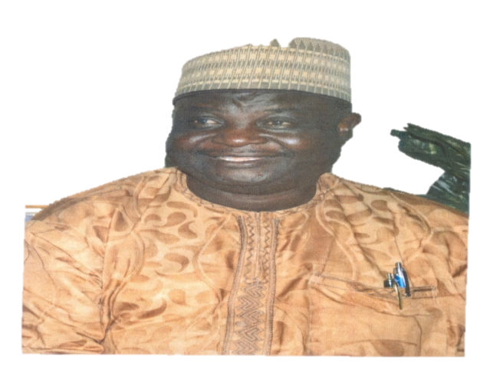  DR. YAKUBU GAMBO  DEPUTY EXECUTIVE SECRETARY (SERVICES)
Dr. Sharon ‘Rowo Oriero-Oviemuno was born on 22nd January in Lagos State but hails from Isoko South Local Government Area of Delta State. She attended Anglican Girls Grammar School (A.G.G.S), now Adesuwa Grammar School (1977/78) G.R.A-Benin City. After which she worked with Standard Bank in Lagos State (changed to First Bank of Nigeria PLC while she was there.) She then proceeded to the College of Education, Benin City, where she obtained the National Certificate in Education (N.C.E) 1981/82 pioneer set. Thereafter, she graduated with a B.Sc. Ed. Geography & Regional Planning/Education (1985/86) from the University of Benin, Benin City, Edo State.  Dr. Sharon, in her quest for further knowledge, immediately proceeded to attain the Master’s Degree in Education (M.Ed.) from the University of Ibadan (1986/87), focusing on Personnel Management. She practiced as a Management Consultant during which she studied and obtained the Ph.D. degree in 2002/2003 from the same University of Ibadan. Her final research work focused on Personnel Management (Human Resources Management and Development with some attention on Gender and Equal Opportunities Studies). Other broad – based part-time studies include: Executive Course on e-Governance/Project Management/ICT- Office Automation/Digitalization (International Best Practices in Paperless/Electronic Records) USA, a Master’s Degree in Law –L.L .M (in view) USA.  She founded and managed a Government Approved Private School in addition to being a seasoned Management Consultant till her appointment as Special Adviser (Inter & Intra Party/Political Matters) to the President - Senate (National Assembly), Federal Republic of Nigeria.  Her giant strides in the field of Education, her work in the Senate (FRN) and other positive contributions to the Society at the Grassroots, National and International levels, culminated in her appointment as the Deputy Executive Secretary (Technical), Universal Basic Education Commission. She had at different times worked as a Banker, Journalist/Broadcaster, Entrepreneur, Private School Proprietress, Management Consultant and appointed/served as Member on different Federal Government Governing Boards including UBEC’s Governing Board.  She is a mobilizer and motivator of Youths/Children, Women and Men towards entrenching the culture of excellence in all they do for ultimate positive impact in their individual lives in particular and the Nation in general. She is especially very passionate about best practices/Internationally acceptable quality in Education at all levels (including 21st Century ICT/e-Learning/Digitalization (Automation) of Education and work/work place generally for optimal productivity).  Dr. Sharon is a Chartered Manager, a Certified Management Consultant (CMC) and a Fellow of the Institute of Policy Management Development (IPMD), also a Fellow of the Institute of Management Consultants (FIMC) and a Member of Nigerian Institute of Management (NIM) amongst others. She is widely travelled globally, interacting internationally and has won numerous awards. She loves Reading, Constructive Writing, Teaching/Motivational Speaking, Traveling, Playing Golf, Table Tennis, Gyming, Indoor Games, Farming, Cooking, etc.  Dr. Sharon is happily married with Children. | Dr. Yakubu Gambo a grassroot mobilizer, an astute politician, sound educationist and season administrator was born on the 15th day of June, 1960 in Talbushi of Jahr Chiefdom in Kanam L.G.A of Plateau State. He attended Central Primary School Gyangyang between 1970 and 1977 and obtained the First School Leaving Certificate (FSLC). He proceeded to Government Teachers’ College Garkawa from 1977 and graduated with distinction in 1982 as a Grade II Teacher.  He was in College of Education, Gindiri between 1984 and 1987 where he studied Mathematics/Geography graduating with distinction for the NCE. H  e later enrolled in the University of Jos from 1992 – 1997 for the first degree in Education (B.sc Ed. Administration & Planning) and graduated with Second Class Upper Degree. He equally got the Masters Degree in International Relations and Strategic Studies in 2000 from the same University. He also attended Bayero University, Kano (BUK)Kano State from 2005 to 2010 and obtained the Doctorate Degree in Political Science.  Dr. Gambo started working as a Class Teacher from 1982 – 1984 and taught briefly at Government Teachers’ College, Amper in 1986/1987 Academic Session and was later elected Councilor representing Gagdi Ward of Kanam LGC in 1987. He was made the Deputy Chairman of Kanam LGC between 1987 and 1989.  In 1992, he was appointed Special Adviser to the Executive Governor of Plateau State on Youths, Sports and Culture. He was later appointed Permanent Member 1, Local government service, Plateau State from 1992 – 1996. While at the Local Government Service Commission, his performance was excellent, this paved way for his appointment as Commissioner for Agriculture and Water Resources from 1997 – 1998 and he was later appointed Commissioner for Education between 1998 and 1999.  In 1999, he doubled as Commissioner for Education and Commissioner for Agriculture and Water Resources in Plateau State thus running the two Ministries concurrently.  Dr. Gambo became the member representing North Central Zone following his appointment into the Governing Board of Universal Basic Education Commission from 2005 – 2007.  He has served in several State and National Ad-hoc Assignments and also has many publications to his credit and has received several awards.  Dr. Gambo is happily married with Children.  His Hobbies/Leisure include:  - Reading/Research  - Farming/Travelling  - Badminton/Lawn Tennis
1.1.4 STRUCTURE
The Office of the Executive Secretary consists of:
- Office of the Deputy Executive Secretary (Technical);
- Office of the Deputy Executive Secretary (Services);
- Special Projects Unit (International Development Partners);
- Procurement Unit;
- Federal Teachers Scheme Unit;
- Internal Audit Unit;
- Legal Unit;
- Public Relations & Protocol Unit;
- SERVICOM.

Table 1.1.4 Staff Disposition in Executive Secretary’s Office
S/N | DESIGNATED OFFICE |  | CONRAISS | NO
 | Executive Secretary |  | Consolidated | 1
 | Deputy Executive Secretaries (Technical&  Services) |  | Consolidated | 2
 | Special Asst. to ES/ DEST/National Coordinator (FTS)/Deputy Director (Audit) |  | 14 | 5
 | Assistant Director PR/Procurement/SERVICOM &Internal Audit |  | 13 | 4
 | Chief Confidential Secretary/Head, Legal/ Chief Executive Officer, Protocol |  | 12 | 3
 | Assistant Chief Data Processing Officer/Internal Auditor/Quality Assurance Officer/ Admin. Officer |  | 11 | 4
 | Principal Admin Officer/Confidential Secretary/ Legal Officer/Internal Auditor/Quality Assurance Officer/ Accountant |  | 10 | 7
 | Senior Legal Officers/Senior Internal Auditor |  | 09 | 5
 | Senior Executive Officer/Admin Officer I/Legal Officer I/Information Officer I/Quality Assurance Officer I/Civil Engr. I |  | 08 | 7
 | Higher Exec Officer (Protocol)/Planning Officer II/Project Officer II/Information Officer II/Auditor II/Confidential Secretary |  | 07 | 6
 | Chief Clerical Officer I/Senior Clerical OfficerI/Chief Driver/Mechanic |  | 06 | 5
 | Asst. Executive Officer (Admin) |  | 05 | 3
 | Clerical Officer |  | 03 | 1
 | Clerical Officer/Driver |  | 02 | 2
 |  | TOTAL |  | 55

1.2 FUNCTIONS
The functions of the Office of the Executive Secretary include:
- formulating and coordinating the execution of policy guidelines for the successful operation of the UBE Programme nationwide;
- ensuring the timely receipt of block grant from the Federal Government and allocating to States, and other related agencies implementing the UBE Programme in accordance with an approved formula;
- inquiring into and advising the Federal Government, through the Honourable Minister of Education, on the effective funding and orderly development of basic education in Nigeria;
- ensuring efficient collation and preparation of periodic master plans for a balanced and coordinated development of basic education in Nigeria;
- ensuring effective monitoring of Federal Government inputs into the implementation of basic education;
- presenting periodic progress reports on the implementation of the UBE Programme to Mr. President through the Honourable Minister of Education;
- liaising with the Honourable Minister of Education on matters of implementation, funding and general management of the UBE Programme;
- liaising with the Presidency and National Assembly from time to time on the funding and implementation of the programme;
- sustaining cordial relationship and cooperation with SUBEBs, State Governments and other stakeholders;
- pursuing enrolment campaigns and programme implementation to achieve UBE set objectives and goals; and
- supervising activities in the Special Project, Federal Teachers Scheme, Internal Audit, Legal, Public Relations/Protocol, Procurement and Almajiri Education Programme Units.
1.3 ACTIVITIES/ACHIEVEMENTS
In its efforts to ensuring the effective implementation of the UBE Programme for the benefit of the Nigerian child the Commission undertook some major activities which resulted in some achievements and challenges were encountered and these helped to sustain the tempo of basic education delivery in Nigeria in the year under review. These are as outlined in Reports from the various Departments.
It is worthy of note that during the year under review, the Commission witnessed a change in leadership. This change which took place in August, 2016 saw Dr. Dikko Suleiman handing over to Dr. Hamid Bobboyi as the Executive Secretary.
Nevertheless, between January and July, 2016, Dr. Dikko Suleiman engaged in some activities related to the implementation of the UBE Programme at different fora. These included the following:
- Opening Ceremony of the Two-Day Workshop for SUBEB Desk Officers in Charge of Early Childhood Care Development and Education (ECCDE) on the Implementation of the One Year Compulsory Pre-Primary Education and Community Based Early Child Care (CBECC) Initiative, held at the UBEC Conference Hall, Abuja , January, 2016.
- Flag-Off of Sokoto State 2015/2016 Birth Registration and Enrolment Drive Campaign, Retention and Completion of Basic/Secondary Education in Sokoto, January, 2016.
- Meeting on Home Grown School Feeding & Health Programme (HGSF&HP) in Nigeria delivered at the State House, June, 2016
- A One-Day Annual Review Meeting of Registrars/Chief Executive Officers of States and FCT Examination Bodies on Harmonization and Standardization of Basic Education Certificate Examination (BECE), held at Katsina State Ministry of Education Resource Centre, Katsina, February, 2016.
- Meeting on Teacher Professional Development (TPD) Implementation Guidelines in Ghana, February, 2016.
- Commissioning of UBEC’s e-Library Project at Barewa College, Zaria, Kaduna State, April 16, 2016.
- Nigeria’s Statement at the 49th Session of the United Nations Commission on Population and Development, New York – USA, April 2016.
- Status Report to the Honourable Minister of Education on Boy-Child Education Programme in South-East and South-South States – June 2016.

- Opening Ceremony of the Fifteenth (15th) Quarterly Meeting of UBEC Management with Executive Chairmen of SUBEBs, at the International Conference Centre, Calabar, Cross River State, June 2016.  - A Keynote Address on the occasion of the handing-over and taking-over ceremony for JICA Supported Project for the Construction of Additional Classrooms Phase II in Oyo State, held at Saint Luke’s Primary School, Molete, Ibadan, Oyo State, July 2016. | 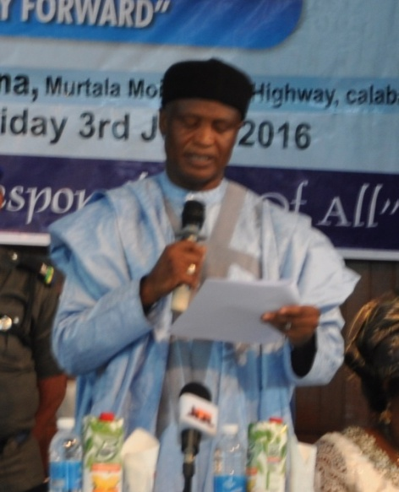
The former Executive Secretary, Alhaji (Dr.) Dikko
Suleiman delivering his speech at the 15thMeeting
of UBEC/SUBEB Chairmen Meeting held at the
International Conference Centre, Calabar
- Public Presentation of NUJ Year Book and A Practical Guide to Journalistic Writing, held at Sheraton Hotel and Towers, Abuja, July, 2016.
- Sustainable Funding for Integration: Federal Government Support to IQTE Systems; at A 2-Day National Conference on Integrated Qur’anic and Tsangaya Education (IQTE), held at African House, Government House, Kano; August 2016.
- National Flag-Off Ceremony for the 2015 Teacher Development Trainings for Basic Education Teachers and Managers, held at the Government Junior Secondary School, Jabi, FCT, Abuja, August 2016.
Following his appointment as the Executive Secretary, Dr. Hamid Bobboyi assumed duty in the Commission on 2ndAugust, 2016. Having settled down, he embarked on re-structuring of the Commission for better service delivery.

He created two additional Departments: Tsangaya Education Programme to take care of the out-of-schoolchildren and Special Duties to effectively administer the Zonal and State Offices as well as act as liaison Department. He also initiated other novel programmes such as the North-East-Education Recovery to reclaim the Basic Education institutions destroyed by the Boko Haram insurgency and Model School Development to engender better service delivery in Basic Education.

During his first five-month stewardship in the Commission, the Executive Secretary:
- convened a Meeting with Executive Chairmen of SUBEBs in August, 2016 for familiarization and sharing of ideas.
- Sent Goodwill Message at the Launching and Dissemination of National Quality Assurance Handbook for Basic and Secondary Education in Nigeria at Sheraton Hotels and Towers, Abuja, August 2016.
- presided over the 17thQuarterly UBEC Meeting with SUBEBs’ Chairmen held in Jos, Plateau State from 4th – 7th October, 2016.
- presented a paper along with the Executive Secretary, NERDC at UNESCO-DTCA-ECOWAS Parliament Joint Regional Consultative Workshop in Ghana, October, 2016.
- Gave an Address at a workshop tagged Market Place organised by UNICEF at Sheraton Hotels & Towers, Abuja between 10th and 11th November, 2016.
- organised a meeting on 22nd& 23rd November, 2016 with other related parastatals in Federal Ministry of Education to discuss the out-of-school children syndrome in Nigeria. The meeting discussed and developed an initiative on the strategies to tackle the menace for effective basic education delivery in Nigeria.
- convened a meeting of experts to review guidelines on UBEC funded Cluster School Model for Teacher Professional Development on 17th& 18th December, 2016.
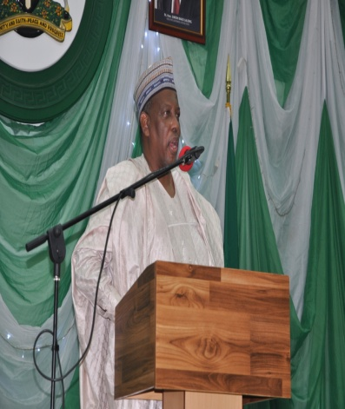 |  | 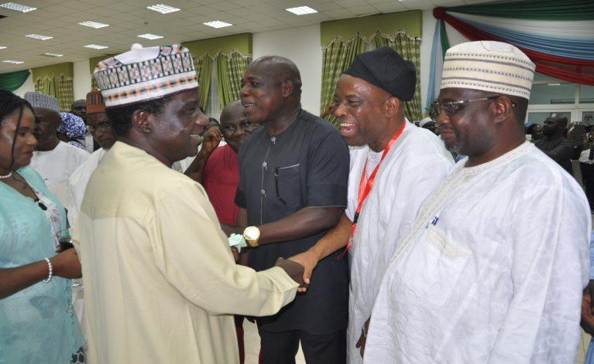
Dr. Hamid Bobboyi(ES) giving a speech at the  Meeting of UBEC/SUBEB Chairmen in Jos |  | The Governor of Plateau State, Mr. Simon Lalong, welcoming some chairmen who paid a courtesy call to his office

1.3.1 Visit from Some Dignitaries
- Courtesy visit by M. A. Abubakar Esq., the Governor of Bauchi State – September 2016.
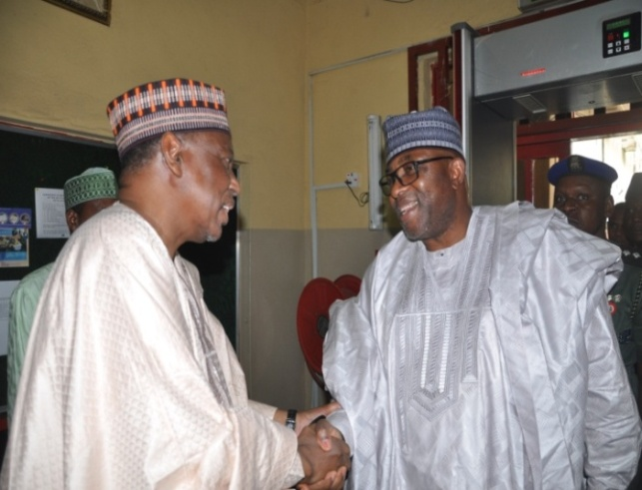 |  | 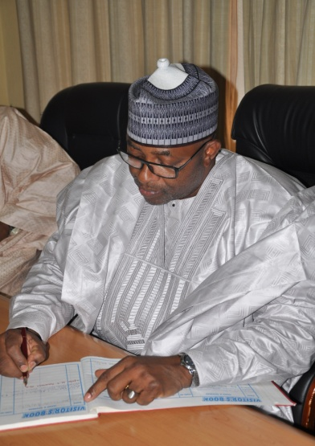
The Executive Secretary, Dr. Hamid Bobboyi welcoming  M. A. Abubakar Esq., the Executive Governor of Bauchi State |  | The Executive Governor of Bauchi State,  signing the Visitors Book

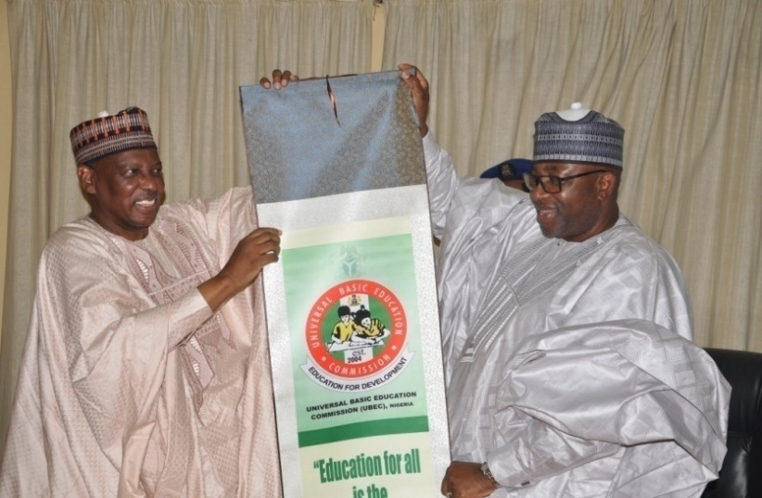
The Executive Secretary, Dr. Hamid Bobboyi presenting a gift to
M. A. Abubakar Esq., the Governor of Bauchi State
- Courtesy visit by a Team from Universal Learning Solutions, UK, October 2016.
- Courtesy visit by Prince Eze Madumere, Deputy Governor of Imo State, November 2016.
- Courtesy visit by Alhaji Kashim Shettima, Governor of Borno State, November 2016.

1.4 UNITS UNDER THE EXECUTIVE SECRETARY’S OFFICE
    - INTERNAL AUDIT UNIT

1.4.1.1 INTRODUCTION

The Internal Audit Unit is one of the Units in the Executive Secretary Office that implements all the control measures put in place by Management to ensure effective internal control systems in the Commission. It reports directly to the Accounting Officer for audit of the accounts and records of the organization as well as the examination of the system and procedures. It also submits to the Accounting Officer detailed Audit Programme and reports the progress being made on the Programme.

1.4.1.2 STRUCTURE
The Internal Audit Unit is headed by a Deputy Director. He is assisted by an Assistant Director and a Chief Internal Auditor on the day-to-day running of the Unit.

There were7 staff in the Unit. They are as contained in Table 1.4.1.2.
Table 1.4.1.2: Staff Disposition
S/N | RANK | CONRAISS | NUMBER
 | Deputy Director | 14 | 1
 | Assistant Director | 13 | 1
 | Chief Internal Auditor | 12 | 1
 | Principal Internal Auditor | 10 | 1
 | Senior Internal Auditor | 09 | 1
 | Auditor II | 07 | 1
 | Confidential Secretary | 07 | 1
TOTAL |  |  | 7

1.4.1.3 FUNCTIONS
The Internal Audit Unit liaises with the Department of Finance and Accounts on professional matters by working in close concert to ensure that the mandate of the Commission as enshrined in the enabling Act UBE 2004, is carried out.

Therefore, in line with the Financial Regulations (FR) 1701-1706, the Internal Audit performs the following functions:
- pre-audits all payment vouchers (staff claims, payrolls, pension and gratuities and other third party claims) before payments are effected;
- ensures compliance with Financial Regulations and other extant rules as they relate to the operations and activities of the Commission;
- issues Special Reports (where necessary) to the Executive Secretary and the Director of Finance and accounts;
- verifies Assets and Liabilities of the Commission in order to ensure that the Commission assets are secured while liabilities are properly incurred;
- monitors fund disbursements to SUBEBs and FCT UBEB, Intervention projects, instructional materials, Teacher Professional Development, Good Performance, Almajiri, Library, Girl-Child and Boy-Child education projects across the states of the Federation and FCT, ;
- performs any other function(s) as may be directed by the Executive Secretary from time to time.

1.4.1.4 ACTIVITIES/ACHIEVEMENTS
- Pre-payment Audits were done before payments were effected consistently.
- Conducted Compliance Audit of 2015 Teacher Professional Development Fund disbursed to the 36 States and FCT in July, 2016.
- Reviewed the 2015 UBEC Accounts and Operations within the period under review and the draft Report was prepared in November, 2016.
- Conducted Market Survey on the stocks consumables in October, 2016.
- Conducted Verification of Instructional Materials supplied by contractors to SUBEBs and schools before recommendation for payment.
- Conducted Interactive Session between the Unit and other Departments/Units on Evaluating the strength or otherwise of Internal Controls in the system between October and November, 2016.
- Determined the Selling Prices of Scrap/Obsolete Furniture/Office Equipment in December, 2016.
- Conducted 2016 End-of-Year Physical Stock Counting, crosschecked ledger balances, bin cards and stock purchased during the year in December, 2016.

1.4.1.5 CONSTRAINTS
The underlisted were some of the limitations that the Unit encountered during the year under review.
- Absence of special budgetary provision for Internal Audit activities considering its mandate covers Special Audit, Investigative Audit, Performance Audit and Risk Based Audit that may emerge from time to time;
- Lack of understanding of internal audit functions by other staff, contractors and other business partners; and
- Non-inclusion of Internal Audit Unit in most of the Commission’s Committees e.g. Procurement processes.

1.4.1.6 ON-GOING ACTIVITIES
- Audit Review of Year2016 UBEC accounts and operations.

1.4.1.7 FUTURE ACTIVITIES
- Submission of year 2016 Audit Report of UBEC Accounts and operations
- Conduct of UBEC Staff Audit (Headquarters, Zonal and State offices accounts and operations).
- Conduct of comprehensive market survey of consumables.
- Compliance Audit of year 2015 Teacher Professional Development funds in the 36 States and FCT.
- Participation in 26th-28thFinancial Monitoring of FGN-UBE Intervention funds in the 36 States and FCT.
- Verification of the supply and delivery of instructional materials (office furniture, books and equipment) supplied by contractors.
- Conducting performance audit on UBEC intervention funds.
- Preparation and production of Audit Procedure
- Manual/Guide in conjunction with the Auditor General of the Federation.

1.4.2 LEGAL UNIT

1.4.2.1INTRODUCTION
The Legal Unit is under the Office of the Executive Secretary. It is mandated to interpret laws and instruments entered into/ executed by the Commission. It represents the Commission in courts through external solicitors, in the event of any litigations.

1.4.2.2STRUCTURE
The Unit is headed by a Chief Legal Officer/Legal Adviser who is ably assisted by 4 Legal Officers.
Table 1.4.2.2: Staff Disposition
S/N | RANK | CONRAISS | NUMBER
 | Chief Legal Officer/Legal Adviser | 11 | 1
 | Principal Officer | 10 | 1
 | Senior Legal Officer | 09 | 2
 | Legal Officer 1 | 08 | 1
TOTAL |  |  | 5

1.4.2.3 FUNCTIONS
The functions of the Unit include among others:
- Providing legal advice to the Commission;
- Liaising with appropriate departments and consultant(s) on contract/project matters;
- Drafting and executing legal instruments;
- Proffering legal advice to State Universal Basic Education Boards whenever the need arises;
- Employing Alternative Dispute resolution without resulting to litigation;
- Liaising with Banks on the confirmation of Contractors Advance Payment Guarantees;
- Compilation and computation of Insurance premiums on the Commission’s assets.

1.4.2.4 ACTIVITIES/ACHIEVEMENTS
The Unit engaged in 2 major areas of its functions viz: Cases and Insurance.

- The Commission had 3 cases pending in different Courts in the year under review. The cases were:
- Mr. Agi Solomon Oga vs. Universal Basic Education Commission & anor (Instituted by an FTS Participant for alleged nonpayment of his allowances. The Commission is liaising with the Benue SUBEB with a view to resolving Mr Solomon Agi Oga and Hemen Enoch Inigbiafam cases out of court;
- Hemen Enoch Inigbiafam vs. Universal Basic Education Commission & 2ors (instituted by an FTS Participant for alleged nonpayment of his allowances;
- Paulicap Okechukwu Okeke vs. Macmillian Publishing Co. Ltd& Universal Basic Education Commission wherein the Commission was sued alongside Macmillan Publishing Co. Nig Ltd for alleged infringement of copyright and unauthorized printing, publication, distribution and sale of book titled “BIRIBAMBA THE LONELY ELEPHANT”. Macmillan Publishing Company is handling this matter with a view to resolving it out of court.
- successful delisting of the Commission’s name from the suit instituted by Fast track Tech Ltd Vs UBEC & 7ors;

- compiled the Commission’s Assets for the 2016/2017 Insurance year and insured them through Brokers for the period Nov 2016 -Nov 2017;
- successfully obtained the copyrights to print jolly phonics handbooks for use in Schools from the UK Author; and
- conducted training for
- Legal staff on “Contract Management and Administration: Minimizing Risk Exposure”.
1.4.2.5CONSTRAINT
The main constraint that the Unit encountered during the year under review was delay in information dissemination. Staff of the Unit had to follow up on the Departments for additional information required on Action files. This took time and this delayed prompt output of work.
1.4.2.6 ON-GOING ACTIVITIES
Some activities the Unit is executing include the following:
- Documenting and perfecting Instruments entered into between UBEC and Contractors;
- Liaising with relevant SUBEBs and contractors and holding Conciliatory Meetings with some non-governmental/civil organizations who have threatened Court actions with a view to resolving such issues out of court.

1.4.2.7 FUTURE ACTIVITIES
The Unit plans on embarking on the following activities.
- Advise the Commission and SUBEBs, when the need arises, on legal matters;
- Documentation of all contracts entered into by the Commission;
- Amicable dispute resolution between Contractors and the Commission;
- Attend Court sittings and watch briefs on behalf of the Commission; and
- Hold regular meetings with dis-satisfied contractors on ways to settle issues without recourse to Courts.

    - PROCUREMENT UNIT
1.4.3.1 INTRODUCTION
The ProcurementUnit is a Service Unit in the Office of the Executive Secretary. The Unit has staff who undertakes various assignments of the different sections.
1.4.3.2 STRUCTURE
The Head of Procurement is assisted by three other Procurement Officers who undertake activities relating to Goods, Works and Services. The Unit has five Procurement Officers with 1 Ad-hoc Procurement Officer from BPP who report directly to the Head of Procurement Unit.
Table 1.4.3.2: Staff Disposition
S/N | RANK | CONRAISS | NUMBER
1. | Assistant Director, Procurement | 13 | 1
2. | Assistant Chief Procurement Officer (BPP) | 11 | 1
3. | Principal Procurement Officer | 10 | 1
4. | Procurement Officer I | 08 | 2
5. | Clerical Officer | 02 | 1
TOTAL |  |  | 6

1.4.3.3 FUNCTIONS
The ProcurementUnit’s primary functions and responsibilities are to conduct the process for procurement of goods, works and services. The activities in the process are as listed below.
- Preparing needs analysis.
- Preparing procurement plans.
- Advertising/solicit for tenders or proposals.
- Conduct market surveys.
- Evaluate proposals.
- Recommend awards to Tenders Board.
- Monitor procurement performance.
- Advise the Executive Secretary on issues of procurement.
- Any other duty that may be assigned by the Executive Secretary or the Tenders Board.

1.4.3.4 ACTIVITIES/ACHIEVEMENTS
During the period under review, the Unit only facilitated payments for retention fees for the previous year’s awards.
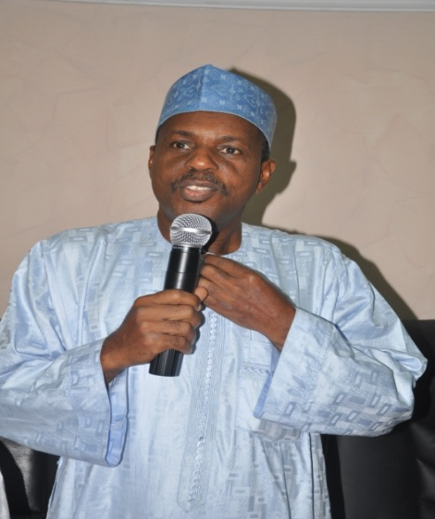
The SA to the ES, Baba Sali Song making a speech on behalf of the Executive
Secretary at the bid opening of Constituency Projects

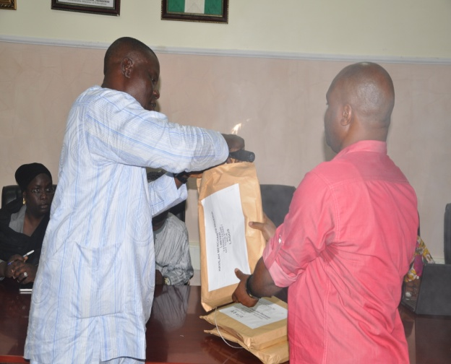 |  | 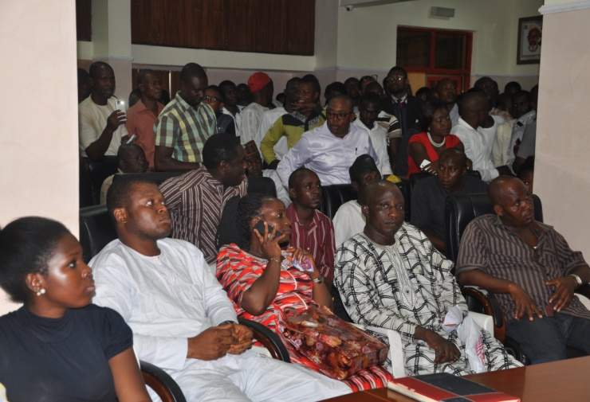
Mr. Benjamin Smart, Head of Procurement conducting the Tenders bid opening |  | A cross-section of contractors present at the  Tenders bid opening
1.4.3.5 CHALLENGES
The Unit was faced with the challenge of store space for keeping documents.
1.4.3.6 FUTURE ACTIVITIES.
All procurements related activities in the future will be undertaken.

1.4.3.7 CONCLUSION
The Unit has resolved to ensure that all procurement activities are carried out in compliance with the 2007 Procurement Act. This will ensure that quality goods, works and services are procured and delivered on time.
1.4.4 PUBLIC RELATIONS AND PROTOCOL UNIT

1.4.4.1 INTRODUCTION
The Public Relations/Protocol Unit is responsible for developing and implementing public enlightenment and corporate communication strategies and activities for UBEC.
1.4.4.2 STRUCTURE
The Unit is headed by Assistant Director Public Relations (ADPR) who reports directly to the Executive Secretary. He however, works closely with other Heads of Department and other relevant officers in performing its functions.
Table 1.4.4.2: Staff Disposition
S/N | RANK | CONRAISS | NUMBER
 | ADPR | 13 | 1
 | Chief Protocol Officer | 12 | 1
 | Admin Officer 1 | 08 | 1
 | Information Officer I | 08 | 1
 | Information Officer II | 07 | 1
 | Camera Man | 05 | 1
TOTAL |  |  | 6

1.4.4.3 FUNCTIONS
The Unit seeks to build and sustain a positive image for the Commission as well as reinvigorate public trust and confidence in UBEC’s capacity to lead and mobilize Federal, State and LGA Agencies for the implementation of Basic Education programmes in the country. It has the responsibility of:
- managing the image of the Commission.
- Maintaining good relationship with the public to achieve set goals and objectives of the Commission.
- Mediating between the Commission and the public.
- Producing Newsletters and writes Press releases on the activities of the Commission.
- Providing and sustaining a vibrant protocol services that ensure smooth logistics arrangement for UBEC’s activities.
- Monitors news stories, documentaries, and feature articles of the Commission in the newspapers.
- Anchor briefings, meetings and courtesy calls to the Commission.

1.4.4.4ACTIVITIES/ACHIEVEMENTS
During the period under review, the Unit successfully executed the following media related and protocol activities:
- Monitored and tracked News stories, documentaries, and feature articles of and on the Commission in the news media.
- Broadened access to improved reportage of the UBE Programme;
- Provided on and off site media coverage for major UBEC internal and external events including:
- 15thand 16thQuarterly Meetings of UBEC Management with SUBEB Chairmen in Cross Rivers and Plateau States respectively.
- UBEC’s events, meetings and interview sessions with designated media;
- Internal Departmental briefings
- Various engagements of UBEC Professional Departments with SUBEB Directors and Desk Officers at various destinations across the country;
- Advocacy visits to major UBE stakeholders at National and State levels;
- Courtesy calls to UBEC and on UBEC Executive Secretary by major government functionaries, UBE stakeholders, Advocacy groups, media correspondents, International Development Partners, etc.
- Compiled and provided direction for the production of critical UBEC informative and advocacy materials.
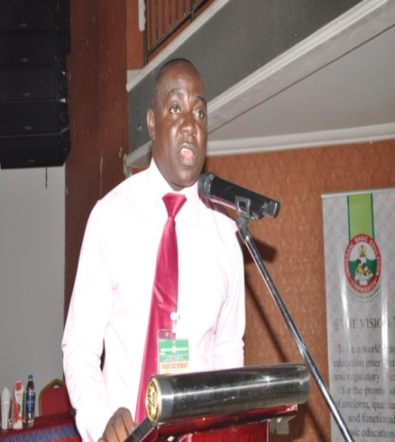
- Coordinating various print and online advertorials, announcements and publicity of UBEC events;
- Ensured smooth logistics operations and arrangements for UBEC events and activities;
- Facilitated visa processing, documentation and other arrangements for hitch free local and International travels and boarding for UBEC staff on assignments;
- Effectively managed the public relations profile and image of the UBE Commission through regular press releases, interviews between UBEC
Ossom Ossom,
UBEC PRO anchoring an official function
Executive Secretary and key media organs, press
briefings, etc;
- Putting in place an effective global distribution system to facilitate ticketing.

1.4.4.5 CONSTRAINTS
The Unit was constrained in the exercise of its mandates and set targets by the following factors:
- Low budgetary and funding for media related activities and increasing cost of media production, broadcast and media related activities.
- Absence of a strategic media focuses leading to low media presence and visibility of UBEC.
- Low stakeholders and public awareness of UBE.

1.4.4.6 ON-GOING ACTIVITIES
- Collating of materials for future documentaries on NTA, AIT and Channels Networks.
- Routine engagement of UBEC Executive Secretary with media practitioners
- Routine publication of events as they occur.

1.4.4.7 FUTURE ACTIVITIES
The Unit intends to pursue a more vigorous public relations framework that seeks to integrate contemporary and creative mechanisms for publicizing the modest achievements of UBEC and creating a robust platform for mobilizing stakeholder support for UBE programme activities. Along this line:
- A public relations strategy and action plan has been developed for 2017 with specific budgets for key items.
- Public Relations staff functionaries are being mobilized to offer improved professional services in the coming year.
- Development and production of UBE TV jingle in English and other major language variations (Hausa, Yoruba, Igbo, Pidgin English).
- Production of UBE TV Documentaries.
- Production of 30 minutes UBE TV and radio programme.
- Structured feature writing on UBEC intervention/ UBE issues in major national and regional newspapers.
- UBE newspaper publicity on UBE funding, deliverables, contemporary issues and adverts.
- Printing of bi-monthly UBEC in-house newsletter and quarterly newsmagazine.
- Printing and dissemination of UBE posters and other light publicity of advocacy messages on the UBE programmes to mass audience using bulk SMS.
- Creation of social media account for engagement with the public.

1.4.4.8 CONCLUSION
At the end of this year, the Unit’s activities would have drastically improve media presence in the following areas:
- stakeholders’ awareness of UBEC achievements, challenges and prospects;
- Galvanize increased non-public interest and involvement in UBE processes.
- Improve the public perception and general rating of UBEC among key stakeholders and the general public.

1.4.5 SPECIAL PROJECTS UNIT
1.4.5.1 INTRODUCTION
The Special Projects Unit is under the Office of the Executive Secretary. It is the main entry point and clearing house of all International Development Partners and Donor Agencies in the Basic Education Programmes delivery.

1.4.5.2 STRUCTURE
The Unit is headed by a Deputy Director/Project Coordinator.
He works under and reports directly to the Executive Secretary. He, however, also works closely with other Heads of Departments in performing its functions. He is assisted by two Project Officers and an Assistant Chief Confidential Secretary.

STRUCTURE Table 1.4.5.2: Staff Disposition
S/N | Ranks | CONRAISS | Number
 | Deputy Director/Project Coordinator | 14 | 1
 | Assistant Chief Confidential Secretary | 11 | 1
 | Senior Project Officer | 09 | 1
 | Project Officer | 07 | 1
Total |  |  | 4

1.4.5.3 FUNCTIONS
The main functions of the Unit are:-
- coordinating the implementation of the UBE activities in collaboration with multi and bi-lateral agencies, and
- Liaising with Donor Agencies, Non-governmental Organizations and other Development Partners on support for basic education in Nigeria. These are in keeping with the provision of UBE Act, 2004, part II, section (j) and (r)
Other specific functions of the Unit include:
  - Coordinating and provide support to technical officers at both UBEC and SUBEBs to facilitate the achievement of projects targets
  - Initiating new projects or support areas for collaboration with International Development Partners
  - Arranging, coordinating and facilitating High Level Donor Coordination Meetings in the area of Basic Education

1.4.5.4 ACTIVITIES/ACHIEVEMENTS
The Unit, in performing its functions, had been collaborating with major International Development Partners in providing support in several different areas for the development of Basic Education in Nigeria during the year under review. They are as stated below.

- Japan International Cooperation Agency (JICA).
- The Japan International Cooperation Agency(JICA) officially handed-over the Supported Project, Construction of Additional Classroom Phase III, in Oyo State to the Federal Government of Nigeria on July 4, 2016. The project was executed in 30 schools across selected 19 Local Government Areas of the State. The deliverables consisted of the construction of 231 classrooms, 2 teachers’ offices,220 toilets, 4,620 sets of students’ furniture as well as 245 sets of teachers’ furniture.
- Yachiyo Engineering Co. Ltd provided support for the conduct of the Soft Component of the Project in Oyo State, June, 2016. The soft component is for the Community leaders, head teachers and teachers to take ownership of the project after completion by way of maintaining facilities provided.
- Provided support to the Japan International Corporation Agency (JICA), 28th July to 28th August 2017, to administer Questionnaire on Ex-Post Evaluation FY 2016 on Grant Aid Project “The Project for Construction of additional classrooms for primary schools (Phase 2)” in Kano State.
- Korea International Cooperation Agency (KOICA).
- While the Agency trained 65 teachers in Phase I of the Teacher Trainings in August 2016, the Phase II is on-going with 75 beneficiaries. Both Phases are conducted in Abuja.
- Twenty (20) educational policy makers, managers, administrators and teachers were trained on various aspects of educational concerns in Seoul, South Korea in March 20th to 26th 2016.
- KOICA supported the provision of ICT equipment in Adamawa and Gombe States. It procured 200 All-in-One computers for the four KOICA constructed schools in the 2 States in November 2016 to January 2016.
- The Special Project Office, through the World Bank Supported Projects supported the capacity building of teachers and school administrators at both UBEC and SUBEB levels in May, 15th to 20th2016.

- The World Bank:
The World Bank has been a long time partner and is currently supporting the State Education Programme Investment Project and the Global Partnership for Education (GPE)/Nigerian Partnership for Education Project (NIPEP)in Nigeria.
- State Education Program Investment Project (SEPIP)
The State Education Programme Investment Project in Nigeria is a novel project being piloted in three States: Anambra, Bauchi, and Ekiti States. Under this project, funds are disbursed to States after they achieved and accomplished some pre-determined performance/disbursement indicators called Disbursement Linked Indicators (DLIs). Thus, this is a result-based financing project. UBEC as a statutory agency charged with the responsibility or coordinating Basic Education in Nigeria has a major responsibility in this project.
- Global Partnership for Education (GPE)/Nigerian Partnership for Education Project (NIPEP)
The Global Partnership for Education (GPE) is under the World Bank supervision. The GPE/NIPEP is a 100 million US Dollars Project aimed at assisting Nigeria to achieve SDG goal 2 through increased access and improved quality to basic education. Beneficiary States are; Katsina, Kano, Kaduna, Jigawa and Sokoto. The major areas of focus in the project are (i) Increasing girl-child enrolment and retention through conditional cash transfers, (ii) Strengthening SBMC and (iii) TPD especially on classroom management.
The Special Project Unit has provided Technical Assistance to the States on M&E and Project Coordination between April and August 2016.

- Program for Result (PforR) Operations
The proposed programme for Result (P4R) is an operational project that has been requested by the Federal Government of Nigeria from the World Bank to support Basic Education in Nigeria especially with reference to the Ministry’s Ministerial Strategic Plan (MSP) 2016-2019. The project’s total package is $ 610,000,000 US Dollars to be expended in the support of Pillar I of the MSP, the out of school children. Beneficiary States are; Adamawa, Taraba, Gombe, Bauchi, Borno, Yobe, Niger, Ebonyi, Rivers, Kaduna, Kano, Jigawa, Katsina, Sokoto, Kebbi, Zamfara and Oyo (17).These are the States with the highest ration of Out of School Children in Nigeria as reported in the 2015 National Education Data Survey.
The Unit coordinated the following meetings leading to the Negotiation and Approval of 2 Projects by the World Bank Board;
- Meeting of UBEC and the Bank Team with SUBEBs on the formulation of the Result Areas November 20 16.
- Project Coordination Work Shop on for the Beneficiary State
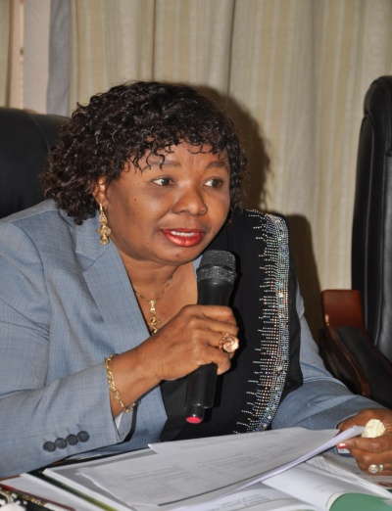 |  | 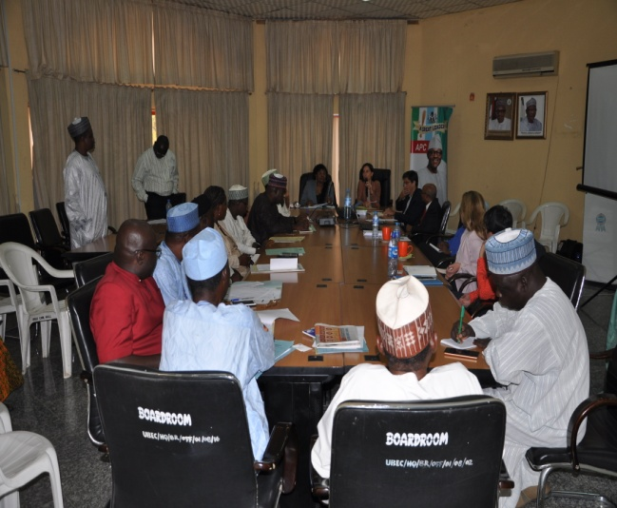
Dr. Sharon Oriero-Oviemuno, DES (T), making a  speech at a meeting with the World Bank |  | Members of Management of the Commission  present at the Meeting

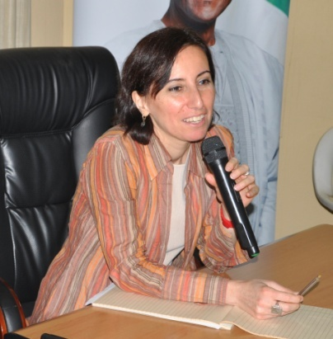 |  | 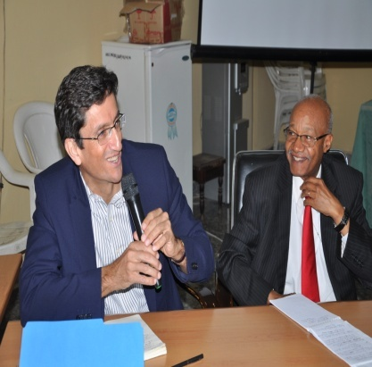 |  | 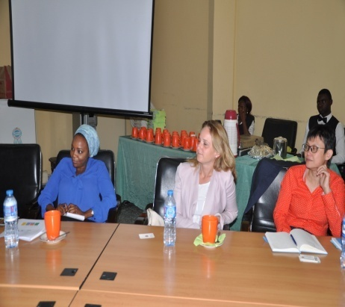
A cross-section of the staff of World Bank at the meeting

- Jolly Phonics
The Jolly Phonics Project is a project that introduces phonetics teaching methods that enable children learn to read and write in the shortest period of time ever recorded in the history of Basic Education in Nigeria.
Key officers of UBEC were invited to the United Kingdom in November 2016 to discuss further on the partnership. The discussion was aimed at providing UBEC with deeper understanding of the Jolly Phonics implementation strategies, challenges and best practices. The outcome of the visit was the signing Memorandum of Understanding with Universal Learning Solutions (USL) to scale-up the project to cover all states of the Federation, and Jolly Learning has given UBEC the copyright of the materials. Recently, Jolly Learning Solutions granted UBEC the approval to print the Jolly Phonic Materials.
1.4.5.5 CONSTRAINTS
- Inclusion of the SEPIP and NIPEP in the Treasury Single Accounts.
- Limited avenues and poor mobility/logistics on reaching IDPs for dialogue on collaboration that may lead to improvement of the UBE Programme.
- Limited office space/accommodation.
- Budgetary provision for adequate project monitoring (counterpart funding).

1.4.4.6 ON-GOING ACTIVITIES
Local and overseas Capacity Building Activities for different categories of the Commission’s/SUBEBs’ staff are on-going.
1.4.5.6 FUTURE ACTIVITIES
- Establishing additional and stronger linkages with related Ministries and Departments such as FME, NPC, FMF, Immigration, Customs, Nigeria Ports Authority, etc. and other IDPs such as USAID, Canadian International Cooperation Agency (CIDA) and the Emirate International Cooperation Agency, for ease of coordination and implementation of IDPs supported Programmes and Projects.
- Discussion and dialogue with Multi-National Corporations such as Samsung, LG and Microsoft Cooperation for area of collaboration in basic education.
- Conduct regular Meetings with IDPs on collaboration in the basic education sub- sector.

1.4.4.8 CONCLUSION
It is clear from the submission of the Unit that UBEC, through the Unit, is effectively engaging with a good number of infrastructural developments and provision of equipment in schools as well as securing huge investments, in terms of funding and local/ overseas capacity building activities from the collaborating Partners/Agencies and these were effectively utilized by the Commission.

1.4.6 SERVICOM UNIT

1.4.6.1 INTRODUCTION
The SERVICOM Unit is under the Executive Secretary’s Office. It ensures excellent, timely, fair, honest, effective and transparent) customer service and mind-set changes as well as strong collaboration and ownership across all governments in the coordination of the implementation of the UBE Programme by the Commission.
1.4.6.2 STRUCTURE
The Unit is headed by an Assistant Director. He is assisted by 2 Senior Legal Officers.
Table 1.4.6.2: Staff Disposition
S/N | Ranks | CONRAISS | Number
1. | Assistant Director | 13 | 1
2. | Senior Legal Officer | 09 | 2
Total |  |  | 3
1.4.6.3 FUNCTIONS
The basic functions of the SERVICOM Unit include but are not limited to:
- formulate, implement and review the Commission’s Service Charter.
- Liaise with the Federal Ministry of Education and other relevant stakeholders on SERVICOM matters.
- Monitor, update and report on activities of State and Zonal offices on Service delivery.
1.4.6.4 ACTIVITIES/ACHIEVEMENTS
- Representation of the Commission at the 4th quarter Ministerial SERVICOM Committee meeting organized by Federal Ministry of Education which held in National Institute for Educational Planning and Administration (NIEPA), Ondo State in September, 2016.
- Upgraded the Headquarters’ Reception Area of the Commission in December, 2016.

1.4.6.5 CONSTRAINTS
- Inadequate funds to implement the Unit’s activities.
- Lack of Training of SERVICOM staff.
1.4.6.6 ON-GOING ACTIVITIES
There is no on-going activity.
1.4.6.7FUTURE ACTIVITIES
- Follow-up Monitoring of the SUBEBs, LGEAs, and Schools to ensure the implementation of SERVICOM Unit Establishment at the State Level.
- Quarterly Networking Seminar with all SUBEBs’ SERVICOM Desk Officers.
- Training of UBEC SERVICOM Unit staff by SERVICOM Institute.
- Training of UBEC members of staff on SERVICOM ideals.
- Review and submission of Commission’s Service Charter to the SERVICOM Office (Presidency).

1.4.7 FEDERAL TEACHERS’ SCHEME (FTS)
1.4.7.1 INTRODUCTION
The Federal Teachers’ Scheme is a Unit in the Office of the Executive Secretary. It coordinates all activities that are related to the Federal Teachers’ Scheme which is one of the Federal Government’s intervention programmes that is aimed at achieving the goal of the Universal Basic Education programme. Established in 2006, FTS serves as a strategy for improving the quality of education delivery through supply of qualified teachers.
The Scheme targets holders of the Nigeria Certificate in Education (NCE) for enlistment for a two-year voluntary teaching service in public basic education schools. During the service period, the Federal Government pays the participants a monthly allowance.

1.4.7.2 STRUCTURE
The Unit is headed by a National Coordinator who is assisted by staff deployed from other Departments in the Commission. The Scheme is implemented using the existing UBEC structure (Headquarters, Zonal and State Offices). The Commission works closely with the SUBEBs, through a designated Desk Officer, appointed by each Board. The Desk Officer oversees the day to day implementation of the Scheme at the State level.
Table 1.4.6.2: Staff Disposition
S/N | Ranks | CONRAISS | Number
1. | National Coordinator | 14 | 1
2. | Assistant Chief Quality Assurance Officer | 12 | 1
3. | Principal Quality Assurance Officer | 10 | 2
4. | Quality Assurance Officer II | 08 | 1
5. | Driver | 03 | 1
Total |  |  | 6

1.4.7.3 FUNCTIONS
The functions of the Federal Teachers’ Scheme Unit include the following.
- Conduct of the selection process of enlistment of candidates into the Scheme.
- Deployment of selected teachers to States.
- Maintenance of accurate database on the Scheme.
- Monitoring the performance of serving teachers and generating reports for Management consideration.
- Preparation of monthly list of eligible participants for payment.
- Coordinating other activities relating to the Scheme such as induction/orientation training, capacity building and physical verification of serving teachers.
- Liaising with the State Universal Basic Education Boards on matters affecting the implementation of the Scheme.

1.4.7.4 ACTIVITIES/ACHIEVEMENTS
Funds were not appropriated for the Federal Teachers’ Scheme in 2016 and as such no fresh intake of teachers was undertaken. This was due to the fact that the Debt Relief Gains (DRGs) which the Scheme had been funded from inception dried up at the end of 2015, the terminal year for the Millennium Development Goals.
Over the period that the Scheme ran, it made some modest contributions to the delivery of quality basic education. A total of 120,000 teachers with the Nigeria Certificate in Education (NCE) participated in the Scheme and were deployed to basic education schools in all the States and the Federal Capital Territory (FCT), Abuja.
- According to an impact assessment study conducted on the scheme in 2010, the scheme was found to be addressing the major focus of the Universal Basic Education programme, viz: Access, Equity and Quality. In addition, the scheme:
- increased the number of qualified teachers at basic education level;
- specifically addressed, to some degree, the issue of acute shortage of teachers in schools located in rural areas, as seventy percent (70%) of the teachers were deployed to the rural areas;
- provided opportunity for the teachers to have first-hand experience classroom challenges, as they apply knowledge and skills acquired during pre-service training.
The Sustainable Development Goals (SDGs), which is the successor global development agenda to the Millennium Development Goals, is expected to run from 2016 to 2030. SDG 4 targets inclusive quality education. The attainment of this goal and that of the Universal Basic Education Programme would depend largely on the availability of qualified, competent and motivated teachers. The challenge of teacher shortage in the face of dwindling resources, especially at State and Local Government levels, makes it imperative for sustained Federal Government’s intervention in basic education in the area of supply of qualified teachers.
It is in the realization of the foregoing that the sum of Two Billion, One Hundred and Thirty One Million, Six Hundred and Seventy One Thousand, Three Hundred and Fifty Naira (N2,131,671,350.00)only was appropriated for the Scheme in 2017, signaling its return to the national development platform.

2.0 THE DEPARTMENTS OF THE COMMISSION
The UBE Commission has ten (10) Departments which are headed by Directors. Each Department carries out its functions in line with the Commission’s mandates as enshrined in the UBE Acts 2004. The achievements, challenges, and future activities are also highlighted under each Department.
Most of the Departments have staff at the Zonal and State offices and these are reported in the Zonal and State offices’ section.

2.1 DEPARTMENT OF ACADEMIC SERVICES

Mallam Wadatau Madawaki was born on 28th December, 1961 in Gusau town, Gusau Local Government Area of Zamfara State. He had his primary education at the Township Primary School, Gusau; teachers training at the Sultan Abubakar College, Sokoto; and obtained his Nigeria Certificate in Education (NCE) at the College of Education, Sokoto, before attending the Ahmadu Bello University (ABU), Zaria, for his Bachelor of Education (B.Ed) Degree in 1989.

He started his working career as a primary school teacher and rose to become a Headmaster with the Sokoto State Local Government Service Commission before he went on to teach at the secondary school level after obtaining his NCE in 1984. He rose to the position of Vice Principal (Academics) before he transferred his service to the then Universal Basic Education Programme (UBEP) in 2002 as an Assistant Chief Monitoring Officer.

He became Chief Monitoring Officer in 2004, Assistant Director (Academic Services) in 2008 and Deputy Director (Academic Planning) in 2012. He is presently the Acting Director, Department of Academic Services, UBEC.
Mallam Wadatau Madawaki
Ag. Director, Department of
Academic Services

2.1.1 INTRODUCTION
The Department of Academic Services is vested with the responsibility of coordinating curriculum development, provision of instructional materials, library development, guidance and counselling, sports and quiz activities, other co-curricular activities and Teacher Professional Development in the UBE Programme.

2.1.2 STRUCTURE
The Department comprises of three Units which are Academic Planning, Education Support Services and Teacher Professional Development. It is currently headed by an Acting Director who is assisted by an Assistant Director.
On the whole there were Twenty-Two (22) staff in the Department during the period under review.

Table 2.1.2: Staff Disposition
S/N | Designation | CONRAISS | Number
 | Acting Director | 15 | 1
 | Assistant Director | 13 | 1
 | Chief Academic Planning Officer | 12 | 1
 | Assistant Chief Academic Planning Officer | 11 | 4
 | Principal Academic Planning Officer | 10 | 1
 | Principal Librarian | 10 | 1
 | Senior Academic Planning Officer | 09 | 1
 | Academic Planning Officer I | 08 | 5
 | Academic Planning Officer II | 07 | 3
 | Higher Assistant Academic Planning Officer | 07 | 1
 | Confidential Secretary | 08 | 1
 | Higher Data Processing Officer | 07 | 1
 | Driver | 04 | 1
TOTAL |  |  | 22

2.1.3 FUNCTIONS
The Department performs the following functions:
- Promoting physical education activities, Guidance and Counselling services and sports and quiz activities in schools and other co-curricular activities;
- Coordinating and drawing up of guidelines on the utilization of the Federal Government Intervention Funds by states in the provision of instructional materials and teacher professional development;
- Stimulating the provision and coordination of functional libraries and classroom collections for all UBE target groups for the enhancement of learning-to-learn skills and a reading habit for life-long literacy;
- Serving as an observatory of events in the basic education sub-sector for reporting on early warning signs of deterioration as well as a means of proposing strategies for quick remediation;
- Stimulating and sensitizing the States to their responsibilities in the provision of quality Early Childhood Care Development and Education {ECCDE}; and
- Serving as desk for participation in Joint Consultative Committee on Education (JCCE) and National Council on Education (NCE) meetings.

2.1.4 ACTIVITIES/ACHIEVEMENTS
- Coordinated the Commission’s participation at the Reference Committee Meeting of the Joint Consultative Committee on Education (JCCE) from 1st to 5th February, 2016.
- Held interactive Meeting with SUBEB Directors and Desk Officers in charge of Teacher Professional Development in order to improve the Teacher Development Programme from 20th – 21st January, 2016.
- Held Meeting with representatives of Training Institution on implementation of Capacity Building Programmes for education managers and teachers in the UBE Programme from 10th – 11th April, 2016.
- Monitored the availability and utilization of JSS Textbooks, ECCDE and library resource materials distributed to some JSS and primary schools across the states.
- Reviewed the library Resource materials sent in by states for procurement.
- Monitored the availability and utilization of 2,964,200 JSS Textbooks, ECCDE and library resource materials distributed to some JSS and primary schools across the States procured using the 2014 FGN/UBE Intervention Funds from 20th June to 1st July, 2016.
- Conducted training workshop for headteachers and caregivers in collaboration with UNICEF in some selected schools in 3 Area Councils of Abaji, Kuje and Kwali.
- The Department in collaboration with UNICEF monitored the actualization of the use of Reggio Emilia and child-centered approaches implementation in all the schools involved in the trainings at Abaji, Kwali and Kuje.

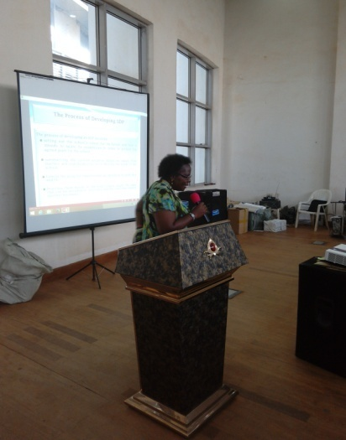 |  | 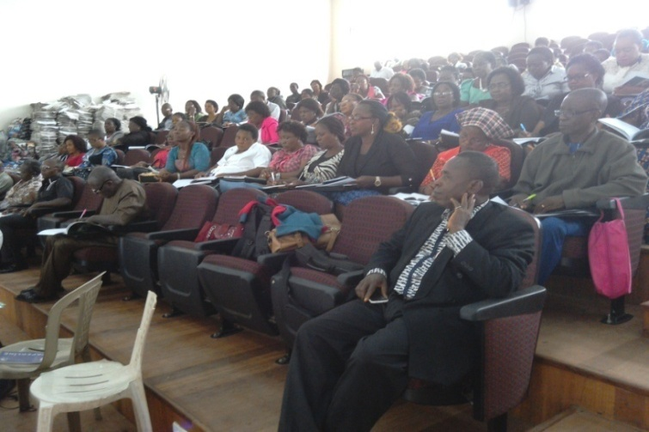
Barr. Tofunmi Akamo, a Resource Person at the Quality Assurance Teacher Professional Development Training held in Enugu |  | Participants at the Quality Assurance Teacher Professional Development Training listening with rapt attention

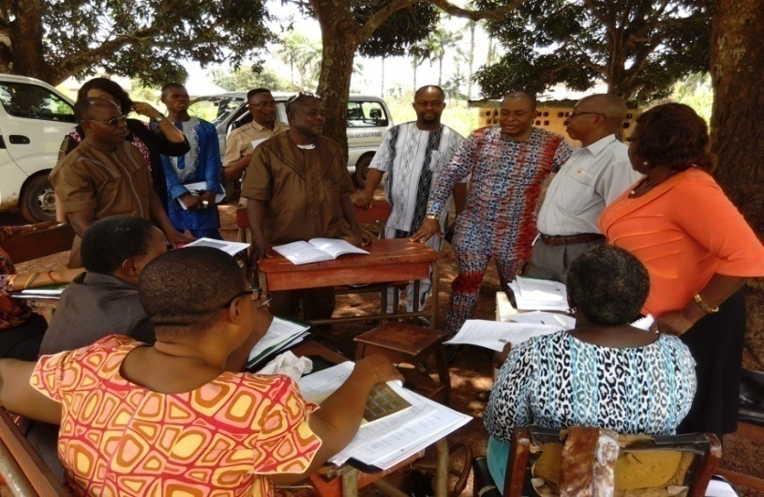
Resource Persons inspecting participants at the Teacher Professional Development Training undertaking practicum in one of the schools

- Conducted in collaboration with UNICEF Training Workshop on Reggio Emilia and other Child-centred approaches for headteachers and caregivers in some selected schools in 3 Area councils of Abaji, Kuje and Kwali from 13th – 17th June, 2016.

 |  | 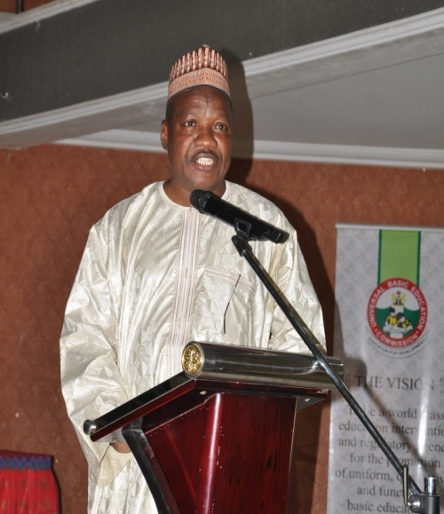
Mallam Wadatau Madawaki, the Ag. Director of the
Department addressing participants at the training

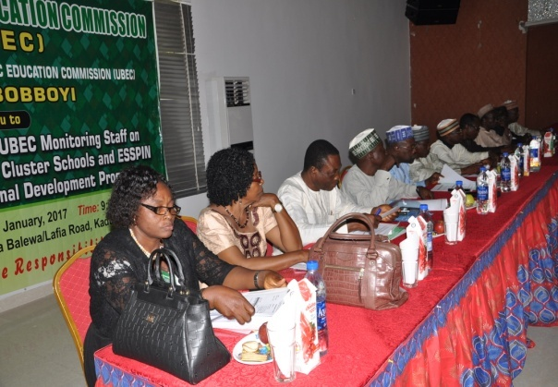 |  |  |  | 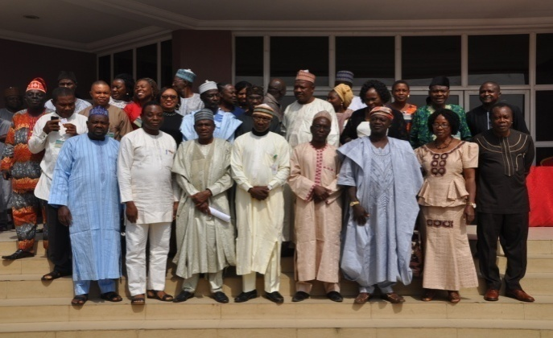
Management of the Commission on the  High Table at the Training |  |  |  | Group photograph of participants at the training

- Reviewed recommended list on Core textbooks and library Resource materials sent in by States for procurement.
- Conducted Meeting with ECCDE Desk Officers across the States on Fast-tracking the implementation of Pre-Primary Education across the States and FCT.
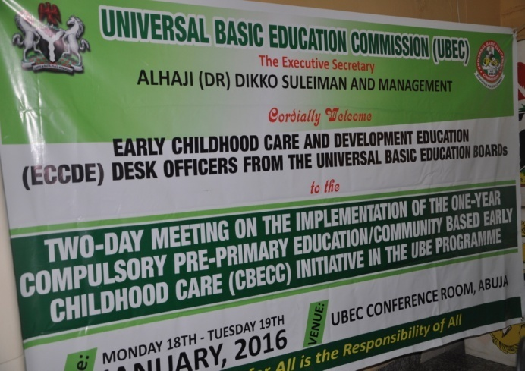 |  | 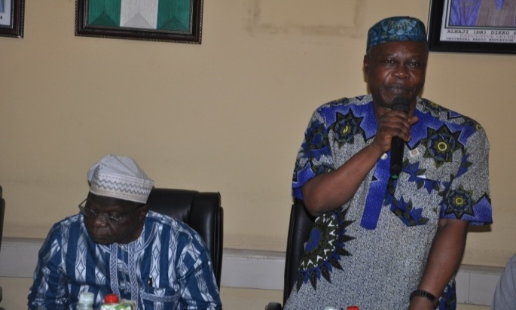
Meeting of UBEC with SUBEBs ECCDE Desk Officers on  fast-tracking of One-Year Pre-Primary |  | The former Director of the Department, Mr. Pius Osaghae, addressing the participants at the meeting

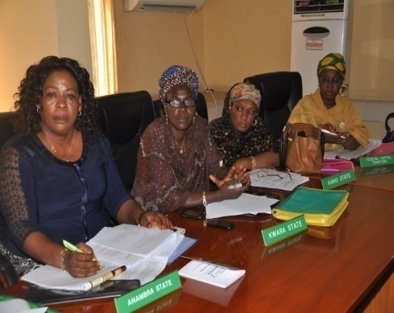 |  | 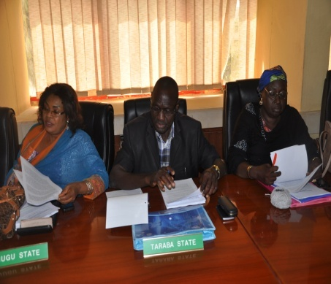 |  | 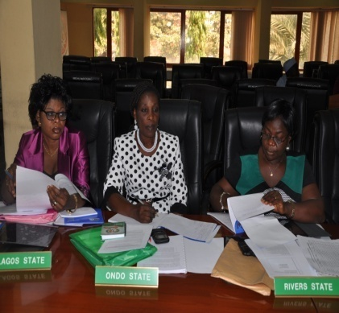
A cross-section of participants from SUBEBs present at the Meeting

- Conducted a National Flag-off of the 2015 TPD in 2nd August, 2016.
- Coordinated the Commission’s participation at the 76th Plenary Meeting of Joint Consultative Committee on Education (JCCE) Reference Committees and 61st National Council on Education (NCE)held from Tuesday 30th August – Friday 2nd September, 2016 and Tuesday 27th – Friday 30th September, 2016 respectively.
- Conducted Advocacy Visit on fast-tracking the implementation of Community Based Early Childhood Education and Pre-primary Education in 16 States from 17th to 21st October, 2016.

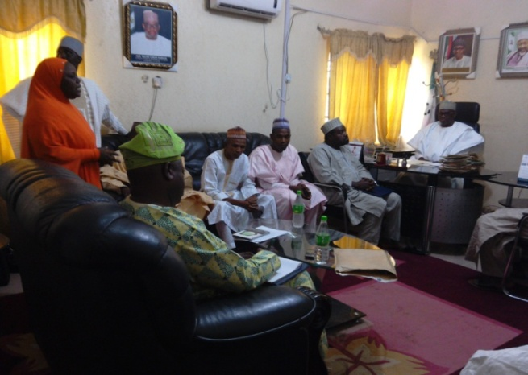 |  |  |  | 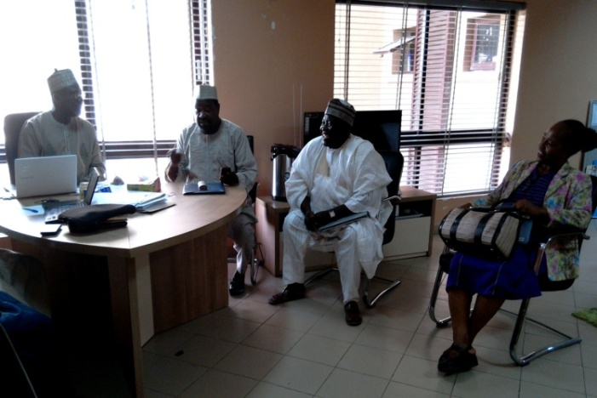
The Advocacy Team to Jigawa State meeting with Alhaji  Salisu Zakar Hadejia, Executive Chairman,  SUBEB in hisoffice |  |  |  | Permanent Secretary, Jigawa State Ministry of Education, Alhaji  Abdullahi Hudu who represented the Commissioner of Education
 |  | 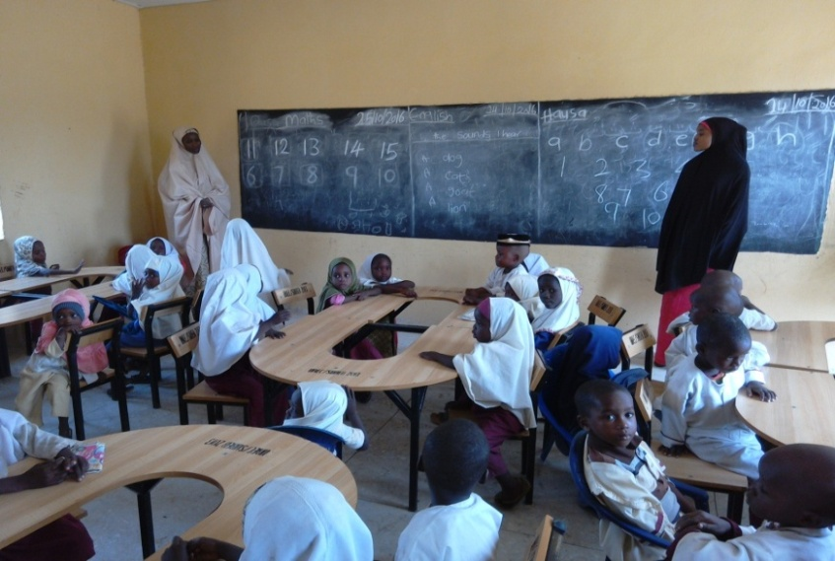
An ECCDE classroom monitored by the Advocacy Team in Takur Site
Primary School, Dutse, Jigawa State
- The Commission donated trophies and attended the 56th Independence Debate Championship of President School Debate Nigeria(PSDN) from 24th – 28th October, 2016.
- Conducted 2014 Impact Assessment of Cluster Schools Model in one State of each geo-political Zone. The activity was held in 2 Phases. First Phase was from 7th – 16th November, 2016 and 2nd Phase was held from 21st November 2nd December, 2016.
- Held a one-day Meeting on the Review of the Guidelines of UBEC funded Cluster Schools Model Training from 8th – 9th December, 2016.

    - CONSTRAINTS
- Non-adherence by the States to the Guidelines on distribution of textbooks, Cluster Schools Model training and other teacher Development Program. Nonuse of the Book Management Information System {BMIS} in the management of the textbooks.
- Non-committal attitude of some States to ECCDE implementation despite the recent approval of a one-year compulsory ECCDE/Pre-primary Education and its entrenchment in the National Policy on Education (NPE).
- Lack of budgetary allocation for Physical Education and Sporting Activities in the UBE Programme;
- Low level or total absence of Guidance &Counselling services Unit in most of the UBE schools: and
- Delay in the release of intervention funds for the conduct of TPD;
- Sole reliance on FGN-UBE Funds for TPD by most of the States;
- Poor or inadequate follow-up trainings, monitoring, evaluation and impact assessment of training by States.

2.1.6 ON-GOING ACTIVITIES
- Provision of instructional materials to public schools nationwide using the 2015/2016 UBE Instructional Materials Intervention funds.
- Cataloguing of UBE information materials as well as creating newspaper index proforma
- Monitoring of the 2015 TPD in the remaining States.
- Analysis of reports of the conduct and monitoring of 2015 TPD
- Disbursement of 2nd tranche funds to States for the conduct of the 2015 trainings

2.1.7 FUTURE ACTIVITIES
- Advocacy and Sensitization Visit to the eight (8) non-focal UNICEF States of Akwa Ibom, Anambra, Cross River, Imo, Kaduna, Kano, Ogun and Ondo for the Fast Tracking of the Implementation of ECCDE and the Community Based Early Child Care Centres (CBECC).
- Follow up visits on Community Based Early Child Care Centres (CBECC) and Pre Primary Education implementation in 23 States.
- Verification of the adequacy, availability and utilization of Instructional/Pedagogical Materials in Basic Education Institutions (Primary, JSS and ECCDE) and the Disbursement of Support Fund to States for the distribution of textbooks 2016.
- Provision of textbooks to public schools nationwide using the 2016 UBE Instructional Materials Intervention funds.
- Participation in the 2017 JCCE and 63rd NCE policy meetings.
- Preparation for the conduct of 2016 TPD trainings.
- Coordination of the conduct of 2016 Teacher Professional Development
- Meeting of UBEC Management with Directors and Desk Officers in charge of TPD from SUBEBs.
- Meeting of UBEC Management with Representatives of Training Institutions
- Analysis of the Action Plans to ensure adherence to the guidelines for TPD
- Disbursement of funds to States for the conduct of the 2016 trainings
- Monitoring of the 2016 TPD trainings.
- Impact Assessment of 2015 Cluster Schools Model.

2.1.8 CONCLUSION
The Department will continue to work hard in order to develop feasible guidelines on the utilization of the Federal Government Intervention Funds by States in the conduct of Teacher Professional Development and the provision of Instructional Materials. The Department will ensure that in the coming year, it will continue to sensitize the States on the importance of the Implementation of ECCDE and the Community Based Early Child Care Centres (CBECC) in order to improve access and equity in the sector.

2.2 ADMINISTRATION AND SUPPLIES DEPARTMENT

Rt. Rev. Edwin Musa Jarumai was born on 19th October, 1960 in Numan, Adamawa State. He attended the Ahmadu Bello University, Zaria from 1982 - 1987 where he graduated with a Bachelor of Science Degree (Hons) in Textile Science and Technology. After graduation, he did the National Youth Service Corps at the Institute of Management and Technology (IMT), Enugu, from August 1987 - October 1988.  He was employed as the pioneer staff of the defunct National Primary Education Commission (NPEC) on 2nd November, 1988 as Assistant Secretary II. NPEC was later reconstituted as the Universal Basic Education Commission (UBEC) and he continued his career there. He was appointed the Director of Administration and Supplies on 1st September, 2016.  Before then, he had served in various capacities, amongst which were:  - Zonal Administrative Officer, NPEC South-East Zonal Office, Owerri, November 1989 -January 1992;  - Liaison Officer NPEC, Universal Basic Education Commission (UBEC), Abuja Liaison Office, October 1995 – September 2000;  - Member of Secretariat, UBEC Governing Board2004 – 2014;  - Secretary, UBEC Management Committee, 2012 – 2014; and Adamawa State Coordinator Yola, May –June, 2014. | 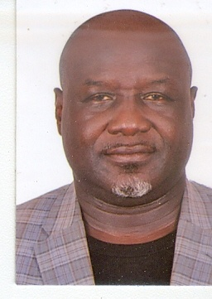
Rt. Rev. Edwin Musa Jarumai, FCPA
Director, Administration and Supplies

- Adamawa State Coordinator, May – June, 2014.
- Zonal Director, UBEC North-Central Zonal Office, Lokoja, June 2014 – August 2016.

Rt. Rev. Jarumai, a seasoned Administrator, has spent his entire career in the Commission and the Department of Administration in particular He is a Fellow of the Certified Public Administrators and an Associate Member of the Certified Institute of Personnel Management in Nigeria. He is an ordained Pastor and Consecrated into the Office of Charismatic Churches (ICCC) and the Bishop of Abuja Diocese of the International Praise Church.
2.2.1 INTRODUCTION

The Department of Administration and Supplies provides daily/routine assistance to the Chief Executive in the administration of the Commission particularly in ensuring that matters affecting the Organization and staff are handled and processed in accordance with the provisions of the Public Service Rules, Establishment and External Circulars, and the Commission’s Staff Conditions of Service. The Department carries out general administrative duties bothering on the control and coordination of personnel and equipment. Being a service support department, all its functions are geared towards assisting other Departments towards effective implementation of the UBE programmes.
2.2.2 STRUCTURE

The Department is headed by a Director who is assisted by 3 Deputy Directors in the day-to-day running of its affairs. The Department has four (4) Units namely: Establishment; Training and welfare; Stores and supplies; Maintenance and services.

Table 2.2.2: Staff Disposition
S/N | DESIGNATION | CONRAISS | NUMBER
 | Director | 15 | 1
 | Deputy Director | 14 | 3
 | Assistant Director | 13 | 1
 | Assistant Chief Admin. Officer | 11 | 3
 | Principal Admin. Officer | 10 | 4
 | Senior Admin. Officer | 09 | 2
 | Admin. Officer 1 | 08 | 9
 | Senior Confidential Secretary | 10 | 1
 | Senior Executive Officer | 08 | 1
 | Admin. Officer II | 07 | 4
 | Higher Executive Officer | 07 | 1
 | Senior Executive Officer (Computer) | 08 | 1
 | Executive Officer | 06 | 1
 | Senior Driver/Mechanical I | 05 | 1
 | Work Superintendent | 06 | 1
 | Driver | 03 | 4
 | Driver | 02 | 1
TOTAL |  |  | 47

2.2.3 FUNCTIONS

The functions of the Department mainly centers on the efficient and effective management of both human and material resources of the Commission. These include:
- Handling Senior Staff Matters (Appointments, Promotions and Discipline);
- Processing applications for Secondment, Transfers, Upgrading, Conversions of staff, Regularization and Merger of Service, requests for Seminars, Conferences and Workshops for both local and international, etc.;
- General maintenance of the Commission`s equipment, furniture and provisions of other related utility services for better service delivery;
- Coordination of the activities of Staff Welfare such as, National Housing Fund, Code of Conduct Bureau, NHIS, etc.;
- Regulating Staff Training & Development using the Commission Training Policy, PSR, Extant circulars etc.;
- Purchases on behalf of the Commission in line with requests from Departments and issuing of Job Orders and Local Purchase Orders (LPOs) as well as auctioning of unserviceable furniture and equipment in the Commission.

2.2.4 ACTIVITIES/ACHIEVEMENTS
- Coordinated the participation of 54 staff to attend workshops/seminars/ conferences.
- Processed Confirmation of Appointment of staff that were due;
- Effected staff requests such as Transfer of Service, Upgrading, Conversion and Change of Name;
- Maintained Headquarters’ Office Complex, equipment, facilities, furniture;
- Processed the payment for 2016 facilities/utilities such as: electricity bills, courier services, supply of 68,300 litres of diesel;
- Facilitated the approval by Management and Ratification by the Head of Service of the Federation, the reviewed UBEC Staff Conditions of Service;
- Received Furniture and equipment for the Department of Finance and Accounts, Legal, and Procurement Units as well as, Anambra, Niger and Nasarawa State offices received stationery, computer consumables, and tyres for the Commission’s vehicles;
- Auctioned unserviceable furniture and equipment;
- Printed file jackets, letter head paper, memo pad and complementary cards;and
- Obtained approval for 13 Staff to proceed on Diploma and Degree programmes in different higher institutions in Nigeria in 2016.

2.2.5 ON-GOING ACTIVITIES
- Establishment of a sustainable Staff Housing Scheme through an internal revolving housing loan policy;
- Establishment of Public/Private Partnership with reputable Estate Developers to secure allocation of Land by FCDA and establishment of UBEC Staff Housing Estate;
- Working with the Federal Mortgage Bank of Nigeria (FMBN) to ensure prompt registration and update of Staff NHF contributions as well as direct on-line access to individual accounts;
- Ensuring that all retired UBEC Staff obtain full refund from FMBN of their unutilized contributions as well as those of deceased staff through their next-of-kins;
- Facilitating provision of sustainable UBEC Staff Bus system for all routes to ease transportation to and from the work place;
- Planning towards a well-equipped and befitting Staff Canteen;
- Facilitating continuous payment of yearly Rent Supplement.
- Facilitating registration of staff to access NHIS facilities; and
- Following up on staff’s timely compliance with the Code of Conduct Declaration of Assets requirement.
2.2.6 CHALLENGES
Challenges encountered by the Department during the period under review included:
- Untimely releases of funds for maintenance works;
- High cost of maintenance works and spare parts due to inflation;
- Late payment of utility and services bills;
- Scarcity of genuine spare parts and materials in the market for vehicle maintenance;
- Need for additional computers to migrate from manual operation to GIFMIS as directed by the office of the Accountant General of the Federation;
- Inadequate funds to carry out scheduled trainings; and
- Late conduct of promotion examinations.
2.2.7 FUTURE ACTIVITIES
- Compilation of the list of officers who are due for confirmation of appointment;
- Provision of more storage facilities at the Headquarters;
- Provision and improvement of Office Security facilities (Internal & External);
- Replacement of Twenty-Eighty (28) Fire extinguishers in Headquarters;
- Review and Renewal of Contract Agreements of outsourced cleaning /security providers for the Commission;
- Construction of One motorized Borehole at UBEC Headquarters;
- Replacement of obsolete Air Conditioners, Office Equipment and Furniture at the Headquarters, Zonal and State Offices;
- Boarding of unserviceable Equipment, Plant and Vehicles;
- Replacement of three (3) Units torn/weak car port Tarpaulin;
- Installation of window blinds in the offices of Management Staff and other Senior Officers at the Headquarters;
- Routine maintenance of all Office equipment, plant and other service-related activities of the Unit;
- Compilation of requests for the 2017 Long-Term Training; and
- Compilation of training needs of staff for 2017.

2.2.8 CONCLUSION
The Department of Administration and Supplies has achieved a lot in the year under review and remains committed to ensuring the smooth running of the Commission as well as making sure that staff matters are handled and processed in accordance with the provisions of the Public Service Rules, Extant Rules and the Commission’s Staff Conditions of Service.

2.3 DEPARTMENT OF FINANCE AND ACCOUNTS
The Department of Finance and Accounts is headed by a Director and assisted by 4 Deputy Directors and two (2) Assistant Directors.

Alhaji Mohammed Sambo Dukku was born on 14th January, 1959 in Dukku, Gombe State. He graduated from Bayero University, Kano with a B.Sc. Accounting in 1986. He had his National Youth Service with the Nigerian Television Authority (NTA), Ibadan, where he was employed as Accountant II, thereafter.

Alhaji Dukku rose to the post of Principal Accountant from 1987 - 1995 before joining the defunct National Primary Education Commission in 1995. He is a member of the Institute of Chartered Accountants of Nigeria (ICAN) and obtained a Master’s degree in Business Administration(MBA) in2010 from the Ahmadu Bello University, Zaria. Alhaji Dukku is a seasoned Accountant who held various positions within the Commission’s service such as Head of State Accounts (1995), Chief Accountant (2001), Assistant Director (2005) and Deputy Director (2009).

Alhaji Mohammed Sambo Dukku
Director, Finance & Accounts

Alhaji Dukku, who is happily married and blessed with children, can therefore, be referred to as a fulfilled career Public Servant.
2.3.1 INTRODUCTION
The Department of Finance and Accounts was established at the inception of the defunct NPEC in 1988 and it takes care of all financial matters of the Commission.
2.3.2 Structure
The Department is headed by a Director and assisted by (5) Deputy Directors and two (2) Assistant Directors. It consists of 4 units, namely: i. Expenditure Control; ii. State Accounts; iii. Funds and Budget; and iv. Final Accounts. In addition, the Department supervises the financial activities of the Federal Teachers’ Scheme Sub Unit.
The Department had a total number of 44 staff domiciled at the Headquarters and 41 spread across the 6 Zonal, 1 Sub-zonal and 30 State Offices. Details of Staff disposition in the Zonal, Sub-zonal and State Offices is given in Zonal Office Report.

Table 2.3.2: Staff Disposition (Headquarters)
S/N | DESIGNATION | CONRAISS | NUMBER
1. | Director | 15 | 1
2. | Deputy Director | 14 | 5
3. | Assistant Director | 13 | 2
4. | Chief Accountant/Chief Conf. Secretary | 12 | 3
5. | Asst. Chief Accountant | 11 | 5
6. | Principal Accountant/PEO (Accounts) | 10 | 6
7. | Senior Accountant/SEO (Accounts) | 09 | 12
8. | Accountant I | 08 | 5
9. | Higher Executive Officer (Accounts) | 07 | 3
10. | Executive Officer | 06 | 1
11. | Senior Driver Mechanic | 06 | 1
TOTAL |  |  | 44

2.3.3 Functions
Apart from its traditional functions of financial record keeping, payment of staff salaries, preparation of Annual Budget, and preparation of Annual Financial statements, the Department is also involved in fund disbursement to States, Financial Monitoring, Sourcing of funds and payment of Federal Teachers’ Scheme participants’ monthly allowances (Primary and JSS).
Some of the specific functions of the Department are as follows:
- keeping the Commission’s financial records;
- processing and payment of monthly staff salaries, emoluments and other financial entitlements as well as monthly allowances to Federal Teachers’ Scheme Participants;
- determining the basis of allocating Funds to states and other UBE Implementing Agencies;
- conducting quarterly Financial Monitoring of the FGN-UBE Intervention Funds;
- verifying compliance with the 50% State Counterpart Fund lodgment requirement;
- managing Local and International Donor Agencies’ Grants;
- preparing and presenting Financial Progress Reports on the Implementation of the UBE Programme, the Commission’s Annual Budgets, Annual Financial Statements and Cash Flow Analysis;
- recommending for the appointment of External Auditors for Annual Audit of UBEC/SUBEBs in respect of FGN-UBE Intervention funds; and
- providing other financial advisory services to the Commission on Taxation, Investment, and Foreign Exchange Management, etc.
2.3.4 ACTIVITIES/ACHIEVEMENTS
The Department executed programmes and recorded the following achievements in the year under review.
- Received the sum of N77,110,000,000.00 being 2% Consolidated Revenue Fund for 2016.
- Disbursed - N46,706,896,038.88 UBE Matching Grant to 29 States and FCT as contained in Table 2.3.4(ii) below.
Table 2.3.4(ii): Matching Grant’s Disbursement by State and by Period
S/N | STATE | PERIOD | AMOUNT
 | Adamawa | 3rd&4thQtrs., 2014 | 476,148,648.64
 | Akwa Ibom | 1st -4thQtrs., 2013 &2014 | 1,983,094,594.60
 | Anambra | 1st - 4th Qtrs., 2015 | 876,756,756.76
 | Bauchi | 1st -4thQtrs., 2014& 2015 | 1,829,054,054.06
 | Benue | 1st -4thQtrs., 2011-2015 | 3,838,100,367.49
 | Borno | 1st- 4th Qtrs., 2015 & 2016 | 1,745,112,612.61
 | Cross River | 1st-4thQtrs., 2011- 2015 | 3,712,788,065.28
 | Delta | 1st - 4th Qtrs., 2014 | 952,297,297.30
 | Ebonyi | 3rd&4thQtrs., 2010 & 3rd Qtr., 2012 | 1,918,783,783.96
 | Edo | 1st-4th Qtr. 2013-2nd Qtr., 2014 | 1,506,945,945.96
 | Ekiti | 1st - 4thQtrs, 2013 - 15 | 2,799,207,751.08
 | Enugu | 4th Qtr., 2011 &2ndQtr., 2013 | 1,500,000,000.00
 | FCT-Abuja | 1st-4th Qtrs., 2014 & 2015 | 1,829,054,054.06
 | Gombe | 1st-4thQtrs., 2015 | 876,756,756.76
 | Imo | 1st - 4th Qtrs., 2015 | 876,756,756.76
 | Jigawa | 1st&4thQtrs., 2014 & 2015 | 952,297,297.30
 | Kaduna | 1st-4th Qtrs., 2015 | 876,756,756.76
 | Kano | 1st - 4th Qtrs., 2015 | 876,756,756.76
 | Katsina | 1st -4th Qtrs., 2015 | 876,756,756.76
 | Kebbi | Bal. of 4thQtr., 2015 | 143,671,171.17
 | Kwara | 1st - 4th Qtrs., 2014 & 2015 | 1,729,054,054.06
 | Nasarawa | 1st- 4th Qtrs., 2012 – 3rd Qtr., 2016 | 4,320,637,165.76
 | Niger | 1st -4thQtrs., 2013 | 1,030,797,297.30
 | Ogun | 1st -4th Qtrs., 2012 & 2013 | 1,883,734,010.98
 | Osun | 1st&4th Qtrs., 2014 | 952,297,297.30
 | Oyo | 1st- 4th Qtrs., 2012&2013 | 1,883,734,011.22
 | Plateau | 1st-4th Qtrs., 2014 | 952,297,297.30
 | Sokoto | 1st-4th Qtrs., 2015 | 876,756,756.76
 | Taraba | 1st-4th Qtrs., 2015 | 876,756,756.76
 | Zamfara | 1st-4th Qtrs., 2014 & 2015 | 1,753,735,207.37
TOTAL |  |  | 46,706,896,038.88

- Disbursed N900,862,162.80 Special Education Fund to 26 states and to duly-registered Non-Governmental Organizations (NGOs) that provide free special education to the public as contained in Table 2.3.4(iii) below.
Table 2.3.4(iii): Special Education Fund’s Disbursement by State and by Period
S/N | STATE | PERIOD | AMOUNT
 | Abia | 2015 | 23,434,324.32
 | Akwa Ibom | 2015 | 23,434,324.32
 | Anambra | 2015 | 23,434,324.32
 | Bauchi | 2015 | 23,434,324.32
 | Benue | 2015 | 23,434,324.32
 | Borno | 2015 | 23,434,324.32
 | Cross River | 2014 & 2015 | 51,409,459.46
 | Ebonyi | 2015 | 23, 434,324.32
 | Edo | 2014&2015 | 51,409,459.46
 | Ekiti | 2015 | 23,434,324.32
 | Enugu | 2013-2015 | 74,843785.46
 | Gombe | 2015 | 23,434,324.32
 | Kano | 2013 & 2014 | 47,893,783.46
 | Katsina | 2013 & 2014 | 47,893,783.46
 | Kebbi | 2015 | 23,434,324.32
 | Kwara | 2015 | 23,434,324,32
 | Lagos | 2014 & 2015 | 47,893,783.46
 | Nasarawa | 2015 | 23,434,324.32
 | Ogun | 2014 & 2015 | 51,409,459.46
 | Osun | 2015 | 23,434,324.32
 | Oyo | 2015 & 2016 | 51,409,459.46
 | Plateau | 2015 | 23,434,324.32
 | Rivers | 2015 | 23,434,324.32
 | Sokoto | 2015 | 23,434,324.32
 | Taraba | 2015 | 23,434,324.32
 | Yobe | 2015 | 23,434,324.32
 | NGOs | 2014 Private Providers of Special Education | 101,750,000.00
TOTAL |  |  | 900,862,162.80

- Disbursed/utilized the sum of N7,228,649, 644.44 on the construction and rehabilitation of schools, Almajiri Education projects, Boy-Child and Girl-Child projects in Educational Imbalance Fund to 35 states and the FCT.
- Utilized the sum of N8,870,608,964.40 as Instructional Materials Fund to procure science equipment for JSS, textbooks in core subjects and library resource materials.
- Disbursed the sum of N2,561,000,000.00 as 2015 Teacher Professional Development Fund for training of teachers and Education managers in the 35 States and the FCT at N60,000,000.00 per State. Adamawa State has not accessed yet.

Table 2.3.4(iii): TPD’s Disbursement by State and by Period
S/N | STATE | PERIOD | AMOUNT
 | Abia | 2015 1st Tranche | 60,000,000.00
 | Akwa Ibom | 2015 1st Tranche | 120,000,000.00
 | Anambra | 2015 1st Tranche | 60,000,000.00
 | Bauchi | 2015 1st Tranche | 60,000,000.00
 | Bayelsa | 2015 1st Tranche | 120,000,000.00
 | Benue | 2015 1st Tranche | 60,000,000.00
 | Borno | 2015 1st Tranche | 60,000,000.00
 | Cross River | 2015 1st Tranche | 60,000,000.00
 | Delta | 2015 1st Tranche | 60,000,000.00
 | Ebonyi | 2015 1st Tranche | 60,000,000.00
 | Edo | 2015 1st Tranche | 60,000,000.00
 | Ekiti | 2015 1st Tranche | 60,000,000.00
 | Enugu | 2015 1st Tranche | 60,000,000.00
 | Gombe | 2015 1st Tranche | 60,000,000.00
 | Imo | 2015 1st Tranche | 60,000,000.00
 | Jigawa | 2015 1st Tranche | 60,000,000.00
 | Kaduna | 2015 1st Tranche | 60,000,000.00
 | Kano | 2015 1st Tranche | 60,000,000.00
 | Katsina | 2015 1st Tranche | 60,000,000.00
 | Kebbi | 2015 1st Tranche | 60,000,000.00
 | Kogi | 2015 1st Tranche | 60,000,000.00
 | Kwara | 2015 1st Tranche | 60,000,000.00
 | Lagos | 2015 1st Tranche | 80,500,000.00
 | Nasarawa | 2015 1st Tranche | 60,000,000.00
 | Niger | 2015 1st Tranche | 60,000,000.00
 | Ogun | 2015 TPD Funds | 120,000,000.00
 | Ondo | 2015 1st Tranche | 60,000,000.00
 | Osun | 2015 TPD FUNDS | 120,000,000.00
 | Oyo | 2015 TPD FUNDS | 120,000,000.00
 | Plateau | 2015 TPD FUNDS | 60,000,000.00
 | Rivers | 2015 TPD FUNDS | 120,000,000.00
 | Sokoto | 2015 1st Tranche | 60,000,000.00
 | Taraba | 2015 TPD FUNDS | 60,000,000.00
 | Yobe | 2015 1st Tranche | 60,000,000.00
 | Zamfara | 2015 1st Tranche | 60,000,000.00
 | FCT-Abuja | 2014 2nd Tranche | 80,500,000.00
TOTAL |  |  | 2,561,000,000.00

- Conducted 24th and 25thFinancial Monitoring of the FGN-UBE Intervention Funds in all the 36 states of the federation and the FCT.
- Conducted Training Workshop for UBEC/SUBEB staff on implementation of IPSAS.
2.3.5 ON-GOING ACTIVITIES
- 2017 Budget preparation and defense before the National Assembly.
- Updating the new Accounting Manual.
- Implementation of new accounting policy called International Public Sector Accounting Standard (IPSAS).
2.3.6 CHALLENGES
- Irregular release of Constituency Projects Funds which causes delay in project execution which invariably might result in abandoned projects.
- Inadequate office accommodation.
- Slow utilization of the FGN-UBE Intervention Funds by SUBEBs.
- Too little political will by some State Governments to access the FG-UBE Matching Grants.
- High turnover rate of SUBEBs Accounting Personnel leading to those trained on certain accounting packages to be removed and replaced with untrained ones.
- Delay in submission of Financial Returns by SUBEBs.
- Low level of budgetary allocation to Basic Education by State and Local Government levels.
- Withdrawal of Tertiary Education Trust Fund (TETFUND) from funding basic education.
- Inadequate monitoring of FTS participants by SUBEBs and LGEAs who are the beneficiaries.
- Inadequate working equipment like computers.

2.3.7 FUTURE ACTIVITIES
- Developing, printing and distribution of the new Accounting Manual.
- Training of UBEC/SUBEB staff on the new Accounting Manual.
- Development of procedural manual.
- Audit of the 2015/2016 FGN-UBE Intervention Funds and MDG Funds.
- Full implementation of IPSAS.

2.3.8 CONCLUSION
The Finance and Accounts Department was able to respond to most of the challenges encountered by it owing to the support of Management. This has resulted in new and efficient ways of performing its functions. Data on disbursement of FGN-UBE Intervention Funds are posted on the UBEC’s website for public perusal.

2.4 DEPARTMENT OF PHYSICAL PLANNING
Arch. Molkat M. Mutfwang is the Director in-charge of the Department of Physical Planning.  He was born on 1st November, 1957 in Ampang-West, Mangu Local Government Area of Plateau State. He studied Architecture in the Ahmadu Bello University, Zaria and graduated with a B.Sc. (1980) and M.Sc in Architecture in 1982. He did his National Youth Service in Kaduna State after which he worked with the Ministry of Works and Housing, Plateau State before returning to the Ahmadu Bello University, Zaria as Lecturer II in 1984.  He joined the National Primary Education Commission (NPEC) as Assistant Chief Architect in Kaduna in 1989 and rose to the rank of Chief Architect in 1994, after which he became a Deputy Director in UBEC in 1999. He is a seasoned Architect that has been engaged in various projects and continues to contribute his quota to the development of the nation. |  | 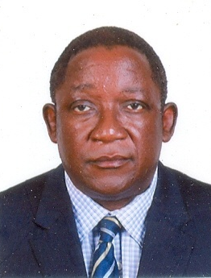
Arch. M.M. Mutfwang
Director, Department of Physical Planning
2.4.1 INTRODUCTION
The Physical Planning Department is mandated to ensure the provision of qualitative infrastructural facilities in Public Schools by the States, FCT, Donor Agencies and direct intervention by the Federal Government.

2.4.2 STRUCTURE
The Department is headed by a Director and assisted by 1 Deputy Director. It has three (3) major Units namely: Architecture, Engineering and Quantity Surveying.
There are 16 staff domiciled at the Headquarters.

Table 2.4.2: Staff Disposition (Headquarters)
S/N | RANK | CONRAISS | NUMBER
 | Director | 15 | 1
 | Deputy Director | 14 | 1
 | Chief Architect/Civil Engineer. | 12 | 2
 | Assistant Chief Data Officer | 11 | 1
 | Principal Admin. Officer | 10 | 1
 | STO (Q.S), (Town Planning). | 09 | 2
 | Civil Engineer I/Town Planning Officers I/Real Estate Officer I | 08 | 3
 | Civil Engineer II/Architect II | 07 | 2
 | Senior Driver | 07 | 1
TOTAL |  |  | 12

Note:
21 Technical Officers are currently in the Zonal and State Offices as Resident Supervisors.

2.4.3FUNCTIONS
The specific functions of the Department include:
- Setting up of minimum standards for Basic Education infrastructure.
- Assessment and vetting of the infrastructural component of SUBEBs Action Plans.
- Participating in the Monitoring of Approved UBEC/SUBEB executed projects.
- Participating in the preparation of short, medium and long term budgets for the Commission.
- Carrying out market surveys for basic construction materials with a view to updating cost norms for Basic Education Infrastructural projects across the country and setting cost specific benchmarks for each SUBEB in the federation.
- Participating in the monitoring of Special Education Projects and donor agencies’ projects.
- vii) Attending to major maintenance of UBEC building facilities.
- viii) Acting as technical partner on the projects of Donor Agencies such as JICA, KOICA, etc.
- Coordinating the activities of Consultants for intervention projects engaged by the Commission.
- Creating and updating the database for UBEC/SUBEBs projects in terms of approved proposals and confirmed deliverables.
2.4.4 ACTIVITIES/ACHIEVEMENTS
The Department executed programmes and recorded the following achievements in the year under review.
- Assessed and vetted the infrastructural components (FGN-UBE Matching Grant and Special Education Funds) of the Action Plans submitted by SUBEBs for approval.
- Monitored approved and executed projects by various SUBEBs for both the Matching Grants and Special Education Funds within the year under review for approval.
- Monitored FGN/UBE direct Intervention Projects such as Junior Girls’ Model Secondary Schools, Almajiri (now Tsangaya) School projects, e-Library and Boys Vocational Schools Project within the year under review.
- Coordinated the Monitoring of MDG Constituency Projects across the country as well as the Supervision of special intervention projects.
- Updated the Data Base for deliverables from projects executed by SUBEBs from 2005 to 2014.

2.4.5 ON-GOING ACTIVITIES
The Department is presently monitoring the construction of:
- 153 Almajiri School projects spread across the 36 States of the Federation including FCT, out of which 103 had been completed while 50 are ongoing.
- 67 Junior Girls’ Model Secondary Schools under construction.While54 of them have been completed, the remaining 13 are at various stages of completion.
- 62 e-Library projects in 62 Unity Schools awarded; out of which 57 had been completed while 2 are at finishing stages.
- 14 Vocational Schools awarded in 14 States, out of which 9 were completed and 5 are at various stages of completion.

The projects are virtually completed with the exception of the few which are already selected for termination.
2.4.6 FUTURE ACTIVITIES
- The Department plans to organize workshops for the technical Staff of SUBEBs on Project Monitoring, Basics of Sites Supervision and Preparation of Action Plans to take cognizance of the 2016 Ministerial Strategic Plan (MSC) and Sustainable Development Goals (SDG) in Basic Education Delivery
- Strengthening the mechanism for project monitoring and supervision by promoting the adoption of the RESIDENCY STRUCTURE for all basic education projects
- Promotion of capacity building through attendance of local/overseas trainings.
- Introduce innovative building systems and materials in basic education infrastructure.
- Develop a maintenance plan for all basic education infrastructural projects.
- Re-conceptualizing SCHOOL DESIGN in Nigeria to conform to international standards, drawing inputs from all sources.

2.4.7 CHALLENGES
The Department’s major challenges included:
- Absence of projects vehicles to access projects in remote areas and difficult terrains.
- Inadequate office space.
- Inadequate Quantity, Architects and Engineers to fully operate RESIDENT SUPERVISON at the rate of one supervisor permanently at not more than five sites.

2.4.8 CONCLUSION
In spite of the challenges mentioned above, the Department, with the support of the various Departments and Management of the Commission, was able to record some reasonable levels of success. It is therefore, the hope of the Department to record additional and higher levels of successes in the years to come.

2.5 DEPARTMENT OF PLANNING, RESEARCH AND STATISTICS
The Department of Planning, Research and Statistics is one of the ten departments in the Commission. It is currently headed by an Acting Director who is assisted by 4 Heads of Units.
Dr. Tokunbo Tserun Onosode was born on 17th October, 1960. She attended the University of Ife, Ile-Ife, Osun State. She graduated with a Bachelor of Arts in English in 1986 and Master’s/Ph.D. degrees in Educational Evaluation from the University of Ibadan, Oyo State in 1991/2004. She took up teaching appointment with the Lagos State Government after her National Youth Service in 1987. She later joined the Federal Civil Service in 1998 as Education Officer VIII and was deployed to the defunct National Educational Technology Centre (NETC), Kaduna.  She was later redeployed to the Special Programme Unit of the Federal Ministry of Education, Kaduna which metamorphosed into the erstwhile National Primary Education Commission. She served as Monitoring Officer in Benin and Ibadan Zonal Offices at different times. She later served as the State Coordinator at the Edo State Office of the Universal Basic Education Commission from 2006 – 2011 before she was transferred to the headquarters. She is skilled in Programme Evaluation, Research Design and Development of Inventory on Basic Education Standards with special interest in Teaching and Learning at the | 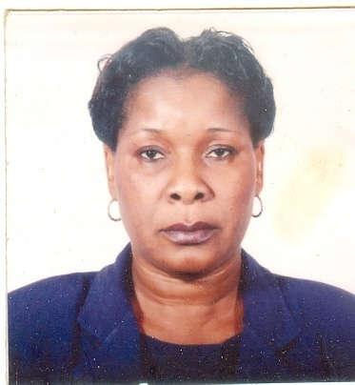
Dr. Tokunbo Tserun Onosode
Ag. Director, Planning, Research
and Statistics.
 | Basic Education Level. She is presently the Acting Director of the Department of Planning, Research and Statistics.

2.5.1 INTRODUCTION
The Department of Planning, Research and Statistics is headed by the Acting Director, assisted by 4 Heads of Units. The Department, through the Acting Director, is answerable to the Executive Secretary through the Deputy Executive Secretary (Technical).
    - DEPARTMENTAL UNITS
The Department has four units namely: i. Education Management Information System and Statistics (EMIS); ii. Information and Communication Technology (ICT); iii. Research and Publications and iv. Strategic Planning.

Table 2.5.2: Staff Disposition (Headquarters)
S/N | DESIGNATION | CONRAISS | NUMBER
 | Director | 15 | 1
 | Deputy Director | 14 | 2
 | Assistant Director | 13 | 2
 | Chief Statistician | 12 | 1
 | Assistant Chief Planning Officer/Research Officer/ Confidential Secretary/Programme Analyst | 11 | 7
 | Principal Statistical Officer | 10 | 2
 | Senior Planning Officer | 09 | 2
 | Planning Officer 1/ Research Officer 1/Statistician 1 /Programme Analyst I | 08 | 8
 | Planning Officer II/Statistician II | 07 | 3
 | Driver | 06 | 1
TOTAL |  |  | 29

2.5.3 FUNCTIONS OF THE DEPARTMENT
The basic functions of the Department include, but are not limited to:
- advising Management on acquisition, maintenance, utilization and updating of ICT facilities in the Commission.
- setting standards and monitoring the progress of the Computer Centres at the SUBEBs as well as providing technical support on the development of EMIS at UBEC, SUBEBs, LGEAs and School levels.
- designing and developing data collecting instruments, coordinating and managing the basic education databank through collation, processing and dissemination.
- serving as link between collaborating agencies and other stakeholders on ICT development, data management and other related issues.
- coordinating the development of UBEC Action, Strategic and Rolling Plans.
- coordinating UBECs’ Action Plans and Budget.
- organizing quarterly In-house Seminars for UBEC staff.
- CoordinatingAction Research in identified areas of Basic Education.
- managing research and development components of assisted projects by International Development Partners – IDPs.
- serving as a Secretariat for Inter-Departmental Committee on Research and serving as Technical Partners on special research assignments.
- providing professional and technical support to SUBEBs on the development of their Strategic Plans, data generation, analysis, dissemination and EMISS.
- carrying out any other functions as may be directed by the Executive Secretary from time to time.

2.5.4 ACTIVITIES/ACHIEVEMENTS
The major activities that the Department carried out during the year under review and the ensuing achievements among others are as follows:
- organized consultative Meetings with representatives of the World Bank, UNICEF and DFID-ESSPIN to discuss the development of Medium Term Basic Education Strategic Plan (MTBESP) at both State and National levels in November 2016;
- developed Staff Salary and Instructional Materials Supplies Software for schools and Verification Software for Instructional Materials supplied to schools in February 2016;
- coordinated the verification of e-Library ICT equipment in Unity schools, Junior Girls’ Model Schools and Almajiri Schools across the country from January to December 2016;
- carried out routine maintenance and update of UBEC website from January to December 2016;
- managed the Commission’s Computer systems and Network from January to December 20166;
- Integrated all Departments and Units into one networking family;
- Compiled a list of primary and JS schools in Nigeria in September, 2016 from January to December 2016;
- disseminated Basic Education Data to stakeholders and other end-users at different times in the year;.
- collated, reviewed and edited the 2015 Annual Report, UBEC’s Publications: the UBE Forum and the Basic Educationist magazine.

2.5.5 CHALLENGES
The Department was faced with numerous challenges in the year in focus. The major problems faced are as follows:
- omission of Planning, Research and Statistics personnel to provide professional and technical inputs in the interactive meetings of the SUBEBs on Action Plan development;
- inadequate funding, implementation machinery for the Department and capacity building for staff of the Department;
- difficulties in the development of Action and Rolling Plans due to unreliable and incomplete data returns.
- low collaborations between Departments/Units in the Commission to ensure proper implementation of Strategic and Operational Plans;
- obsolete EMIS and ICT equipment which hampers provision of effective and efficient EMIS and ICT services.

2.5.6 ON-GOING ACTIVITIES
The on-going activities that the Department is still executing are:
- automation of the ICT (computerization of all Departmental activities);
- development of Medium Term Basic Education Strategic Plan (MTBESP) at both State and National levels;
- migration from the Current Website to .gov.ng domain;
- collation of the 2015 and 2016 Basic Education Data Returns from the SUBEBs.
- collation, reviewing and editing of the UBEC’s Publications: the UBE Forum Volume 7 and the Basic Educationist magazine Volume 2.

2.5.7 FUTURE ACTIVITIES
The Department has scheduled to undertake the underlisted activities in 2017.
- Organize the Bi-annual Meetings of the Forum of UBEC and SUBEBs’ Directors in-charge of Strategic Planning.
- Bi-annual monitoring to ascertain the extent of implementation of SESOP/ESP by SUBEBs in all the states of the federation.
- Develop, publish and disseminate a National Medium Term Basic Education Strategic Plan.
- Provide Local Area Network (LAN) and Internet Connectivity to the Zonal Offices, State Office and SUBEBs thereby moving the Commission and the SUBEBs to paperless level.
- Checking the functionality of the e-library facilities supplied.
- Provide technical support in the planning, conduct, processing, critiquing, analysis, report writing, publication and dissemination of the 2017 National Personnel Audit (NPA).
- Collect, collate and analyse 2015/2016 and 2016/2017Basic Education Data.
- Define and set up the modalities for the establishment of Basic Education Management Information System (BEMIS).
- Conduct Quarterly In-house seminars.
- Collect, collate and publish the 2017 Annual Report, papers for UBE Forum and the Basic Educationist magazine.

2.5.8 CONCLUSION
Despite the challenges mentioned above, the Department was able to kick-start the Development of the MTBESP with the proactive and passionate support of the Executive Secretary and Management of the Commission. It is therefore, the hope of the Department to conclude the State and National MTBESP in 2017.

2.6 DEPARTMENT OF QUALITY ASSURANCE

Mallam Jibo Abdullahi was born in 1958 at Birnin Yauri, Ngaski Local Government Area, Kebbi State. He attended Birnin Yauri Primary School from 1965 to 1971. He was admitted into Sokoto Teachers’ College in 1972 and he finished in 1976 with a Teacher Grade II Certificate. He gained admission into the University of Pittsburgh, Pennsylvania, USA in 1978 and graduated in 1982 with a Bachelor’s Degree in Business Education. He obtained the Master’s Degree in Business Administration (Finance) in 2002 from Abubakar Tafawa Balewa University, Bauchi.

He had attended several trainings overseas which included Project Management in Dar-es-Salaam, Tanzania; Procurement, Management and Monitoring in London, UK; Procurement of Goods and Services, Montreal, Canada and Study on Korean Education System, Seoul, South Korea.

He started his Teaching career with the Sokoto State Ministry of Science and Technology, Sokoto in 1983 from where he obtained literal transfer of service to the Federal Ministry of Education. He was posted to the then, Federal School of Arts and Science, now Federal Government Academy, Suleja, Niger State. In 1990, he was transferred to Federal Government College, Kwali, Abuja.

In 1994, he transferred his service to the defunct National Primary Education Commission (NPEC) as Principal Monitoring Officer. He was posted to Owerri Zonal Office and served there from 1994 to 1996. Later in 1996, he was transferred to the NPEC Headquarters, Kaduna. While at the headquarters, he assisted the Head of Regional Office matters of the Department of Monitoring and Evaluation.

In Abuja, he served briefly in the Department of Special Projects and then moved to the Monitoring & Evaluation (M & E) Department upon the re-structuring of the Departments. He was later appointed Special Assistant to the Deputy Executive Secretary (Technical).He later became Deputy Director in the Department of Quality Assurance and Zonal Director (North-East Zone).
Mallam Jibo Abdullahi
Director, Quality Assurance
Currently, he is the Director, Quality Assurance. The recognition he received included Exemplary Service award by the Commission in 2014 and award of professional contribution to the achievements of Cambridge Education-Led Consortium in the successful implementation of DFID’s Education Sector Support Programme in Nigeria (ESSPIN) in 2016.

He served as member/Secretary of various committees including Technical Working Committee on World Bank Project II (PEP II); Assessment of Action Plan Committee; Member, TAFSEP Committee; Technical Sector Committee; Technical Working Committee on Monitoring and Evaluation; Technical Working Committee on National Assessment of Learning Achievements in Basic Education (NALABE); Planning Committee on UBE Intervention Funds, Senior Staff Disciplinary and Promotion Committee, Planning Committee on Federal Teachers’ Scheme (FTS), Restoration Committee on Self-Help Projects and Good Performance, Planning Committee on National Personnel Audit, etc.

2.6.1 INTRODUCTION
The Department of Quality Assurance is one of the 10 Departments of the Commission. It is charged with the responsibility of ensuring high quality Basic Education through appropriate Quality Assurance mechanisms as well as prescribing, monitoring, evaluating and maintaining minimum standards, especially in the area of teaching and learning, in Basic Education institutions.

2.6.2 STRUCTURE
The Department has 3 Units: i. Assessment Unit; ii. Monitoring and Evaluation; iii. Zonal Office Matters and also supervised the Zonal and State offices till September, 2016. Each Unit is headed by the most senior officer in the unit.

Table 2.6.2: Staff Disposition at the Headquarters
S/N | STAFF POSITION | CONRAISS | Number
 | Director | 15 | 1
 | Deputy Director | 14 | 1
 | Assistant Director, Quality Assurance | 13 | 1
 | Chief Confidential Secretary | 12 | 1
 | Assistant Chief Quality Assurance Officer | 11 | 2
 | Principal Quality Assurance Officer | 10 | 1
 | Senior Data Processing Officer | 09 | 1
 | Senior Quality Assurance Officer | 09 | 1
 | Quality Assurance Officer I | 08 | 3
 | Quality Assurance Officer II | 07 | 1
 | Chief Driver/Mechanic | 06 | 1
TOTAL |  |  | 14

2.6.3 FUNCTIONS
The main tasks of the Department are to prescribe and maintain minimum standards, monitor, appraise and evaluate the UBE Programme through the following mechanisms:
- Designing and implementing Quality Assurance activities and programmes for UBE.
- Establishing performance indicators for Monitoring and Evaluation of UBE programme.
- Carrying out regular Quality Assurance in Basic Education schools in Nigeria.
- Setting Monitoring and Ensuring Maintenance of Minimum Standards.
- Preparing and Reporting to UBEC Management on: Quality Assurance activities in Basic Education Programme; National Assessment of Learning Achievements (NALABE) and National Unified Continuous Assessment (NUCA)on regular basis.
- Developing Instruments for various monitoring activities of the Commission.
- Carrying out any other assignment that may be directed by the Executive Secretary/Management.

2.6.4 ACTIVITIES/ACHIEVEMENTS
The major activities achievements of the Department in the year under review included the followings.
- Selected valid, reliable and good test items of different types (Objective and Essay) in the four core subjects: English Studies, Mathematics, Social Studies and Basic Science & Technology for the conduct of 2017 National Assessment of Learning Achievements in Basic Education (NALABE).
- Evaluated 389 ECD centres, 740 primary schools and 181 Junior Secondary Schools for the 2nd term of 2015/2016 and 1st term of 2016/2017 sessions. The schools covered were mainly in the rural areas.
- Conducted Second Level QA training for a total of 956 Quality Assurance Officers of SUBEBs and LGEAs in 29 States.
- Conducted the 15th Quarterly Meetings of UBEC Management with SUBEBs Chairmen in Calabar, Cross River, June, 2016.

 | 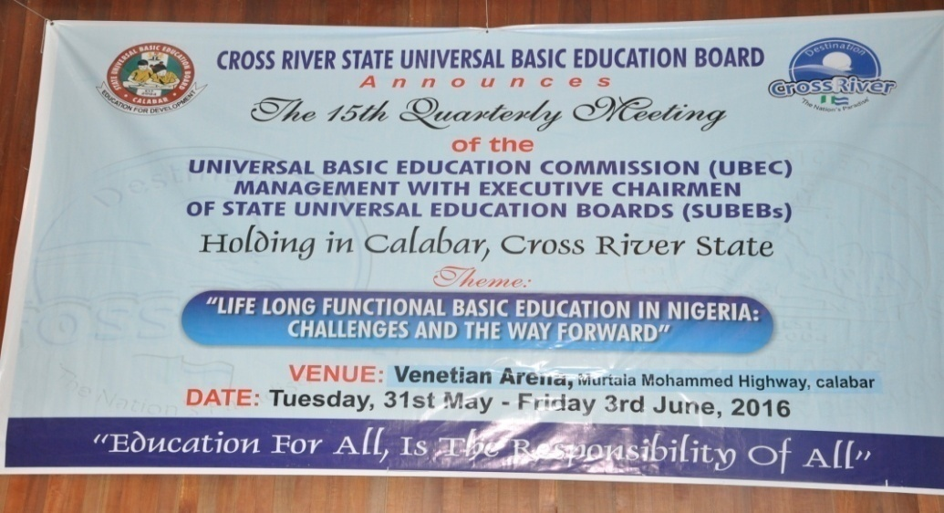
 | Banner of the 15th Quarterly Meeting held in Calabar
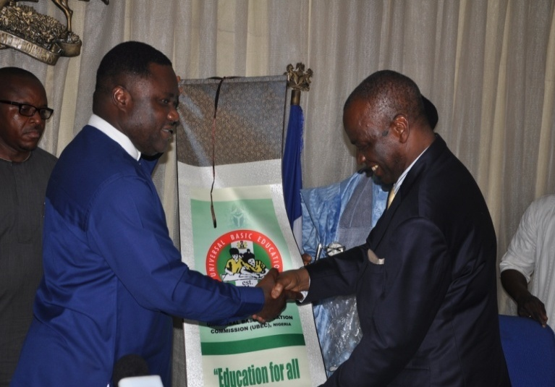 |  |  | 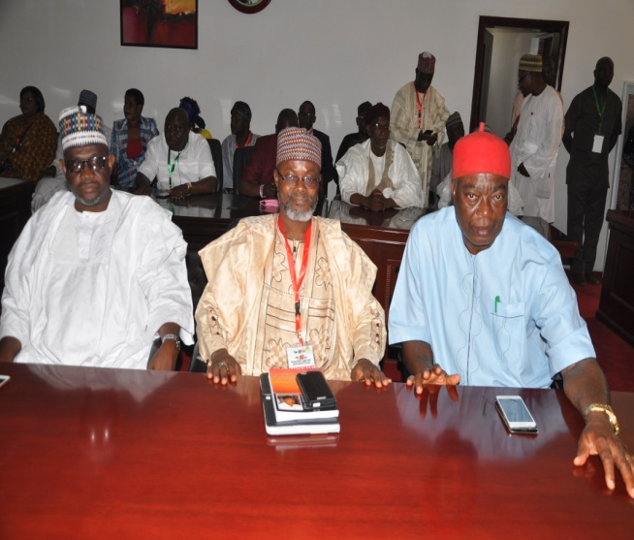
The Minister of State for Education, Prof. Anthony Anwuka, presenting a gift to the Executive Governor of Cross River  State, Prof. Ben Ayade, during the meeting. |  |  | A cross-section of Executive Chairmen and other participants at the 15th Quarterly Meeting in Calabar.

2.6.5 ON-GOING ACTIVITIES
The following activities are currently being carried out by the department:
- Editorial work and process of critiquing selected test items for 2017 National Assessment of Learning Achievements in Basic Education (NALABE).
- Harmonization of the November 1st term 2016/2017 session Quality Assurance Reports from States for National Report.
- QA Training for Quality Assurance Officers of SUBEBs and LGEAs in the remaining 3 States (Adamawa, Lagos, Zamfara) and the FCT UBEB.

2.6.6 CHALLENGES
The challenges that the Department encountered in the implementation of quality assurance activities included, among other things:
- Inadequate number of trained Quality Assurance Officers at SUBEB and LGEA levels.
- Irregular conduct of Quality Assurance and Follow-Up Monitoring in schools due to paucity of funds at the UBEC, SUBEB and LGEA levels.
- Inadequate monitoring vehicles in most SUBEBs and LGEAs.
- Inadequate of continuous training for UBEC Quality Assurance Officers at the Zonal and State levels.
- Non-implementation of recommendations contained in Quality Assurance Reports by stakeholders (UBEC, SUBEBs, LGEAs, Schools and other stakeholders).
- Some SUBEBs and LGEAs are yet to establish functional Quality Assurance Departments.
2.6.7 FUTURE PLANS
The Department plans to conduct the following activities:
- Printing of hard copies of test items for the conduct of NALABE.
- Administration of instruments for National Assessment of Learning Achievements in Basic Education (NALABE) in the 36 States and the FCT.
- Regular conduct of termly quality assurance of basic education institutions and follow-up monitoring of the previous Quality Assurance.
- Capacity building for headteachers/Principals and teachers on School Self-evaluation (SS-e).

2.6.8 CONCLUSION
The Department duly ascribes all its achievements to the tremendous support/assistance received from the Management. It, therefore, looks forward to a more exciting 2017 with the hope of impacting positively on the implementation of all UBE programmes.

2.7 DEPARTMENT OF SOCIAL MOBILIZATION2016 REPORT
Alhaji Bello Kagara was born on 22nd November, 1960 at Kagara in Kafur Local Government, Katsina State. He attended Galadima Primary School, Mahuta (1967-1973), Kufena College, Wusasa, Zaria (1973-1975), the famous Katsina Teachers’ College (1975-1979), College of Education, Kafanchan, (1980-1983), Ahmadu Bello University, Zaria (1987-1990 and 1993-1994). Kagara holds the Teacher Grade II Certificate (1979), NCE (1983),and B.A. Ed. (English) (1990).  He is an alumnus of the prestigious Harvard University, Boston, USA, where he obtained a certificate in Improving Quality in Education System. He has attended several international trainings on Project Planning, Management, Procurement, Policy and Strategic Planning, Educational Planning and Administration, Financing and Modernizing Public Sector Organizations, etc. Kagara is a seasoned administrator traversing primary school administration as Headmaster, Local Government Councillor for Education and Health and later Council Secretary, Malumfashi and Kafur Local Governments, Katsina State, and Head of Planning, Research and Statistics at Katsina State Transport Authority from where he joined the services of the then National Primary Education Commission (NPEC), now UBEC, as Principal Project Officer, World Bank Department in 1994. | 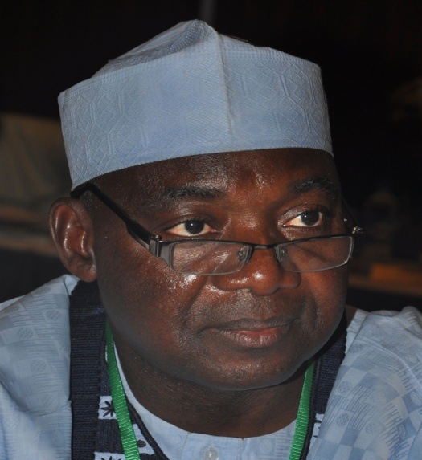  Alhaji Bello Kagara  Director, Social Mobilization  He was the Personal Assistant to the Interim Administrator, NPEC in 1996; Project Coordinator, World Bank Special Project, Deputy Director (Special Projects) and Head of the Executive Secretary’s Office. His service as the Project Coordinator of the Special Projects brought fame to the Commission and he has to his credit the successful implementation of the Second World Bank-Supported Primary Education Project (PEP II) (2002-2005) and bringing in many International Development Partners (IDPs) such as JICA, USAID, KOICA, and CHINA Commercial Office, etc, within the ambit of the Commission’s Partnership activities.  An accomplished administrator, Bello Kagara is happily married and blessed with children.
He rose through the ranks to become Director, Planning Research and Statistics in September, 2014 to July 2016 and later Director, Department of Administration and Supplies. He is currently the Director of Social Mobilization.

2.7.1 INTRODUCTION
The Department of Social Mobilization is one of the statutory Departments of the Commission. It has the responsibilities to carrying out mass mobilization, advocacy and sensitization of the general public, forging partnerships with stakeholders in Basic Education as well as disseminating various messages of the UBE programme to the general public for increased awareness, community empowerment, participation and ownership in order to achieve the overall objectives of the compulsory, free Universal Basic Education in Nigeria.
2.7,2 STRUCTURE
The Department has 2 main Units and 6 Sections, which undertake activities of the Commission that are related to its functions. The Units and their corresponding sections are: i. Social Mobilization (Advocacy, Campaigns and Promotion, HIV/AIDS Awareness) and ii. Community Development and Empowerment; Community Initiated Self-Help Projects, Special Needs Education, Donor Intervention/Partnerships
The Department is presently manned by a staff strength of nineteen (19) senior officers and one (1) driver at the Headquarters as shown in the Table below.

Table 2.7.2: Staff Disposition
S/N | DESIGNATION | CONRAISS | NO.
 | Director | 15 | 1
 | Deputy Director | 14 | 2
 | Chief Social Mobilization Officer | 12 | 1
 | Asst. Chief Social Mobilization Officer | 11 | 1
 | Principal Social Mobilization Officer | 10 | 2
 | Senior Social Mobilization Officer | 09 | 1
 | Social Mobilization Officer I | 08 | 6
 | Social Mobilization Officer II | 07 | 5
 | Senior Driver | 06 | 1
TOTAL |  |  | 20

2.7.3 FUNCTIONS
In order to facilitate the achievement of the overall objectives of the Commission, the Department carries out the following functions:
- Initiating Social Mobilization activities on all policies and programmes, especially as they relate to:
- Advocacy, sensitization and mobilization of the general public on all matters of basic education delivery.
- Community empowerment and mobilization through Self-Help projects to promote enrolment, improve and facilitate ownership of the UBE programme by the communities.
- Facilitating resource mobilization for the execution, monitoring and evaluation of all basic education delivery processes.
- Liaising with other UBEC professional Departments and other Government agencies for effective mobilization and promotion of all basic education-related programmes e.g. Girl-Child Education, Education of Street Children and other Disadvantaged Groups, Home-Grown School Feeding and Health Programmes, etc.
- Liaising and promoting linkages with local and international organizations and NGOs in policy design programme implementation, production and distribution of public enlightenment publications, etc, of the UBE programme.
- Researching into, monitoring and evaluating the efficacy of the advocacy and mobilization strategies of the UBE programme.
- Carrying out any other activities that may be assigned by the UBEC Board or the Executive Secretary.

2.7.4 ACTIVITIES/ACHIEVEMENTS

During the period under review, the following activities were accomplished:
- UBEC in collaboration with Federal Ministry of Education (FME) and Education Sector Support Programme in Nigeria (ESSPIN) organised a Conference on “National Stakeholders’ Conference with Civil Society Organization (CSO) ‘Marketplace’ on partnership for community engagement in Basic Education in Nigeria” with the theme ‘Building Lasting Impact: Partnering to Improve Basic Education’ in Abuja from 10th and 11th November, 2016. The Conference underscored the value of the SBMC-CSO partnership in improving school governance, physical development and quality assurance.
- Reviewed the Mentoring and Monitoring Packs of SBMC later, UBEC and UNICEF held Training for Staff of UBEC Social Mobilization Department and selected SUBEBsin Kaduna from February – May, 2016. The Mentoring and Monitoring packs were updated, keying in the roles and responsibilities of partners in finalising, printing, dissemination and usage of the packs.
- Review of SBMC Guidelines. UBEC, UNICEF, ESSPIN and some Civil Society Organisations (CSOs) reviewed the UBEC’s Guidelines for the development of School-Based Management Committees in Kaduna from February – May, 2016. States shared experiences which guided the review. Improvements were made to areas of the SBMC guidelines where necessary in line with the recently approved National School-Based Management Policy (NSBMP).
- Completed Mid-term Monitoring of 2014 projects executed by the private providers that benefitted in the 2014 fund disbursement in February, 2016 in all the 36 States and FCT, Abuja.
- Completed Final Monitoring of 2014 projects executed by the private providers of Special Needs Education and the Verification of submissions from private providers that sought support from the 2015 Special Needs Intervention Fund were jointly carried out across the country in November, 2016.

2.7.5 CONSTRAINTS
- In spite of all efforts at sensitizing the SUBEBs on the need to access the Intervention Funds, there was still low drawdown of UBE Intervention Fund meant for special needs education by some SUBEBs.
- Inadequate fund to carry out some Departmental statutory functions and activities.
- In spite of approval by the National Council on Education (NCE) and provision in the UBE Implementation guidelines, support for SBMC activities by the Commission has stopped. .
- Stakeholders’ engagement and partnership, which are supposed to be the key drivers of the Commission’s activities, were apparently not being efficiently used as tools to promote basic education delivery in Nigeria.
- Inability of SUBEBs to augment the fund provided by UBEC to carry out activities of the School Based Management Committees (SBMCs).

2.7.6 ON-GOING ACTIVITIES
- Selection of private provider to benefit from the 2016 special education support fund.
- High level advocacy to State Governors.
- Mobilization on mopping up out-of-school children.
- Mobilization and sensitization of the North – Eastern States Stakeholders on the value of education.

2.7.7 FUTURE ACTIVITIES
The following activities have been proposed to drive the Department’s activities in the year ahead:
- Review of the Self-Help Programme through the Whole School Development Approach.
- Disbursement of funds to eligible beneficiaries of 2015 Special Education Needs Funds.
- Monitoring of Special Education Projects undertaken by the SUBEBs and Private Providers.
- Expanding the scope of UBE Mobilization/Enlightenment through collaborations with the News Media for the broadcast and dissemination of UBE messages.
- Production of light print enlightenment materials such as posters, fliers, etc.
- Critiquing, printing and dissemination of the reviewed SBMC Mentoring and Monitoring Packs, Guide Book and Training Manuals.
- Further collaboration with UNICEF on School-Based Management (SBM).
- Mobilization activities on Mopping up out-of-school children.

2.7.8 CONCLUSION
The report contains the highlights of the major activities achieved by the Department. These achievements were all geared towards the realization of the basic education objectives in Nigeria. Necessary measures have, however, been put in place to accomplish the pending activities in the year ahead.

2.8 DEPARTMENT OF SPECIAL DUTIES
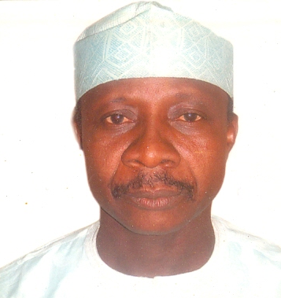

Alhaji Usman Aliyu Kaoje
Director, Special Duties
Alhaji Kaoje’s upgrading to Directorate level opened to him an opportunity to serve as Ag. Director, Administration and Supplies in 2014; Director, Social Mobilization and currently, Director, Special Duties.

Kaoje is a seasoned administrator and a Fellow of the Institute of Industrial and Corporate Administrators (FIICA).

Alhaji Kaoje is happily married with children.

Alhaji Usman Aliyu Kaoje was born on 23rd November, 1958 in Kaoje Town of Bagudo Local Government Area in Kebbi State. He attended LEA Primary School, Kaoje from 1966 – 1972. After his primary education, he was admitted into Government Secondary School, Gwadabawa in the then North Western State where he obtained his West African School Certificate from 1972 – 1977, after which he proceeded to Usmanu Dan-Fodio University, Sokoto where he obtained a B.Sc. Degree in Political Science in 1982. After his university education, he proceeded for the mandatory National Youth Service (NYSC) in Kwara State where he was posted to Gwanera Community Secondary School in Baruten Local Government Area of the State.

Usman Kaoje started his Civil Service career as an Assistant Secretary (AS) in July 1983 in the then Sokoto State where he served in many capacities.

Upon the creation of Kebbi State in 1992, Usman relocated to Kebbi State being an indigene. He also served in different capacities therein before he joined the Federal Civil Service in 1995 in order to contribute his quota to the Federal Service. Thus, he joined the then National Primary Education Commission (Kaduna) in September, 1995 as an Assistant Chief Personnel Officer GL 13 and rose through the ranks to the post of Director.

2.8.1 INTRODUCTION
The Department of Special Duties was created following the approval of the Executive Secretary for the restructuring, appointments and adjustments in the Commission’s Structure for effective and efficient service delivery.

The Department was initially named Field Services, but was later changed to “Special Duties” in order to fall in line with the Federal Scheme of Service.

2.8.2 STRUCTURE
The Department is headed by a Director and assisted by a Deputy Director.It has 3 staff as contained in Table 2.8.2.
Table 2.8.2: Staff Disposition
S/N | DESIGNATION | CONRAISS | NO.
 | Director | 15 | 1
 | Deputy Director | 14 | 1
 | Principal Admin Officer | 9 | 1
TOTAL |  |  | 3

2.8.3 FUNCTIONS
This change that was endorsed by the Management at its 24th Emergency Meeting on 15th December, 2016, mandated the Department to perform the main function of:
- coordinating the activities of the Zonal, FCT Sub-Zonal and the State offices in order to ensure effective delivery of the UBE Programme;
- receiving and collating Quarterly Administrative Reports from the Zonal offices;
- facilitating Meetings of UBEC Management with SUBEB Chairmen;
- investigating and reporting on allegations/complaints concerning the Zonal/State Offices; and
- Carrying out any assignment that may be directed by the Executive Secretary or Management.
2.8.4 ACTIVITIES/ACHIEVEMENTS
The Department successfully conducted the 16th Quarterly Meetings held in Jos, Plateau State in October, 2016.
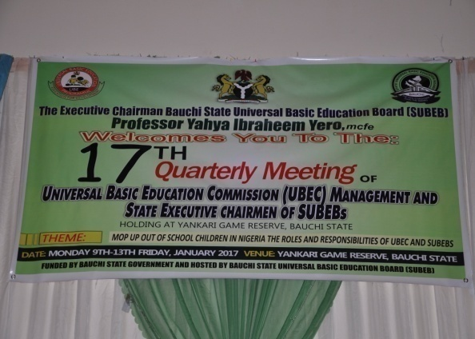 |  | 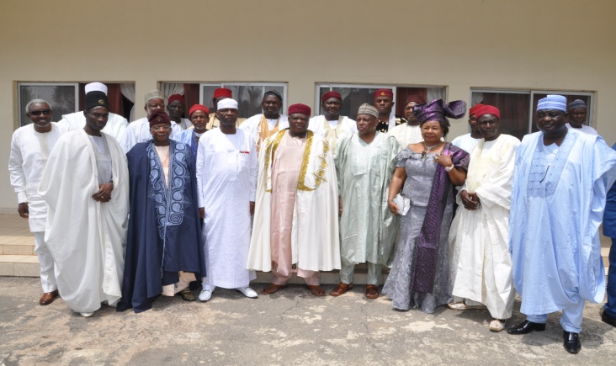
The banner of the UBEC/SUBEB Chairmen’s  Meeting held in Bauchi. | Group photograph of the Gbong Gwom Jos, Da Jacob Gyang Buba, with the Minister of State for Education, Prof. Anthony Anwuka, the ES, Management of UBEC and SUBEB Chairmen, during the meeting in Jos.
2.8.5 CHALLENGES
Being a new Department, there are dire needs for support staff, additional office space, furniture and equipment for effective and efficient service delivery.
2.8.6 ON-GOING ACTIVITIES
Preparations for the forthcoming 18th Quarterly Meeting of UBEC Management and the SUBEBs Executive Chairmen scheduled for Abia State.
2.8.7 FUTURE ACTIVITIES
- Familiarization visits to Zonal offices for in-depth discussions with the Zones/States under each region with a view to coming up with sustainable mechanisms of empowering the Zonal/State offices.
- Verification of UBEC’s landed properties for proper documentation and fortification in the states.
2.8.8 CONCLUSION
As a newly established Department, it was able to carry out its statutory duties during the short period of its existence. However, it is the hope of the Department that the challenges mentioned in the preceding paragraphs would be addressed in the nearest future to enable the Department render effective and efficient services.

2.9 DEPARTMENT OF SPECIAL PROGRAMMES
Alhaji Dauda Alhassan was born on 6th April, 1957 in Dutsen-wai town of Kabau LGA in Kaduna State. He attended LEA Primary School, Dutsen-wai from 1965-1971, and later gained admission into Arabic Teachers College, Katsina, for his Teachers Grade II Certificate from 1972-1976.  He started his teaching career as a Classroom Teacher and rose to the position of Head Teacher, and later Schools Supervisor.  In 1979, he gained admission into College of Education, Kafanchan, where he graduated as an N.C.E holder in 1982, specializing in Physical and Health Education (P.H.E). After his NYSC in 1983, he joined the Ministry of Education, Kaduna State and was posted to teach in one of the Secondary Schools in the state.  In 1985, he went for his B.Ed (Physical and Health Education) course in the Ahmadu Bello University, Zaria through in-service training secured from Kaduna State Ministry of Education. After the completion of his course, he continued with his teaching career where he rose to the position of Vice-Principal between 1988 and 1989.  In November 1989, he was employed as Senior Monitoring Officer by the defunct National Primary Education Commission (NPEC), now UBEC. He worked in the Ibadan, Ilorin, Sokoto, Kano, Uyo, Makurdi, Jos and Gombe State Offices at different times between 1990 and 2010. | Alhaji Dauda Alhassan  Ag. Director, Special Programmes
He was deployed to the UBEC Headquarters as Deputy Director, Social Mobilization in 2010 and later made the Ag. Director, Social Mobilization where he served from 2013 - 2014.

Again, he was later redeployed to the Executive Secretary’s Office as Deputy Director, E.S Office in 2014. Finally, he was posted to the Special Programmes Department of the Commission as the Ag. Director in July 2015.

2.9.1 INTRODUCTION
The Department of Special Programmes is saddled with the responsibilities of coordinating the implementation of Special Programmes in the Commission such as the Girl-Child Education, Boy-Child Education and the activities of the Education Sector Support Programme in Nigeria (ESSPIN).
2.9.2 STRUCTURE
The Department is headed by an Ag. Director and assisted by a Chief Programme Officer. It has 3 Units namely: i. Girl-Child, ii. Boy-Child and iii. Education Sector Support Programme in Nigeria (ESSPIN) and a total number of 10 staff, all domiciled at the Headquarters.

Table 2.9.2: Staff Disposition
S/N | DESIGNATION | CONRAISS | NUMBER
 | Ag. Director | 15 | 1
 | Chief Programme Officer | 12 | 1
 | Principal Quality Assurance Officer | 11 | 1
 | Principal Confidential Secretary | 11 | 1
 | Quality Assurance Officer I | 08 | 1
 | Programme Officer 1 | 08 | 2
 | Academic Planning Officer I | 08 | 1
 | Programme Officer I | 07 | 1
 | Chief Driver/Mechanic | 06 | 1
TOTAL |  |  | 10

2.9.3 FUNCTIONS
The Department performs the following functions which include:
- Implementing policy direction and activities on access and equity that are geared towards reducing the existing gender disparity in access, retention and completion rates in Basic Education.
- Effective collaboration with other relevant Departments, National and International Agencies in order to create appropriate opportunities for socialization.
- Setting of a robust Monitoring and Evaluation Standards in order to enhance learning achievements of out-of-school children education in the country.
- Organising seminars/workshops with relevant stakeholders on the effective implementation of the Boy-child and Girl-child education.
- Supervision/Monitoring of the Boy-child and Girl-child education programmes.

2.9.4 ACTIVITIES/ACHIEVEMENTS
The major activities accomplished by the Department centred mainly on the development of framework for the All Girls’ School Initiatives (AGSI).

2.9.5 CONSTRAINTS
- Low participation of host communities in conception and implementation of the programmes.
- Inability of the SUBEBs to replicate policy direction and activities on access and equity at their own levels.

2.9.6 ON-GOING ACTIVITIES
- Review of the Boy-child and Girl-child Programmes;
- Monitoring of the Boy-child, Girl-child and Almajiri schools.

2.9.7 FUTURE ACTIVITIES
- Monitoring the full commencement of academic activities in the Model Junior Girls schools and Boy-child Vocational Centres.
- Training of relevant stakeholders on the effective implementation of the programmes.
- Public enlightenment of stakeholder to key into the education of Boy-child and Girl-child in the country.
- Capacity building training on inclusive Education.

2.9.8 CONCLUSION
The Department was able to accomplish some of the activities in line with its functions despite the challenges that were faced in the field.

2.10 DEPARTMENT OF TSANGAYA (ALMAJIRI) EDUCATION PROGRAMME

Alhaji Aliyu Musa Kardi was born on 30th September, 1959 in Kardi village, Birnin Kebbi Local Government Area of Kebbi State. He obtained the NCE from the College of Education, Sokoto, Sokoto State. He then proceeded to Bayero University, Kano (BUK) where he obtained the B.A. in Sociology/Hausa in 1986. He performed the National Youth Service in Daura Teachers’ College in Kaduna State.  He was employed by the Ministry of Education, Sokoto State in 1982 as Master III Teacher and posted to Government Girls’ Secondary School, Ilela. He was later posted to the Primary Education Department in the Ministry of Education headquarters as an inspector of primary schools in the State. He was thereafter posted to head the operation of the mobile classroom and later Primary School Management Board (PSMB) as Chief Education Development Officer.  He then joined the National Primary Education Commission (NPEC) as Senior Monitoring Officer in November, 1989 and was deployed to Owerri Zonal Office in 1992. He was later posted to the Benin Zonal Office in 1992 and Uyo Zonal Office in 1993. He was appointed Zonal Coordinator, Ibadan in 1994 and Zonal Coordinator, Sokoto, Sokoto State in 2001. He was later posted to the Kaduna Zonal Office in 2007. | Alhaji Aliyu Musa Kardi  Director, Tsangaya Education Programme
He was appointed the Special Assistant (SA) to the Deputy Executive Secretary (Technical) in 2014 and later National Coordinator, Almajiri Education in the same year, from where he rose to the rank of Director.

He was appointed the Director, Special Programmes and later Director, Executive Secretary’s Office in 2015. Aliyu M. Kardi is the Director in-charge of the Tsangaya Education Programme.
2.10.1 Introduction
Tsangaya Education Programme is one of the initiatives of the Federal Government to address the problems of out-of-school children with the following objectives:
- provide access and equity to Basic Education for all Almajiri school age children which will discourage and gradually eliminate itinerancy and begging of Almajiri in the country
- support the emergence of an enabling environment that would facilitate the effective integration of Islamic disciplines into the Basic Education Programme.

The National Council on Education (NCE) at its 60thMeeting held in November, 2014 in Abeokuta, Ogun State, approved the change of the name ‘’Almajiri’’ to ‘’Tsangaya’’ because of the derogatory nature associated with the word.

2.10.2 STRUCTURE
The Department is headed by a Director and assisted by an Assistant Director. The Director coordinates the Department and relates with other Departments and SUBEBs on Tsangaya Education Programme and reports to the Executive Secretary through the Deputy Executive Secretary (Services).
During the year under review, the Department had a total number of 4 staff.
Table 2.9.2: Staff Disposition
S/N | RANK | CONRAISS | NUMBER
 | Director | 15 | 1
 | Assistant Director | 13 | 1
 | Computer Programme Officer | 08 | 1
 | Programme Officer II | 07 | 1
TOTAL |  |  | 4

    - FUNCTIONS
The Department carries out the following functions.
- Implement all decisions of the Commission’s Board and Management on Tsangaya Education Programme.
- Initiate Programmes and Projects for implementation of Tsangaya Education.
- Coordinate the activities of SUBEBs that are related to Tsangaya Education.
- Collect, collate and report status of Tsangaya Model Schools to UBEC Management.
- Carry out other duties as directed by the Executive Secretary and Management.

    - ACTIVITIES/ACHIEVEMENTS
The Department being new was only able to perform 1 main activity in the year under review.
- Conducted capacity building on the utilization of curriculum for teachers and proprietors of Tsangaya Model Schools in Minna, Niger State from 25th – 29th May, 2016.

    - CONSTRAINTS
In the process of implementing the Tsangaya Education Programme, the following challenges undermined the success of the programe in the year under review. They included:
- Non adoption and replication of the Programme by States Governments.
- Non Integration of Alarammas/Mallams/Proprietors into the Programme by the state.
- Inadequate funding.

    - ON-GOING ACTIVITIES
The Department is reviewing the 2016-2019 Ministerial Strategic Plan to address the challenges that affect the Tsangaya Education.
    - FUTURE ACTIVITIES
The Department plans to execute the following activities.
- Translation of Tsangaya Education Textbooks and Teachers’ Guides (Mathematics, Basic Science, Social Studies and Teachers’ Guides) into English Language.
- Production of additional textbooks.
- Continuous Strengthening of the capacity of teachers of model Tsangaya Education schools.
- Continuous Sensitization and mobilization of critical stakeholders.
- Review of the Tsangaya Education Programme vis-à-vis the challenges of implementation in order to chart a new course.

3.0 UBEC ZONAL AND STATE OFFICES
3.1 INTRODUCTION
The Zonal Offices are mandated to ensure that qualitative Basic Education is being delivered across all the States and the FCT. There are 6 Zonal Offices located across the 6 Geo-political Zones of the country. All the States have UBEC’s offices. The locations of the Zonal offices and the States that they cover are contained in Table 3.1.
Table 3.1: Locations and Coverage Areas of the UBEC Zonal Offices
S/N | ZONAL OFFICE | LOCATION OF OFFICE | STATES COVERED | TOTAL NUMBER OF STATES
- 1. | North-Central | Lokoja, Kogi State | Benue, Kogi, Kwara, Nasarawa, Plateau, Niger and FCT | 7
- 2. | North-East | Bauchi, Bauchi State | Adamawa, Borno, Bauchi, Gombe, Taraba and Yobe. | 6
- 3. | North-West | Kaduna, Kaduna State | Jigawa, Kano, Kaduna, Katsina, Kebbi, Sokoto and Zamfara. | 7
- 4. | South-East | Owerri, Imo State | Abia, Anambra, Ebonyi, Enugu and Imo. | 5
- 5. | South-South | Uyo, Akwa Ibom State | Akwa Ibom, Bayelsa, Cross River, Delta, Edo and Rivers. | 6
- 6. | South-West | Abeokuta, Ogun State | Ekiti, Lagos, Ogun, Ondo, Osun and Oyo. | 6
TOTAL |  |  |  | 37

3.2 STRUCTURE
The Zonal Offices are headed by Directors while the State Offices/FCT Sub-Zonal Offices are headed by Officers of the cadre of Assistant Director and not less than Principal Quality Assurance Officer.
The total number of staff in the Department at the Zonal, State Offices and the FCT Sub-Zonal Office are contained in Tables 2 and 3a - 3f respectively.

Table 3.2a: Staff Disposition at the North-Central Zonal Office and State Offices
A | North-Central Zonal Office
S/N | DESIGNATION | CONRAISS |  | NO. |  | DEPARTMENT
 | Ag. Zonal Director | 15 |  | 1 |  | Quality Assurance
 | Chief Social Mobilization Officer. | 12 |  | 1 |  | Social Mobilization
 | Chief Accountant | 12 |  | 1 |  | Finance & Accounts
 | Senior Technical Officer | 08 |  | 1 |  | Admin. & Supplies
 | Civil Engineer I | 10 |  | 2 |  | Physical Planning
 | Quality Assurance Officer I | 08 |  | 1 |  | Physical Planning
 | Planning Officer | 08 |  | 1 |  | PRS
 | Auditor I | 08 |  | 1 |  | Audit
 | Confidential Secretary I | 07 |  | 1 |  | Quality Assurance
 | Driver/Mechanic | 05 |  | 1 |  | Admin. & Supplies
TOTAL |  |  |  | 11
B | Benue State Office
 | ACQAO | 11 | 1 |  | Quality Assurance
 | Prin. Confidential Secretary I | 10 | 1 |  | Admin.& Supplies
 | Accountant I | 08 | 1 |  | Finance & Accounts
 | Quality Assurance Officer I | 07 | 1 |  | Quality Assurance
 | Data Processing Assistant | 07 | 1 |  | Admin. & Supplies
 | Quality Assurance Officer II | 07 | 2 |  | Quality Assurance
 | H.E.O | 07 | 1 |  | Finance & Accounts
 | Chief Motor Driver/Mechanic | 06 | 1 |  | Admin.& Supplies
 | Assistant Executive Officer | 05 | 1 |  | Admin.& Supplies
 | Chief Clerical Officer (Accts) | 06 | 1 |  | Finance & Accounts
TOTAL |  |  | 10
C. | Kwara State Office
 | Assistant Director | 13 | 1 |  | Quality Assurance
 | Quality Assurance Officer I | 08 | 1 |  | Quality Assurance
 | Senior Data Processing Officer | 08 | 1 |  | Admin. & Supplies
 | Admin. Officer I | 08 | 1 |  | Quality Assurance
 | Admin. Officer II | 07 | 1 |  | Admin. & Supplies
 | Quality Assurance Officer II | 07 | 1 |  | Quality Assurance
 | Chief Clerical Officer I | 06 | 1 |  | Finance & Accounts
 | Executive Officer | 05 | 1 |  | Admin. & Supplies
 | Motor Driver | 02 | 1 |  | Admin. & Supplies
TOTAL |  |  | 9
D | Nasarawa State Office
 | Principal QA Officer | 10 | 1 |  | Quality Assurance
 | Senior Admin. Officer | 09 | 1 |  | Admin. & Supplies
 | SQAO | 09 | 1 |  | Social Mobilization
 | S.E.O Admin. | 08 | 1 |  | Admin. & Supplies
 | H.E.O Accounts | 07 | 1 |  | Finance & Accounts
 | Quality Assurance Officer II | 07 | 1 |  | Quality Assurance
TOTAL |  |  | 6
E | Niger State Office
 | Asst. Director | 13 | 1 |  | Quality Assurance
 | Snr. Executive Officer (Admin) | 08 | 1 |  | Quality Assurance
 | Planning Officer II | 07 | 1 |  | PRS
 | Academic Planning Officer II | 07 | 2 |  | Academic Services
 | HEO (Accounts) II | 07 | 1 |  | Finance & Accounts
 | Social Mobilization Officer II | 07 | 1 |  | Social Mobilization
 | Quality Assurance Officer II | 07 | 1 |  | Quality Assurance
 | Admin. Officer II | 07 | 1 |  | Admin.& Supplies
 | Clerical Officer | 03 | 1 |  | Admin.& Supplies
TOTAL |  |  | 10
F | Plateau State Office
 | Chief QA Officer | 12 | 1 |  | Quality Assurance
 | Senior Admin. Officer | 09 | 1 |  | Admin.& Supplies
 | Planning Officer I | 08 | 1 |  | PRS
 | Quality Assurance Officer I | 08 | 1 |  | Quality Assurance
 | Accountant I | 08 | 1 |  | Finance & Accounts
 | Planning Officer II | 07 | 1 |  | PRS
 | Social Mobilization Officer II | 07 | 1 |  | Social Mobilization
 | Accountant II | 07 | 1 |  | Finance & Accounts
 | Executive Officer (Admin.) | 07 | 1 |  | Admin.& Supplies
 | Architect II | 07 | 1 |  | Physical Planning
 | Academic Planning Officer II | 07 | 1 |  | Academic Services
 | Quality Assurance Officer II | 07 | 2 |  | Quality Assurance
 | Asst. Exe. Officer (Admin.) | 05 | 1 |  | Admin.& Supplies
 | Snr. Motor Driver/Mechanic I | 05 | 1 |  | Admin.& Supplies
TOTAL |  |  | 15
G. | FCT Sub-Zonal Office
 | Chief Quality Assurance Officer | 13 | 1 |  | Quality Assurance
 | ACEO(Accounts) | 12 | 1 |  | Finance & Accounts
 | AC. Academic Planning Officer | 11 | 1 |  | Finance & Accounts
 | Principal Admin. Officer | 10 | 1 |  | Admin.& Supplies
 | PEO (Admin.) | 10 | 2 |  | Admin.& Supplies
 | Snr. Quality Assurance Officer | 09 | 1 |  | Quality Assurance
 | Admin. Officer I | 08 | 3 |  | Admin.& Supplies
 | Accountant I | 08 | 1 |  | Finance & Accounts
 | Legal Officer I | 08 | 1 |  | Legal Unit
 | Admin. Officer II | 08 | 2 |  | Admin.& Supplies
 | Academic Planning Officer I | 08 | 1 |  | Academic Services
 | Planning Officer II | 07 | 1 |  | PRS
 | Social Mobilization Officer II | 07 | 2 |  | Social Mobilization
 | Academic Planning Officer II | 07 | 1 |  | Academic Services
 | Quality Assurance Officer | 07 | 1 |  | Quality Assurance
 | Social Mobilization Officer I | 07 | 1 |  | Social Mobilization
 | Social Mobilization Officer III | 07 | 1 |  | Social Mobilization
 | Statistician II | 07 | 1 |  | PRS
 | Confidential Secretary I | 07 | 1 |  | Admin.& Supplies
 | Driver | 02 | 1 |  | Admin.& Supplies
 | TOTAL |  | 25

Table 3.2b: Staff Disposition at the North-East Zonal Office and State Offices
A | North-East Zonal Office
S/N | DESIGNATION | CONRAISS | NO. | DEPARTMENT
 | Ag. Director (NE) | 15 | 1 | Quality Assurance
 | Chief Executive Officer | 12 | 2 | Finance & Accounts
 | Chief Building Officer | 12 | 1 | Physical Planning
 | Principal Admin. Officer | 10 | 1 | Admin.& Supplies
 | Senior Building Officer | 09 | 1 | Physical Planning
 | Senior Electrical Engineer | 09 | 1 | Physical Planning
 | S.E.O (QS) | 08 | 1 | Physical Planning
 | Programme Analyst | 08 | 1 | PRS
 | Legal I | 08 | 1 | Legal Unit
 | Admin. Officer I | 08 | 1 | Admin.& Supplies
 | Quality Assurance Officer II | 08 | 1 | Quality Assurance
 | Town Planning Officer II | 07 | 1 | Physical Planning
 | Architect II | 07 | 1 | Physical Planning
 | Civil Engineer II | 07 | 1 | Physical Planning
 | Chief Driver/Mechanic | 07 | 1 | Admin. & Supplies
TOTAL |  |  | 16
B | Adamawa State Office
 | Prin. Quality Assurance Offr. | 10 | 2 | Quality Assurance
 | Assistant Chief Admin. Officer | 11 | 1 | Admin.& Supplies
 | Prin. Auditor | 10 | 1 | Audit
 | Quality Assurance Officer | 09 | 1 | Quality Assurance
 | Acad. Planning Officer | 07 | 1 | Academic Services
 | Higher Exec. Officer (Admin.) | 07 | 2 | Admin.& Supplies
 | Engineer II | 07 | 1 | Physical Planning
 | Chief. Driver/Mech. | 06 | 1 | Admin.& Supplies
TOTAL |  |  | 10
C | Borno State Office
 | Snr. Quality Assurance Officer | 09 | 1 | Quality Assurance
 | Quality Assurance Officer I | 08 | 1 | Quality Assurance
 | Confidential Secretary | 07 | 1 | Admin.& Supplies
 | Admin. Officer | 08 | 1 | Admin.& Supplies
TOTAL |  |  | 4
D | Gombe State Office
 | Asst. Quality Assurance Officer II | 11 | 1 | Quality Assurance
 | Prin. Executive Officer (Accts) | 10 | 1 | Finance & Accounts
 | Admin. Officer I | 08 | 1 | Admin.& Supplies
 | Quality Assurance Officer II | 07 | 1 | Quality Assurance
 | Confidential Secretary III | 06 | 1 | Admin.& Supplies
 | Driver | 02 | 1 | Admin.& Supplies
TOTAL |  |  | 6
E. | Taraba State Office
 | Asst. Director, Quality Assurance | 13 | 1 | Quality Assurance
 | Admin. Officer II | 07 | 1 | Admin.& Supplies
 | Quality Assurance Officer II | 07 | 1 | Quality Assurance
 | Snr. Mobilization Officer II | 07 | 1 | Social Mobilization
 | Accountant II | 07 | 1 | Finance & Accounts
TOTAL |  |  | 5
F | Yobe State Office: Staff yet to be posted to the office

Table 3.2c: Staff Disposition at the North-West Zonal Office and State Offices
A | North-Central Zonal Office
S/N | DESIGNATION | CONRAISS |  | NO |  | DEPARTMENT
 | Zonal Director | 15 |  | 1 |  | Quality Assurance
 | Asst. Chief Admin. Officer | 12 |  | 1 |  | Admin.& Supplies
 | Chief Tech. Officer (Arc.) | 12 |  | 1 |  | Physical Planning
 | Asst. Chief Tech. Officer | 11 |  | 1 |  | Physical Planning
 | Principal Accountant | 10 |  | 1 |  | Finance & Accounts
 | Principal Admin. Officer | 10 |  | 1 |  | Admin. & Supplies
 | Senior Legal Officer | 09 |  | 1 |  | Legal Unit
 | Chief Typist | 08 |  | 1 |  | Admin.& Supplies
 | Senior Architect I | 09 |  | 1 |  | Physical Planning
 | Social Mobilization Officer I | 08 |  | 1 |  | Social Mobilization
 | Programme Analyst | 08 |  | 1 |  | PRS
 | Quality Assurance Officer I | 08 |  | 1 |  | Quality Assurance
 | Architect I | 08 |  | 1 |  | Physical Planning
 | Building Officer I | 08 |  | 1 |  | Physical Planning
 | Planning Officer I | 08 |  | 1 |  | PRS
 | Senior Executive Officer | 08 |  | 1 |  | Admin.& Supplies
 | Legal officer I | 08 |  | 1 |  | Legal
 | Social Mobilization Officer II | 08 |  | 1 |  | Social Mobilization
 | Academic Planning Officer II | 07 |  | 1 |  | Academic Services
 | Civil Engineer II | 07 |  | 1 |  | Physical Planning
 | Planning Officer II | 07 |  | 2 |  | PRS
 | Quality Assurance Officer II | 07 |  | 1 |  | Quality Assurance
 | Higher Executive Officer | 07 |  | 1 |  | PRS
 | Social Mobilization Officer II | 07 |  | 1 |  | Social Mobilization
 | Chief Driver/Mechanic | 06 |  | 1 |  | Admin.& Supplies
 | Snr. Motor Driver/Mechanic | 04 |  | 1 |  | Admin.& Supplies
TOTAL |  |  |  | 27
B | Jigawa State Office
 | Assistant Director, QA | 13 |  | 1 |  | Quality Assurance
 | Principal QA Officer | 10 |  | 1 |  | Quality Assurance
 | Snr. Admin. Officer | 09 |  | 1 |  | Admin.& Supplies
 | SEO (Accounts) | 08 |  | 1 |  | Finance & Accounts
 | Academic Planning Officer II | 07 |  | 1 |  | Academic Services
 | Quality Assurance Officer II | 07 |  | 1 |  | Quality Assurance
TOTAL |  |  |  | 6
C. | Kano State Office
 | Asst. Chief | 11 | 1 |  | Quality Assurance
 | Asst. Chief Social Mobilization Officer | 11 | 1 |  | Social Mobilization
 | Quality Assurance Officer I | 08 | 2 |  | Quality Assurance
 | Administrative Officer I | 08 | 1 |  | Admin.& Supplies
 | Senior Executive Officer | 08 | 1 |  | Admin.& Supplies
 | Social Mobilization Officer II | 07 | 1 |  | Admin.& Supplies
 | Social Mobilization Officer II | 07 | 1 |  | Social Mobilization
 | Accountant II | 07 | 1 |  | Social Mobilization
 | Chief Driver/Mechanic | 06 | 1 |  | Admin.& Supplies
 | Confidential Secretary III | 05 | 1 |  | Admin.& Supplies
 | Clerical Officer I | 05 | 1 |  | Admin.& Supplies
 | TOTAL |  | 12
 | Katsina State Office
 | Chief Quality Assurance  Officer | 12 | 1 |  | Quality Assurance
 | Prin. Information Officer | 10 | 1 |  | ES Office
 | Prin. Confidential Secretary | 10 | 1 |  | Admin.& Supplies
 | Senior Executive Officer | 08 | 1 |  | Finance & Accounts
 | Quality Assurance Officer II | 07 | 1 |  | Quality Assurance
 | Admin. Officer II | 07 | 1 |  | Admin.& Supplies
 | Senior Mobilization Officer | 07 | 1 |  | Social Mobilization
 | Senior Data Processing Asst. | 05 | 1 |  | PRS
 | Driver | 02 | 1 |  | Admin.& Supplies
 | Clerical Asst.(Admin.) | 02 | 1 |  | Admin.& Supplies
TOTAL |  |  | 10
E | Kebbi State Office Staff are yet to be posted to the office
 | Asst. Chief QA Officer | 11 | 1 |  | Quality Assurance
 | Quality Assurance Officer II | 08 | 1 |  | Quality Assurance
F | Sokoto State Office
 | Asst. Dir., Quality Assurance | 13 | 1 |  | Quality Assurance
 | Prin. Exec. Officer (Admin.) | 10 | 1 |  | Admin.& Supplies
 | Academic Planning Officer I | 08 | 1 |  | Academic Services
 | Quality Assurance Officer II | 08 | 1 |  | Quality Assurance
 | Accountant I | 08 | 1 |  | Finance & Accounts
 | Quality Assurance Officer II | 07 | 1 |  | Quality Assurance
 | Quality Assurance Officer II | 07 | 1 |  | Quality Assurance
 | Chief Driver/Mech. | 06 | 1 |  | Admin.& Supplies
TOTAL |  |  | 8
G | Zamfara State Office
 | Chief Quality Assurance | 12 | 1 |  | Quality Assurance
 | Senior Admin. Officer | 08 | 1 |  | Admin.& Supplies
 | Snr. Conf. Sec. | 08 | 1 |  | Admin.& Supplies
 | Quality Assurance Engr. | 07 | 1 |  | Quality Assurance
 | Academic Planning Officer | 07 | 1 |  | Academic Services
 | Assistant Executive Officer | 07 | 1 |  | Admin. & Supplies
TOTAL |  |  | 6

Table 3.2d: Staff Disposition at the South-East Zonal Office and State Offices
A | South-East Zonal Office
S/N | DESIGNATION | CONRAISS | NO. | DEPARTMENT
 | Ag. Zonal Coordinator | 15 | 1 | Quality Assurance
 | Chief Confidential Secretary | 12 | 1 | Admin.& Supplies
 | Asst. Chief Accountant | 11 | 2 | Finance & Accounts
 | Legal Officer I | 08 | 2 | Legal Unit
 | Planning Officer II | 07 | 1 | Academic Services
 | Engineer II | 07 | 1 | Physical Planning
 | Admin. Officer II | 07 | 1 | Admin.& Supplies
 | Chief Driver/Mechanic | 06 | 1 | Admin.& Supplies
 | Asst. Executive Officer | 06 | 1 | Admin.& Supplies
 | Snr. Clerical Officer | 05 | 1 | Finance & Accounts
TOTAL |  |  | 12
B | Abia State Office
 | Chief Quality Assurance Offr. | 12 | 1 | Quality Assurance
 | Quality Assurance Officer | 08 | 1 | Quality Assurance
 | Higher Exec. Officer, Admin. | 07 | 1 | Admin.& Supplies
TOTAL |  |  | 3
C | Anambra State Office
 | Snr. Quality Assurance Officer | 09 | 1 | Quality Assurance
 | Snr. Quality Assurance Offr. II | 08 | 1 | Quality Assurance
 | Planning Officer II | 07 | 1 | PRS
 | Executive Officer (Accounts) | 06 | 1 | Finance & Accounts
TOTAL |  |  | 4
D | Ebonyi State Office
 | Prin. Quality Assurance Officer | 10 | 1 | Quality Assurance
 | Snr. Admin. Officer | 09 | 1 | Admin.& Supplies
 | Accountant I | 08 | 1 | Finance & Accounts
 | Confidential Secretary III | 06 | 1 | Admin.& Supplies
 | Senior Driver | 04 | 1 | Admin.& Supplies
TOTAL |  |  | 5
E | Enugu State Office
 | Chief Quality Assurance Officer | 12 | 1 | Quality Assurance
 | Principal Executive Officer | 10 | 1 | Finance & Accounts
 | Snr. Quality Assurance Officer | 09 | 1 | Quality Assurance
 | Planning Officer I | 08 | 1 | PRS
 | Admin. Officer | 07 | 1 | Admin.& Supplies
 | Accountant | 07 | 1 | Finance & Accounts
 | Programme Analyst | 07 | 1 | Academic Services
 | Confidential Secretary II | 07 | 1 | Admin.& Supplies
 | Chief Driver/Mechanic | 06 | 1 | Admin.& Supplies
 | Chief Clerical officer (Accts.) | 06 | 1 | Admin.& Supplies
TOTAL |  |  | 10

Table 3.2e: Staff Disposition at the South-South Zonal Office and State Offices
A. | South-South Zonal Office
S/N | DESIGNATION | CONRAISS |  | NO. | DEPARTMENT
 | Ag. Zonal Director | 15 |  | 1 | Quality Assurance
 | Principal Accountant | 10 |  | 2 | Finance & Accounts
 | Snr. Architect | 09 |  | 1 | Physical Planning
 | Quality Assurance Officer I | 08 |  | 1 | Quality Assurance
 | Admin. Officer II | 07 |  | 1 | Admin.& Supplies
 | High Tech. Officer (Elec.) | 07 |  | 1 | Physical Planning
 | Accountant II | 07 |  | 1 | Finance & Accounts
 | Executive Officer (Admin.) | 07 |  | 1 | Admin.& Supplies
 | Chief Driver/Mech. | 06 |  | 1 | Admin.& Supplies
 | Confidential Secretary III | 06 |  | 1 | Admin.& Supplies
TOTAL |  |  |  | 11
B | Bayelsa State Office
 | ACQAO/Ag. State Coordinator | 11 |  | 1 | Quality Assurance
 | Prin. Confidential Secretary I | 10 |  | 1 | Admin.& Supplies
 | Accountant I | 08 |  | 1 | Finance & Accounts
 | Quality Assurance Officer I | 08 |  | 1 | Quality Assurance
 | Academic Planning Officer II | 07 |  | 1 | Academic Services
 | Senior Driver/ Mechanic | 04 |  | 1 | Admin.& Supplies
TOTAL |  |  |  | 6
C | Cross River State Office
 | Chief Planning Officer | 12 |  | 1 | PRS
 | Accountant I | 08 |  | 1 | Finance & Accounts
 | Admin. Officer I | 08 |  | 1 | Admin.& Supplies
 | Academic Planning Officer II | 07 |  | 1 | Academic Services
 | Confidential Secretary I | 07 |  | 1 | Admin.& Supplies
 | Snr. Motor Driver/Mechanic | 04 |  | 1 | Admin.& Supplies
TOTAL |  |  |  | 6
D. | Delta State Office
 | Snr. Quality Assurance Officer |  | 09 | 2 | Quality Assurance
 | Academic Planning Officer I |  | 08 | 1 | Academic Services
 | Admin. Officer I |  | 08 | 1 | Admin.& Supplies
 | Accountant II |  | 07 | 1 | Finance & Accounts
 | Driver/Mechanic |  | 04 | 1 | Admin.& Supplies
TOTAL |  |  |  | 6
E. | Edo State Office
 | Asst. Chief Quality Assurance Officer |  | 11 | 1 | Quality Assurance
 | Snr. Quality Assurance Officer |  | 10 | 1 | Quality Assurance
 | Academic Planning Officer |  | 08 | 1 | Academic Services
 | Executive Officer (Accounts) |  | 06 | 1 | Finance & Accounts
TOTAL |  |  |  | 4
F. | Rivers State Office
- 1. | Chief Quality Assurance Officer |  | 12 | 1 | Quality Assurance
- 2. | Prin. Quality Assurance Officer |  | 10 | 1 | Quality Assurance
- 3. | Principal Exec. Officer I |  | 10 | 1 | Admin.& Supplies
- 4. | Accountant I |  | 08 | 1 | Finance & Accounts
- 5. | Social Mobilization Officer I |  | 08 | 1 | Social Mobilization
- 6. | Mechanical Engr. I |  | 08 | 1 | Physical Planning
- 7. | Administrative Officer II |  | 07 | 2 | Admin.& Supplies
 | TOTAL |  |  | 8

Table 3.2f: Staff Disposition at the South-West Zonal Office and State Offices
A | South-West Zonal Office
S/N | DESIGNATION | CONRAISS | NO. | DEPARTMENT
 | Acting Zonal Director | 14 | 1 | Quality Assurance
 | Senior Administrative Officer | 09 | 1 | Admin.& Supplies
 | Accountant II | 09 | 1 | Finance & Accounts
 | Quality Assurance Officer I | 08 | 1 | Quality Assurance
 | Senior Executive Officer (Audit) | 08 | 1 | Finance & Accounts
 | Planning Officer I | 08 | 1 | PRS
 | Qty Assurance Officer II | 07 | 1 | Quality Assurance
 | Electrical Engineer | 07 | 1 | Physical Planning
 | Chief Driver/Mech. | 06 | 1 | Admin.& Supplies
 | Confidential Sec. III | 06 | 1 | Admin.& Supplies
 | TOTAL |  | 10
B. | Ekiti State Office
 | Prin. Quality Assurance Officer | 10 | 1 | Quality Assurance
 | Snr. Quality Assurance Officer | 09 | 1 | Quality Assurance
 | Senior Executive Officer (Acct.) | 08 | 1 | Finance & Accounts
 | Quality Assurance Officer II | 07 | 2 | Quality Assurance
 | Admin. Officer II | 07 | 1 | Admin.& Supplies
 | Academic Planning Officer II | 07 | 1 | Academic Services
 | Chief Driver | 06 | 1 | Admin. & Supplies
 | Confidential Secretary III | 06 | 1 | Admin. & Supplies
TOTAL |  |  | 9
C. | Lagos State Office
 | Deputy Director | 14 | 1 | Quality Assurance
 | Accountant I | 09 | 1 | Finance & Accounts
 | Social Mobilization Officer | 09 | 1 | Social Mobilization
 | Chief Typist | 08 | 1 | Admin. & Supplies
 | Social Mobilization Officer I | 08 | 1 | Social Mobilization
 | Quality Assurance Officer II | 08 | 1 | Quality Assurance
 | Admin. Officer II | 07 | 2 | Admin. & Supplies
 | Chief Driver/Mechanic | 06 | 1 | Admin. & Supplies
TOTAL |  |  | 9
D | Ondo State Office
 | Assistant Director | 13 | 1 | Quality Assurance
 | Prin. Executive Officer (Accounts) | 10 | 1 | Finance & Accounts
 | Quality Assurance Officer I | 08 | 1 | Quality Assurance
 | Admin. Officer I | 08 | 1 | Admin.& Supplies
TOTAL |  |  | 4
E. | Osun State Office
 | Asst. Chief Qty Assurance Officer | 11 | 1 | Quality Assurance
 | Asst. Chief Conf. Secretary | 11 | 1 | Admin. & Supplies
 | Prin. Academic Planning Officer | 10 | 1 | Academic Services
 | Quality Assurance Officer I | 08 | 2 | Quality Assurance
 | Accountant | 07 | 1 | Finance & Accounts
TOTAL |  |  | 6
F. | Oyo State Office
 | Asst. Chief Qty Assurance Officer | 11 | 1 | Quality Assurance
 | Asst. Chief Admin. Officer | 11 | 1 | Admin.& Supplies
 | Asst. Chief Conf. Secretary | 11 | 1 | Admin.& Supplies
 | Principal Qty Assurance Officer | 10 | 1 | Admin.& Supplies
 | Snr. Quality Assurance Officer I | 09 | 2 | Quality Assurance
 | Accountant I | 08 | 1 | Finance & Accounts
 | Admin. Officer II | 08 | 1 | Admin.& Supplies
 | Quality Assurance Officer II | 07 | 1 | Quality Assurance
 | H.E.O (Soc. Mob.) | 07 | 1 | Social Mobilization
 | Planning Officer II | 07 | 1 | PRS
 | Driver/Mechanic | 04 | 1 | Admin.& Supplies
TOTAL |  |  | 12

3.3 FUNCTIONS
The main tasks of the Zonal Offices are to among others:
- ensure that qualitative Basic Education is being delivered across all the States and the FCT;
- Coordinate the activities of Basic Education in their various Zones to ensure State offices carry out their jobs effectively;
- serve as Grassroots contacts to the SUBEBs and as the Secretariat of the Quarterly Meeting of UBEC Management with the Executive Chairmen of SUBEBs;
- liaise with SUBEBs for the collections of Data/Information; and
- carry out any assignment that may be assigned to it from the Headquarters.

3.4 ACTIVITIES/ACHIEVEMENTS
The Zonal Offices were able to perform the underlisted activities in the year under review.
- Participated in the conduct of Quality Assurance in school on termly basis.
- Collected and collated data of the 4th Quarter Administrative Reports on the SUBEBs.
- Participated in the Departmental Monitoring activities.
- Documentation of new Staff posted to the Zones.
3.5 ON-GOING ACTIVITIES
The following activities are currently being carried out by the Zonal Offices.
- Monitoring of school resumption in States.
- Receiving the delivery of instructional materials supplied by UBEC to SUBEBs.
- Monitoring of UBEC intervention and constituency projects.
- Liaising with SUBEB on the Development of 3 years Medium Term Strategic Plan.
- Liaising with SUBEBs on Data returns to Headquarters.

3.6 FUTURE PLANS
- Carrying out any assignments which will be given to the Zones from Headquarters to ensure effective delivery of basic education in States.
3.7 CHALLENGES
- Lack of adequate functional Vehicles in the Zone to conduct monitoring activities.
- Inadequate funds to perform the functions of the office effectively.
- Lack of internet facilities to communicate with Headquarters effectively.
- Some of the Zonal and State offices are still operating in the rented apartments.
3.8 CONCLUSION
The Zonal Offices were able to carry out their duties despite the challenges mentioned above. It is hoped that some of the challenges identified will be overcome in the years ahead.

