TABLE OF CONTENT
Table of Content …………………………………………………………..……… i
Acronyms………………………………………………………………………… iii
UBE Vision Statement ………………………………………………………..….vii
UBE Mission Statement ….…………………………………………………..….vii
UBE Core Values …………………………………………………………...……vii
Foreword…………………………………………………………………………viii
Management Team………………………………………………………………..x
Zonal Directors…………………………………………………………………...xii

SECTION 1:
OFFICE OF THE EXECUTIVE SECRETARY
Introduction….……………………………………………………………….... 1
Office of the Executive Secretary …………………………………………….….. 4
Almajiri Education Programme Unit …………………………………………...14
Internal Audit Unit ……………………………………………………………...18
Federal Teachers’ Scheme ………………………………………………………24
Procurement Unit ……………………………………………………………….28
Legal Unit ……………………………………………………………………… 31
Public Relations & Protocol Unit ………………………………………………34
Special Projects Unit ……………………………………………………………37
SECTION 2:
DEPARTMENTAL REPORTS
Academic Services …………………..………………………………………….. 42
Administration and Supplies ……………………………………………………58
Finance and Accounts ……………………………………………………............65
Physical Planning ……………………………………………………………….74
Planning, Research and Statistics …………………………………………….....78
Quality Assurance …………………………………………………………….…85
Social Mobilization ……………………………………………………….............96
Special Programmes ……………………………………………………….. …..112

ACRONYMS
AIDS - Acquired Immune Deficiency Syndrome
AIT - African Independent Television
APER - Annual Performance in Evaluation Report
AZALEA - AZALEA Initiatives
BMIS - Book Management Information System
CA - Continuous Assessment
CAADEI - Children and Adult Empowerment Initiative
CATI - Community Accountability and Transparency Initiative
CBECC - Community-Based Early Childcare Center
CBOs - Community-Based Organizations
CGPs - Civil Society and Government Partners
CIDA - Canadian International Development Agency
CODE - Connected Development
COMPRO - Combined Promotion and Confirmation Examination
CONRAISS - Consolidated Research and Allied Institutions Salary Structure
CRF - Consolidated Revenue Fund
CSACEFA - Civil Society Action Coalition on Education for All
DFID - Department for International Development
DLIs - Disbursement Linked Indicators
DRG - Debt Relief Grants
EAC - Educate a child
ECAN - Education Correspondence Association of Nigeria
ECCDE - Early Childhood Care Development and Education
ECD - Early Child Development
EDOREN - Education Data, Operational Research and Evaluation in
Nigeria
EFA - Education for All
EMIS - Education Management Information System
ESSPIN - Education Sector Support Program in Nigeria
FCT - Federal Capital Territory
FGN - Federal Government of Nigeria
FMBN - Federal Mortgage Bank of Nigeria
FME - Federal Ministry of Education
FMF - Federal Ministry of Finance
FMI - Federal Ministry of Information
FRCN - Federal Radio Corporation of Nigeria
FTS - Federal Teachers’ Scheme
G&C - Guidance and Counseling
GPE - Global Partnership for Education
GTC - Global Training Consulting
ICT - Information and Communication Technology
IDB - Islamic Development Bank
IDPs - International Development Partners
IGR - Internally Generated Revenue
IPSAS - International Public Sector Accounting Standard
JCCE - Joint Consultative Committee on Education
JICA - Japan International Cooperation Agency
JSS - Junior Secondary School
KOICA - Korea International Cooperation Agency
KPI - Key Performance Indicator
LAN - Local Area Network
LGEA - Local Government Education Authority
MDGs - Millennium Development Goals
MSAP - Modern Statistical Application Packages
NABTEB - National Business and Technical Examinations Board
NALABE - National Assessment of Learning Achievement in Basic
Education
NBTE - National Board for Technical Education
NCCE - National Commission for Colleges of Education
NCE - Nigeria Certificate in Education
NCOA - National Chart of Account
NEI - Northern Education Initiative
NERDC - Nigerian Educational Research and Development Council
NETC - National Education Technical Commission
NGOs - Non – Governmental Organizations
NHIS - National Housing Insurance Scheme
NIEPA - National Institute for Educational Planning and
Administration
NIIMP - National Integrated Infrastructure Master Plan
NPC - National Population Commission
NTA - Nigerian Television Authority
NTI - National Teachers Institute
NUT - National Union of Teachers
NYSC - National Youth Service Corp
PIC - Project Implementation Committees
PSDN - President’s Schools Debate of Nigeria
PTA - Parent – Teachers Associations
SBMC - School-Based Management Committee
SEPIP - State Education Programme Investment Project
SERVICOM- Service Compact
SMASE - Strengthening of Mathematics and Science Education
STVEP - Skills Training and Vocational Education Project
SUBEBs - State Universal Basic Education Boards
TAF - The Albino Foundation
TETFund - Tertiary Education Trust Fund
TKT - Teaching Knowledge Test
TPD - Teacher Professional Development
UBE - Universal Basic Education
UNCAP - Unified National Continuous Assessment Programme
UNCPD - United Nations Commission on Population and Development
UNICEF - United Nations International Children Education Fund
USAID - United States Agency for International Development
WREP - Women Rights for Education Programme

VISION OF THE COMMISSION
To be a world class education intervention and
regulatory agency for the promotion of uniform,
qualitative and functional basic education.

MISSION OF THE COMMISSION
The Commission shall operate as an intervention, coordinating and monitoring Agency to progressively improve the capacity of States, Local Government Agencies and Communities in the provision of unfettered access to high quality basic education in Nigeria.

CORE VALUES OF THE COMMISSION
- Honesty and Accountability
- Integrity and Transparency
- Teamwork with Commitment

FOREWORD
This year’s Annual Report gives a summary of the activities executed by the Commission aimed at achieving the Federal Government’s efforts in providing quality basic education service delivery in Nigeria. The report also contains the implementation challenges and future plans.
Various programmes and projects such as the Almajiri Education Programme, Procurement and distribution of Instructional and Library Resource Materials, Capacity Building for Basic Education Teachers and Managers through the Teacher Professional Development, Receipt and disbursement of funds for Implementation of Basic Education to States and Local Government Areas, Provision of Schools Infrastructure, Data generation, analysis and dissemination to education stakeholders and the public for policy decisions, Quality Assurance best practices, Advocacy and sensitization of education stakeholders at all levels of governance, Mentoring and Monitoring of School-Based Management Committees (SBMCs) were carried out in the year under review with the sole aim of providing access, equity and quality basic education towards realization of EFA and MDGs.
In an effort to reduce the number of out-of-school children by providing access for them to quality education, 103 Almajiri schools, 62 Junior Girl’s Model Secondary Schools, 57 E-Libraries were built and put into use in some selected States. In addition, instructional materials were procured and distributed to all Almajiri Model Schools across the country while under 2014 Model III intervention, 84 schools located in 27 States and the FCT were provided with grants to improve school infrastructure.
The basic education sub-sector equally benefitted from the Commission’s collaboration with International Development Partners (IDPs) such as Japan International Cooperation Agency (JICA), Korea International Cooperation Agency (KOICA), China Economic and Commercial Office, British Council, World Bank, Islamic Development Bank (IDB), and UNICEF in the provision of basic education infrastructure/facilities and capacity building for teachers and education managers.
Under these various collaborations, the following activities, among numerous others, were carried out:
- 200 NCE teachers were trained on Skills Training and Vocational Education Project (STVEP) programme with support from African Development Fund after which they were absorbed into FTS and deployed to nomadic schools in 28 States.
- 116 NCE teachers were recruited and deployed to teach in 58 Almajiri Schools in 21 States for the purpose of promoting the integration of basic education into Qur’anic education.
- 38 qualified NCE teachers with different forms of physical challenge were absorbed into the FTS.
In the year under review also, 15% of the 2% of the FGN CRF meant for UBE intervention, set aside for the provision of instructional materials in the basic education sub-sector, was used to supply the following teaching and learning items nationwide:
- Various Science and Vocational Equipments distributed to Unity Schools.
- 49,950 notebooks and pencils to Almajiri schools.
- Procurement of 4.9m copies of Social Studies, Basic Science, Mathematics and English Language Textbooks for JSS.

While modest achievements were recorded through the efforts of the various departments and units of the Commission, the State Basic Education Boards and other stakeholders, the implementation of the UBE Programme within the period was done in the midst of challenges and operational gaps, many of which we hope to overcome or improve upon in 2015.
We wish to use this opportunity therefore to appreciate the cooperation received from the SUBEB Chairmen, LGEA Education Secretaries and other stakeholders in 2014 and solicit for better collaboration and cooperation in the New Year, so that collectively we can achieve the mandate of providing free, uniform and qualitative education for the Nigerian child. Remember always that “Education for All, is the responsibility of All”.

Alh. (Dr.) Suleiman Dikko
Executive Secretary

MANAGEMENT TEAM
 | 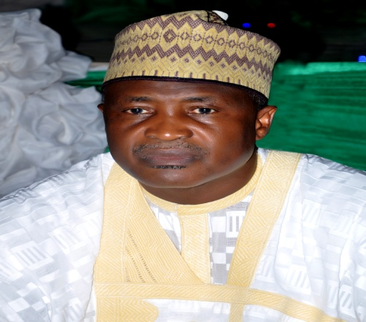
 |  | 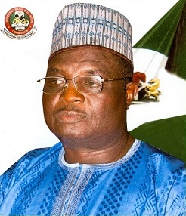
 | ALH. (DR.)  DIKKO SULEIMAN  EXECUTIVE SECRETARY | DR YAKUBU GAMBO  DEPUTY EXECUTIVE SECRETARY (SERVICES)  UNIVERSAL BASIC EDUCATION COMMISSION
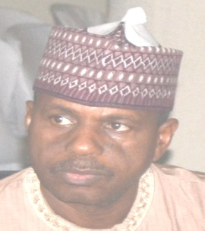 | 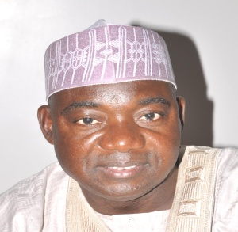 |  | 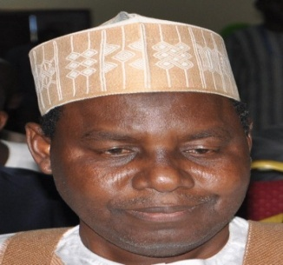
Baba Sali Song  Director, Department of Admin. & Supplies | Alh. Bello Kagara  Director, Department of Planning,  Research & Statistics | Dr. C. C. Agomoh  Director, Department of Quality Assurance | Alh. M. S. Dukku  Director, Department of  Finance & Accounts
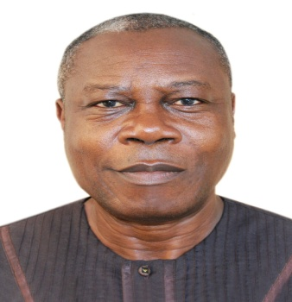 | 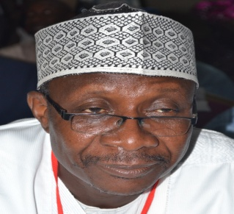 | 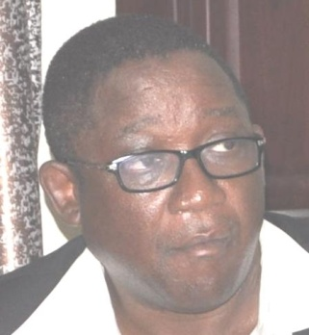 | 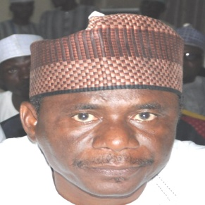
Mr Pius Osaghae  Director, Department of Academic Services | Alh. UsmanAliyuKaoje  Director, Department of Social Mobilization | Arc. M. M. Muftwang  Director, Department of Physical Planning | AlhAliyuKardi  Director, Department of Special Programmes

ZONAL DIRECTORS

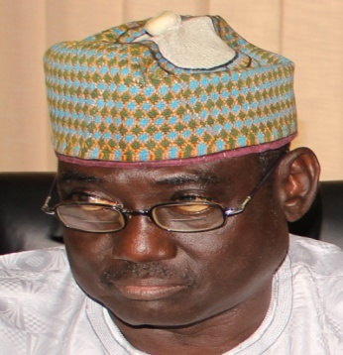 |  | 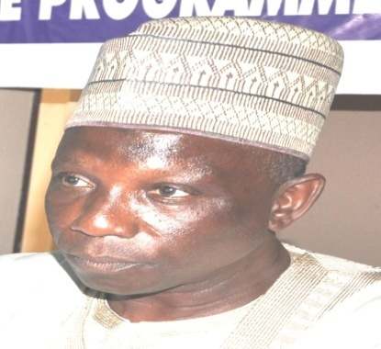
Mr. Benjamin Tsado  Zonal Director, FCT Sub-Zone |  | Alh. Jibo Abdullahi  Zonal Director, North-East
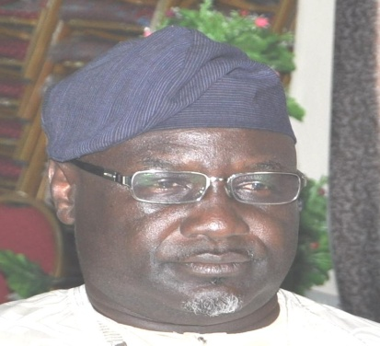 |  | 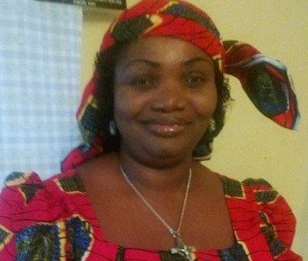
Bishop Edwin Jarumai  Zonal Director, North Central |  | Mrs. N.B. Ojukwu  Zonal Director, South-East
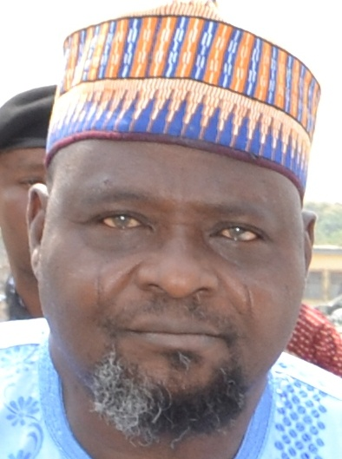 |  | 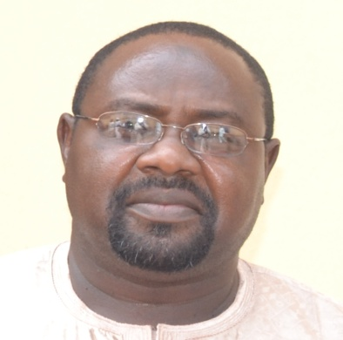
Alh. Amuda  Acting Zonal Director, South-West |  | Alh. MansirIdris  Zonal Director, North-West
 | 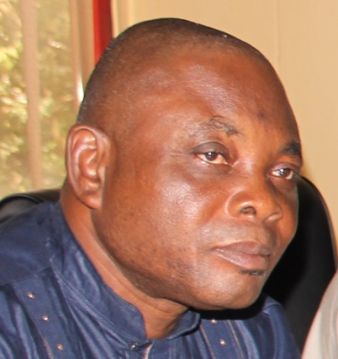
Mr. Sylvester Enyinnaya
Acting Zonal Director, South-South

