2014 ANNUAL REPORT

Introduction
Fundamentally, there are two main concerns in the delivery of basic education in Nigeria, which are provision of ‘access’ and ensuring ‘quality’. In the height of the pursuit for solutions to these concerns emanated some noticeable educational imbalances among different parts of the country due to the glaring variations in access to and quality of basic education within and among the geo-political Zones, States and Local Government Areas. These imbalances prompted the need for ensuring ‘equity” in the delivery processes. Thus, the implementation of basic education in Nigeria, with the legal backing of the UBE Act, 2004, is geared toward addressing three key issues, viz: access, equity and quality.
Over the years of its implementation activities, the Universal Basic Education Commission has stepped up strategies aimed at improving, the hitherto, poor access opportunities to and deteriorating quality of education as well as solving the educational imbalances that pervade the Sub-sector. This Report captures the implementation focus of the Commission in 2014 which tried to build and consolidate on the gains recorded in the previous years: activities for improving teaching and learning environment were scaled up through the provision of inputs like additional classrooms, learning equipment and facilities, instructional materials, capacity building for teachers and other school administrators. At the same time, provision of access to basic education was improved considerably with focus, on the ‘almajirai’ and other categories of Out-of-School Children.
Creditably, the year 2014 had to its advantage the vibrant leadership of a new Executive Secretary, Dr. Dikko Suleiman, who took over the mantle of leadership of the Commission in November, 2013. The burning desire in Dr. Suleiman to make a difference in the Management and Implementation parameters of the Commission ushered in some spectacular programmes, policies and initiatives that enlivened the entire Commission and propelled the delivery of basic education within the year under review.
Principal among such initiatives are; (i) improving staff welfare by approving and securing permission from the National Salary and Wages Commission for the upward migration of Staff Salary Structure from CONTISS to CONRAISS and approving the replacement of Staff Rent Advance System with a Rent Supplement Policy. Rent advance was formerly paid to Staff as loan and recovered through monthly deductions. These and other positive concerns for the Commission’s workforce boosted Staff morale and improve their attitude to work thereby enhancing their productivity.
Steadily, Dr. Suleiman re-positioned the Management structure of the Commission giving birth to two new directorates at the Headquarters, viz; Departments of Special Programmes and Physical Planning, while at the same time uplifting the status of the Zonal offices to directorate level and promoting six Deputy Directors to the rank of Directors to head the Commission’s six Zonal Offices. Significantly, it was worth mentioning here that, with the addition of eight (8) new directorates, the magnanimity of Dr. Suleiman opened access for Staff mobility within the service of the Commission.
Other notable implementation successes recorded in 2014 include, but not limited to, the supply of Notebooks to Almajiri schools nationwide, printing and supply of 4,961,469 copies of Social Studies, Basic Science, Maths, English, textbooks for Junior Secondary Schools, Renovation of existing classrooms and other school structures, building of additional ones, training of 138,158 teachers and other school administrators.
The challenge of out-of-school children was vigorously pursued by the Commission through building of Almajiri, Girl-Child Vocational Schools and Boy-Child Vocational Centres.
Then, for the first time in the history of the Commission, a meeting was held between UBEC and SUBEBs Directors of Strategic Planning with the view to re-strategizing implementation activities of the UBE Programme to be anchored by a result-oriented plan. This activity took place in Kaduna in October, 2014.
At partnership level, year 2014 witnessed the approval of three major International Development Partners Projects, which are (i) Japan International Cooperation Agency’s (JICA) Project for the Construction of Additional classrooms for which Oyo State is benefiting; (ii) World Bank Supported “State Education Programme Investment Project piloted in Anambra, Ekiti, and Bauchi States; and (iii) Global Partnership for Education (GPE) Projects in Kaduna, Katsina, Jigawa, Sokoto and Kano States. Never indeed, has any educational Parastatal had this feat of IDPs’ Support Programmes.
The UBE Implementation progress was impressive within the year, but not without constraints. The inability of the Commission to pay the participants of the Federal Teachers Scheme (FTS) their full allowances constituted one of the major implementation challenges that confronted the Commission during the year. Some States’ derelictions in accessing the UBE Matching Grants and non-adherence to approved Action Plans also became cogs in the wheel of the Commission’s progress. These and other scenarios affected the rates at which States-based teacher training, classroom constructions, renovations, etc, were carried out.
Mitigating plans have been put in place to address these implementation challenges in 2015, but by and large, year 2014 as contained in this Report will remain a significant turning point, a game changer in the management of basic education in Nigeria, and a year that brought hope and meaning into the lives of UBEC Staff.

- OFFICE OF THE EXECUTIVE SECRETARY
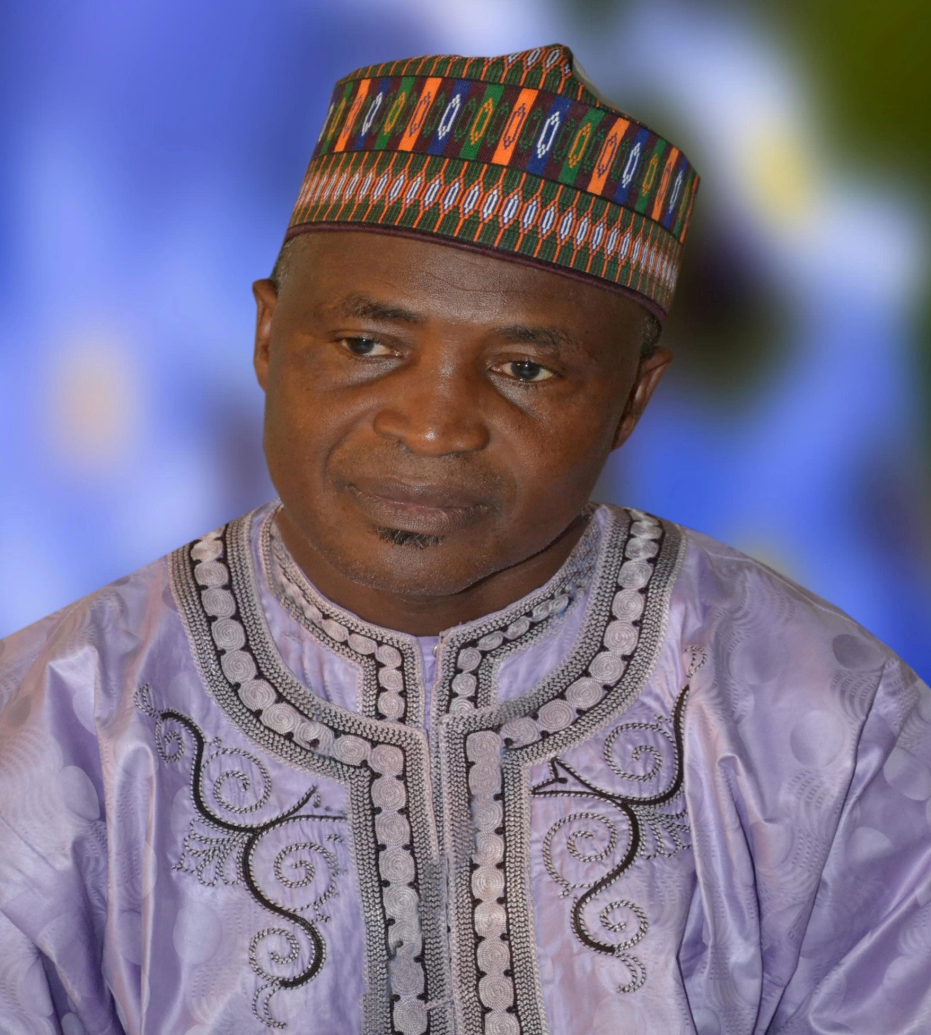
ALH. (DR.) DIKKO SULEIMAN
EXECUTIVE SECRETARY
Alhaji (Dr.) Dikko Suleiman was born in 1957 and hails from Danmusa Local Government Area of Katsina State. He holds the Grade Two Teacher’s Certificate (GR II), National Certificate in Education (NCE), Bachelor’s Degree in Education Art (B. A. Ed), Master’s Degree (M. Ed) in Developmental Psychology and a Ph.D. in Child Development.
Dr. Dikko is a prolific writer and has authored several professional educational books including Developmental Psychology; Human Learning, Psychology of Child Rearing; Psychology of Abnormal Personality; Beginning Psychology and Concise Guidance and Counseling Practices; and Fundamentals of Guidance and Counseling Practices, etc.
Arising from his educational pedigree, Dikko has served in many strategic educational and administrative capacities and has utilized his rich academic and professional background in contributing to the formulation and implementation of educational policies in Nigeria. As a teacher and administrator of outstanding repute, he has served as a member of the Standing Committee on Implementation of Public/Private Partnership in the Provision of Students Hostel Accommodation in FCE, Katsina; Staff Development Committee, FCE Katsina; Students Screening Committee, FCE Katsina and was Chairman, FCE Katsina Staff School Management Committee; Chairman, Primary School Management Committee; Dean, Students Affairs and Provost, Katsina State College of Education, etc. He was the Executive Chairman of Katsina State Universal Basic Education Board (SUBEB) prior to his appointment as Executive Secretary of UBEC in November, 2013.
His current tenure at UBEC has witnessed the innovation of result-oriented mechanisms for the implementation of the UBE programme in line with global best practices. Laying much emphasis on staff welfare and professionalism, he is working assiduously with his Management team towards repositioning the UBE Commission and making it more responsive to delivering the objectives of the UBE programme. His vision in this regard has led to uplifting the status of the Zonal Offices to directorates, creating two additional directorates at the UBEC Headquarters and improving the salary package of the Commissions’ workforce, amongst others. He has initiated sustainable partnerships with International Development Partners (IDPs) such as UNESCO, Japan International Cooperation Agency (JICA), Korea International Cooperation Agency (KOICA), British Council, The Commonwealth of Learning (COL), etc, in developing the basic education sub-sector.

Dr. Dikko is widely travelled and is a recipient of several National and International Awards. He is happily married and blessed with children.

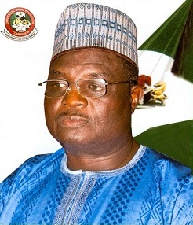
DR. YAKUBU GAMBO
DEPUTY EXECUTIVE SECRETARY (SERVICES)
UNIVERSAL BASIC EDUCATION COMMISSION
Dr. Yakubu Gambo was born 15th June, 1960 in Talbushi, Kanam Local Government Area, Plateau State. A native of Jahr Chiefdom, Dr. Yakubu attended Central Primary School, Gyangayang from 1970 - 1977, Government Teachers’ College, Garkawa (1982) and graduated with a Teachers’ Grade II Certificate. He also obtained his Nigeria Certificate in Education from College of Education, Gindiri in 1987.  Dr. Gambo furthered his education in University of Jos and graduated with a B.Sc degree in Education (1997). His quest for knowledge led him to undertake a Master’s Degree in International Relations and Strategic Studies (2000). He also has a Doctor of Philosophy in Political Science from Bayero University, Kano (2010).  Prior to his appointment as Deputy Executive Secretary (Services) of Universal Basic Education Commission in 2013, Dr. Gambo has served in many committees, which amongst others include Committee of Elders Forum, Plateau State; Presidential Committee on COJA; National Political Reform Conference, Abuja and was Coordinator, Presidential Campaign Organisation. He also engages in writing and has published many books and articles both nationally and internationally.  He is a recipient of many prize awards and recognitions such as Best Local Government Administrator in Projects Implementation in Plateau State; Award of Excellence in Educational Planning, University of Jos and Best Agric Commissioner in Plateau State; amongst others.  Dr. Gambo enjoys reading and research. He is a farmer, politician and happily married with children. | Dr. Sharon ‘Rowo Oriero-Oviemuno was born in Lagos State and hails from Isoko South Local Government Area of Delta State. She attended Anglican Girls Grammar School also known as Adesuwa Grammar School Benin City (1977/78) after which she attended the College of Education, Benin City (1981/82) as the Pioneer Set. Dr. Sharon then furthered her studies in University of Benin and graduated with a B.Sc Geography & Regional Planning/Education (1985/86).  Dr. Sharon, in her pursuit of knowledge, went further to attain her Master’s Degree in Education from the University of Ibadan (1986/87), focusing on Personnel Management. This achievement led to her going for her PhD in the same University (2002/2003) where her research work focused on Personnel Management/Human Resources Management and Development/Gender Studies.  Her giant strides in the field of education resulted in her appointment by the former President Goodluck Ebele Jonathan as the Deputy Executive Secretary (Technical), Universal Basic Education Commission. She has previously worked as a Banker, Management Consultant, and served on different Federal Government Governing Boards including UBEC. She is a mobilizer and motivator of youths/children, women and men to mention but a few.  Dr. Sharon is a Chartered Manager and a Fellow of IPMD, a member of Nigerian Institute of Management and Institute of Policy Management Development. She has numerous awards attached to her and is happily married with children.

1.1 Introduction
The Executive Secretary is the Chief Executive and Accounting Officer of the Commission responsible for the day-to-day administration of the Commission. He is assisted by two Deputies Executive Secretary (Technical and Services) and is answerable to the Governing Board and the Minister of Education.

In addition, the Special Projects, Almajiri Education Programme, Internal Audit, Legal Services and Public Relations and Protocol Units are being supervised directly by the Office of the Executive Secretary.

1.2 Functions
The functions of the Office of the Executive Secretary include:
- formulating and coordinating the execution of policy guidelines for the successful operation of the UBE Programme nationwide;
- ensuring the timely receipt of block grant from the Federal Government and allocating to States and other related agencies implementing the UBE Programme in accordance with an approved formula;
- inquiring into and advising the Federal Government, through the Honourable Minister of Education, on the effective funding, implementation and orderly development of basic education in Nigeria;
- ensuring efficient collation and preparation of periodic master plans for a balanced and coordinated development of basic education in Nigeria;
- ensuring effective monitoring of Federal Government inputs into the implementation of basic education;
- presenting periodic progress reports on the implementation of the UBE Programme to Mr. President through the Honourable Minister of Education
- liaising with the Honourable Minister of Education on matters of implementation, funding and general management of the UBE Programme;
- liaising with the Presidency and National Assembly from time to time on the funding and implementation of the programme;
- sustaining cordial relationship and cooperation with State Governments, SUBEBs and other stakeholders;
- pursuing enrolment campaigns and programme implementation to achieve UBE set objectives and goals; and
- supervising activities in the Special Project, Federal Teachers Scheme, Internal Audit, Legal, Public Relations/Protocol, Procurement and Almajiri Education Programme Units.
1.3 Structure
The Office of the Executive Secretary consists of
- Executive Secretary;
- Office of the Deputy Executive Secretary (Technical);
- Office of the Deputy Executive Secretary (Services);
- Special Projects Unit (JICA, KOICA, World Bank, etc);
- Procurement Unit;
- Federal Teachers Scheme Unit;
- Internal Audit Unit;
- Legal Unit;
- Public Relations & Protocol Unit; and
- Almajiri Programme Unit.

1.4 Staff Disposition in ES’ Office
S/N | RANK | CONRAISS | NO.
1 | Executive Secretary | Consolidated | 1
2 | Deputy Executive Secretary (Technical) | Consolidated | 1
3 | Deputy Executive Secretary (Services) | Consolidated | 1
4 | Special Asst. to ES, DD (ES’ Office), National Coordinator (FTS), DD (DES(T) Office), DD (DESS) Office, DD (Internal Audit) and DD (FTS) | 14 | 7
5 | AD, Procurement/AD Special Projects | 13 | 2
6 | Chief Internal Auditor, Chief Prog. Officer/Chief Confidential Secretary | 12 | 4
7 | Asst. Chief Public Relations Officer, Asst. Chief Proc. Officer | 11 | 2
8 | Asst. Chief Data Proc. Officer, Legal Adviser, Principal Quality Assurance Officer, Principal Protocol Officer, Principal Internal Auditor and Principal Procurement Officer | 10 | 7
9 | Principal Confidential Secretary, Senior Legal Officer, Senior Quality Assurance Officers (2), Senior Internal Auditors (2) | 09 | 7
10 | Legal Officer I, Admin Officer I, Quality Assurance Officer I, Auditor I and Admin Officer II | 08 | 6
11 | Protocol Officer II (PA-ES), Project Officer II, Information Officer II, Information Officer II, Auditor II, Conf. Sec. II, Procurement Officer II, Admin Officer, Computer Prog. Officer /H.E.O. (Accounts)/H.E.O./Planning Officer I | 07 | 12
12 | Executive Officer Protocol, Senior Data Proc. Asst, and Chief Motor Driver/Mechanic | 06 | 8
13 | Camera Man and Confidential Secretary | 05 | 2
14 | Senior Clerical Officer I | 05 | 2
15 | Motor Driver IV/Clerical Officer | 03 | 2
16 | Clerical Assistant | 02 | 1
 |  |  | 65

1.5 Highlights of Achievements
The Universal Basic Education Commission during the year under review worked out strategies as usual to ensure the effective implementation of the UBE programme in Nigeria. The year 2014 experienced more coordinated approaches to implementing UBE activities, which include among others, building of synergy between Federal, State and relevant agencies and International Development Partners involved in supporting various activities in the basic education sub-sector. The Commission, as a result, harvested a lot of deliverables in 2014.
During the year, the Executive Secretary, in addition to his day-to-day administrative and coordinating responsibilities of the activities of the various units and departments, represented the Commission at different fora, made remarks, presented papers or delivered addresses on various topics related to the implementation of Universal Basic Education programme. These include the following:
- A Speech at the Opening Ceremony of the Eleventh Quarterly Meeting of UBEC Management with Executive Chairmen of SUBEBs at Osogbo, the State of Osun, January 2014.
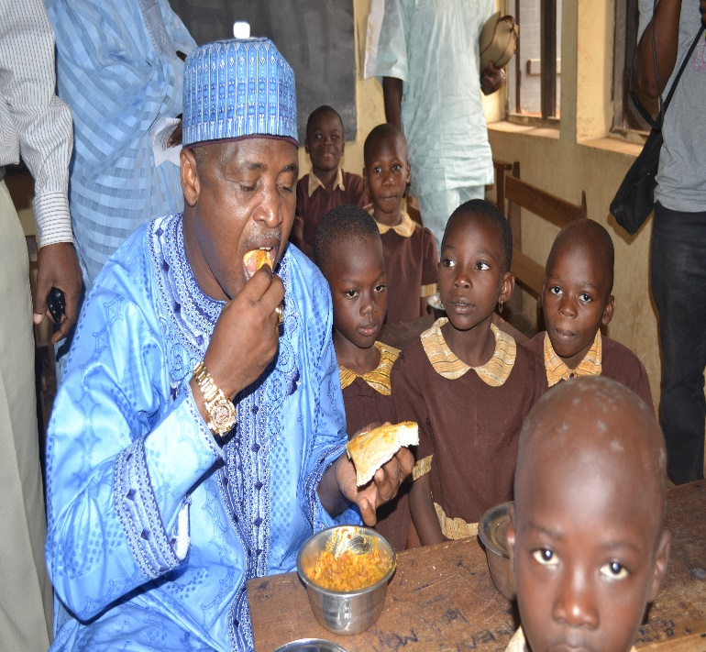 |  | 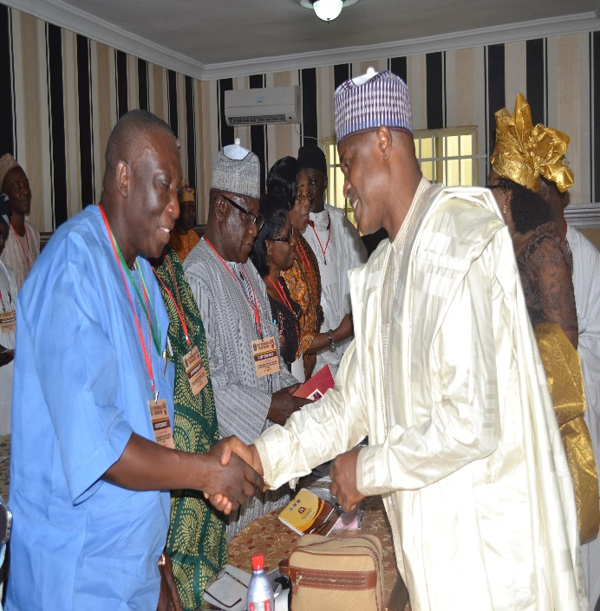
ES UBEC, Alh. Dr, Suleiman Dikko with pupils having breakfast in a primary school practicing school feeding programme in Osun State |  | ES UBEC, Alh. Dr. Suleiman Dikko (Right ) welcoming SUBEB Chairmen to the 11th Quarterly Meeting in Osun State
- An Address presented at the Opening of the Training Programme for Quality Assurance Officers by Abia SUBEB; Kolping Society, Umuahia, Abia State; January 2015.
- A Speech on the Achievements of the Executive Governor of Katsina State, His Excellency, Dr. Ibrahim Shehu Shema, FNIM, CON (Sarkin Yakin Hausa), in Basic Education, Katsina; January 2014.
- A Speech at the Handover Ceremony of All Girls Model School in Ikwo, Ebonyi State, February 2014.
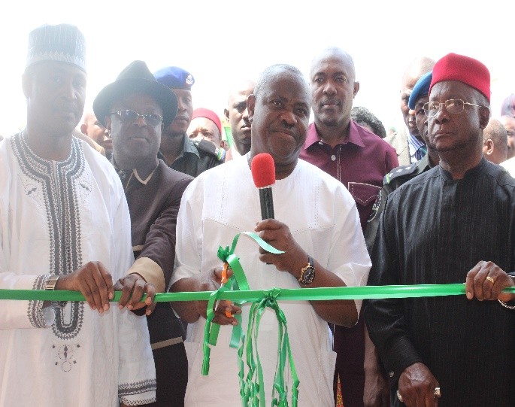 |  | 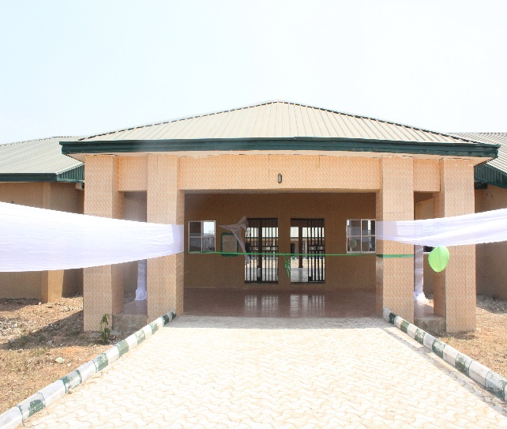
The Supervising Minister of Education, Chief Barr. Ezenwo Nyesom Wike(middle) cutting the tape to commission the Girl-Child Secondary School, Ikwo, Ebonyi State |  | The entrance of the Girl-Child Secondary School, Ikwo, Ebonyi State
- An Address at the occasion of the ground-breaking ceremony for the construction of the UBEC Special Vocational School in Evwreni, Ughelli North LGA, Delta State; April 2014.
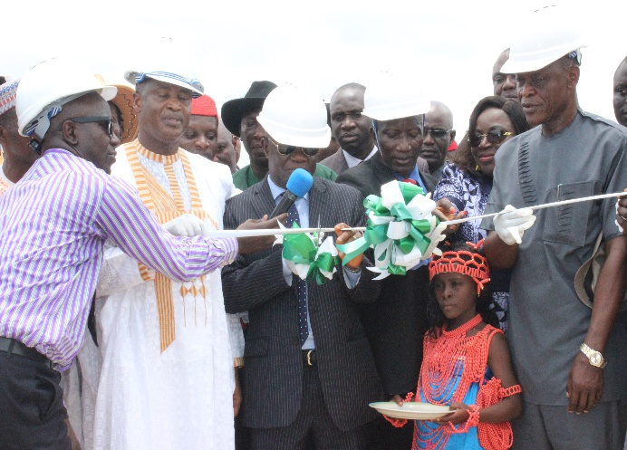 |  | 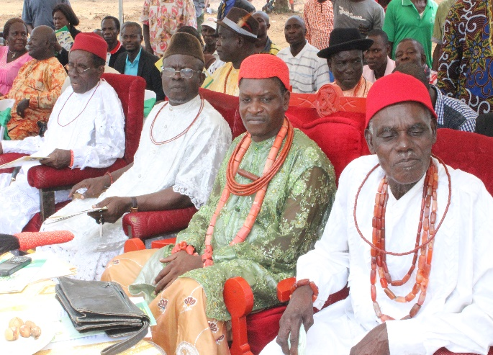
Permanent Secretary FME (middle), ES UBEC and other dignitaries at the ground-breaking ceremony for the construction of the UBEC Special Vocational School in Evwreni, Ughelli North LGA, Delta State. |  | Cross-section of traditional rulers at the ground-breaking ceremony for the construction of the UBEC Special Vocational School in Evwreni, Ughelli North LGA, Delta State.
- An Address delivered at the Review Workshop on Training Manual for UBE Para-Counsellors at Parkview Hotel, Wuse Zone 2, Abuja, April 2014.
- A Speech at the Plenary Session of the Twelfth Quarterly Meeting of UBEC Management with Executive Chairmen of SUBEBs in Owerri, Imo State; April 2014.
- A goodwill message at the opening ceremony of the 56th (5th Quadrennial) National Conference of Delegates of the Nigeria Union of Teachers (NUT); Uyo, Akwa Ibom State; July 2014.
- “Importance of Ensuring a Safety Culture in the Education Sector”, Being A Keynote Address presented at the Distribution of Safe School Manuals to Schools by Exam Ethics Marshals International; Transcorp Hilton Hotel, Abuja; July 2014.
- Address at the One-Day Meeting with SUBEB Directors and Desk Officers In-Charge of Teacher Professional Development; Abuja; July 2014.
- Achieving Millennium Development Goal 2 in Nigeria: Progress & Challenges; A Focus on the North-Central Geo-Political Zone; Being a Presentation at the Presidential Summit on the MDGs and the Post-2015 Development Agenda at Transcorp Hilton, Abuja; August, 2014.
- 2013 and 2014 Budget Performance as at 15th August, 2014 presented to House Committee on Education; August 2014.
- Millennium Development Goals (MDGs) and Post-2015 Agenda: The Implementation of Universal Basic Education Programme: Progress, Challenges & Lessons Learnt; Being a Presentation at the Presidential Summit on the MDGs and the Post-2015 Development Agenda at Transcorp Hilton, Abuja; August, 2014.
- A Speech at a 2-Day Capacity Building Workshop for Almajiri School Model III School Proprietors and Teachers at Minna, Niger State; September 2014.
- An Address at the ground breaking ceremony of Junior Girls’ Model Secondary School, Ogu Bolo LGEA, Rivers State; September 2014.
- SERVICOM: Towards Efficient Service Delivery in the Universal Basic Education Programme in Nigeria; A Speech at the Thirteenth Quarterly Meeting of UBEC Management and Executive Chairmen of SUBEBs; Gusau, Zamfara State; September 2014.
- Opening Address at the Maiden Edition of the Meeting of UBEC and SUBEB Directors in charge of Strategic Planning; Malali, Kaduna; October 2014.
- An Address at the Opening of the Training of Quality Assurance Officers of Niger SUBEB; Minna, Niger State; October 2014.
- Address at the National Flag-Off Ceremony of the Distribution of 2013 Instructional Materials for Public Basic Education Schools in Nigeria; Dr. Ibrahim Shema Science Model Primary School, Kofar Sauri, Katsina; October 2014.
- An Address delivered at A 5-Day Capacity Building Workshop for Almajiri School Proprietors, Local Government Education Secretaries and Almajiri Desk Officers on Establishment of School-Based Management Committees (SBMCs) at Nasfah Hotel, Minna, Niger State; November 2014.
- A Speech at a Capacity Building Workshop for Almajiri School Administrators and Teachers; Minna, Niger State.
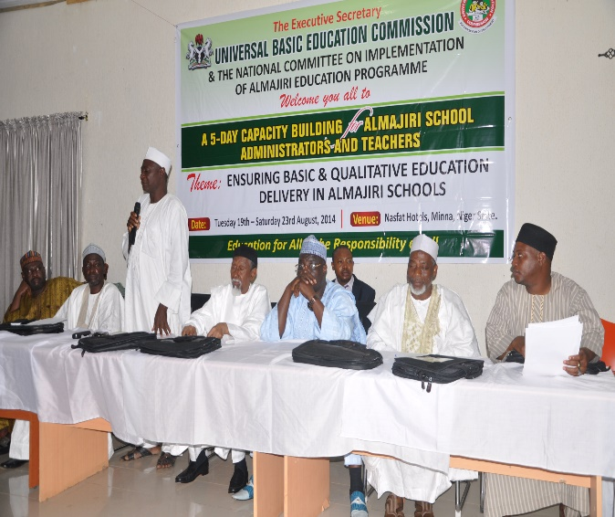 |  | 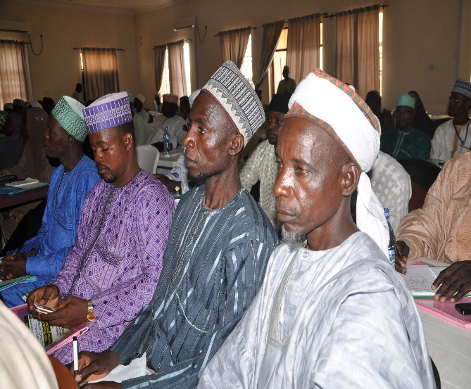
Members of the high table at the Capacity Building Workshop for Almajiri School Administrators and Teachers in Niger State. |  | A cross-section of Participants at the Capacity Building Workshop for Almajiri School Administrators and Teachers in Niger State.
- A Speech at the Taking Over of the Anambra State Office of UBEC in Awka; November 2014.
- An Address at the Orientation for the 4th Level Training of Trainers for the Establishment of School Based Management Committees (SBMCs); Kaduna; November 2014.
- An Address at the National Conference on Community Participation in School Governance; November 2014; Abuja.
- An Address at the Workshop on Harmonization of SBMC Intervention with Girls’ Education Project States; Kaduna; December 2014.
Apart from numerous National Conferences, Seminars and Workshops attended by the Chief Executive, below are some of his international engagements within the period covered by this report:
- Study Tour to China on Boy-Child (Out-of-School Children); March 2014.
- Tenth E-9 Ministerial Review Meeting, Islamabad, Pakistan; November 2014.
1.6 Merit Awards
It is worthy to mention some of the Merit Awards received by the Executive Secretary in the year 2014, which are directly linked with his performances in the delivery of basic education in Nigeria.
- Award of Excellence as Distinguished Personality of Inestimable Value in the Nigerian Education Sector by National Association of Niger-Delta Students;
- Patron, UNESCO Read and Learn Association;
- Award of Excellence in Recognition of Outstanding Contribution to the Development and Transformation of Basic Education in Nigeria by Education Correspondents Association of Nigeria (ECAN); and
- Award of Excellence by Institute of Policy Management and Development.
- Award of Excellence by Oduduwa Youth Association.

2.0 UNITS UNDER THE EXCUTIVE SECRETARY’S OFFICE
2.1.0 ALMAJIRI EDUCATION PROGRAMME UNIT
2.1.1 Introduction
In view of the importance of developing a comprehensive system of education that will cater for all Nigerian Children of school going age, the integration of Qur’anic schools into the UBE programme becomes imperative. This is in recognition of the UBE Act 2004 mandate given to UBEC to provide free, universal and compulsory basic education for a duration of 9 years to all categories of children in respective of their social, religious and physical status. The Act specifically mentions the Almajirai as a critical group of school-going age children whose inclusion in UBE Delivery is essential towards the attainment of EFA and MDGs goals.
In response to this, the Federal Government set up a Ministerial Committee on Madrasah Education on 16th February, 2010 to:
- develop policy guidelines for the establishment and implementation of the Madrasah Education programme in Nigeria;
- recommend best practices and other strategies to be adopted in integrating Madrasah Education into the UBE programme;
- evolve a credible plan for the development of Madrasah Education in Nigeria and provide leadership in driving the process;
- provide guidelines for effective partnership between critical stakeholders in Madrasah Education and;
- carry out any other activities that may be assigned to the Committee by the Minister from time to time.
This led Government to set up an implementation Committee for the integration of Almajiri Education into the Universal Basic Education (UBE) Programme after establishing that there were over 9 million Out-of-School Almajiris in the country. Subsequently, a unit was established under the Executive Secretary’s Office for the implementation of Almajiri Education.
2.1.2 Structure of the Unit
The Almajiri programme has a ministerial committee made up of erudite scholars and representatives of major stakeholders, who meet regularly to deliberate on activities that bordered on implementation of the programme, while the unit serves as secretariat of the Committee.
The Programme Coordinator supervises the day-to-day activities of SUBEBs with regards to Almajiri Education programme and reports to the Executive Secretary, through the Deputy Director, Executive Secretary’s Office.

2.1.4 Functions
The Unit is saddled with the following functions:
- Presenting decision/recommendations of the National Almajiri Committee to the Management for approval.
- Provision of Secretariat services to both National Almajiri Committee and its Sub-Committees.
- Implementing all decisions of the Universal Basic Education Commission Management on Almajiri Education Programme.
- Presenting decisions/recommendations of the National Almajiri Committee to the Management for approval.
- Provision of secretariat services to both National Almajiri Committee and its Sub-Committees.
- Implementing all decisions of the Universal Basic Education Commission Management on Almajiri Education Programme.
- Initiating and planning programmes for the implementation of Almajiri Education Programme.
- Coordinating the activities of SUBEBs related to the implementation of Almajiri Education Programme.
- Collecting, collating and reporting status of Almajiri Model Schools to the National Committee and the UBEC Management.

2.1.5 Achievements
The Unit achieved the following within the year under review:
- Production and distribution of additional instructional materials to Almajiri Model Schools across the Federation.
- Procurement of 2 Hilux vehicles for effective supervision and monitoring of Almajiri programmes.
- 84 schools located in 27 states and the FCT were selected and provided with grants under the Model III intervention for improving school infrastructure.
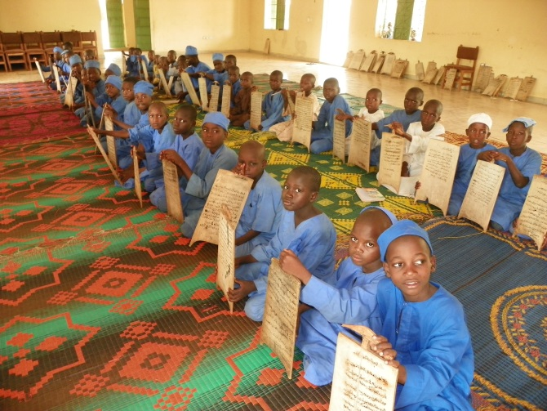 |  | 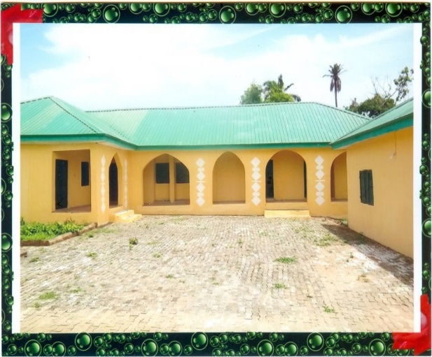
Almajiri pupils in Kebbi State |  | Completed Almajiri School in Oyo State

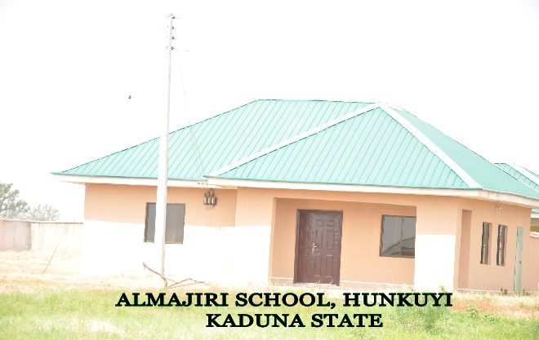
Completed Almajiri School in Kaduna State

- Training of SUBEB Almajiri Desk Officers on ensuring quality assurance in Almajiri Schools.
- Capacity building for teachers and proprietors of Almajiri Model Schools on how to set up SBMCs in their schools.
- In its 6oth meeting held in November, 2014, the NCE approved the change of the Almajiri to Tsangaya.
2.1.6 Future Plan
- Construction of more model Almajiri Education Programme Schools.
- Support/Intervention for the Islamiyya (Model III) Schools.
- Translation of Almajiri Textbooks at the lower basic education level from
Hausa to English in the following subjects: Basic Science, Mathematics and
Social Studies.
- Mass advocacy and sensitization of major stakeholders in all the Almajiri
participating states.
v. Evaluation of the programme.
vi. Research, Documentation and Publication of the Almajiri programme activities.
2.1.7 Challenges
- Inability of the states to implement the MoU on Almajiri Programme signed between the Federal Government and State Governments.
- Weak adoption and replication of the programme by the States.
- Poor commitment in the recruitment and deployment of teachers to these schools by the States.
- Non-inclusion of feeding as a retention strategy by the States and Local Governments.
- Inadequate mechanism for the enrolment of Almajirai into schools by States and Local Governments (e.g. adoption of Whole Tsangaya into the Model School).
- Non-integration of Alarammas/Mallams/Proprietors into the programme.
- Effective management and ensuring the sustainability of the schools.
- Poor maintenance of the infrastructural facilities.

2.1.8 Way Forward
In response to the growing concern for Nigeria’s ability to attain EFA, related MDG goals and address the out-of-school syndrome and other national aspirations, the Federal Government of Nigeria through UBEC adopted the integration of Almajiri pupils into the basic education system. There is, therefore, need for sustainable political will on the part of the Federal Government and, in particular, State Governments for the success of this programme. Adequate facilities should be provided in order to sustain the programme. The efforts of the Government at all levels should be complemented by communities, NGOs and well-meaning individuals with vigor.

2.2.0 INTERNAL AUDIT UNIT
2.2.1 Introduction
The Internal Audit as a managerial control unit functions by measuring and evaluating the effectiveness and efficiency of the internal control system of any organization.

The mandate of Internal Audit is enshrined in FR 1701 (ii) which states that “The Accounting Officer of a Ministry or extra-ministerial office and other arms of government shall ensure that an Internal Audit Unit is established to provide a complete and continuous audit of the accounts and records of revenue and expenditure, assets, allocated and un-allocated stores (where applicable) with a view to promoting transparency and accountability in the system.’’

To this end, the Internal Audit ensures compliance with Government Circulars, Financial Regulations, Management Circulars and other extant rules governing the organization.

2.2.2 Structure
- The Internal Audit Unit reports directly to the Executive Secretary and is currently being headed by a Deputy Director.
- The Head of Internal Audit Unit who is assisted by a Chief Internal Auditor oversees the day-to-day running of the Unit.
- The Internal Audit Unit liaises with Management through the Deputy Executive Secretary (Services) as it does not have representation on the Management Committee.

The Internal Audit Unit functionally relates with the Finance and Accounts Directorate on professional matters by working in close concert to ensure that the mandate of the Commission as stipulated by the provisions of the enabling act is realized.

2.2.3 Functions
- Reporting directly to the Accounting Officer for a detailed audit of the accounts and records of the organization and the examination of the system and procedures in force;
- Submitting to the Accounting Officer a detailed Audit Programme and thereafter, reporting to the Accounting Officer on the progress of the Audit;
- Pre-auditing of all payment vouchers before payments are effected;
- Ensuring compliance with Financial Regulations and other extant rules as they apply to the operations and activities of the organization;
- Issuing Special Reports (where necessary), if in the opinion of the Auditor, the attention of the Chief Executive and the Director of Finance and Accounts must be called to an apparent weakness in the accounting procedure, irregularity in the accounting procedure, or to any apparent in-attention to the reports of the Auditor-General, or to earlier internal audit report(s) issued by him;
- Verifying Assets and Liabilities of the organization in order to ensure that assets are safeguarded and liabilities are properly incurred;
- Vetting Staff Claims, Payrolls, Pension and gratuity payments;
- Monitoring Funds disbursed to State Universal Basic Education Boards in compliance with Section 9(b) of UBE Act, 2004;
- Monitoring the procurement, supply and delivery of instructional materials to States;
- Monitoring intervention projects in Teacher Professional Development, Almajiri, Good Performance, Library, Junior Girl-Child and Boy-Child Education Projects in the States;
- Monitoring capital projects embarked upon by States using the Matching Grant funds and;
- Performing any other function(s) as may be directed from time to time by the Executive Secretary.

2.2.4 Staff Disposition
During the year under review, the Internal Audit Unit had a total of Fifteen (15) Staff at both the Headquarters and Zonal Offices as follows:

S/N | Rank | CONRAISS | Number
1 | Deputy Director | 14 | 1
2 | Chief Internal Auditor | 12 | 1
3 | Principal Internal Auditors | 10 | 2
4 | Senior Internal Auditors | 09 | 4
5 | Auditor 1 | 08 | 1
 | Auditors II | 07 | 4
 | Secretary | 06 | 1
 | NYSC | - | 1
 | TOTAL |  | 15

2.2.5 Activities and achievements
S/N | ACTIVITIES | ACHIEVEMENTS | % PERFORMANCE | REMARKS
1 | Submission of Status Audit Report on 2012 Almajiri, Library and Junior Girls Model construction projects | This was carried out and report submitted to Management in February, 2014 | 100% | Accomplished
2 | Collation, Production of 2012 Audit Review of UBEC Accounts and Operations | Draft copy ready since December, 2014 | 95% | Above average
3 | Development and Production of Audit Manual | NIL | 0% | Lack of adequate budgetary provision. Process yet to commence.
4 | Review of Year 2013 Audit Review of UBEC Accounts and Operations | This has been achieved awaiting the production of Draft copy of the Report | 80% | Work in Progress
5 | Compliance Audit on utilization of Year 2011-2013 Teacher Professional Development Funds disbursed to States | Great achievement.  Report was submitted to Management in August, 2014 with concrete recommendations | 100% | Task accomplished
6 | Training Workshop for UBEC and SUBEB Auditors | NIL | 0% | Lack of budgetary provision
7 | Quarterly Review of Year 2014 UBEC Accounts and Operations | This was done in 1st Quarter 2014. | 25% | Work in Progress
8 | Final Phase Development and Production of Audit Manual | NIL | 0% | Lack of adequate budgetary provision
9 | Audit Monitoring of UBEC Zonal, SUB-Zonal and State offices | NIL | 0% | Lack of budgetary provision
10 | Status Audit of Year 2013 Almajiri, Library, Constituency and Junior Girls Model Schools projects | Only the Status Audit of 2013 Junior Model Girls projects was approved and only conducted in February, 2015 | 25% | Lack of budgetary provision.  Budget of N7.5million was reduced to N2.75million by the Budget Committee.
11 | End-of-year Stock taking of UBEC Central Stores | This was achieved | 100% | Task accomplished
12 | Financial Monitoring of FGN/UBEC Intervention funds in the States and FCT | Only 20th and 21st Financial Monitoring were carried out instead of 20th, 21st, 22nd and 23rd. | 50% | Partly accomplished

2.2.6 Other Achievements
- Monitoring of supply and delivery of instructional materials in the States
- Verification of supply and delivery of Almajiri, Library and Junior Girls Model Furniture and Equipment in benefitting Schools.
- Submission of Status Audit Report of Junior Girls Model Projects to Management.

2.2.7 Constraints
- Inadequate allocation of funds to execute Annual Audit Programmes.
- Lack of effective synergy between Finance and Accounts Directorate and Internal Audit Unit.
- Lack of a Zonal Auditor in UBEC North-East Zonal Office (Bauchi).

2.2.8 Ongoing activities
- Submission of clean copy of Audit Report of Year 2012 UBEC Accounts and Operations
- Submission of Draft and Clean Copy of Year 2013 Audit Report to Management.

2.2.9 Future activities
- Audit Review of Year 2014 UBEC Accounts and Operations;
- Quarterly Review of Year 2015 UBEC Accounts and Operations;
- Quarterly Financial monitoring of FGN/UBEC Intervention funds in States and FCT;
- Periodic monitoring of Almajiri, Junior Girls Model, Construction and Rehabilitation projects nationwide;
- Verification of Supply and Delivery of Furniture and Equipment to Almajiri, Library and Junior Girls Model Schools;
- Training of UBEC and SUBEB Auditors;
- Performance Audit of 2013 Constituency and Intervention projects;
- Compliance Audit of Year 2011-2013 Special Education Projects nationwide;
- Audit monitoring of UBEC Zonal/sub-Zonal and State offices.

2.3.0 FEDERAL TEACHERS’ SCHEME UNIT
2.3.1 Introduction
The Federal Government established the Federal Teachers’ Scheme in 2006 as a strategy for addressing the shortage of teachers at basic education level. The goal is to improve the quality of education delivery through supply of qualified teachers.
The scheme enlists holders of the Nigeria Certificate in Education (NCE), which is the prescribed minimum teaching qualification in Nigeria, for a two-year voluntary teaching service in public basic education schools. During the service period, the Federal Government pays the participants a monthly allowance.
The scheme is funded by the Federal Government from the Debt Relief Gains and implemented under the Millennium Development Goals projects.
To date, a total of 105,000 teachers have served under the scheme across the country. Another 15,000 teachers are currently in service.
Thirty-five States and the Federal Capital Territory participated in the scheme in 2014. Only Lagos State did not participate.

2.3.2 Objectives
The following are some of the objectives of the scheme:
i. assisting States to reduce shortage of teacher requirement for the success of the UBE programme;
ii. exposing young NCE graduates to full practical experience in their chosen career;
iii. ensuring quality education delivery in basic education;
iv. providing employment to NCE graduates and invariably reducing poverty.
2.3.3 Structure
The implementation of the Federal Teachers’ Scheme is coordinated by a Unit in the Office of the Executive Secretary and is headed by a National Coordinator. The other members of staff in the Unit are deployed from other Departments in the Commission.
The scheme is implemented using the existing UBEC structure (Headquarters, Zonal and State Offices). Since the scheme is implemented at the State level, the Commission works closely with the State Universal Basic Education Boards to ensure effective coordination and smooth implementation. Each State Universal Basic Education Board has a designated FTS Desk Officer who oversees the day-to-day implementation of the scheme.

2.3.4 Functions
Among others, the Federal Teachers’ Scheme Unit is responsible for the following:
i. coordinating the selection process of enlistment of candidates into the Scheme;
ii. deployment of selected teachers to States;
iii. maintenance of accurate database on the scheme;
iv. monitoring the performance of serving teachers and generating reports for Management consideration;
v. preparation of monthly list of eligible participants for payment;
vi. coordinating other activities relating to the scheme such as induction/orientation training, capacity building and physical verification of serving teachers; and
vii. liaising with the State Universal Basic Education Boards on matters affecting the implementation of the scheme.

2.3.5 Staff Disposition

S/N | Rank | CONRAISS | Number
1 | National Coordinator | 14 | 1
2 | Deputy Director | 14 | 1
3 | Prin. Quality Assurance Officer | 10 | 1
4 | Prin. Asst. Quality Assurance Officer | 10 | 1
5 | Senior Quality Assurance officer | 09 | 1
6 | Quality Assurance Officer 1 | 08 | 1
7 | Administrative Officer 1 | 08 | 1
8 | Chief Data Processing Assistant | 06 | 1
 | Total |  | 8

2.3.6 Activities
The Unit performed the following activities during the year under review:
1. Verification of the selected participants’ certificates.
2. Resolution of complaints relating to non-receipt of allowances by participants.
3. Held a meeting of FTS Unit and State FTS Desk Officers.
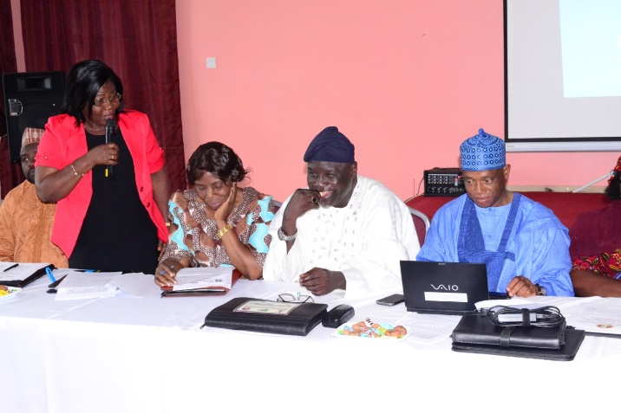 | 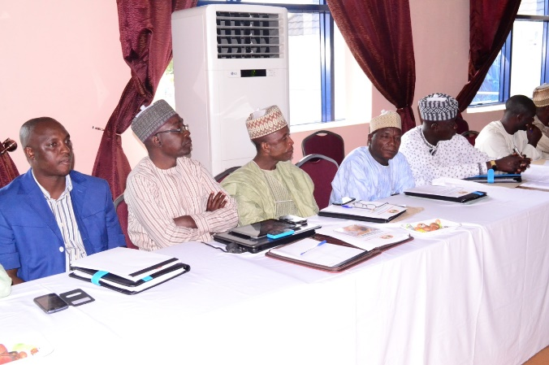
The Representative Of The Special Assistant to the President On MDGs, Dr Ivy (2nd left) delivering an address at the meeting. | A cross-section of participants at the meeting
4. Collation and vetting of monthly list of participants eligible for payment from the States.
5. Review, production and distribution of FTS Information Booklet for participants.
6. Concluded preparations for a nationwide verification exercise due to commence early in 2015.

2.3.7 Achievements
A total of 120,000 teachers (including the serving 15,000) have so far participated in the scheme across the country. A major area of impact of the scheme is the attention the schools in rural areas are receiving with respect to teacher supply. Seventy percent (70%) of the FTS participants in each State were posted to schools in rural areas.
The selection process which commenced in 2013 was successfully concluded in 2014. States’ participation in the process was increased by giving each participating State the opportunity to select the 400 teachers allotted to it from a list of the top 600 performers (with scores of 50% and above) in the screening test in each State.
Some innovations were also introduced in the management of the scheme in 2014, which were intended to promote inclusiveness and quality at basic education level. These innovations included the following:
- 200 NCE teachers, specially trained under the Skills Training and Vocational Education Project (STVEP) programme with support from African Development Fund, were absorbed into FTS and deployed to nomadic schools in 28 States;
- 116 NCE teachers were enlisted and posted to 58 functional Models I and III Almajiri Schools in 21 States to teach basic education subjects in fulfillment of promoting the concept of integrating basic education into Qur’anic education; and
- 38 qualified NCE teachers with different forms of physical challenge, who expressed interest in teaching, were given automatic enlistment into FTS to promote the concept that disability is not a disadvantage and to promote dignity of labour among the physically challenged.

2.3.8 Constraints
The main challenge the scheme faced in 2014 was the delay in the release of funds. These affected the scheme in the following ways:
- the Commission could not pay participants until June 2014 when adequate funds were released to cover the January – June allowances;
- the participants did not receive their allowances for October, November and December, 2014, due to non-release of the 4th Quarter allocation.

2.3.9 Future Activities
The major activities of the Unit in 2015 will include the following:
- Verification of FTS participants across the country to identify those who are demonstrating commitment and dedication through regular attendance and exhibition of satisfactory conduct.
- Coordination and conduct of the Screening and Section of participants for the 2015-2017 service periods.
- Continuous updating of FTS data to promote accountability.

2.4.0 PROCUREMENT UNIT
2.4.1 Introduction
Procurement is a service Unit under the Office of the Executive Secretary. Its primary functions and responsibilities are to conduct the process for procurement of goods, works and services. The activities in the process are listed below:
- Preparing needs analysis.
- Preparing procurement plans.
- Advertising/Soliciting for Tenders or proposals.
- Conducting market surveys.
- Evaluating proposals.
- Recommending award to Tenders Board.
- Monitoring procurement performance.
- Advising the Executive Secretary on issues of procurement.
- Any other duty that may be assigned by the Executive Secretary or the Tenders Board.

2.4.2 Structure.
The Unit is headed by the Head of Procurement, who is supervised by the Special Assistant to the Executive Secretary.
The Head of Procurement is assisted by four other Procurement Officers who undertake activities relating to Goods, Works and Services. The officers all report to the Head of Procurement Unit.

2.4.3 Staff disposition.
S/N | Rank | CONRAISS | Number
1 | Assistant Director | 13 | 1
2 | Assistant Chief Procurement Officer | 11 | 1
3 | Principal Procurement Officer | 10 | 2
4 | Procurement Officer II | 07 | 1
5 | Clerical Officer | 03 | 1
 |  | Total | 6

2.4.4 Achievements.
For the period under review, the Unit recorded some major achievements in the areas of procurement of goods, works and services. The activities which were successfully concluded and ongoing are listed below:
2.4.4.1 Completed activities.
- Procurement of various furniture and equipment for the Commission’s headquarters, State and Zonal Offices.
- Procurement of various sizes of tyres for vehicles in the Commission, State and Zonal Offices.
- Procurement of two nos. Hilux for Almajiri Units for Monitoring of Projects.
- Supply of Instructional Materials for JSS to Unity Schools nationwide.
- Supply of various Science and Vocational Equipment to Unity Schools nationwide.
- Supply of 49,950 Notebooks and Pencils to Almajiri schools nationwide.
- Procurement of 4.9m copies of Social Studies, Basic Science, Mathematics and English Language Textbooks for JSS nationwide.

2.4.5 Ongoing activities.
- Construction of various Blocks of Classrooms, ICT Centres, Procurement of Hilux Vehicles, Generator and Motorcycles under the 2014 Constituency projects in some states of the federation.
- Construction of various blocks of Classrooms, Offices and V.I.P Toilets, Renovation of blocks of Classrooms in various LGAs in selected states of the Federation under the Intervention projects.
- Construction of 52 Junior Girls Model Secondary Schools in selected states of the country.
- Procurement of Computers and Accessories and Installation for Almajiri schools in Kaduna and Bauchi states.
- Construction of 28 Almajiri Models I schools.
- Furnishing of 52 Junior Girls Model Secondary Schools.
- Construction of four additional vocational schools in Abia, Bayelsa, Rivers and Ebonyi states.

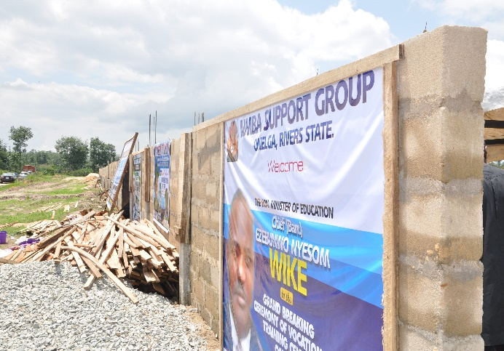 |  | 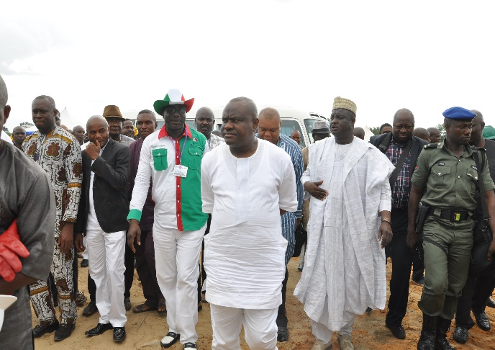
Construction of Vocational School  in Rivers underway. |  | The Supervising Minister of Education, Barr. Ezenwo Nyesom Wike, leading a team of dignitaries to carry out the ground-breaking ceremony
2.4.6 Payment status.
Payments for all completed projects have been made. For ongoing projects, payments are made based on delivery and terms of payment. There are no payment constraints.

2.4.7 Challenges.
The Unit is faced with the challenges of lack of store space for keeping our documents and office space for staff.
2.4.8 Future activities.
All procurement related activities in the future will be undertaken as they become due.
2.4.9 Conclusion.
The Unit has reaffirmed its commitment to ensuring that all procurement activities are carried out in compliance with the 2007 Procurement Act and that quality goods, works and services are procured and delivered on time.

2.5.0 LEGAL UNIT
2.5.1 Introduction:
The Legal Unit is mandated to interpret laws and instruments entered into/ executed by the Commission and, in the event of any litigation, represent the Commission in courts through external solicitors.
2.5.2 Structure
The unit is headed by a Legal Adviser who is assisted by 3 other Legal Officers.
2.5.3 Staff disposition
S/N | Rank | CONRAISS | Number
1 | Principal Legal Adviser | 10 | 1
2 | Senior Legal Adviser | 09 | 2
3 | Legal Adviser I | 08 | 1
 |  | Total | 4

2.5.4 Functions
The Unit’s principal functions are:
- Proffering legal advice to the Commission;
- Liaising with appropriate departments and consultant(s) on contract/project matters; and
- Drafting and executing legal instruments.
However, with the impact of the Commission’s activities being felt nationwide, the Unit’s role has widened to include:
- Proffering legal advice to the State Universal Basic Education Boards whenever the need arises;
- Liaising with Banks on the confirmation of Contractors Advance Payment Guarantees;
- Alternative resolution of dispute and other controversies without resorting to litigation; and
- Compilation & computation of Insurance premiums of the Commission’s assets.

2.5.5 Accomplished Activities.
a. Cases
In the year 2014, the Commission had 6 cases pending in various courts viz;
- Abdulsalam Suleiman vs. Universal Basic Education Commission & 1or
( Appeal);
ii. Registered Trustee Of African Initiative For Education Development vs. Universal Basic Education Commission (civil);
iii. Friday Okereke Alagi vs. Universal Basic Education Commission (Appeal);
iv. Deljatt Services Ltd vs. UBEC;
v. Public & Private Development Centre/GTE vs. UBEC &1or; and
vi. Abuja Environmental Protection Board vs. UBEC.

b. Legal documentation/instruments
i. Documentation of contracts for construction of Junior Girls Model Schools Phase III and supply of furniture to those schools;
ii. Documentation of contracts for construction of Almajiri Schools, expansion of some already existing schools and supply of furniture in various States of the Federation;
iii. Documentation of contracts for construction of Special Intervention/construction and rehabilitation of dilapidated schools and supply of furniture to those schools;
- Documentation of 2014 constituency projects.

c. Insurance
The Unit compiled the Commission’s assets for the 2014/2015 insurance year. Based on this list of assets, the Commission insured its assets through Brokers for a period of 1 year.
2.5.6 Achievements
- Successfully perfected legal instruments for:

- 2014 Constituency projects;
- Construction of additional Junior Girls Model Schools Phase III;
- Construction of additional and expansion of existing Almajiri Schools,
- Construction, renovation/rehabilitation and supply of furniture and equipment under the Special Intervention Scheme; and
- Supply of Science and Technical Equipment to Federal Unity and Technical Colleges;

- Successfully averted court action resulting from allegations of fraud leveled against a contractor by Divine Links Integrated Ltd;

- Designed a databank of all contracts showing the State, Contractor and exact location of projects.

2.5.7 Constraints
- Delay in information dissemination. Staff of the Unit have to follow up Departments for any additional information required on Action files. This usually takes time which delays prompt output of work.
- The working equipment are not adequate. There is need for additional table top computer and accessories to complement what we already have.

2.5.8 Ongoing activities
- Documenting and perfecting instruments entered into between UBEC and Contractors;
- Liaising with the Commission’s external solicitors on cases involving UBEC; and
- Conciliation Meetings with some non-governmental/civil organizations which have threatened Court action on ways to resolve issues without recourse to the courts.

2.5.9 Future activities
- Advise to the Commission and the SUBEBs (when the need arises) on legal matters;
- Documentation of all contracts entered into by the Commission;
- Amicable dispute resolution between Contractors and the Commission;
- Attending Court sittings to watch briefs on behalf of the Commission; and
- Regular meetings with dissatisfied contractors on ways to settle cases without recourse to the Courts.

2.6.0 PUBLIC RELATIONS AND PROTOCOL UNIT

2.6.1 Introduction
The Public Relations and Protocol Unit is responsible for making UBEC a household name that Nigerians can identify with and relate to through deliberate carriage of information on the activities of the Commission.

2.6.2 Structure
The Unit is headed by an Assistant Chief Public Relations Officer (ACPRO) who reports directly to the Executive Secretary.
He, however, works closely with other Heads of Department and other relevant officers in performing the functions of the Unit.

2.6.3 Functions
The Unit:
- Has the responsibility of managing the image of the Commission.
- Maintains good relationship with the public to achieve set goals and objectives of the Commission.
- Mediates between the Commission and the public.
- Sustains and maintains information about the Commission.
- Produces Newsletters and writes press releases on the activities of the Commission.
- Plans hitch free flight for both local and international travels.
- Facilitates hotel reservations and transport arrangements for resource persons and official guests of the Commission.
- Shows hospitality to various guests of the Commission.
- Serves as advance team during advocacy/official visits to states.
- Monitors news stories, documentaries and feature articles of the Commission in newspapers.
- Anchors briefings, meetings and courtesy calls to the Commission.

2.6.4 Staff disposition

S/N | RANK | CONRAISS | NUMBER
1 | ACPRO | 11 | 1
2 | Principal Protocol Officer | 10 | 1
3 | Information Officer II | 07 | 2
4 | Protocol Officer II | 07 | 1
5 | Exe. Officer (Protocol) | 06 | 1
6 | Camera Man | 05 | 1
 |  | Total | 7

2.6.5 Activities
- Constant Monitoring of UBEC activities in both print and electronic media.
- Interaction with the media, especially the Education Correspondents on how best to improve the image of the Commission.
- Placement of UBEC Adverts on TV and Radio Stations.
- Media Coverage of UBEC activities.
- Production and Printing of Videos and Pictures of UBEC activities.
- Reservation and Booking of Hotels for UBEC Guests at programmes to be hosted by the Commission.
- Processing, renewing and obtaining International Passports and Visas.
- Distribution of souvenirs and co-ordination of programmes/activities.
- Buying of Newspapers for the Executive Secretary.

2.6.6 Activities
The unit recorded a number of achievements in the year under review as indicated below:

The Commission’s activities were adequately covered in both print and electronic media, especially FRCN, NTA, AIT, Channels television, the Punch, the Guardian, This day and Daily Trust.
- Provided media coverage for the UBEC/SUBEB quarterly meetings in Osun, Imo and Zamfara States.
- Documented the ground-breaking ceremonies of the Special Vocational Schools in Anambra, Akwa Ibom State and Delta States.
- Covered and aired the Commissioning of Girl Child Junior Secondary School in Ebonyi State.
- Successfully covered and aired the handing over of report by the Committee on Almajiri Implementation and inspection of Almajiri School in Katsina.
- Hosted a Capacity Building Training Workshop for all 36 SUBEBs and FCT PROs in Abuja with the aim of harmonizing the duties of all PROs/information officers in line with UBEC mandate.

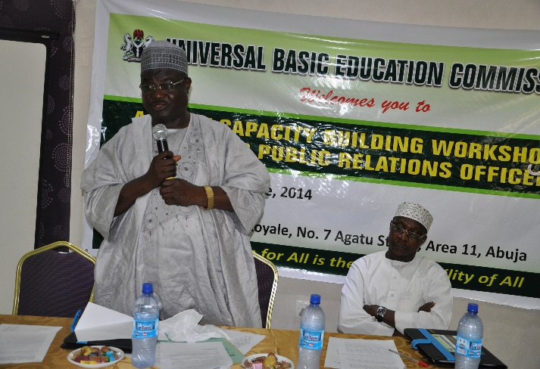 | 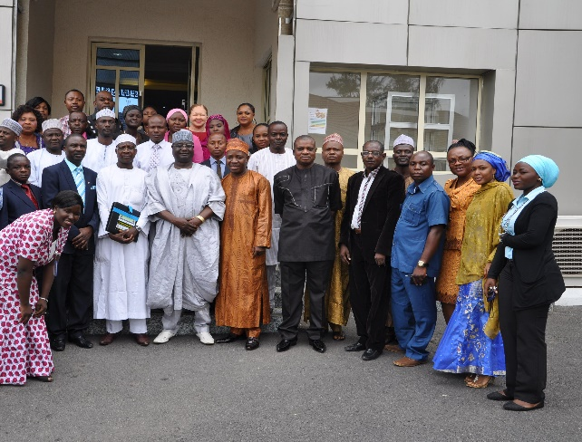
Dr. Yakubu Gambo, Deputy Executive Secretary (Services) (left), declaring open the Capacity Building Training Workshop for all 36 SUBEBs and FCT PROs in Abuja | Group photograph of PROs in attendance at the workshop.
The unit was able to achieve the following under Protocol:
- Arranged many hitch-free local and international official trips for management and other UBEC staff.
- Adequate hotel bookings and transport arrangements were made for Resource Persons and guests of the Commission.
- Successfully processed international passports and secured visas for many staff of the Commission.
- Successfully hosted and entertained NGOs and IDPs in the Commission.

2.6.7 Ongoing activities
- Collating of materials for future documentaries on NTA, AIT and Channels Networks.
- Production of Booklets on the Transformation Agenda of the President in the Basic Education Sub-sector.

2.6.8 Future activities
- Organizing regular trainings and interactions between UBEC and SUBEBs, PROs, Protocols, Information officers.
- Process, renew and obtain international passports for various staff of the Commission.
- Purchase of souvenirs.
- Documentaries on the Commission’s programmes.
- Purchase more laptops and i-pads for all officers in the Unit.
- There is the need for more, on-the–job training for the Unit Staff.

2.6.9 Constraints
Some SUBEB PROs are not well grounded on the activities/relationship between the Commission and their Board.

2.7.0 SPECIAL PROJECTS UNIT
2.7.1 Introduction
The Special Projects Unit is under the Office of the Executive Secretary. It is the main entry point and clearing house of all International Development Partners and Donor Agencies in the basic education sub-sector.
2.7.2 Mission
The mission of the Unit is to be a key facilitator in the delivery of basic education in Nigeria through collaborations with International Development Partners.
2.7.3 Structure of the unit
The Unit is headed by an Assistant Director/Coordinator, Special Projects who works under and reports directly to the Executive Secretary. He, however, works closely with the Heads of Departments and their relevant technical officers in performing the functions of the unit. He is assisted by an Assistant Project Coordinator and some project staff.
2.7.4 Functions of the unit
The main functions of the unit are:-
- coordinating the implementation of the UBE activities in collaboration with multilateral and bilateral agencies, and
- liaising with Donor Agencies, Non-governmental Organizations and other Development Partners on support for basic education in Nigeria. These are in keeping with the provision of UBE Act, 2004, Part II, Sections (j) and (r)
- Other functions of the Unit include to:
  - coordinate the implementation of all Development Partners’ support
activities in the improvement of basic education in Nigeria.
  - coordinate and provide support to State technical officers to facilitate the achievement of project targets.
  - initiate new projects or support areas for collaboration with International Development Partners.
  - arrange, coordinate and facilitate High Level Donor Coordination meeting in the area of basic education.

2.7.5 Staff disposition
S/N | Rank | CONRAISS | Number
1 | Project Coordinator | 13 | 1
2 | Prin. Confidential Sec. | 09 | 1
3 | Project Officer | 07 | 1
 |  | TOTAL | 3

2.7.6 International Development Partners and their support activities.
The major International Development Partners collaborating with the Universal Basic Education Commission and providing support for the development of basic education in Nigeria are:

- Japan International Cooperation Agency (JICA).
JICA supported the provision of additional classrooms through its Project for the Construction of Additional Classrooms in Niger, Plateau, Kaduna and Kano States and is currently working in Oyo State. The Agency also builds the capacity of primary school teachers under the project for the Strengthening of Mathematics and Science Education (SMASE) and provides managerial training for policy makers and managers of education in the country.

- Korea International Cooperation Agency (KOICA).
This Agency supports the provision of additional classrooms and building of new schools. It also develops the capacity of management staff, teachers and administrators of primary schools. It has operated in Kogi, Katsina, Adamawa and Gombe States and is currently working in the FCT. KOICA is also supporting the provision of ICT equipment in Gombe and Adamawa States. Many educational policy makers, managers, administrators and teachers were trained in various aspects of educational concern in Seoul, South Korea. There is ongoing plan to train additional policy makers, project managers and school teachers under the FCT project for the construction of model primary and secondary schools.

- The World Bank:
- The World Bank supports the State Education Programme Investment Project (SEPIP) in Nigeria. This is an innovation project being piloted in three States: Anambra, Bauchi and Ekiti States. Under this project, States’ funds are disbursed to the States after they achieved and accomplished some pre-determined performance/disbursement indicators called Disbursement Linked Indicators (DLIs). Thus, this is a result-based project. Therefore, the institutional arrangement for the SEPIP designated UBEC as a Technical Assistance provider to the beneficiary States. UBEC is also the main Monitoring & Evaluation outfit for the project.

- Also, under the World Bank supervision, the Global Partnership for Education (GPE) is supporting a GPE project which aims at assisting Nigeria to achieve EFA goals through increased access and improved quality to basic education for the girl-child in particular. The GPE Project has now been approved and is at take-off stage. It is being implemented in five states: Katsina, Kano, Kaduna, Jigawa and Sokoto states.

- UNICEF
UNICEF recently met with UBEC for collaboration in Islamiyya and Qur’anic Education. There are however, patches of support in other departments by UNICEF especially Social Mobilization and Academic Services Departments.
2.7.7 Achievements
The achievements of the Unit in the year under review are:
- Completed local level training for 7,600 Maths and Science teachers in Niger, Plateau and Kaduna States under the JICA supported project for the Strengthening of Maths and Science Education (SMASE).
- Coordinated the successful completion of National INSET for the 12 SMASE Non-pilot States and FCT in collaboration with JICA and NTI.
- Coordinated and carried out sensitization visits to all 33 SMASE non-pilot States in collaboration with FME and NTI.
- Participated in follow-up technical discussions on the 2015 JICA support programmes/projects for the construction of additional classrooms in Oyo State which led to the signing of the main project Agreement in September 2014. Currently, the Agent Agreement has been signed and the Government of Japan has already deposited the funds totalling Y1, 277,000,000 Japanese yen which is about N1.8b into the project account domiciled in Tokyo Japan. Construction work is scheduled to commence in March, 2015.
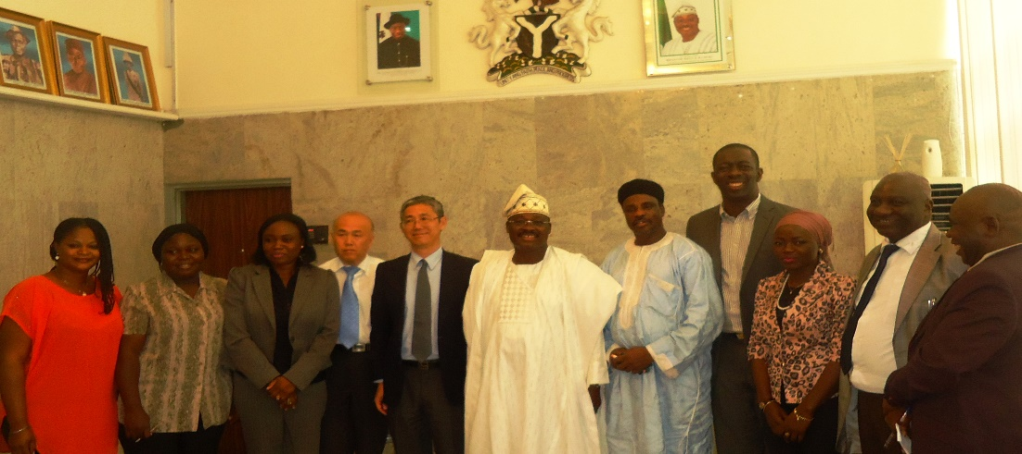
UBEC’s Special Project Coordinator, Alh. Umar Iro with Specialists from JICA during courtesy visit to Governor Ajibola Ajimobi during the Final Implementation Mission to Oyo State.

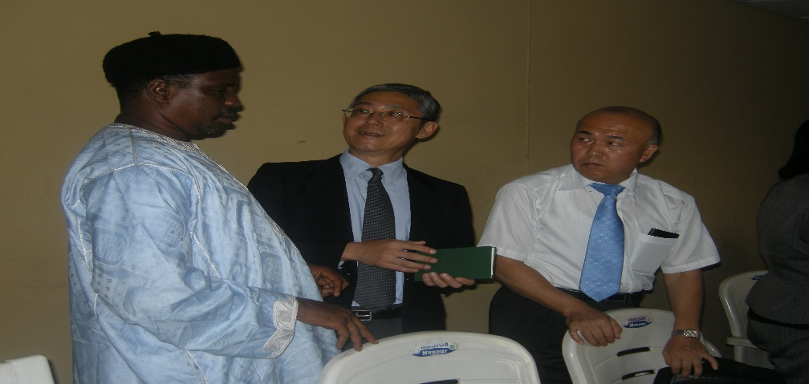
UBEC’s Special Project Coordinator Alh. Umar Iro with Specialists from
JICA at the Final Implementation Mission to Oyo State.
- Coordinated and participated in KOICA missions on the construction of a Comprehensive Model School which comprises kindergarten, primary, Junior Secondary Schools in FCT. Project Agreement has been signed while project consultant will soon be engaged.
- Coordinated the appraisal mission activities and final approvals for the take-off of the World Bank supported State Education Programme Investment Project (SEPIP) for Anambra, Bauchi and Ekiti States including project effectiveness in April, 2013.
- Coordinated the take-off activities of Global Partnership for Education in collaboration with FME, the World Bank, USAID, JICA and other IDPs. The project is operating in 5 States of Kaduna, Jigawa, Sokoto, Katsina and Kano.
- Facilitated discussion on collaboration with UNICEF on Qur’anic and Tsangaya Islamic Education.
- Secured Training for one UBEC staff on Improvement of Teaching Methodology in Primary Science and Mathematics for sub-Saharan Africa in Japan.

2.7.8 Constraints
- Difficulty in reaching out to Islamic Development Bank on project follow-up discussion.
- Limited avenues and poor mobility logistics in reaching IDPs for collaboration dialogue that may lead to proposal writing.

2.7.9 Future activities
- Establishing more linkages with related Ministries and Departments such as FME, NPC, FMF, Immigration, Customs, Nigeria Ports Authority, etc, for smooth coordination and implementation of IDPs supported Programmes and Projects.
- Opening up dialogue with other IDPs such as USAID, Canadian International Cooperation Agency (CIDA) and the Emirate International Cooperation Agency.
- Discussion and dialogue with Multi-national Corporations such as Samsung, LG and Microsoft Corporation for areas of collaboration in basic education.
- Regular meetings with IDPs on collaboration in the basic education sub- sector.
3.0 DEPARTMENT OF ACADEMIC SERVICES

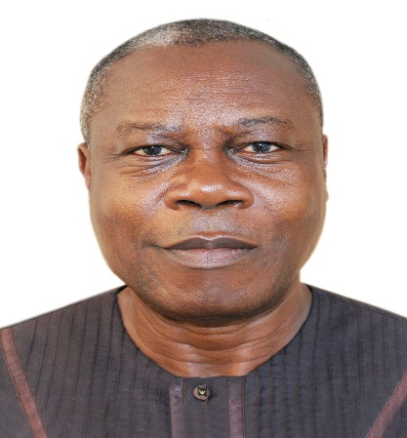 | 3.1 Introduction  The Department of Academic Services is vested with the responsibility of coordinating Curriculum Development, provision of Instructional Materials, Library Development, Guidance/Counseling, Sports/Quiz Activities, other co-curricular activities and Teacher Professional Development in the Commission.  3.2 Functions  The Department performs the following functions:  - Coordinating and drawing up of guidelines on the utilization of the Federal Government Intervention Funds by States in the provision of instructional materials and teacher professional development;
Pius O. Osaghae.
Director, Department of Academic Services
Mr. Pius Osaghae was born on 31st August, 1956. He graduated with Bachelor of Education in 1980 and a Master’s degree in 1982 from University of Jos. He began his career as Assistant Lecturer I at the College of Education, Gindiri, where he rose to the rank of Senior Lecturer.
He proceeded to the erstwhile National Primary Education Commission (NPEC) in 1990. He served as Zonal Coordinator, Bauchi Zone (Bauchi, Plateau and Yobe States) and later as Desk Officer, North-West Region. The Director served in the then Special Programme Unit of the Federal Ministry of Education after which he joined the Universal Basic Education Commission in 2004 and served in Department of Teacher Training and Curriculum Development. He later served as Zonal Coordinator, South-South, Deputy Director, Quality Assurance in 2003 from where he was deployed to Department of Academic Services in 2009. He is a member of the Science Teachers Association of Nigeria (STAN) and presently the Director in charge of the Department of Academic Services.

- Stimulating the provision and coordination of functional libraries and classroom collections for all UBE target groups for the enhancement of learning-to-learn skills and a reading habit for life-long literacy;
- Stimulating and sensitizing the States to their responsibilities in the provision of quality Early Childhood Care Development and Education {ECCDE}; and
- Promoting physical education activities, Guidance and Counseling services and sports/quiz activities in schools and other co-curricular activities;
- Serving as desk for JCCE/NCE.

3.3 Structure
The Department comprises of three Units as follows:
- Academic Planning
- Education Support Services and
- Teacher Professional Development

3.4 Staff Disposition
The Department had twenty One (21) staff in the period under review as follows.

Personnel
S/N | DESIGNATION | CONRAISS | NUMBER
1. | Director | 15 | 1
2. | Assistant Director | 13 | 1
3. | Chief Academic Planning Officer (CAPO). | 12 | 1
4. | Assistant Chief Academic Planning Officer (ACAPO). | 11 | 1
5. | Principal Academic Planning Officer (PAPO). | 10 | 4
6. | Senior Academic Planning Officer (SAPO). | 09 | 2
7. | Academic Planning Officer (APO) 1. | 08 | 2
8. | Librarian 1 | 08 | 1
9. | Academic Planning Officer (APO) 11. | 07 | 3
10. | Higher Assistant Academic Planning officer (HAAPO). | 07 | 2
11. | Confidential Secretary | 06 | 1
12. | Chief Data Processing Assistant | 06 | 1
13. | Driver | 05 | 1
 | TOTAL | - | 21

3.5 Academic Planning Unit
The Unit has the following sections:
- Curriculum (ECCDE, Primary and JSS).
- Instructional Materials.
- JCCE/NCE.

3.5.1 The Functions of the Academic Planning Unit are:
- coordinates academic activities at all levels of Basic Education i.e. ECCDE, Primary and Junior Secondary Education;
- prescribes standards for curriculum development and implementation in the UBE Programme;
- liaises with relevant agencies and parastatals in developing and reviewing ECCDE, primary and junior secondary curricula in accordance with the UBE Act 2004;
- supports States to ensure that every learner has adequate access to good quality textbooks and other instructional materials to facilitate effective learning;
- liaises with SUBEBs and assists them in the development and training for effective use of instructional materials and the implementation of ECCDE; and
- coordinates the effective participation of the Commission at JCCE and NCE meetings.

3.5.2 Achievements of the Academic Planning Unit
The following are the achievements recorded by the Academic Planning Unit:
- Facilitated the procurement and distribution of 4,961,469 copies of JSS textbooks in three core subjects of Mathematics, English Language and Social Studies. The books have impacted positively on the teaching and learning in Primary and Junior Secondary Schools across the States. The performance indicator is attached as an Appendix to this report.
- Monitored the distribution and utilization of 2013 basic education instructional materials supplied to primary schools nationwide. The performance indicator is shown in tables, 5.2.1, 5.2.2, 5.2.3, 5.2.4 and 5.2.5.
- Monitored the distribution and utilization of 4,961,469 copies of textbooks in three core subjects of Mathematics, English language and Social Studies which were made available in JSS schools nationwide.
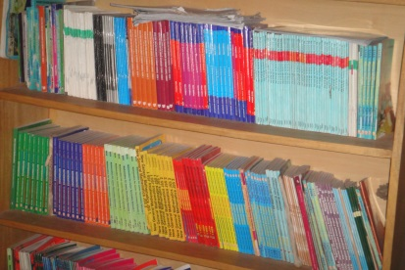 |  | 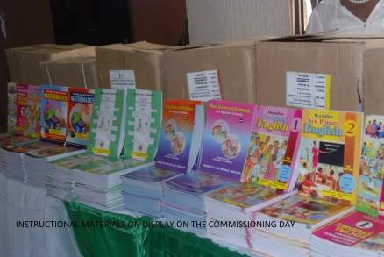
Books supplied to Oyo State |  | Books displayed in Kaduna State on Commissioning Day

- Conducted Advocacy Visits in collaboration with UNICEF to fast track the implementation of Community Based Early Childhood Care (CBECCE) in 13 focus States namely: Ebonyi, Bauchi, Benue, Gombe, Katsina, Kebbi, Lagos, Niger, Oyo, Sokoto, Taraba and Zamfara and the FCT.
- Conducted Baseline Survey in five communities in each of the 13 focus States mentioned above.
- Generated data for the establishment of CBECCE Centres and focus Intervention by UNICEF in 13 States and FCT.
- Assessed External Monitors’ report on the delivery and distribution of 2013 Basic Education Instructional Materials.
- Participated in the Joint Consultative Committee (JCCE) and the National Council on Education (NCE) Meetings.

Table 5.2.1: PUPIL –SOCIAL STUDIES TEXTBOOK RATIO AS VERIFIED IN 2013 SAMPLED SCHOOLS
STATE | PRY 1 | PRY 2 | PRY 3 | PRY 4 | PRY 5 | PRY 6 | Remark
ABIA
ADAMAWA
AKWA IBOM
ANAMBRA
BAUCHI
BAYELSA
BENUE
BORNO
CROSS RIVER
DELTA
EBONYI
EDO
EKITI
ENUGU
GOMBE |  |  | -
IMO |  |  |  | -
JIGAWA
KADUNA |  |  |  | -
KANO
KATSINA
KEBBI
KOGI
KWARA
LAGOS
NASARAWA
NIGER
OGUN
ONDO
OSUN
OYO
PLATEAU
RIVERS
SOKOTO
TARABA
YOBE
ZAMFARA
FCT
KEY
- States that have achieved book ratio 1:1
Table 5.2.2: PUPIL –ENGLISH TEXTBOOK RATIO AS VERIFIED IN 2013 SAMPLED SCHOOLS
STATE | PRY 1 | PRY 2 | PRY 3 | PRY 4 | PRY 5 | PRY 6 | Remark
ABIA
ADAMAWA
AKWA IBOM
ANAMBRA
BAUCHI
BAYELSA
BENUE
BORNO
CROSS RIVER
DELTA |  | -
EBONYI |  | -
EDO
EKITI
ENUGU
GOMBE
IMO |  |  |  | -
JIGAWA
KADUNA |  |  |  | -
KANO
KATSINA
KEBBI
KOGI
KWARA
LAGOS
NASARAWA
NIGER
OGUN
ONDO
OSUN
OYO
PLATEAU
RIVERS
SOKOTO
TARABA
YOBE
ZAMFARA
FCT

Table 5.2.3: PUPIL –MATHEMATICS TEXTBOOK RATIO AS VERIFIED IN 2013 SAMPLED SCHOOLS
STATE | PRY 1 | PRY 2 | PRY 3 | PRY 4 | PRY 5 | PRY 6 | Remark
ABIA
ADAMAWA
AKWA IBOM
ANAMBRA
BAUCHI
BAYELSA
BENUE
BORNO
CROSS RIVER
DELTA
EBONYI
EDO
EKITI
ENUGU
GOMBE
IMO |  |  |  | -
JIGAWA
KADUNA |  |  |  | -
KANO
KATSINA
KEBBI
KOGI
KWARA
LAGOS
NASARAWA
NIGER
OGUN
ONDO
OSUN
OYO
PLATEAU
RIVERS
SOKOTO
TARABA
YOBE
ZAMFARA
FCT

Table 5.2.4 PUPIL –BASIC SCIENCE AND TECHNOLOGY TEXTBOOK RATIO AS VERIFIED IN 2013 SAMPLED SCHOOLS
STATE | PRY 1 | PRY 2 | PRY 3 | PRY 4 | PRY 5 | PRY 6 | Remark
ABIA
ADAMAWA
AKWA IBOM
ANAMBRA
BAUCHI
BAYELSA
BENUE
BORNO
CROSS RIVER
DELTA
EBONYI
EDO
EKITI
ENUGU
GOMBE |  |  | -
IMO
JIGAWA
KADUNA
KANO
KATSINA
KEBBI
KOGI
KWARA
LAGOS
NASARAWA
NIGER
OGUN
ONDO
OSUN
OYO
PLATEAU
RIVERS
SOKOTO
TARABA
YOBE
ZAMFARA
FCT

Table 5.2.5 PUPIL –THINK AND DO TEXTBOOK RATIO AS VERIFIED IN 2013 SAMPLED SCHOOLS
STATE | PRY 1 | PRY 2 | PRY 3 | PRY 4 | PRY 5 | PRY 6 | Remark
ABIA
ADAMAWA
AKWA IBOM
ANAMBRA
BAUCHI
BAYELSA
BENUE
BORNO
CROSS RIVER
DELTA
EBONYI
EDO
EKITI
ENUGU
GOMBE
IMO
JIGAWA
KADUNA
KANO
KATSINA
KEBBI
KOGI
KWARA
LAGOS
NASARAWA
NIGER
OGUN
ONDO
OSUN
OYO
PLATEAU
RIVERS
SOKOTO
TARABA
YOBE
ZAMFARA
FCT

3.5.3 Constraints
- Non-adherence of the States to the UBEC guidelines on distribution of textbooks.
- Refusal of States to use Book Management Information System {BMIS} in the management of the textbooks.
- Lack of Book Management Committees in most of the States.

3.5.4 Future Activities
- Meeting with Desk Officers in-charge of instructional materials in the 36 States and FCT. This will enable the Commission to share its report on the Verification exercise on the availability and utilization of textbooks in the States.
- Training of Teachers on Teaching and Reading in the UBE schools.
- Scale up of Advocacy Visits to 24 States for establishment of Community-Based Early Childcare Centres (CBECC) that were not involved in the UBE/UNICEF advocacy visits.
- Sensitization Meeting for Policy Makers and Administrators on the importance of Reading and Reading Skills.
- Provision of textbooks to public schools nationwide using the 2015 UBE Intervention funds meant for the provision of Instructional materials.

3.6 EDUCATION SUPPORT SERVICES UNIT
The Unit has the following Sections:
- Guidance/Counselling
- Library Services and
- Sports Development & Co-curricular Activities

3.6.1 Functions
The Unit initiates and coordinates programmes and activities relating to:
- the development of Guidance and Counseling Services in the UBE Programme;
- management of the UBE Headquarters’ Library mainly as a clearing house of information on the UBE Programme;
- library information services to staff and accredited stakeholders;
- library support services at SUBEBs and school levels; and
- Sports Development support in the UBE Programme.

3.6.2 Achievements of Education Support Services Unit
Below are the achievements of the Unit:

- Library Services
- catalogued UBE information materials;
- created a new newspaper index proforma;
- attended the International Workshop on Librarianship and demand for new Leadership Skills in Ghana from 14th – 16th April, 2014.

- Guidance and Counseling
Developed Guidance and Counseling Training Manual for UBE Para-counselors.

- Sports Development and C0-curricular activities
Supported the conduct of the President’s Schools Debate of Nigeria (PSDN) for the organization of the 54th Independence Debate Activities.

3.6.3 Constraints
- Lack of Guidance/Counseling services in most of the UBE schools;
- Inadequate data on school libraries;
- Poor implementation of sports and physical and health education activities in UBE schools.

3.6.4 On-going Activities
- Printing of Guidance and Counseling Manual for training of UBE Para-counselors.
3.6.5 Future Activities
- Distribution of the Guidance and Counseling Training Manual to States.
- Training workshop for Guidance and Counseling Desk Officers in the 36 SUBEBs and FCT UBEB.
- Sensitization of States in the Implementation of Sports and Physical and Health Education activities in the UBE schools.

3.7 TEACHER PROFESSIONAL DEVELOPMENT UNIT

Teacher Professional Development (TPD) is one of the mandates of the Commission and therefore 10% of the 2% Consolidated Revenue Fund of the Federal Government allocated to basic education has been earmarked for the purpose of conducting training and boosting the capacity of teachers and education managers at the Basic Education level.

3.7.1 Functions
The Unit performs the following functions:
- Co-coordinating and developing guidelines on the utilization of the FGN/UBE Intervention Funds by States for Teacher Professional Development (TPD).
- Ensuring judicious utilization of funds released for Teacher Professional Development activities.
- Ensuring that teachers and education managers are regularly exposed to trainings and re-trainings for quality basic education delivery.
- Analyzing reports on TPD forwarded by SUBEB in collaboration with Training Institutions
- Harmonizing of the States’ reports into National report for dissemination to Stakeholders.
- Organizing and coordinating effective monitoring of the Teacher Professional Development trainings organized by the SUBEBs.
- Analyses the reports forwarded by the Independent Consultants with necessary recommendations to UBEC management.

3.7.2 Activities: The following trainings were conducted during the year
S/N | TYPE OF TRAINING | NO OF PARTICIPANTS
1 | Cluster Trainings | 73,453
2 | Strengthening Mathematics and Science Education (SMASE) | 13,681
3 | Education Support Services Programme in Nigeria (ESSPIN) | 38,545
4 | Teaching Knowledge Test (TKT) | 1,740
5 | Jolly Phonics | 3,864
6 | Information and Communication Technology(ICT) | 1,625
7 | Special/Inclusive Education | 100
8 | Curriculum | 150
9 | Northern Education Initiative (NEI) | 1,265
10 | Early Childhood Curriculum Development (ECCD) | 2,114
11 | Education Managers | 210
12 | Guidance and Counseling (G&C) | 560
13 | Quality Assurance (QA) | 773
TOTAL |  | 138,158

3.7.3 Achievements
The following are the achievements recorded by the Unit
- Coordinated and monitored the conduct of 2013 Teacher Professional Development Programme in all the 36 States and FCT to ensure adherence to work plan.
- A total of 138,158 participants which comprise of 113,753 teachers and 29,638 education managers benefitted from the various forms of trainings.
- Coordinated the External Monitors engaged by the Commission to monitor the TPD trainings.
- Analysed the 2014 TPD Action Plans submitted by all the 36 States and FCT.
- Facilitated the release of the 2014 1st tranche of 50% to 34 States and FCT whose Action Plans met the guidelines stipulated for release of funds.
- Co-ordinate the monitoring of 2014 TPD trainings in the States.
3.7.4 Constraints/Challenges
The 2014 TPD was saddled with series of challenges peculiar to different States. They include:
- Non-adherence to Action Plans by SUBEBs.
- The time allotted to the trainings of Education Managers in some states was too short.
- Inadequate provision of computer systems for ICT training.
- Lack of provisions for medical emergencies.
- Inclusion of non-science in the SMASE trainings in some states.
- Inadequate training and non-utilization of training materials.
- Delay in submission of TPD reports by SUBEBs.
- Inadequate supervision of trainings by SUBEBs.

3.7.5 Ongoing activities
- Harmonization of the 2013 TPD State reports into a National Report.
- Coordination of the conduct of 2014 TPD trainings.
- Facilitating the monitoring of the 2014 TPD trainings.
- Analyzing the 2014 Interim reports submitted by the SUBEBs on the basis of Components, areas of specialization and number of beneficiaries.

3.7.6 Future activities
- Coordinating the conduct of 2015 Teacher Professional Development activities.
- Meeting of UBEC Management with SUBEBs Chairmen, Directors and Desk Officers in charge of TPD.
- Meeting of UBEC Management with Representatives of Training Institutions.
- Analysis of SUBEB Action Plans to ensure adherence to the guidelines for TPD.
- Facilitating the disbursement of funds to States for the conduct of the 2015 trainings.
- Monitoring of the 2015 TPD trainings.

3.7.7 Conclusion

The department will continue to work hard in order to evolve workable guidelines on the utilization of the Federal Government Intervention Funds by States in the provision and monitoring of Instructional Materials and Teacher Professional Development. Provision of Support Services in the areas of Guidance and Counseling, Sports Development and Library Facilities shall be improved in subsequent years.

4.0 DEPARTMENT OF ADMINISTRATION & SUPPLIES

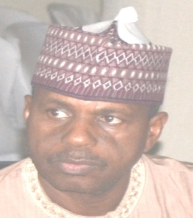 | 4.1 Introduction  The Department of Administration & Supplies is saddled with the task of assisting the Chief Executive in the day-to-day administration of the Commission. Through effective management of the available human and material resources, the Department creates a favourable working environment, mobilizes and motivates the entire workforce towards attaining the goals and objectives of UBE, as well as achieving the UBE dictum, “Education for All is the Responsibility of All”.
Baba Sali Song
Director, Department of Administration & Supplies
Baba Sali Song was born in Song, Adamawa State, in April, 1956. He attended University of Maiduguri and graduated with B.Sc Sociology and Anthropology in 1982. After the National Service, he took up appointment with the defunct Gongola State College of Education in Jalingo. After 7 years with the College, he joined the defunct Nigerian Students Loans Board and served from 1989-2002, after which he transferred his service to UBE Commission. He is presently the Director in-charge of Administration and Supplies.
4.2 Structure
The Department has four units, namely:
- Establishment
- Training and Welfare
- Stores and Supplies
- Maintenance and Services

4.3 Functions
The Department of Administration & Supplies is a service department which performs the following functions:
- Assisting the Executive Secretary in the daily/routine administration of the Universal Basic Education Commission (UBEC).
- Advising Management on general administration, establishment and personnel matters.
- Providing secretariat services to UBEC Management Committee
- Implementing UBEC Board and Management decisions.
- Providing secretariat services to the Governing Board and its Committees
- Evolving and coordinating training and manpower development for the Commission.
- Interpreting and implementing the Commission’s policies as they affect staff welfare such as health/medical care, housing, transport, etc.
- Liaising with the Establishment Department of the Office of the Head of Service of the Federation for the participation of Clerical Staff in the Combined Promotion and Confirmation (COMPRO) Examination.
- Interpreting and implementing administrative and personnel policies in accordance with government rules, regulations, codes and circulars.
- Keeping records of all applications for employment, requests for transfer of service, secondments and contract appointments.
- Liaising with other departments for the compilation and coordination of existing vacancies for purposes of appointments and promotions.
- Distributing, collating and compiling the Annual Performance and Evaluation Report (APER) forms and writing promotion briefs for presentation to the appropriate Committees.
- Preparing the Commission’s nominal roll and departmental/unit staff list and reviewing same on regular basis.
- Compiling annual increments and issuing salary variation advice in conformity with Government regulations.
- Providing secretariat services to the Board of Trustees for the Commission’s Staff Pension Scheme as well as handling general Insurance matters.
- Ensuring documentation of newly employed staff and organizing induction/orientation courses for them.
- Issuing annual and casual leave advice to deserving staff and processing their resumption of duty certificate.
- Providing and coordinating security for UBEC assets.
- Ensuring the beautification and cleanliness of offices and office environment through supervision of the cleaners.
- Ensuring the procurement and sustained provision of utility services like telephones, water, electricity, postal/mailings, etc.
- Administration and maintenance of official vehicles.

4.4 Staff disposition
S/N | DESIGNATION | CONRAISS | NO
1 | Director | 15 | 1
2 | Assistant Director | 13 | 4
3 | Chief Admin Officer | 12 | 1
4 | Principal Admin Officer | 10 | 1
5 | Senior Admin Officer | 09 | 3
6 | Principal Conf. Sec II | 09 | 1
7 | Principal Exec. Officer (Admin) | 09 | 2
8 | Senior Exec. Officer (Admin) | 08 | 1
9 | Admin Officer I | 08 | 5
10 | Senior Conf. Sec I | 08 | 1
11 | Admin Officer II | 07 | 12
12 | Higher Data Processing Officer II | 07 | 1
13 | Conf. Sec II | 07 | 1
14 | Chief Technical Asst. | 06 | 1
15 | Chief Driver Mech. | 06 | 6
16 | Chief Clerical Officer | 06 | 2
17 | Asst. Work Superintendent | 05 | 1
18 | Motor Driver/Mech. | 02 | 1
 | TOTAL |  | 45

4.5 Achievements
- Processed the payment of Monthly Pension up to date.
- Remitted Staff Pension Contributions to their Retirement Savings Accounts (RSAs).
- Processed and forwarded documents for payment of death benefits of deceased staff.
- Processed and coordinated the supply of furniture and equipment to departments in the Headquarters, Zonal and State offices.
- Serviced and maintained all Air–Conditioners in the Commission.
- Carried out general plumbing work and maintenance of office toilets.
- Replaced Intercom PABX CPU CARD.
- Processed Office furniture and equipment needs of Headquarters, Zonal and State Offices.
- Replaced and upgraded the Borehole.
- Constructed 4 additional car pots in the Headquarters.
- Constructed a new office in the Library complex.
- Replaced CONTISS with CONRAISS.
- Conducted the 2012/2013 promotion exercise.
- Sponsored 19 Staff (admin. officers, public relations officers, and conf. secretaries) on Capacity Building Workshop organized in collaboration with the Organization for the Enhancement of Transparent Leadership from 24th to 26th June, 2014.
- Three officers participated in the 12th Nigeria Development Forum organized by the African Centre for Development Studies held from 23rd to 27th June, 2014 at the Imo Concorde Hotel, Owerri.
- One officer was sponsored to attend workshop on “ Librarianship and the Demands for New Leadership Skills” at the Balme Library Seminars Hall, University of Ghana, Legon, Accra, from 13th to 17th April, 2014.
- An officer attended the 47th Session of the United Nations Commission on Population and Development (UNCPD) from 7th to 11th April, 2014 at the United Nations Headquarters, New York.
- Six (6) Staff were sponsored on International Training organized by Unity-Plus Concepts in collaboration with the Newcastle University from 26th May to 6th June, 2014.
- Two drivers attended training workshop on Effective and Efficient Driving Skill for Drivers and Transport Officers organized by the Industrial Dev. Centre in collaboration with Dugab Int. Ltd. in Kaduna from 18th to 22nd August, 2014.
- One officer attended a workshop on Management Development Training for Confidential Secretaries, Personal Assistants and Senior Typists from 20th to 25th July, 2014 in Kaduna.
- One officer attended the 2014 Information Technology Professionals’ Assembly held from 18th to 19th August, 2014 at the Nicon Luxury Hotels, Abuja.
- One officer attended a 2-day Conference organized by the Public Administration and Management Development Institute held at the Rock View Hotel, Abuja.
- Permanent Secretary, FME & a staff were sponsored to attend the Meeting of Educate a Child, EAC in Doha, Qatar from 28th April to 2nd May, 2014.
- The Executive Secretary attended the Second Global Education and Skills Forum in Dubai, from 15th to 17th March, 2014.
- 16 Staff on Executive Cadre were trained locally by UBEC in collaboration with ASCON in a 3-day workshop titled Admin. Practices, Processes & Procedures held in Nasarawa.
- Three officers attended International Training organized by GTC in London and Dubai.
- Carried out Inspection/valuation of all unserviceable motor vehicles in the Headquarters, zonal and state offices in conjunction with the staff of Ministry of Works for possible disposal through Public Auction.
- Initiated/Aided the process of establishing/implementing the Rent Supplement policy in place of the Rent Advance system.
- Facilitated the processing and eventual approval for the implementation of a higher salary structure (CONRAISS) for staff, effective 1st January, 2014.
- Collaborated with the Department of Finance Account to ensure that the statutory monthly deductions/remittances from Staff salaries were forwarded to FMBN as contributions for the National Housing Fund.
- Facilitated, in collaboration with Staff Welfare Committee, the process of establishing a sustainable Housing Scheme with possible internally generated Revolving Fund/loan facilities for staff members.
- Facilitated the process of acquiring land from FCT for staff Housing Scheme.
- Facilitated the provision of financial relief to staff in cases of emergencies and loss of staff or their close relations.
- Ensured that staff access medical facilities through National Health Insurance Scheme (NHIS).
- Initiated the process of reviewing the Staff Conditions of Service.

4.6 Constraints
- Lack of computerization of store activities.
- Delay in the release of funds for maintenance works.
- High cost of maintenance services and spare parts.
- Inadequate funds to carry out scheduled trainings.
- Inadequate number of drivers.

4.7 On-going activities
- Payment of monthly pension.
- 2014 end of year stock-taking.
- Updating and short listing senior and junior staff for 2014/2015 and 2016 promotion.
- Preparation of 2013 and 2014 confirmation of appointment for junior and senior staff.
- Submission of 2014/2015 staff returns to Federal Character Commission.
- Reimbursement of tuition fees and other allowances to those granted sponsorship in 2014 are being processed.
- Processing of staff applications seeking long-term training sponsorship for year 2015 and outstanding ones in 2014.
- Procurement of new project vehicles.
- Collaborating with the Welfare Committee to establish a sustainable Staff Housing Scheme through establishing an internal Revolving Housing Loan Policy.
- Partnering with the Welfare Committee towards establishing Public Private Partnership with reputable Estate Developers.
- Facilitating registration of/changes for staff on NHIS facilities.
- Provision of a well-equipped and conducive staff canteen.

4.8 Future activities
- Conduct of the 2013/2014 Junior staff promotion.
- Conduct of the Pensioners Verification exercise.
- Provision of more office space in the Library.
- Provision of more storage facilities in the Headquarters.
- Long-term training for Staff in different higher institutions of learning.
- Workshops/Conferences/Seminars for all Staff with effect from second quarter of 2015.
- Procurement of new project monitoring vehicles.
- Maintenance and fueling of official vehicles.
- Securing revolving loan scheme for sustainable UBEC Staff Housing.
- Instituting, through the Welfare Committee, a yearly Long Service/Merit Awards to boost staff morale and productivity.
- Strengthening the performance of the Commission’s Health Management Organization to maximize access and benefits of the National Health Insurance Scheme.
- Facilitating the implementation of proposed provision of a Conducive Staff Canteen.
- Facilitating the Establishment of a fully equipped Sick Bay for UBEC staff.

4.10 Conclusion
The Department of Administration and Supplies achieved a lot in 2014 and looks forward to completing the on-going activities. We hope to perform better in 2015.

5.0 DEPARTMENT OF FINANCE AND ACCOUNTS

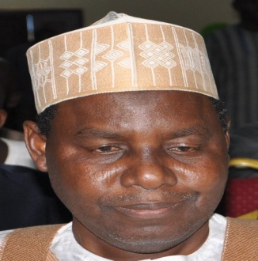 | 5.1 Introduction  The Department of Finance and Accounts has as its key duties, keeping of financial records, payment of staff salaries, preparation of Annual Budget and Annual Financial statements. The department is also responsible for fund disbursement to States, Financial Monitoring, Sourcing of funds, payment of Federal Teachers’ Scheme (FTS) participants’ monthly allowances (Primary and JSS) and supervising the financial activities of the FTS.  5.2 Structure  The Department is headed by a Director and Assisted by a Deputy Directors. It consists of 4 units, namely:  1. Expenditure Control Unit;  2. State Accounts Unit;
Alhaji Mohammed Sambo Dukku.
Director, Finance & Accounts.
Alh. Mohammed Sambo Dukku was born on 14th January, 1959 in Dukku, Gombe State. He graduated from Bayero University Kano with a B.Sc. Accounting in 1986. He had his National Youth Service with the Nigerian Television Authority (NTA), Ibadan, where he was employed as Accountant II, thereafter.

Alh. Dukku rose to the post of Principal Accountant between 1987-1995 before joining the defunct National Primary Education Commission in 1995. He is a member of Institute of Chatered Accountants of Nigeria (ICAN) and possesses Master’s of Business Administration, MBA (2010) from Ahmadu Bello University, Zaria. Alh. Dukku is a seasoned Accountant who held various positions within the Commission’s service such as Head of State Accounts (1995), Chief Accountant (2001), Assistant Director (2005) and Deputy Director (2009); Alh. Dukku, who is happily married and blessed with children can, therefore, be referred to as a fulfilled career Public Servant.

3. Funds and Budget Unit; and
4. Final Accounts Unit.
5.3 Functions
The Department of Finance and Accounts’ functions are as follows:
- disbursing the FGN–UBE Intervention Funds to states and other providers of Basic Education;
- conducting quarterly Financial Monitoring of the FGN–UBE Intervention Funds;
- verifying compliance with 50% State Counterpart Fund Lodgment requirement;
- advising the Federal Government, through the Federal Ministry of Education, on the funding of Basic Education in Nigeria;
- preparing and presenting Financial Progress Report on the Implementation of the UBE Programme to Mr. President through the Honorable Minister of Education;
- managing Local and International Donor Agencies Grants;
- Liaising with other relevant bodies, such as Federal Ministry of Finance, Federal Ministry of Education, Office of the Accountant-General of the Federation, Office of the Auditor-General for the Federation, National Assembly, Presidency, Tertiary Education Trust Fund, etc, on matters relating to funding of UBE Commission;
- preparing the Commission’s Annual Budget;
- preparing Cash Flow Analysis;
- determining the basis of allocating funds to states and other UBE Implementing Agencies;
- Preparing and presenting the Commission’s Annual Financial Statements.
- keeping the Commission’s financial records;
- recommending for the appointment of External Auditors for Annual Audit of SUBEBs in respect of FGN-UBE Intervention funds;
- Providing other financial advisory services to the Commission on Taxation, Investment, and Foreign Exchange Management. e.t.c.;
- processing and paying monthly allowances to Federal Teachers Scheme Participants; and
- Processing and payment of monthly staff’ salary, emoluments and other financial entitlements.
5.4 Staff Disposition
S/N | Designation | CONRAISS | Number
1 | Director | 15 | 1
2 | Deputy Director | 14 | 1
3 | Assistant Director | 13 | 4
4 | Chief Accountant/Chief Executive Officer (Accounts)/Chief Conf. Secretary | 12 | 9
5 | Asst. Chief Accountant | 11 | 2
6 | Principal Accountant/Principal Executive Officer(Accounts) | 10 | 10
7 | Senior Accountant/Senior Executive Officer (Accounts) /Prin. Conf. Secretary I | 09 | 9
8 | Accountant I/ Senior Executive Officer (Accounts) | 08 | 9
9 | Accountant 11/ Higher Executive Officer (Accounts)/Finance Assistant I | 07 | 23
10 | Executive Officer (Accounts)/Finance Assistant II | 06 | 10
 | TOTAL |  | 78
5.5 Activities
- Disbursement of FGN – UBE Intervention Funds.
- Quarterly Financial Monitoring of the FGN-UBE Intervention Funds.
- Preparation of Financial Progress Report on the Implementation of the UBE Programme.
- Preparation of Annual Budget.
- Preparation of Annual Financial Statements.
  - Achievements
- Secured the release of N70,470,000,000.00 appropriated by the National Assembly for the year 2014, being the 2% of the consolidated Revenue Fund meant for delivering of Basic Education, thus representing 100% implementation.
- Disbursed the sum ofN27,799,444,344.46 UBE Matching grants to 26 States and F.C.T. viz:
S/N | STATE | FUND | AMOUNT (=N=)
1 | Adamawa | 4th Quarter,2013 – 2nd Quarter, 2014 | 733,848,232.04
2 | AkwaIbom | 1st – 4th Quarters, 2011 and 2012 | 1,725,464.020.62
3 | Anambra | 4th Quarter, 2011 – 4th Quarter, 2013 | 2,101,864,837.90
4 | Bauchi | 1st – 4th Quarters, 2013 | 1,030,797,297.30
5 | Bayelsa | 1st – 4th Quarters, 2013 & Balance of 4th Qtr, 2010 | 1,048,797,297.30
6 | Benue | 3rd and 4th Quarters, 2011 | 429,733,455.75
7 | Borno | 1st – 3rd Quarters, 2013 | 773,097,297.59
8 | Cross River | 1st – 4th Quarters, 2011 | 872,527,306.70
9 | Ebonyi | 1st and 2nd Quarters, 2010 | 329,390,982.82
10 | Ekiti | 1st – 4th Quarters, 2012 | 852,936,713.92
11 | Gombe | 1st – 4th Quarters, 2013 –3rd Quarter, 2014 | 1,723,939,189.19
12 | lmo | 1st – 4th Quarters, 2013 | 1,030,797,297,30
13 | Kaduna | 4th Quarter, 2013 | 257,699,999.71
14 | Kano | 4th Quarter, 2013 – 3rd Quarter, 2014 | 950,841,891.60
15 | Katsina | 4th Quarter, 2013 – 3rd Quarter, 2014 | 950,044,592.30
16 | Kwara | 3rd & 4th Quarters, 2012- 4th Quarter, 2013 | 1,470,096,322.59
17 | Lagos | 1st – 4th Quarters, 2013 | 1,030,797,297.30
18 | Niger | 3rd & 4th Quarters, 2012 | 341,174,685.20
19 | Ondo | 1st – 4th Quarters, 2012 | 852,936,713.92
20 | Osun | 1st – 3rd Quarters, 2013 | 850,970,000.00
21 | Plateau | 4th Quarter, 2011 – 4th Quarter, 2013 | 2,079,439,219.36
22 | Rivers | 1st – 4th Quarters, 2013 | 1,030,797,297.30
23 | Sokoto | 4th Quarter, 2013 – 3rd Quarter, 2014 | 950,841,991.60
24 | Taraba | 1st – 4th Quarters, 2013 and 2014 | 1,803,297,297.30
25 | Yobe | 3rd& 4th Quarters, 2012 - 4th Quarter,2013 | 1,457,265,654.26
26 | Zamfara | 4th Quarter, 2013 | 257,699,999.71
27 | FCT | 4th Quarter,2012 – 3rd Quarter, 2013 | 862,347,453.88
 | TOTAL |  | 27,799,444,344.46
- Disbursed N1,429,207,829.80 Special Education Fund to 25 States and F.C.T. and to duly registered Non-Governmental Organizations (NGOs) that provide free special education to the public, viz:
S/N | STATE | FUND | AMOUNT (=N=)
1 | Anambra | 2011 & 2012 Allocations | 48,312,991.00
2 | Bauchi | 2014 Allocation | 24,459,459.49
3 | Bayelsa | 2013 &2014 Allocations | 51,409,459.46
4 | Benue | 2011 & 2012 Allocations | 50,832,227.00
5 | Borno | 2014 Allocation | 24,459,459.49
6 | Cross River | 2009 - 2012 Allocations | 65,750,886.00
7 | Delta | 2013 Allocation | 26,950,000.00
8 | Ebonyi | 2012 Allocation | 26,950,000.00
9 | Edo | 2012 Allocation | 23,882,227.00
10 | Ekiti | 2014 Allocation | 24,459,459.49
11 | Gombe | 2013 Allocations | 26,950,000.00
12 | Kaduna | 2010 - 2012 Allocations | 65,750,396.00
13 | Kano | 2013 Allocation | 26,950,000.00
14 | Katsina | 2013 Allocation | 26,950,000.00
15 | Kebbi | 2014 Allocation | 24,459,459.49
16 | Kwara | 2013 Allocation | 51,409,459.49
17 | Lagos | 2011 - 2013 Allocations | 75,262,991.00
18 | Nasarawa | 2013 Allocation | 26,950,000.00
19 | Ogun | 2012 Allocation | 23,882,227.00
20 | Osun | 2014 Allocation | 24,459,459.46
21 | Plateau | 2013 Allocation | 26,950,000.00
22 | Rivers | 2013 Allocation | 26,950,000.00
23 | Sokoto | 2012 & 2013 Allocations | 50,832,227.00
24 | Taraba | 2013 & 2014 Allocations | 51,409,459.46
25 | Yobe | 2011 - 2013 Allocations | 75,262,991.00
26 | Zamfara | 2011 & 2012 Allocations | 48,312,991.00
27 | NGO | 2011 & 2012 Allocations | 409,000,000.00
 | TOTAL |  | 1,429,207,829.80
- Disbursed/Utilized the sum ofN21,938,903,866.30 Educational Imbalance Fund for construction of Skill Acquisition Vocational Centers, Rehabilitation/Renovation of Schools, Construction of Model Girl Junior Schools, Construction of Almajiri Model Schools and procurement of text books.
- Disbursed/utilized the sum ofN4,367,857,708.85 Good Performance Fund for construction of e-libraries and also for procurement of textbooks.
- Disbursed/Utilized the sum of N5,186,180,479.30 Instructional Materials Fund to procure Science Equipment to 104 Unity Schools
- Disbursed Teacher Professional Development Fund of N3,157,500,000.00 to 34 States and FCT, Viz:
S/N | STATE | FUND | AMOUNT (=N=)
1 | Abia | 2012 Allocation | 161,000,000.00
2 | Adamawa | 2014 Allocation (1st tranche) | 80,500,000.00
3 | Akwa Ibom | 2013 Allocation | 170,000,000.00
4 | Anambra | 2014 Allocation (1st tranche) | 250,500,000.00
5 | Bauchi | 2014 Allocation (1st tranche) | 80,500,000.00
6 | Bayelsa | 2014 Allocation (1st tranche) | 80,500,000.00
7 | Benue | 2014 Allocation (1st tranche) | 80,500,000.00
8 | Borno | 2014 Allocation (1st tranche) | 80,500,000.00
9 | Cross River | 2014 Allocation (1st tranche) | 80,500,000.00
10 | Delta | 2014 Allocation (1st tranche) | 80,500,000.00
11 | Ebonyi | 2014 Allocation (1st tranche) | 80,500,000.00
12 | Edo | 2014 Allocation (1st tranche) | 80,500,000.00
13 | Ekiti | 2014 Allocation (1st tranche) | 80,500,000.00
14 | Enugu | 2014 Allocation (1st tranche) | 80,500,000.00
15 | Gombe | 2014 Allocation (1st tranche) | 80,500,000.00
16 | Imo | 2014 Allocation (1st tranche) | 80,500,000.00
17 | Jigawa | 2014 Allocation (1st tranche) | 80,500,000.00
18 | Kaduna | 2014 Allocation (1st tranche) | 80,500,000.00
19 | Kano | 2014 Allocation (1st tranche) | 80,500,000.00
20 | Kebbi | 2014 Allocation (1st tranche) | 80,500,000.00
21 | Kogi | 2014 Allocation (1st tranche) | 80,500,000.00
22 | Kwara | 2014 Allocation (1st tranche) | 80,500,000.00
23 | Nasarawa | 2014 Allocation (1st tranche) | 80,500,000.00
24 | Niger | 2014 Allocation (1st tranche) | 80,500,000.00
25 | Ogun | 2014 Allocation (1st tranche) | 80,500,000.00
26 | Ondo | 2014 Allocation (1st tranche) | 80,500,000.00
27 | Osun | 2014 Allocation (1st tranche) | 80,500,000.00
28 | Oyo | 2014 Allocation (1st tranche) | 80,500,000.00
29 | Plateau | 2014 Allocation (1st tranche) | 80,500,000.00
30 | Rivers | 2014 Allocation (1st tranche) | 80,500,000.00
31 | Sokoto | 2014 Allocation (1st tranche) | 80,500,000.00
32 | Taraba | 2014 Allocation (1st tranche) | 80,500,000.00
33 | Yobe | 2014 Allocation (1st tranche) | 80,500,000.00
34 | Zamfara | 2014 Allocation (1st tranche) | 80,500,000.00
35 | FCT Abuja | 2014 Allocation (1st tranche) | 80,500,000.00
 | TOTAL |  | 3,157,500,000.00
- Conducted 20th and 21st Financial Monitoring of the FGN-UBE Intervention Funds in all the 36 States of the Federation and FCT except Borno and Yobe States.
- Utilized the sum of N4,878,823,835.98 Millenium Development Goals (MDGs) funds for the payment of 210 and 105 constituency projects for the years 2013 and 2014 amounting to N3,676,471,227.31 and N1,202,352,608.67, respectively.
- Utilized the sum of N2,180,070,000.00 for the payment of monthly allowances to 14,469 Federal Teachers’ Scheme (FTS) participants serving across the 36 states and FCT.
- Finalized 2012 and 2013 UBEC Annual Financial Statements.
- Conducted training workshop for UBEC Accounting/Audit staff and SUBEB Directors of Finance, UBE Desk Offices and Audit staff on International Public Sector Accounting Standards (IPSAS) and National Charts of Accounts (NCA)
5.7 Ongoing activities
- Preparation and Defense of 2015 Budget before the National Assembly.
- Computerization of the Commission’s Accounting System.
- Updating the new Accounting Manual.
- Development of International Public Sector Accounting Standards (IPSAS) roadmap.
5.8 Challenges
- Inadequate office accommodation.
- Lack of Operational/Audit Manual.
- Non Computerization of UBEC Accounting System.
- Slow utilization of the FGN-UBE Intervention Funds by SUBEBs.
- Lack of political will by some State Governments to access the FG-UBE Matching Grants.
- High rate of turnover of the SUBEBs Accounting Personnel.
- Delay in submission of Financial Returns by SUBEBs.
- Low level of budgetary allocation to Basic Education at State and Local Government levels.
- Delay in the release of funds to the Commission.
- Lack of regular monitoring of FTS participants by SUBEBs and LGEAs being the ultimate beneficiaries.
5.9 Future activities
- Development of procedural manual of the Commission.
- Auditing of UBEC 2014 Accounts.
5.10 Conclusion
The Finance and Accounts Department has responded to many challenges with the support of Management. This has impacted positively on the efficiency of the Department’s performance. Data on FGN-UBE Intervention Fund were on the internet for public knowledge in line with Mr. President’s Transparency and Accountability Transformation Agenda. This has reduced the time spent by individuals and organizations requesting for update on Intervention Funds. The UBEC financial transactions will remain open and transparent in line with the core values of the Commission.

- DEPARTMENT OF PHYSICAL PLANNING
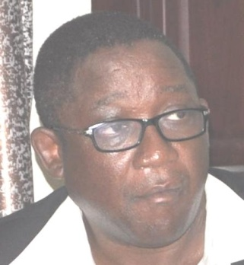 | 6.1 Introduction  The Physical Planning Unit of the PRS Department was upgraded to a full fledged department and has three (3) Units namely Architecture, Engineering and Quantity Surveying. The mandate of the department is to ensure the provision of qualitative infrastructural facilities in Public Schools by the States, FCT, Donor Agencies and direct intervention by Federal Government.  6.2 Functions  The major functions of the department include:  - Setting up of minimum standards for Basic Education infrastructure.  - Assessment and vetting of the infrastructural component of SUBEBs Action Plans.
Arch. M.M. Mutfwang
Director, Department of Physical Planning
Arch. Molkat M. Mutfwang was born on 1st November, 1957 in Ampang-West, Mangu Local Government Area of Plateau State. He studied Architecture at the Ahmadu Bello University, Zaria and graduated with a B.Sc (1980) and M.Sc in Architecture in 1982. He did his National Youth Service in Kaduna State after which he worked with the Ministry of Works and Housing, Plateau State before returning to Ahmadu Bello University, Zari,a as Lecturer II in 1984.
He joined the National Primary Education Commission (NPEC) as Assistant Chief Architect in Kaduna in 1989 and rose to the rank of Chief Architect in 1994 and became a Deputy Director in UBEC in 1999. He is a seasoned Architect that has been engaged in various projects and continues to give his quota to the development of the nation. Arch. M.M. Mutfawang is the Director in-charge of the Department of Physical Planning.
iv) Participating in the Monitoring of Approved UBEC/SUBEB executed projects.
v.) Participating in the preparation of short, medium and long term budgets for the Commission. Carrying out market surveys for basic construction materials with a view to updating cost norms for Basic Education Infrastructural projects across the whole country and to set cost specific benchmarks for each SUBEB in the Federation.
vi) Participating in the Monitoring of Special Education Projects and donor agencies projects.
vii) Attending to major maintenance of UBEC building facilities.
viii) Acting as technical partner on the projects of Donor Agencies such as JICA, KOICA etc.
ix) Coordinating the activities of consultants for intervention projects engaged by the Commission.
x) Creating and updating the data base for UBEC/SUBEBs projects in terms of approved proposals and confirmed deliverables.

6.3 Staff disposition
S/NO | RANK | CONRAISS | NUMBER
1 | Director | 15 | 1
2 | Assistant Director | 13 | 1
3 | Chief Civil Engineer, Chief Technical Officer | 12 | 2
4 | Assistant Chief Building Officer And Assistant Chief Data Officer | 11 | 2
5 | Principal Confidential Secretary | 10 | 1
6 | Senior Architect | 09 | 1
7 | Senior Technical Officer/ Electrical Engineer I/ Civil Engineer I/ Architect I | 08 | 9
8 | Town Planning Officers II/ Agric Engineer II/ Higher technical officer QS/ Civil Engineer II/ Electric Engineer II/ Building Engineer I/ Mechanical Engineer I | 07 | 7
9 | NYSC (Corps members) |  | 2
 |  | TOTAL | 26

6.4 Achievements
The department recorded the following achievements in the year under review:

- Assessed and vetted the infrastructural component of the Action Plans submitted by SUBEBs. This is to ensure that the specifications for the proposed infrastructural projects in the Action Plans comply with the UBE minimum standards and guidelines and are in line with best practices. This aspect of work covers both the FGN-UBE matching Grant and Special Education Funds.
- Participated in the monitoring of approved and executed projects for various SUBEBs for both the matching grants and Special Education Funds within the year.
- Participated in the monitoring of FGN direct intervention projects such as Junior Girls’ Model Secondary Schools, Almajiri School projects and e-Library Projects within the year under review.
- Participated in the co-ordination and Monitoring of MDG Constituency
Projects across the country.
- Participated in the co-ordination and supervision of special intervention
projects.
- Updating the data base for SUBEBs projects in terms of approved proposal.

6.5 On-going activities
The department is presently monitoring the construction of:
- 153 Almajiri School projects spread across the 36 States of the Federation including FCT out of which, 103 had been completed while 50 are on-going.
- 67 Junior Girl’s Model Secondary Schools are under construction, 6 completed while 61 projects are at various stages of completion.

- 62 E- Library projects in 62 Unity Schools were awarded out of which 57 had been completed while 5 are at finishing stages.
- 249 State intervention projects (construction and renovations) across the 36 States of the Federation and FCT.
- Contracts for 14 Vocational schools were awarded in 14 States and were at various stages of completion.

6.6 Future activities
- SUBEBs are expected to submit their Action Plans on soft copies in view of the limitation of storage space for hard copies.
- The department will organize workshop for SUBEBs technical officers on the preparation of Action Plans and project monitoring.
- Need for strengthening the mechanism for project monitoring and supervision to enhance quality of projects.
- The need for capacity building through attendance of local overseas training.
- Source ways of getting cheaper building materials in States in order to reduce the cost of infrastructural facilities.
- Develop a maintenance plan for States for their infrastructural projects.

6.7 Challenges
- The Department’s major challenge is the difficulty in ensuring quality in some projects sites since the department only participated in periodic monitoring and not daily supervision of the projects.
6.8 Conclusion
In spite of the challenge mentioned above, the department, with the support of the various departments and management of the Commission, was able to record the above achievements and it is the hope of the department to record more achievements in the years to come.

7.0 DEPARTMENT OF PLANNING, RESEARCH AND STATISTICS
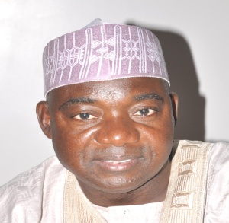 | 7.1 Introduction  The Department is charged with the responsibility of developing Strategic Plans for the Commission, coordination of Research activities, providing Statistical Information needed for the management of basic education effectively and efficiently, and provision of Information Communication Technology (ICT) services to end users.  7.2 Departmental Units  The Department has four units, namely:  - Strategic Planning;  - Research and Publications;  - Education Management Information System and Statistics; and.  - Computer Center
Mallam Bello Kagara
Director, Planning, Research and Statistics
Malam Bello Kagara was born on 22nd November, 1960 at Kagara in Kafur Local Government, Katsina State. He attended Galama Primary School, Mahuta (1967-1973), Kufena College, Wusasa, Zaria (1973-1975), the famous Katsina Teachers’ College (1975-1979), College of Education, Kafanchan, (1980-1983), Ahmadu Bello University (1987-1990 and 1993-1994). Kagara holds the Teacher Grade II Certificate (1979), NCE (1983), B..A. Ed. (English) (1990).
He is an alumnus of the prestigious Harvard University, Boston, USA, where he obtained a certificate in Improving Quality in Education System. He has attended several international trainings on Project Planning, Management, Procurement, Policy and Strategic Planning, Educational Planning and Administration, Financing and Modernizing Public Sector Organizations, etc. Kagara is a seasoned administrator traversing primary school administration as Head-Master, Local Government Councilor for Education and Health and later Council Secretary, Malumfashi and Kafur Local Governments Katsina State, and Head of Planning, Research and Statistics at Katsina State Transport Authority from where he joined the services of the then National Primary Education Commission (NPEC) (now UBEC) as Principal Project Officer World Bank Department in 1994.
He has since then rose through the ranks of the Commission to become Director, Planning Research and Statistics in September, 2014 to date. He was the Personal Assistant to the Interim Administrator NPEC in1996, Project Coordinator, World Bank Special Project and Deputy Director, (Special Projects) under the Executive Secretary’s Office. His service as the Project Coordinator of the Special Projects brought fame to the Commission and has to his credit the successful implementation of the Second World Bank-Supported Primary Education Project (PEP II) (2002-2005) and bringing in many International Development Partners (IDPs) such as JICA, USAID, KOICA, and CHINA Commercial Office, etc, within the ambit of the Commission’s Partnership activities.
An accomplished administrator, Bello Kagara is happily married and blessed with children.
7.3 Staff Disposition
S/No | Designation | CONRAISS | Number
1 | Director | 15 | 1
2 | Asst. Directors | 13 | 2
3 | Chief Statistician | 12 | 1
4 | Asst. Chief Planning Officer | 11 | 1
5 | Principal Research Officers/Prin. Programme Analyst/Prin. Planning Officer/ Prin. Confidential Secretary/ Prin. Statistical Officer | 10 | 7
6 | Programme Analyst | 09 | 1
7 | Research Officers I/Planning Officers I/ Senior Statistical Officers | 08 | 6
8 | Statistical Officers II/Research officers II/ Planning Officers II | 07 | 13
9 | Chief Driver | 06 | 1
10 | NYSC |  | 1
 | T O T A L |  | 34

7.4 Functions of the Department
The key functions of the Department are as follows:
- coordinating the development of UBEC Action, Strategic and Rolling Plans;
- coordinating the collection, analysis, dissemination and utilization of educational data for planning and decision making;
- organizing quarterly In-house Seminars for UBEC staff;
- monitoring the implementation of Action Plans and Budget;
- collating and editing UBEC Annual Report, UBE Forum and UBE Digest;
- designing and developing data collection instruments for UBE field activities that require data generation;
- serving as a link between collaborating agencies and other stakeholders on data management and other related issues;
- setting standards and monitoring the progress of EMIS development at the SUBEBs, LGEAs and school levels;
- providing professional and technical support to SUBEBs on the development of their Sector Plans, data generation, analysis, dissemination and EMIS;
- coordinating action research in identified areas of basic education;
- managing research and development components of assisted projects by International Development Partners - IDPs;
- developing Key Performance Indicators – KPIs from approved Action Plans for UBE and SUBEBs and reporting same to stakeholders;
- Serves as Secretariat for Inter-departmental Committee on Research; and serving as technical Partners on special research assignments.

  - Achievements
- Compiled and listed all Federal Government projects in Imo State 2011-2013
- Compiled and submitted inputs for National Integrated Infrastructure Master Plan (NIIMP) 2014-2018.
- Represented the Commission in the Conference of Directors of Educational Planning and Management at the National Institute for Educational Planning and Administration (NIEPA), Ondo State in June, 2014.
- Planned and conducted the maiden edition of Forum of Directors in-charge of Strategic Planning in UBEC and SUBEBs in October, 2014.
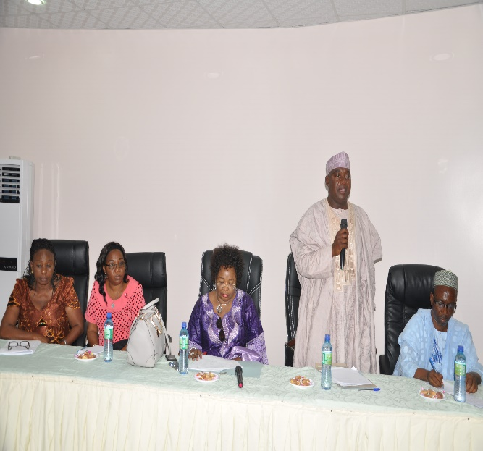 |  | 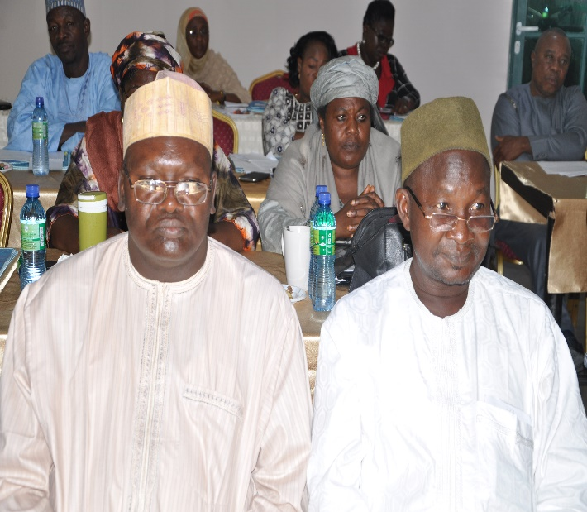
Alh. Bello Kagara, Director, PRS UBEC, addressing participants during the workshop |  | Some SUBEB Directors of PRS  during the workshop
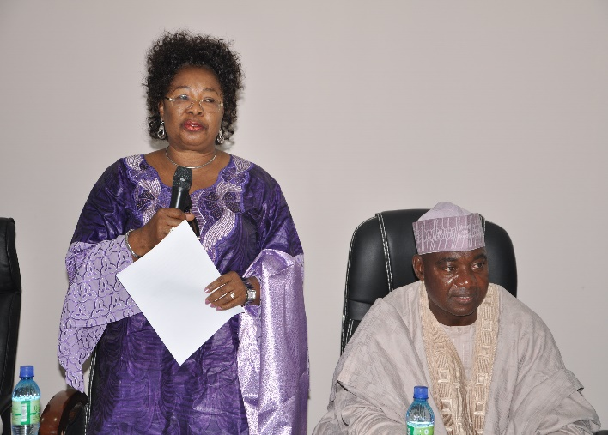 |  | 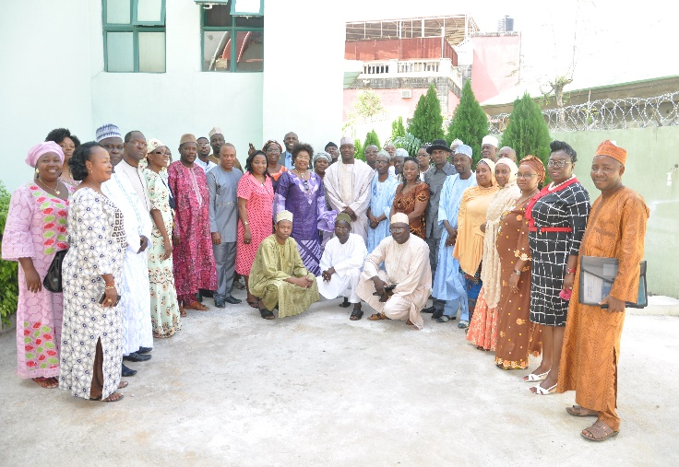
DES (T) UBEC, Dr. Sharon ‘Rowo Oriero-Oviemuno giving an address during the workshop. |  | Group photograph of Participants
- Conducted Impact Assessment on the Utilization of FGN-UBE Funds for Special Education Service Delivery (2005-2012) in Public Schools and Private Providers of Special Needs Education in Nigeria.
- Constituted Editorial Committee for the publication of UBE Forum and UBE Digest.
- Involved in Literature Review of Universal Basic Education Reform in conjunction with EDOREN (Education Data, Operational Research and Evaluation in Nigeria), a subsidiary of DFID.
- Conducted 1st, 2nd and 3rd quarters In-house Seminars.
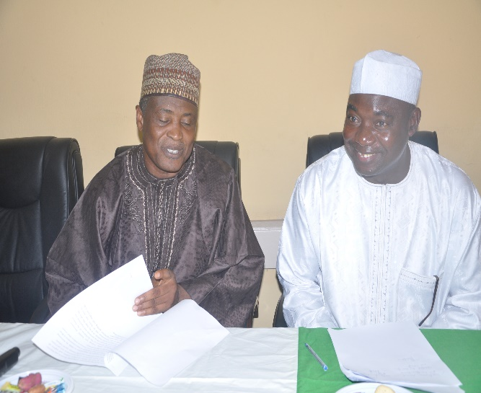 |  | 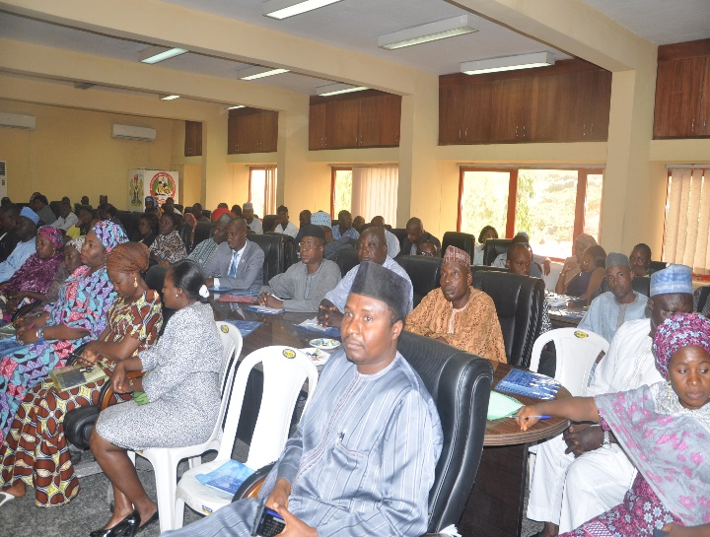
ES UBEC, Alh. Dr. Suleiman Dikko (Left) with Director PRS at the UBEC In-House Seminar |  | UBEC staff participating in the In-House Seminar
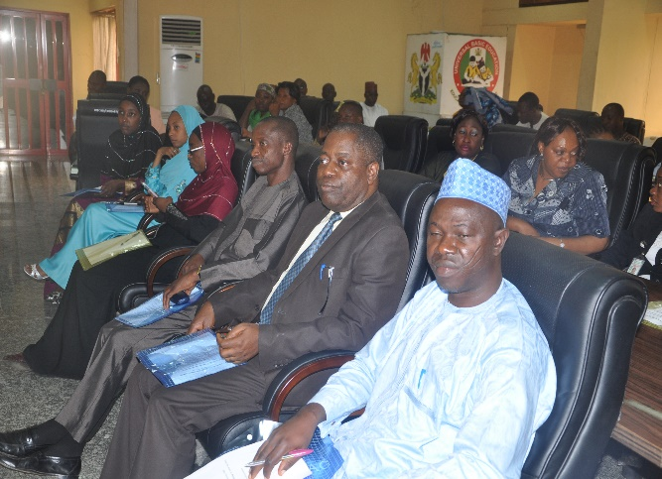 |  | 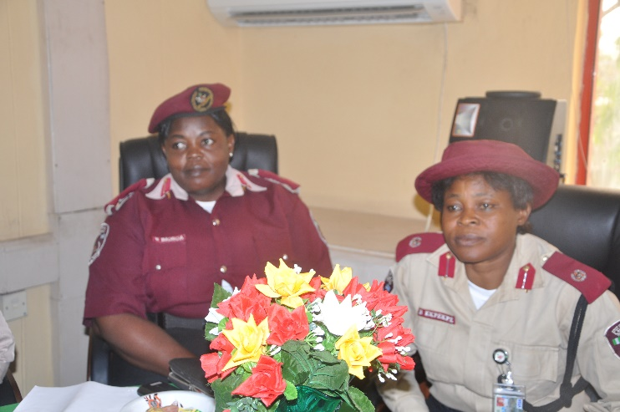
UBEC staff listening attentively during presentations |  | Representatives of FRSC as resource persons during the Seminar
- Upgraded and designed uniform templates for the submission of basic education data from SUBEBs.
- Represented the Commission at various fora on basic education data-related matters.
- Setting up of statistical standards at SUBEBs.
- Setting up of UBEC/EMIS in-house data Committee.
- Completion of School Mapping Project.
- Responded to stakeholder’s data request.
- Managed the Commission’s Computer systems and Network.
- Updating of the Commission’s website.
- Development of Verification Software for Instructional Materials supply to schools.
- Integrating all departments and unit into one networking family.

7.6 Challenges
- Lack of capacity building for Research Officers on Modern-day research techniques.
- Delay in data returns from SUBEBs.
- Inconsistency and falsification of data by SUBEBs.
- Lack of private schools data.
- Lack of modern statistical softwares.
- Shortage of funds for data collection/collation from SUBEBs.
- Inadequate funding, policy formulation and implementation machinery.
- Provision of an ICT Budgets.
- Near absence of financial provisions to conduct many of the Departments activities that are core to the effective functioning of the Commission in the delivery of basic education in Nigeria

7.7 Future Activities
- Conduct of researches on the impact of basic education policy implementation strategies and other related topics.
- Production and publication of UBE Digest, Forum and Annual Report.
- Organizing In-house Seminars.
- Collating and publishing papers presented at the In-house seminars.
- Organizing and conducting meetings of the Forum of UBEC and SUBEBs’ Directors in-charge of Strategic Planning in 2015.
- Capacity building for PRS Staff.
- Collaborating with consultants in carrying out commissioned research for the Commission.
- Consultative meeting of UBEC with Directors of Planning, Research and Statistics (PRS) from States Ministry of Education and SUBEBs on Basic Education data production.
- Verification of status and functionality of EMIS facilities at SUBEBs.
- Capacity building for UBEC EMIS staff in Modern Statistical Application Packages (MSAP).
- Capacity building for EMIS desk officers on derivation and generation of Basic Education Key Performance Indicators (KPI).
- Collation of 2014/2015 Basic Education data from SUBEBs.
- Processing and analysis of 2014/2015 data.
- Validation/Critiquing of 2014/2015 basic education data.
- 2014/2015 Basic Education/National School Census data analysis, report writing and printing.
- Production of UBE Statistical Digest.
- Capacity building of UBEC Headquarters and Zonal Offices staff in Basic Education Key Performance Indicators (KPI).
- Instrumentation of National School Census.
- Migrating the Current Website to .gov.ng domain.
- Provision of Local Area Network (LAN) and Internet Connectivity to the Zonal Offices, State Offices and State Universal Basic Education Boards (SUBEBs).
- Developing e-Instrument for the different Departments.
- Moving the Commission towards a paperless office environment.

7.8 Conclusion
The department has been constrained in undertaking some of its major responsibilities especially in Research and Strategic Planning due mainly to paucity of funds. However, it is hoped that greater attention will be accorded to the programmes and activities of the department.

8.0 DEPARTMENT OF QUALITY ASSURANCE

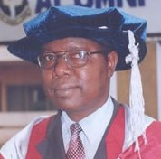 | 8.1 Introduction  The Department of Quality Assurance ensures that high quality basic education is realized through appropriate quality assurance mechanisms as well as prescribing, monitoring, evaluating and maintaining minimum standards, especially in the area of teaching and learning, to Nigerian children. The Department also supervises the 6 UBEC Zonal Offices, 1 FCT Sub-Zone Office and 23 State Offices.  8.2 Functions  The main tasks of the department are to prescribe and maintain minimum standards, monitor, appraise and evaluate the UBE programme through the following mechanisms:  - Quality Assurance - appraising school effectiveness and efficiency; appraising teaching and learning and quality of provisions in schools;  - Monitoring and Evaluation - prescribing, monitoring and maintaining minimum standards in basic education provisions;  - Monitoring Learning Achievements - assessment of learning achievements at the
Dr. Chukwuma Christian Agomoh
Director, Department of Quality Assurance
Dr. Chukwuma Christian Agomoh was born in Umuahia on 17th July, 1957. He had his primary education at Ezeleke Community Primary School, Umuahia (1962-1967); secondary education at Methodist College, Uzuakoli, in then East Central State (1970-1974); tertiary education in the then ATC/ABU, Kano (now FCE, Kano) for N.C.E. (1976-1979); University of Nigeria (1980-1982) for Bachelor of Science degree in Education/Biology; University of Calabar (1990) for Master of Education (M.Ed) degree in Educational Administration and Planning; and University of Ibadan (2003-2006) for Ph.D in Educational Evaluation. His Ph.D thesis, titled “An Evaluation of the Child-Friendly Environmental Status of Primary Schools in Abia State, Nigeria”, was adjudged the second best in the University of Ibadan out of a total of 162 Ph.Ds awarded by the University in the 2005/2006 session. Thus, he was given the “Award for the 1st Runner-Up in the Best Ph.D Thesis Competition in the University of Ibadan for the 2005/2006 Academic Session”.
Dr. Agomoh taught in his alma mater, Methodist College, Uzuakoli, and other colleges between1982 and 1990. He transferred his services to the defunct National Primary Education Commission (NPEC), now Universal Basic Education Commission in October 1990. Dr. C. C. Agomoh rose through the ranks and is now the Director of Quality Assurance in Universal Basic Education Commission.
He had the following awards: War Against Indiscipline Commendation (1983), Staff Award for Hardwork (1984-1986); Elder Statesman Award by the Graduate Students’ Association of Nigeria (GSAN) of University of Ibadan (2006), Good Leadership Award by National Association of Abia State Students of University of Ibadan, Ibadan (2006), Distinguished Old Boy (DOB) by Methodist College Uzuakoli Old Boys’ Association (November 2009); African Credibility Gold Award (May 2013) by Platinum Standard Publications Ltd; Officer of the Order of the Wesleys (OOW) by the Methodist Church Nigeria in 2015; and FCAI by the Institute of Corporate Administration (2015).
He is married to Comfort Agomoh and blessed with two children.
Basic Education level in Nigeria (e.g. National Assessment of Learning Achievements in Basic Education (NALABE) - determining the normative indices for evaluating learners’ performance;
- Institutionalization of Continuous Assessment - development and application of the Unified National Continuous Assessment Programme (UNCAP) in Nigeria at the Basic Education level;
- Harmonization - coordinating the activities of the 6 Zonal Offices and FCT Sub-Zonal Office, and 23 State Offices;
- Collaborative Instrumentation - liaising with other UBEC departments in the development of appropriate instruments for the purpose of evaluating their field activities;
- Quarterly Meetings - serving as the Secretariat of the Quarterly meeting of UBEC Management with the Executive Chairmen of SUBEBs;
- Conducting SERVICOM activities in the basic education sub-sector by ensuring quality service delivery to the public throughout its offices;
- Synergy - Supporting various Development Partners in the monitoring of assisted programmes and projects in Basic Education institutions; and
- Carrying out any assignment that may be directed by the Executive Secretary and/or Management.

8.3 STRUCTURE
The Department has four Units, as indicated in Fig. 1.
Director

Assessment Unit
Monitoring & Evaluation Unit
Zonal Office Matters Unit
SERVICOM Unit

Zonal Offices
State Offices

Fig 1: The four units of Quality Assurance and the Zonal/State Offices
Each Unit is headed by an officer of the rank of Deputy Director (Quality Assurance).

8.4 UBEC Zonal and State Offices
While an Officer of the rank of Director heads each of the Zonal Offices, an Officer of the rank from Assistant Chief Quality Assurance Officer to Assistant Director (Quality Assurance) heads each of the State Offices/FCT Sub-Zonal Office. The locations of these offices and the States under them are contained in Table 1.
Table 1: Locations of UBEC Zonal and State Offices/States of coverage
S/N | ZONAL OFFICE | STATE OFFICE/LOCATION | STATE(S) COVERED
1. | North-Central, Lokoja | Benue, Makurdi | Benue
 |  |  | Kogi
 |  | Kwara, Ilorin | Kwara
 |  | Plateau, Jos | Nasarawa
 |  |  | Plateau
 |  | FCT Sub-Zonal, Abuja | Niger
 |  |  | FCT
2. | North-East, Bauchi | Adamawa, Yola | Adamawa
 |  | Borno, Maiduguri | Borno
 |  |  | Yobe
 |  | Gombe, Gombe | Bauchi
 |  |  | Gombe
 |  | Taraba, Jalingo | Taraba
3. | North-West, Kaduna | Kano, Kano | Jigawa
 |  |  | Kano
 |  | Katsina, Katsina | Kaduna
 |  |  | Katsina
 |  | Sokoto, Sokoto | Kebbi
 |  |  | Sokoto
 |  | Zamfara, Gusau | Zamfara
4. | South-East, Owerri | Anambra, Awka | Anambra
 |  | Ebonyi, Abakaliki | Ebonyi
 |  | Enugu, Enugu | Enugu
 |  | Abia, Umuahia | Abia
 |  |  | Imo
5. | South-South, Uyo | Bayelsa, Yenagoa | Bayelsa
 |  | Cross River, Calabar | Akwa Ibom
 |  |  | Cross River
 |  | Edo, Benin City | Delta
 |  |  | Edo
 |  | Rivers, Port Harcourt | Rivers
6. | South-West, Abeokuta | Ekiti, Ado-Ekiti | Ekiti
 |  |  | Ondo
 |  | Lagos, Victoria Island | Lagos
 |  |  | Ogun
 |  | Oyo, Ibadan | Oyo
 |  | Osun, Osogbo | Osun
Total | 6 | 24 | 37

8.5 Staff disposition
The staff profile in the Department at the Headquarters, Zonal/State Offices and the FCT Sub-Zonal Office are contained in Tables 2, 3 and 4, respectively.
Table 2: Staff Disposition at the Headquarters
S/N | STAFF POSITION | GL | NO OF STAFF
1. | Director | 15 | 1
2. | Deputy Director | 14 | 1
3. | Assistant Director | 13 | -
4. | Chief Quality Assurance Officer | 12 | 2
5. | Assistant Chief Confidential Secretary | 11 | 1
6. | Principal Quality Assurance Officer | 12 | 1
7. | Senior Quality Assurance Officer | 10 | 2
8. | Prin. Data Processing Assistant IV | 10 | 1
9. | Quality Assurance Officer I | 09 | 6
10. | Confidential Secretary II | 09 | 1
11. | Quality Assurance Officer II | 08 | 2
12. | Driver | 05 | 1
TOTAL |  |  | 19

Table 3: Staff Disposition at the Zonal and FCT Sub-Zonal Offices
S/N | STAFF POSITION | CONRAISS | NO OF STAFF
1. | Zonal Director | 15 | 5
2. | Assistant Director | 13 | 2
3. | Chief Quality Assurance Officer | 12 | 2
4. | Chief Accountant | 12 | 1
5. | Assistant Chief Quality Assurance Officer | 11 | 1
6. | Assistant Chief Account Officer | 11 | 2
7. | Assistant Chief Administrative Officer | 11 | 1
8. | Principal Confidential Secretary | 10 | 1
9. | Principal Social Mobilization Officer | 10 | 1
10. | Principal Administrative Officer | 10 | 1
11. | Principal Accountant | 10 | 1
12. | Senior Administrative Officer | 09 | 2
13. | Senior Accountant | 09 | 2
14. | Senior Auditor | 09 | 1
15. | Engineer I | 08 | 2
16. | Quality Assurance Officer I | 08 | 2
17. | Senior Technical Officer I | 08 | 1
18. | Legal Officer | 08 | 1
19. | Auditor I | 08 | 1
20. | Architect II | 08 | 1
21. | Quality Assurance Officer II | 07 | 6
22. | Civil Engineer II | 07 | 1
23. | Administrative Officer II | 07 | 2
24. | Auditor II | 07 | 1
25. | Higher Executive Officer (Accounts) | 07 | 1
26. | Executive Officer (Audit) | 06 | 3
27. | Executive Officer (Accounts) | 06 | 1
28. | Executive Officer (Administration) | 06 | 1
29. | Confidential Secretary II | 06 | 1
30. | Chief Driver | 06 | 4
31. | Confidential Secretary III | 05 | 3
32. | Driver/Mechanic | 03 | 2
TOTAL |  |  | 57

Table 4: Staff Disposition at the State Offices
S/N | STAFF POSITION | GL | NO OF STAFF
1. | Assistant Director, Quality Assurance | 13 | 3
2. | Chief Quality Assurance Officer | 12 | 5
3. | Chief Technical Officer | 12 | 1
4. | Assistant Chief Quality Assurance Officer | 11 | 7
5. | Assistant Chief Accountant | 11 | 3
6. | Principal Quality Assurance Officer | 10 | 6
7. | Principal Accountant | 10 | 1
8. | Principal Administrative Officer | 10 | 1
9. | Senior Quality Assurance Officer | 09 | 12
10. | Senior Administrative Officer | 09 | 2
11. | Senior Accountant | 09 | 2
12. | Senior Computer Programmer | 09 | 1
13. | Senior Confidential Secretary | 09 | 3
14. | Quality Assurance Officer I | 08 | 6
15. | Administrative Officer I | 08 | 2
16. | Accountant I | 08 | 1
17. | Confidential Secretary I | 08 | 2
18. | Chief Typist | 08 | 1
19. | Senior Executive Officer (Accounts) | 08 | 1
20. | Planning, Research and Statistics Officer I | 08 | 1
21. | Quality Assurance Officer II | 07 | 18
22. | Accountant II | 07 | 9
23. | Administrative Officer II | 07 | 16
24. | Higher Executive Officer II (Administration) | 07 | 2
25. | Higher Executive Officer II (Accounts) | 07 | 1
26. | Assistant Quality Assurance Officer II | 06 | 1
27. | Executive Officer Account | 06 | 3
28. | Computer Operator II | 06 | 2
29. | Chief Driver/Mechanic | 06 | 9
30. | Confidential Secretary II | 06 | 2
31. | Executive Officer (Administration) | 06 | 2
32. | Confidential Secretary III | 05 | 6
33. | Senior Driver/Mechanic | 05 | 1
34. | Assistant Executive Officer | 05 | 3
35. | Assistant Executive Officer (Accounts) | 05 | 1
36. | Clerical Officer (Administration) | 05 | 1
37. | Driver/Mechanic | 05 | 1
38. | Motor Driver | 03 | 5
TOTAL |  |  | 144

8.6 Departmental/Unit Activities
The four Units cover different areas that revolve around the functions of the Department during the year under review as follows:
8.6.1 Assessment Unit
This Unit:
- coordinates the assessment of learning achievements at the Basic Education level in Nigeria through the National Assessment of Learning Achievements in Basic Education (NALABE) - determining the normative indices for evaluating learners’ performance;
- develops and maintains a Bank for Test Items especially for the conduct of NALABE and UNCAP and to support assessment activities in Basic Education implementation as well as monitoring its utilization;
- develops and ensures the application of the Unified National Continuous Assessment Programme (UNCAP) in Nigeria at the Basic Education level;
- supporting and coordinating the training of teachers on the generation of reliable and valid Test Items for basic education in Nigeria; and
- any other activity that may be assigned by the Director.
8.6.2 Monitoring and Evaluation Unit
This Unit:
- coordinates the conduct of External Evaluation in Basic Education schools and harmonize all external evaluation reports;
- facilitates the establishment of Quality Assurance Department in all SUBEBs;
- monitors the establishment of Early Child Development (ECD) in the primary schools;
- supports and coordinates the trainings on quality assurance in the SUBEBs, LGEAs and schools; and
- undertakes any other activity that may be assigned by the Director.
8.6.3 Zonal Office Matters Unit
The Zonal Office Matters Unit:
- coordinates the operations and activities of the Zonal/State Offices and the FCT Sub-Zonal Office as well as harmonize the Quarterly Administrative reports from the Zonal/State Offices;
- investigates complaints/allegations relating to SUBEBs/LGEAs and schools;
- facilitates the quarterly meetings of UBEC Management with Executive Chairmen of SUBEBs and other sundry meetings;
- collates and compiles current school calendar from the 36 States and FCT as well as prepares memoranda for the payment of running cost to Zonal/State Offices;
- facilitates meetings of Director, Quality Assurance with Zonal Directors/State Coordinators and Quality Assurance Officers;
- receives and reports on issues raised by the Zonal/States Offices to enable Management take appropriate steps and decisions on official areas of short-term and long-term intervention that would facilitate the achievement of the UBE Programme; and
- Any other activity that may be assigned by the Director.
8.6.4 SERVICOM Unit
This Unit:
- liaises between the Commission and the Federal Ministry of Education on SERVICOM matters, including representing the Commission in the Ministerial Servicom Unit quarterly meetings;
- ensures that steps are taken to improve service delivery in the Commission, effective implementation and strict adherence to the rules;
- views and updates activities of State and Zonal Offices on service delivery;
- formulates, implements and reviews the Commission’s Service Charter;
- processes reports from State and Zonal Offices on the response from stakeholders on UBEC service delivery;
- monitors complaints and suggestions on service delivery;
- submits monthly input on the activities of SERVICOM in the Commission;
- liaises with the Senior Special Assistant (SSA), SERVICOM in the presidency through the Ministerial Servicom Unit on all matters relating to service delivery;
- collates and compiles quarterly reports from 36 SUBEBs and FCT for printing; and
- performs any other assignment that may be assigned to the Unit by the Director, Quality Assurance or the Executive Secretary.

8.7 Achievements.
The Department carried out its oversight functions in basic education through its four units, the Zonal and State Offices thereby recording some major achievements which include the following:
- Conducted external evaluation of 433 ECD centres, 732 primary schools and 147 junior secondary schools. The schools covered were mainly in the rural areas.
- Facilitated quarterly meetings of UBEC Management with the Executive Chairmen of SUBEBs, which have helped in:
- proffering solutions to constraints/challenges and charting a way forward in the UBE implementation in the Federation;
- reducing the number of states that were not accessing their FGN-UBE Intervention Funds; and
- regular and effective Quality Assurance in schools as a result of the emphasis the meeting placed on Quality Assurance.
- Most Zonal/State Offices have been provided with adequate number of staff, furniture, and office equipment with necessary facilities that have enabled the offices to effectively represent the Commission in the states of coverage on occasions requiring the presence of the Commission.
- The generation of test items for the development of an Item Bank for basic education was successfully carried out.
- Conducted meeting of Department of Quality Assurance (UBEC) with the Directors of Quality Assurance (SUBEBs)/UBEC Zonal and State Coordinators with useful outcomes for re-positioning quality assurance in all the SUBEBs in Nigeria.
- Compiled and edited the SUBEB Reports to the 11th, 12th and 13th Quarterly meetings of UBEC Management with Executive Chairmen of SUBEBs in Nigeria.
- Harmonized Quarterly Administrative reports from UBEC Zonal/State Offices.
- Conducted the cleaning and editing of all the items selected for English, Mathematics, Basic Science & Technology and Social Studies at the various workshops.
- Concluded the serialization of selected items and type-setting of the test items in preparation for printing and trial-testing.
- The constitution of eleven (11) SERVICOM Committee members representing all the Departments in the Commission and the hosting of the inaugural & subsequent meetings of the SERVICOM Committee.
- SUBEB Chairmen have been sensitized to institutionalize SERVICOM in their SUBEBs.
- UBEC Officers represented the Commission at SERVICOM Training in Benin which was to improve on the ethics, accounts, and corruption prevention and also at the Ministerial SERVICOM Committee Quarterly Meetings.
- Creation of complaints link in UBEC Website where complaints can be mailed to departments in the Commission.
- Distribution of the Centenary pins to all the Staff of the Commission
8.8 On-going activities
The following activities are currently being carried out by the Department:
- Editorial work on SUBEB Reports on the 9th, 10th, 11th and 12th Quarterly Meetings of UBEC Management with Executive Chairmen of SUBEBs, preparatory to their printing.
- Memorandum to UBEC Management on the relevance of quality assurance reports in the implementation of the UBE Programme;
- Memorandum to UBEC Management on Minimum Standards for Quality Assurance Departments in SUBEBs.
- Editorial work on the Minutes of the 13th Quarterly Meeting of UBEC Management with the Executive Chairmen of SUBEBs held in Zamfara.
- Preparation for the 14th Quarterly meeting of UBEC Management with the Executive Chairmen of SUBEBs to be held in Yenagoa, Bayelsa State.
- Training of SUBEB and LGEA Quality Assurance Officers on the conduct of Quality Assurance in Basic Education Institutions in Nigeria.
8.9 Future Plans
The Department has planned to conduct the following activities:
- Review of the Training Manual for Unified National Continuous Assessment Programme (UNCAP).
- Training of teachers on the Use of Continuous Assessment Instruments up to school level.
- Regular quality assurance in basic education institutions.
- Printing of hard copies of test items.
- Trial-testing of test items to determine the difficulty index, discrimination index and effectiveness of distracters of these items.
- Item analysis and selection of final test items.
- Printing of Termly and Continuous Quality Assurance Reports.
- Conduct of 2015 NALABE.
- Printing of SUBEB Reports to Quarterly Meetings.
8.10 Challenges
The challenges that the Department encountered during the implementation of the activities included, among other things:
- Inadequate number of trained Quality Assurance Officers at SUBEB and LGEA levels.
- Inadequate funding of Quality Assurance activities at UBEC, SUBEBs and LGEAs.
- Inadequate means of transport to schools, especially at the LGEA level.
- The capacity of SUBEB and LGEA Officers has not been adequately enhanced on the implementation of the Unified National Continuous Assessment Programme (UNCAP).
- Non-implementation of recommendations contained in quality assurance reports by stakeholders (UBEC, SUBEB, LGEA, School and other stakeholders).
8.11 Conclusion
The Department notes the tremendous support/assistance received from the UBEC Management in pursuing its mission and contributing to the achievement of the overall objectives of the UBE programme. It, therefore, looks forward to a more exciting year 2015 that will impact positively on the implementation of all UBE Programme activities.

9.0 DEPARTMENT OF SOCIAL MOBILIZATION
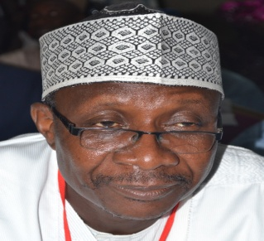 | 9.1 Introduction  The roles of the Department of Social Mobilization, include among other things, carrying out mass mobilization, advocacy and sensitization of the general public, forging partnerships with stakeholders in basic education as well as disseminating various messages of the UBE to the general public for increased awareness, community empowerment, ownership and participation in order to achieve the overall objectives of the compulsory, free universal basic education in Nigeria.  9.2 Departmental structure  The Department has two main units and six sections that are charged with the above-mentioned functions and other related activities of the Commission. The Units and their corresponding sections include:
Alh Usman Aliyu Kaoje.
Director, Department of Social Mobilisation
Alh. Usman Aliyu Kaoje was born on the 23rd November, 1958 in Kaoje town of Bagudo Local Government Area in Kebbi State. He attended LEA Primary School in Koaje town, Gwadabawa Secondary School and proceeded to Usman Danfodio University, Sokoto, where he obtained a B.Sc Degree in Political Science in 1982.
Alhaji Kaoje started his civil service career as an Assistant Secretary in 1983 with Sokoto State Government. By 1995, he joined the services of the defunct National Primary Education Commission as an Assistant Chief Administrative officer and rose to the rank of a Deputy Director Admin by the year 2006. On 1st September 2014, he was appointed the Director of Social Mobilization of the Commission. Alhaji Kaoje is a seasoned Administrator and a Fellow of the Institute of Industrialist and Corporate Administrators.
- Social Mobilization Unit with six sections
  - Advocacy
  - Campaigns and Promotion
  - HIV/AIDS Awareness
  - Special Needs Education
  - Private Operators of Basic Education
  - Good Performance Awards
- Community Development and Empowerment Unit with five sections
  - Community Initiated Self Help Projects
  - Donor intervention/Partnerships
  - Production and Media Relations
  - School Based Management Committees (SBMCs)
  - Non-Governmental Organization (NGOs)
9.3 Functions of the department
- Initiating Social Mobilization policies and Programme especially as they relate to:
- Advocacy, sensitization and mobilization for successful basic education delivery.
- Community empowerment through Self-Help projects and mobilization to promote enrolment, improvement and ownership of the UBE programme.
- Orientating the stakeholders on their duties, obligations and responsibilities in facilitating the implementation of the UBE Programme and understanding its policies drive for increased participation.
- Initiating contacts and programmes towards broadening the network of partnerships with CSOs and other stakeholders at the grassroots.
- Promoting new set of attitude and culture for the attainment of the goals and objectives of the UBE programme.
- Promoting the spirit of dignity of labour, honesty and commitment to qualitative basic education attainment.
- Encouraging formal and non-formal education through public enlightenment and publications that deal with drop-out, withdrawal, inadequate training, etc.
- Liaising with other UBEC professional departments and Government agencies for effective mobilization on the implementation of all basic education related programmes e.g. Girl Child Education, Education of Street Children and other Disadvantaged Groups and Home Grown School Feeding and Health Programme, etc.
- Liaising with/and coordinating the efforts of Government Education Agencies such as NTI, NERDC, NBTE, NETC, NCCE, NABTEB, FMI, etc, local and international organizations and NGOs in the design, production and distribution of public enlightenment and relevant information on UBE.
- Encouraging and promoting the formation and establishment of popular community based organizations in support of UBEC activities such as School Based Management Committees (SBMCs)
- Initiating and implementing programmes such as HIV/AIDS awareness campaign and capacity building for States, LGAs and communities/schools.
- Researching into monitoring and evaluation of advocacy and mobilization strategies.
- Carrying out any other activities that may be assigned by the Executive Secretary.

9.4 Staff disposition
The Department is presently manned by a staff strength of twenty (20) senior officers, viz: one (1) secretariat staff and one (1) driver as shown in the table below.
S/N | DESIGNATION | CONRAISS | NO
1 | Director | 15 | 1
2 | Deputy Director | 14 | 1
3 | Assistant Director | 13 | 2
4 | Asst. Chief Social Mobilization Officer | 11 | 1
5 | Principal Social Mobilization Officer | 10 | 1
6 | Principal Conf. Secretary | 10 | 1
7 | Senior Social Mobilization Officer | 09 | 2
8 | Social Mobilization Officer I | 08 | 1
9 | Social Mobilization Officer II | 07 | 11
10 | Senior Driver | 06 | 1
 | Total |  | 22

9.5 UNITS AND THEIR ACTIVITIES
9.5.1 UBE COMMUNITY INITIATED SELF-HELP PROJECT
9.5.1.1 Introduction
The UBE Community Initiated Self-Help Projects which commenced in 2005 provides a platform for communities working through appropriate community organs such as Parents-Teachers Associations (PTAs) and Community-Based Organizations (CBOs), to initiate, execute and take ownership of designated school projects. Through the programme, UBEC provides financial support for the execution of prioritized school projects that impact positively on access, quality and equity. It further offers opportunities for stakeholder (community and private sector) participation in basic education delivery. Currently beneficiary school/communities receive N1m each for the implementation of prioritized school projects. The Self-help Projects Unit is also responsible for coordinating all aspects of the UBE Community Initiated Self-Help Projects in the States.

9.5.1.2 Functions of the Self-Help Unit
The Unit’s functions revolve solely around planning and implementing community empowerment initiatives known as Self-Help projects for enhancing stakeholder inputs and commitment to school enrolment, learning activities and their outcomes with a view in the eventual ownership of the UBE programme by the communities. This is done through:
- Planning for the allocation of self-help projects to designated beneficiary communities
- Coordinating the listing and pre-verification of potential beneficiaries for projects support fund.
- Disbursement of support funds to beneficiary communities
- Training of self-help Project Implementation Committees (PIC)
- Conduct of monitoring of self-help projects
- Reporting and other necessary services in support of the self-help projects.

9.5.1.3 Constraints/Challenges
The Unit is facing constraints related to inadequate office/work space for its personnel. Additionally, the reports/complaints from SUBEBs and beneficiary communities over funds disbursement are major challenges to the attainment of the Unit’s mandate.
9.5.1.4 Ongoing activities
- Finalization of 2008, 2009 and 2010 projects backlogs that could not be carried out because the beneficiaries access their 1st or and 2nd tranche support funds in good time.
- Oversight supervision of 2011 projects
- Handling reports/complaints on project implementation from SUBEBs especially lack of access to disbursed funds, change of project/location, etc.
9.5.1.5 Future Activities
- Resolution of all issues that are impeding the effective disbursement of 2008, 2009, 2010 and 2011 funds to beneficiary communities 2008, 2009, 2010 and 2011 funding arrangement.
- Completion of all on-going 2007 – 2011 self-help projects.
- Conduct of necessary monitoring of on-going projects.
- A committee was set up by the Executive Secretary for the resuscitation of the Self Help Programme.
- Commencement of the implementation of the 2012 UBE community Initiated Self-Help Projects.
The Unit’s staff are committed to ensuring that, the Self-Help Projects Initiative becomes a veritable tool in mobilizing stakeholder support and ensuring equitable performance among States in UBE delivery. Therefore, with the renewed interest of stakeholders and support from UBEC, the self-help strategy holds a unique future of being a vehicle for the entrenchment of stakeholder participation in basic education delivery through the initiation and implementation of school-based projects.
9.5.2 PRODUCTION AND MEDIA
9.5.2.1 Introduction
The Production and Media Unit provides professional and technical support in aspects of UBE public enlightenment, more especially those related to media production on advocacy, sensitization, community empowerment and mobilization.
      - On-going Activity
The activities of the Unit in the early part of 2014 revolved around providing support to the production and broadcast of the UBE television half-hour programme ‘You and the UBE’ on NTA Network service.
9.5.2.3 Proposed Future Activities
- Expanding the scope of UBE mobilization/enlightenment through collaboration with other electronic and print media for the broadcast and dissemination of UBE messages.
- Replication of on-going broadcast/enlightenment programmes at state level
- Production of light print enlightenment materials; posters, fliers, etc.

9.5.3 THE SPECIAL EDUCATION UNIT
9.5.3.1 Introduction
The Special Education Unit is instituted to supervise and ensure the effective utilization of funds meant for the education of Children with Special Needs according to prescribed UBEC guidelines.
9.5.3.2 Structure
Under the current structure, the Unit is headed by an Assistant Director.
9.5.3.3 Functions
The key functions of the Unit include;
- Sensitization of Public and Private providers of education for Children with Special Needs on the need to access their funds timely;
- Drafting of annual plan/budget for the allocation and disbursement of Special Education funds to Public and Private providers of special education;
- Supervision of the Utilization of the allocated funds to beneficiaries.
- Receiving action plans from Public and Private Providers for accessing the funds and ensuring adherence to UBEC prescribed implementation guidelines;
- Collaborate with the Department of Physical planning in the analysis of action plans submitted by Private and Public providers of education for Children with Special Needs
- Organizing and participating in verification activities to ensure effective and timely utilization of disbursed funds to designated beneficiaries.
- Harmonization of State-by-State Reports of Public and Private providers of Education for Children with Special needs for analysis and subsequent improvement on observed shortcomings.
- Carrying out any other function as may be directed by the Chief Executive of the Commission.
9.5.3.4 Activities
The following activities are undertaken by the Unit:
- Advocacy visits to Key stakeholders, specifically State managers of education of Children with Special Needs.
- Pre-verification of schools to ascertain their eligibility to access the Special Education Fund.
- Verification of implementation status of Special Education projects in beneficiary schools.
- Dissemination of information on disbursement of Special Education funds through mails and subsequent follow-up of such mails.

9.5.3.5 Achievements
The Unit accomplished the following in the year under review:
- Organised and participated in the sensitization visits to States of Anambra, Enugu, Lagos, Ogun, Ondo, and Oyo that have backlogs of un-accessed funds.
- Verified the utilization of 2013 Special Education funds (first tranche) in all the 36 States and FCT with the exception of Enugu, Ondo, and Imo that were yet to access the aforementioned year’s funds.
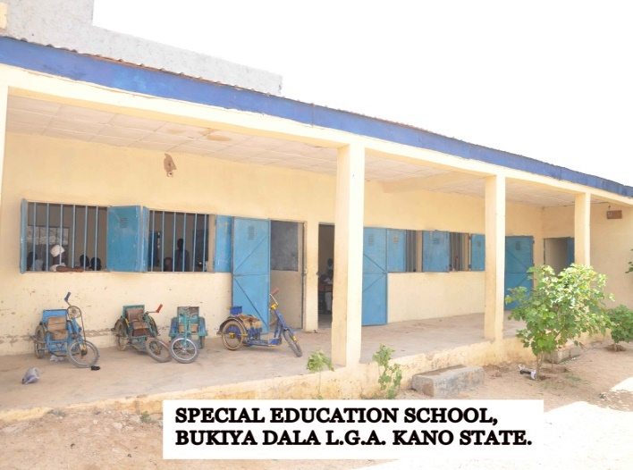 | 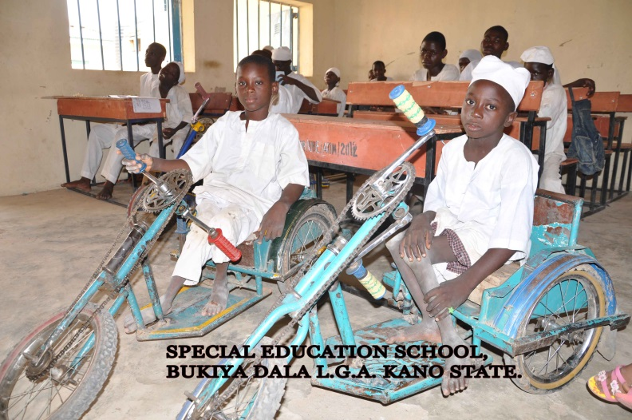
- Through its sensitization programme, States like Anambra, Lagos, Ogun, and Oyo, that had in previous years been unable to access their funds, submitted their Action Plans for accessing their backlog of Special Education funds.
- Disbursed the 2nd tranche of the 2013 Special Education funds to eligible beneficiaries.
9.5.3.6 Constraints
In spite of the above-mentioned achievements, however, the unit encountered the following challenges:
- Inability of some of the Private and Public providers to develop appropriate action plans for accessing the Special Education Fund.
- Inadequate awareness on education of Children with Special Needs in States resulting to indifference among some key stakeholders.
- The reshuffling of SUBEB Chairmen, which necessitates frequent sensitization visits to keep them abreast with the unconditional nature of accessing the Special Education Fund.
- The late release of budget allocations which causes designated year’s project implementation to overlap to another year.
9.5.3.7 On-going Activities
The following activities are on-going:
- final monitoring of the utilization of 2013 2nd tranche Special Education Funds in 31 States.
- collation of 2014 application submitted by Private and Public providers of education for children with Special Needs for verification.
- disbursement of funds to States (Public Schools) who are yet to access their Special Education Fund in the previous years.

7.5.3.8 Future Activities
The Unit intends to carry out the following activities:
- Verification and disbursement of Special Education funds to eligible private providers in the 36 States and FCT for the year 2014.
- Disbursement of funds to public schools who provide education for children with Special Needs and verification of utilization of Such Fund.
- Meetings in the 6 (Six) Geopolitical Zones for desk officers of SUBEBs.
- Collation of data on the education of children with Special Needs in the States.

9.5.4 PRIVATE OPERATORS OF BASIC EDUCATION
9.5.4.1 Introduction
The private operators of Basic Education and other stakeholders in social service delivery have constantly played vital roles in the socio-economic advancement of many developing countries and their interventions have contributed immensely to the educational advancement of many African countries. As part of its responsibilities to set minimum standards for basic education delivery, the Commission is partnering with private providers to ensure such standards are maintained in both public and private schools. The Private Operators of Basic Education Unit is, therefore, established to coordinate such activities.
9.5.4.2 Activities
The Unit made arrangement to hold a National Stakeholders’ Seminar on UBEC Collaboration with private providers to appraise achievements recorded and also fashion a way forward. This could not hold because, there was no budgetary allocation for the activity.
The UBE Commission in the bid to successful implement the UBE programme has identified key institutions whose partnership is relevant in achieving the objectives of the UBE programme.
9.5.5 HOME GROWN AND SCHOOL FEEDING
9.5.5.1 Introduction
The Commission piloted Home Grown and School Feeding in twelve States of the federation and the FCT. After piloting the programme, only two States namely, Kano and Osun sustained the programme.
Now that the Commission is in the process of re-activating the programme, efforts are being made to get the Federal Executive Council through the Federal Ministry of Education to restructure the funding formula of the FGN-UBE Intervention Fund to enable the Commission accommodate the programme.
9.5.5.2 Challenges
The Federal Ministry of Education is yet to respond to the Commission’s request on funding formula, hence, fund is yet to be made available to support the programme for basic education schools across the country.
9.5.5.3 Future Activities
The Commission will support States that indicate interest in embracing the Home Grown School Feeding as soon as fund is made available
9.5.6 GOOD PERFORMANCE AWARD
The Approved Guidelines for the Sharing of the 2% of the FGN Consolidated Revenue Fund set aside 5% of the Fund as grant for Good Performance. The award was introduced to appreciate the State Universal Basic Education Boards (SUBEBs) that are adjudged to be doing well in basic education delivery. It is also aimed at encouraging any SUBEB that is lagging behind to overcome implementation challenges to compete for accessing funds and utilize them judiciously.
9.5.6.1 Activities carried out
No award was given in 2014. However, it is our hope to continue as soon as the challenges that led the suspension are overcome by the Commission.

9.5.7 SCHOOL-BASED MANAGEMENT COMMITTEES (SBMCs)
9.5.7.1 Introduction
The establishment of SBMCs was approved at the National Council on
Education in Ibadan in December, 2005 and the following year, in Calabar
in 2006, the policy was ratified and the then Minister of Education directed that all states of the Federation must have SBMCs in all their Schools. Thereafter, UBEC sent directives to all SUBEBs to have SBMCs in place in all primary and junior secondary schools. While many states have complied with the directive, the SBMCs only exist on paper as they were not as functional and effective as
expected. Not satisfied with the
development, the ESSPIN proposed the establishment of effective
and functional SBMCs as one of the areas of concern for
effective School governance. This, therefore, led to UBEC signing a
Memorandum of Understanding with ESSPIN in order to ensure that
SBMCs become functional in the nations' schools.

9.5.7.2 Activities
4th Level Training (Mentoring and Monitoring) of SBMCs
- After the completion of the 3rd Level Training, which is the training of the actual SBMC members in clusters, the Commission embarked on the 4th level training. This is the mentoring and monitoring of SBMCs in their various communities.
- Conduct of the National Conference on Community Participation in Basic Education Delivery in collaboration with ESSPIN was successfully was carried out.

9.5.7.3 Achievements
- Four (4) UBEC staff per state were trained in Kaduna for 36 states except Borno, for obvious reasons, on mentoring and monitoring of SBMC members in four out of the eight modules.
- The UBEC staff trained replicated the training for Civil Society and Government Partners. (Social mobilization staff at SUBEB and LGEAs). (CGPs) levels
- Some of the SUBEBs have commenced scaling down the training to the SBMC members in different communities.
- The National Conference on SBMC brought together Honourable Commissioners for Education, Chairmen SUBEB, Directors of Social Mobilization and SBMC members to share experiences and suggest ways of ensuring that SBMCs become functional in Nigerian schools. Thirty two States were represented at the conference and a Communiqué which emanated from the conference has since been distributed to States for necessary compliance.
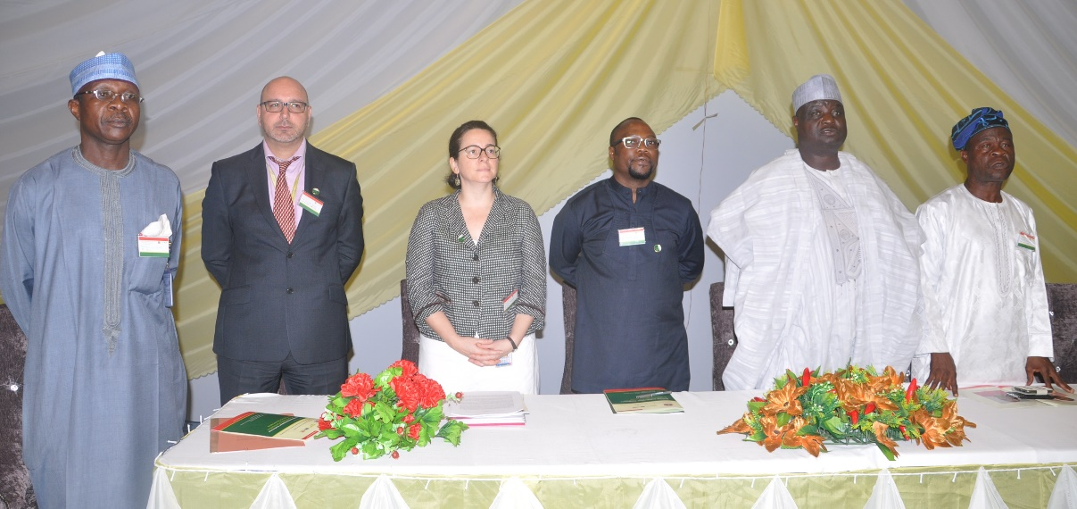
DES(S) UBEC, Dr. Yakubu Gambo (2nd right), DSM UBEC, Alh. Usman Aliyu Kaoje (Left), ESSPIN Officials and other dignitaries at the National Conference on SBMC

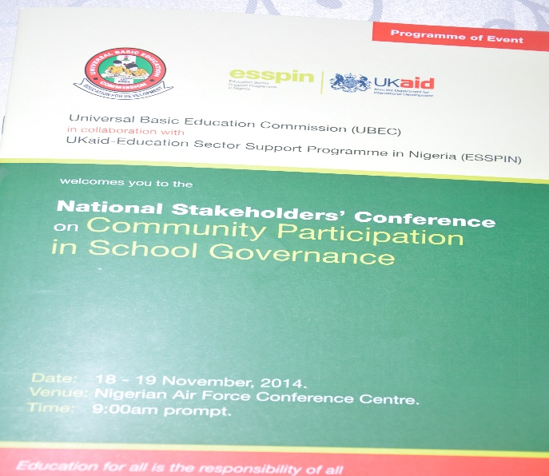 |  | 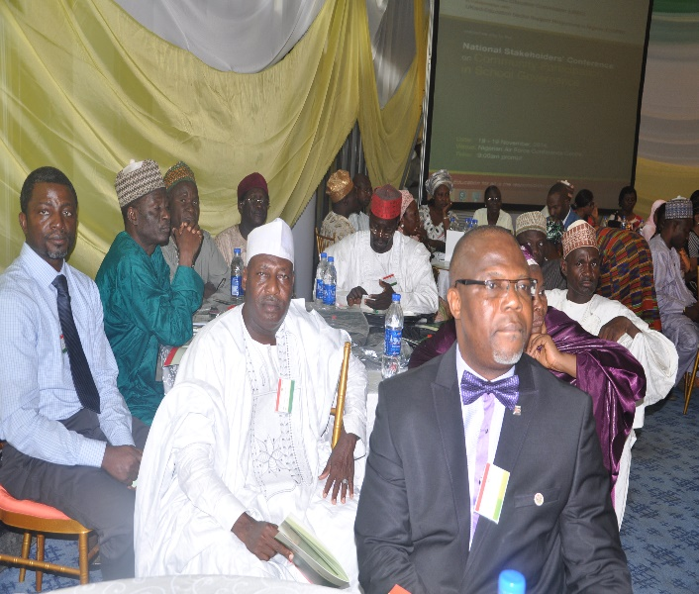
National Conference on SBMC held in Abuja |  | Cross-section of participants at the Conference

9.5.7.4 Constraints
- The fund for the exercise was provided from Teacher Professional Development Funds (TPD) upon submission of action plan. As a result of this, states could not embark on the exercise before the release of TPD fund from UBEC.
- Many SUBEBs were reluctant to release the N10m provided for the TPD fund to carry out the exercise. Some of them release just part of the fund instead of the total sum, which makes completion of the exercise very difficult.
- The fund allocated for CGPs to carry out the exercise was too small compared to the volume of work expected to be done.

9.5.7.5 Ongoing Activities
Mentoring and monitoring exercise is currently going on in states that have received training from UBEC staff.

9.5.7.6 Future Activities
- Train-the-trainers on the remaining four modules on mentoring and monitoring of SBMC members to complete the 4th level training.
- National Conference on Community Participation in Basic Education Delivery.

9.5.8 COLLABORATIONS WITH CIVIL SOCIETY ORGANIZATIONS
Part of the functions of the Department is to initiate contacts and programmes towards broadening the network of partnerships with CSOs and other stakeholders at the grassroots in providing for and participating in the execution, monitoring and evaluating of all basic education programme.
9.5.8.1 Activities of Non-Governmental Organizations (NGOs)/Civil Society Action Coalition on Education for All (CSACEFA) in 2014
- Meeting with CSACEFA Executive members, Zonal representatives with the Deputy Executive Secretary (DES-S). NGOs represented were Connected Development (CODE), AZALEA Initiative, Children and Empowerment Initiative (CAADEI), and Women Right for Education Programme (WREP).
- Meeting with Coalition of Civil Society Groups (Office of the President). Their mission was the evaluation and assessment of 2014 Projects and Programmes of the Commission. The meeting was presided over by the Deputy Executive Secretary (Technical) with all directors in attendance.
- Meeting with The Albino Foundation (TAF). The group requested for funding of a Proposed Five-Year Strategic Plan Development for the foundation. The request was not granted because the plan has no relation with basic education.
9.5.8.2 Achievements
- The initial plan of the team to evaluate UBEC activities had to be put off. It was realized that the activities and programme of UBE Commission are open to public investigation and assessment.
- The meeting enabled the Commission to get acquainted with CSACEFA Executives and representatives of relevant NGOs
- UBEC operations and activities were made clear to the Albino Foundation and subsequently redirected to send request to appropriate agency.
9.5.8.3 Constraints
- NGOs requesting for support are not usually registered with CSACEFA
- The authenticity of some of these NGOs cannot be ascertained as their addresses could not be traced.

9.5.9 COMMUNITY ACCOUNTABILITY TRANSPARENCY INITIATIVE (CATI)
9.5.9.1 Introduction
The Federal Government Reform Programme under SERVICOM is one of the guiding principles and practice for providing unhindered access to information on all forms of public transactions to clients. On the basis of this principle, stakeholders in basic education sub-sectors should be adequately informed of the process, deliverable inputs and interventions provided to communities towards enhancing basic education under the Community Accountability Transparency Initiative (CATI).
9.5.9.2 Achievements under CATI
- Compiled, printed and distributed deliverables from 2006-2009, to
States actors, major stakeholders in UBE implementation and Civil
Society groups.
- Published and distributed the deliverables for 2010 under the CATI activities
in the UBE implementations.
- Completed the compilation of the 2011 deliverables for printing and dissemination.

9.5.9.3 Future Activities: Community Accountability Transparency Initiative (CATI)
- Printing of 2011 CATI document.
- Compilation, printing and distribution of 2012 and 2013 CATI document.

The materials are expected to provide all the information on the Commission’s interventions which are intended to engender feedback from the beneficiary communities on the project execution. The Beneficiary communities have started giving the responses indicating poor quality of work execution, non-existence of some projects and abandoned projects. However, the Commission has since responded to such cases to ascertain the true nature of the complaints and would act on them without delay.

9.5.10 HIV/AIDS
9.5.10.1 Introduction
The Department on behalf of UBEC has continued to collaborate with other relevant agencies in creating awareness on HIV/AIDS, particularly in the area of Curriculum Development for Family Life HIV/AIDS Education (FLHE) and other coordinated HIV/AIDS education initiatives. Sensitization activities that were supposed to be carried out could not take place in 2014.

9.5.10.2 Future Activities on HIV/AIDS
- Building the capacity of States on establishing peer groups in schools.
- Developing strategies for intervention that will support behavioural change among children.
- To promote awareness and education on HIV & AIDS prevention.

9.5.10.3 Challenges
Due to financial constraint being faced by the Commission, there was no budgetary provision for HIV/AIDS in 2014.

9.5.10.4 Way Forward
- Sustained Advocacy for States to buying into the UBE Programme.
- Getting more Stakeholders and private partners involved in UBE process delivery.
- Provision of vehicles for mobilization activities.
- Allocation of more funds to laudable programme such as SBMC from TDP Funds.
- Provision of adequate facilities and equipment to all the constructed Girls’ Model Schools to ensure standard and make the schools girl-child friendly.
- Allocation of more office spaces to the Department.
- SUBEBs to be encouraged to establish functional departments of Social Mobilization.
- Continuous interaction with the Directors of Social Mobilization of SUBEB through biennial and annual meetings.
- Building of capacities of the Communities/SBMCs to effectively monitor self-help projects.
- Increased involvement of SBMCs in key areas of UBE delivery process to include not only Self-Help, but TPD, Textbook distribution, etc.

10.0 DEPARTMENT OF SPECIAL PROGRAMMES

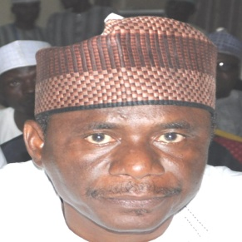 | 10.1 Introduction  The Department was established in the year under review (2014) to co-ordinate and implements all special education programmes in the Commission. The Department collates analyses and presents all special needs of vulnerable children. The Department also prepares strategies on how to achieve sustainable implementation of such programmes in the Commission.  10.2 Structure of the Department  The Department comprises of three major units as follows:  - Girl-Child Education  - Boy-Child Education  - Education Sector Support Programme in Nigeria (ESSPIN)
Alh. Aliyu Kardi
Director, Department of Special Programmes
Alh. Aliyu Kardi was born on 30th September, 1959 in Kardi, Kebbi State. He attended Kardi Primary School and Government Secondary School, Koko, then State College of Art and Science, Sokoto before proceeding to College of Education, Sokoto (1978-1981) where he obtained the NCE. After his National Youth Service, he was employed by Sokoto State Government as a Teacher in 1982. He later gained admission into Bayero University, Kano and graduated with B.A. Sociology and Hausa in 1986.
He developed his career from a classroom teacher, Head Teacher to a Principal Education Officer, and then Chief Education Officer (Development) Primary School Management Board (PSMB) before joining NPEC in 1989. He worked in Owerri, Benin and Uyo as a Senior Monitoring Officer then later in Ibadan Zonal Office as Ag. Zonal Coordinator. In 2001, he was posted to Sokoto as Zonal Coordinator and later transferred to Kaduna Zonal Office in the same capacity. Alh Aliyu Kardi also served as the Special Assistant to DES (T), National Coordinator Almajiri, Director Special Programmes and now Director, Executive Secretary’s Office.
  - Functions
The Department has the following functions:
- Addressing the challenges of lack of access for the Girl-Child in basic education institutions.
- Reducing the existing gender disparity in access and completion ratios of Girl-Child in the country.
- Stimulating and co-ordination of learning achievements of the Girl and Boy-Child education.
- Creating appropriate opportunities for socialization and behavioural moulding along culturally acceptable norms.
- Provision of enabling environment for the integration of Boy-Child into the basic education.
- Co-ordinating the activities of ESSPIN in the Commission in the areas of their intervention.

  - Staff Disposition
S/N | Designation | CONRAISS | Number
1 | Director | 15 | 1
2 | Asst. Chief Programme Officer | 11 | 1
3 | Senior Quality Assurance Officer | 09 | 1
4 | Principal Confidential Secretary | 09 | 1
5 | Computer Programmer II | 07 | 1
6 | Administrative Officer II | 07 | 1
7 | Academic Planning Officer II | 07 | 1
8 | Programme Officer II | 07 | 1
9 | Chief Driver/Mechanic | 06 | 1
Total |  |  | 9

  - Activities
As mentioned earlier, the department is one of the two youngest departments that were added to the Commission’s directorate by the fourth quarter of the year 2014.
Nevertheless, the following activities were carried out during the period under review.
- Monitoring of Construction of Boy-Child vocational centres in Edo, Imo, Anambra, Delta and Akwa-Ibom States.
- Monitoring of Construction of Girl-Child schools in Ebonyi, Nasarawa, Jigawa and Zamfara States.
- Advocacy and Sensitization visits to some major stakeholders to enlighten them on the activities of Boy and Girl Child education in the Commission.

  - Achievements
The following are the achievements recorded by the Department:
- Completion of five (5) Girl-Child schools in Ebonyi, Adamawa, Nasarawa, Jigawa and Zamfara States.

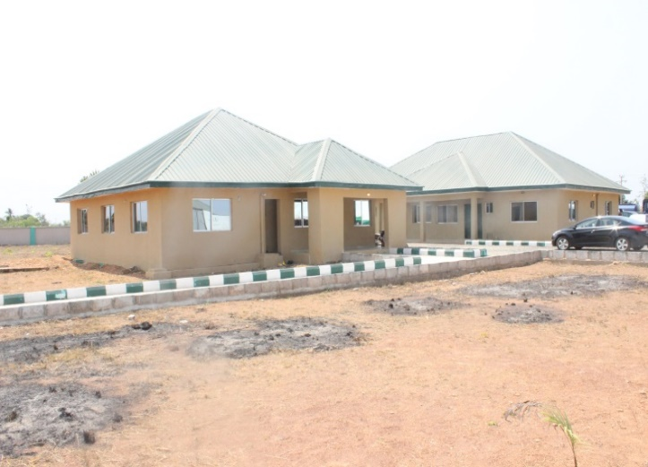 |  | 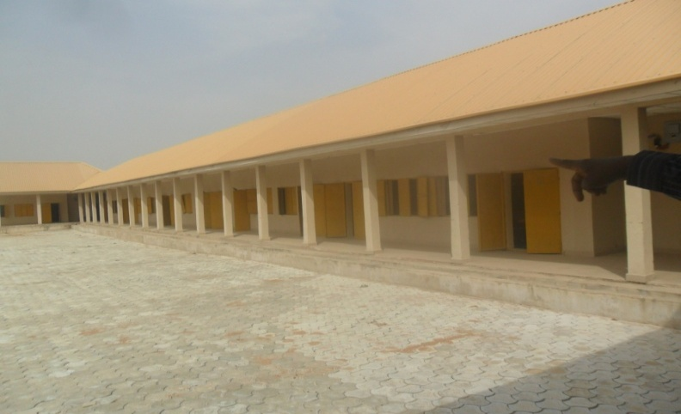
Girl-Child School in Ebonyi |  | Girl-Child School in Adamawa
- 21 new Girl-Child schools were awarded to various Contractors across the Federation.
- Study tour of Boy-Child best practice in vocational education was carried out in Brazil and China.
- Completion of the basic framework for the development of Curriculum for the proposed UBE special vocational schools.

  - Future Plans
The following are the future activities under the Boy and Girl Child Initiative:
- National stakeholders’ summit on Boy and Girl Child Integration.
- Partnership drive at the National and State level to promote the programme.
- 2nd phase of Curriculum Development including editorial and dissemination of the Boy-Child curriculum.
- Finalization of the support framework and partnership details with technical partners for its integration.
- Mass advocacy and sensitization of major stakeholders to key into the Boy and Girl Child Programmes.
- Stakeholders meeting to widen the ESSPIN intervention in the Commission’s programmes in addition to its present intervention on SBMCs.

10.8 Constraints
- Lack of political will by some state governments to fully key into the Boy and Girl-Child Programmes thereby replicating the projects in their states.
- Cultural practices in some states which hamper the full realisation of Girl Child Education.
- Inadequate advocacy and sensitization of communities and major stakeholders on the Boy and Girl Child Education initiatives.
- Inadequate office space for staff of the department.

  - On-Going
- Construction of special vocational centres for the integration of Boy-Child into basic education.
- Construction of Model Girls Schools in Akwa-Ibom, Bayelsa, Cross River, Delta, Ekiti, Kaduna, Rivers and Yobe States.

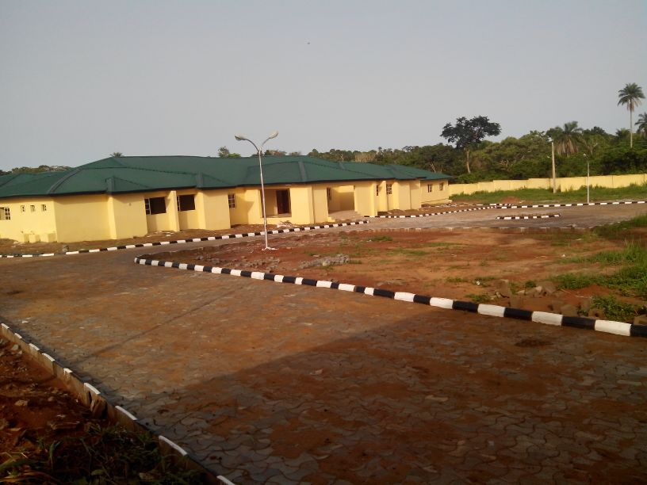
A Girl Child Junior Secondary School in Ekiti State

- Award of 21 Model Girls’ Schools across the Federation.

10.10 Conclusion
As a newly established Department in the Commission, the Department was able to carry out all its statutory duties during the short period of its existence. Although there are a lot of challenges facing the Department, the lack of accommodation was the most prominent. It is the hope and conviction of the department that most of these challenges will be surmounted in the coming year.

