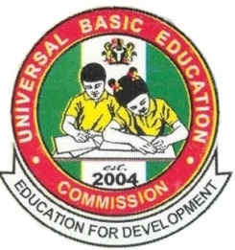

2015 Annual Report

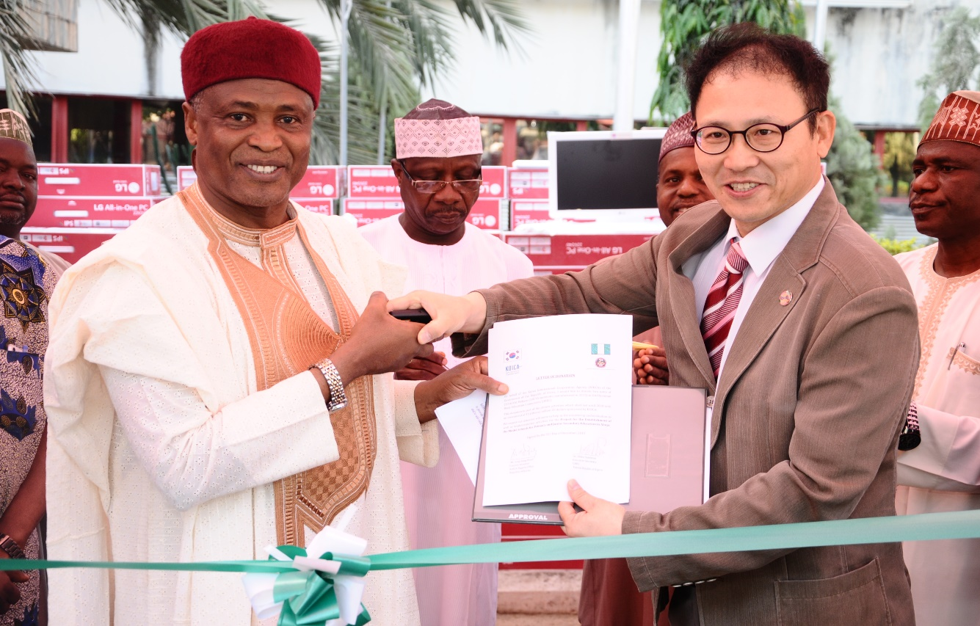

UNIVERSAL BASIC EDUCATION COMMISSION

UBEC
2015
Annual Report

UNIVERSAL BASIC EDUCATION COMMISSION
UBEC Building, No. 7, Gwani Street
Wuse Zone 4, PMB 5086
Post Code 900284, Abuja – Nigeria
www.ubeconline.com
ubenigeria@yahoo.com

Education for All is the Responsibility of All

UNIVERSAL BASIC EDUCATION COMMISSION

Published by

Universal Basic Education Commission
No. 7, Gwani Street, Wuse Zone 4,
Abuja

© UBEC 2016

Except for purely academic purposes, this report may not be reproduced in part or in full or stored in a retrieval system or transmitted in any form or by any means: electronic, mechanical, photocopying, recording or otherwise without the consent of the copyright owner.

ISBN-10 978-52285-4-1
ISBN-13 978-978-52285-4-0
EAN-9789785228540

UNIVERSAL BASIC EDUCATION COMMISSION
TABLE OF CONTENT
Table of Content …………………………………………………………..……... iv
Acronyms………………………………………………………………………….. v
UBE Vision Statement ………………………………………………………..…...x
UBE Mission Statement ….…………………………………………………..….. .x
UBE Core Values …………………………………………………………...……..x
Foreword………………………………………………………………………….xi
Management Team………………………………………………………………xiii
Zonal Directors…………………………………………………………………...xvi

SECTION 1:
OFFICE OF THE EXECUTIVE SECRETARY
Introduction….………………………………………………………………..........1
Office of the Executive Secretary …………………………………………….…... 3
Internal Audit Unit ………………………………………………………….…....19
Public Relations & Protocol Unit ………………………………………….….…24
Procurement Unit …………………………………………………………….….29
Special Projects Unit …………………………………………………………..…34
Legal Unit ……………………………………………………………………..… 41
Servicom Unit………………………………………………………………….… 45
Tsangaya Education Programme Unit …..………………………………….…...48
Federal Teachers’ Scheme ………………………………………………………..52
SECTION 2:
DEPARTMENTAL REPORTS
Academic Services …………………..………………………………………….. 56
Administration and Supplies ……………………………………………………66
UNIVERSAL BASIC EDUCATION COMMISSION
Finance and Accounts …………………………………………………….............74
Physical Planning ………………………………………………………………..85
Planning, Research and Statistics ……………………………………………......90
Quality Assurance ……………………………………………………………....103
Social Mobilization ………………………………………………………............129
Special Programmes ……………………………………………………….. …..137

UNIVERSAL BASIC EDUCATION COMMISSION
ACRONYMS
AIDS - Acquired Immune Deficiency Syndrome
AIT - African Independent Television
APER - Annual Performance in Evaluation Report
AZALEA - AZALEA Initiatives
BMIS - Book Management Information System
CA - Continuous Assessment
CAADEI - Children and Adult Empowerment Initiative
CATI - Community Accountability and Transparency Initiative
CBECC - Community-Based Early Childcare Center
CBOs - Community-Based Organizations
CGPs - Civil Society and Government Partners
CIDA - Canadian International Development Agency
CODE - Connected Development
COMPRO - Combined Promotion and Confirmation Examination
CONRAISS - Consolidated Research and Allied Institutions Salary Structure
CRF - Consolidated Revenue Fund
CSACEFA - Civil Society Action Coalition on Education for All
DFID - Department for International Development
DLIs - Disbursement Linked Indicators
DRG - Debt Relief Grants
EAC - Educate a child
ECAN - Education Correspondence Association of Nigeria
ECCDE - Early Childhood Care Development and Education
ECD - Early Child Development
UNIVERSAL BASIC EDUCATION COMMISSION
EDOREN - Education Data, Operational Research and Evaluation in
Nigeria
EFA - Education for All
EMIS - Education Management Information System
ESSPIN - Education Sector Support Program in Nigeria
FCT - Federal Capital Territory
FGN - Federal Government of Nigeria
FMBN - Federal Mortgage Bank of Nigeria
FME - Federal Ministry of Education
FMF - Federal Ministry of Finance
FMI - Federal Ministry of Information
FRCN - Federal Radio Corporation of Nigeria
FTS - Federal Teachers’ Scheme
G&C - Guidance and Counseling
GPE - Global Partnership for Education
GTC - Global Training Consulting
ICT - Information and Communication Technology
IDB - Islamic Development Bank
IDPs - International Development Partners
IGR - Internally Generated Revenue
IPSAS - International Public Sector Accounting Standard
JCCE - Joint Consultative Committee on Education
JICA - Japan International Cooperation Agency
JSS - Junior Secondary School
KOICA - Korea International Cooperation Agency
KPI - Key Performance Indicator
UNIVERSAL BASIC EDUCATION COMMISSION
LAN - Local Area Network
LGEA - Local Government Education Authority
MDGs - Millennium Development Goals
MSAP - Modern Statistical Application Packages
NABTEB - National Business and Technical Examinations Board
NALABE - National Assessment of Learning Achievement in Basic
Education
NBTE - National Board for Technical Education
NCCE - National Commission for Colleges of Education
NCE - Nigeria Certificate in Education
NCOA - National Chart of Account
NEI - Northern Education Initiative
NERDC - Nigerian Educational Research and Development Council
NETC - National Education Technical Commission
NGOs - Non – Governmental Organizations
NHIS - National Housing Insurance Scheme
NIEPA - National Institute for Educational Planning and
Administration
NIIMP - National Integrated Infrastructure Master Plan
NPC - National Population Commission
NTA - Nigerian Television Authority
NTI - National Teachers Institute
NUT - National Union of Teachers
NYSC - National Youth Service Corp
PIC - Project Implementation Committees
PSDN - President’s Schools Debate of Nigeria
UNIVERSAL BASIC EDUCATION COMMISSION
PTA - Parent – Teachers Associations
SBMC - School-Based Management Committee
SEPIP - State Education Programme Investment Project
SERVICOM- Service Compact
SMASE - Strengthening of Mathematics and Science Education
STVEP - Skills Training and Vocational Education Project
SUBEBs - State Universal Basic Education Boards
TAF - The Albino Foundation
TETFund - Tertiary Education Trust Fund
TKT - Teaching Knowledge Test
TPD - Teacher Professional Development
UBE - Universal Basic Education
UNCAP - Unified National Continuous Assessment Programme
UNCPD - United Nations Commission on Population and Development
UNICEF - United Nations International Children Education Fund
USAID - United States Agency for International Development
WREP - Women Rights for Education Programme

UNIVERSAL BASIC EDUCATION COMMISSION

VISION OF THE COMMISSION
To be a world class education intervention and
regulatory agency for the promotion of uniform,
qualitative and functional basic education.

MISSION OF THE COMMISSION
The Commission shall operate as an intervention, coordinating and monitoring Agency to progressively improve the capacity of States, Local Government Agencies and Communities in the provision of unfettered access to high quality basic education in Nigeria.

CORE VALUES OF THE COMMISSION
- Honesty and Accountability
- Integrity and Transparency
- Teamwork with Commitment

UNIVERSAL BASIC EDUCATION COMMISSION
FOREWORD
Provision of basic education to every Nigerian child remains a collective efforts by government at all levels. This collaboration between the Local Government Education Authorities (LGEAs), State Universal Basic Education Boards (SUBEBs) and Universal Basic Education Commission (UBEC) was tremendous in 2015. Some of such collaborations among others included the meetings of all SUBEB Directors-in-charge of Strategic Planning and Quarterly Meetings of the UBEC Management with SUBEB Chairmen.
The Universal Basic Education Commission in the year under review and in line with its mandate, tailored its functions towards creating access, quality and equity in basic education sub-sector in Nigeria. This has been done to a large extent, in spite of daunting challenges facing the economy of the country.
This annual report highlights the activities of various Departments and Units of the Commission to ensure unfettered access to quality basic education is attained by every school age-going Nigerian child. The staff of the Commission have also at different fora, both nationally and internationally, represented the nation and delivered speeches on issues related to advancement of basic education. These mediums were used to share and adopt best practices on way forward for effective service delivery of basic education in the Country.
All the Departments and Units of the Commission made several efforts at ensuring that the mandates of the Commission are achieved. Programmes and projects undertaken included the construction and renovation of classrooms, provision of furniture and ICT equipment, provision of Instructional Materials, Quality Assurance of Basic Education Institutions and training of teachers. The Commission also collaborated with International Development Partners (IDPs) to further the improvement of the UBE Programme’s service delivery.
In spite of numerous successes achieved by the Commission during the course of the year, the UBE programme was faced with many challenges in the course of its implementation. These challenges include:
- shortage of qualified teachers in the States,
- inability of some States to access the FG-UBE Matching Grants,

UNIVERSAL BASIC EDUCATION COMMISSION
- unreliable and inaccurate basic education data supplied by SUBEBs which in turn affects the position of Management in taking informed decisions.
Whilst acknowledging the impressive strides achieved by the Commission in the year under review, extra efforts will be geared towards the attainment of improved performance and service delivery in the basic education sub-sector. The Commission, as much as possible, whilst using the Road Map as a guide, will endeavour to have sufficient and improved deliverables as identifiable outputs and outcomes in the implementation of basic education from 2016 up to year 2020.
The Commission is working towards re-building of basic education infrastructure in Adamawa, Borno and Yobe States, where countless schools were destroyed by insurgents. A paper on the re-building process was presented in August 2015 by the Executive Secretary to the President of the Federal Republic of Nigeria.
The successes recorded by the Commission all through the year, would not have been possible without the support and contributions of all basic education stakeholders. I want to use this opportunity to express my profound appreciation to them and look forward for more partnership in the years to come. It is indeed a demonstration of the fact that, “Education for All, is the Responsibility of All”.
In line with the change agenda of the Federal Government, we hope, in the coming year, to make more profound impact in the basic education sub-sector which will lead to an improvement in the quality of service delivery in all our public primary and secondary schools.

Alh. (Dr.) Suleiman Dikko
Executive Secretary

UNIVERSAL BASIC EDUCATION COMMISSION

MANAGEMENT TEAM

 | 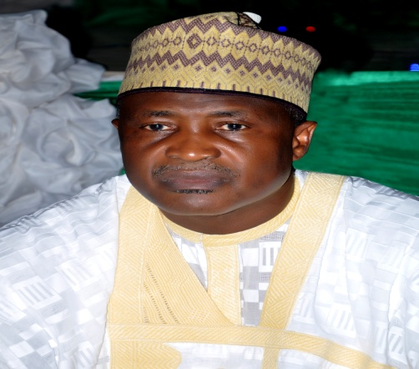
 |  | 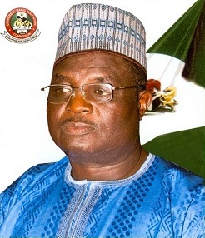
 | ALH. (DR.)  DIKKO SULEIMAN  EXECUTIVE SECRETARY | DR YAKUBU GAMBO  DEPUTY EXECUTIVE SECRETARY (SERVICES)

UNIVERSAL BASIC EDUCATION COMMISSION
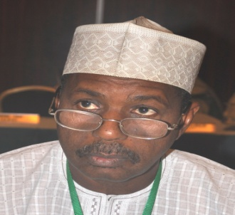 |  | 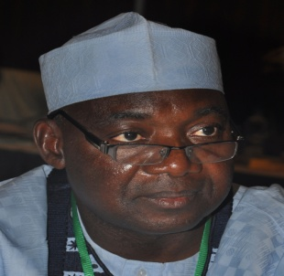 |  | 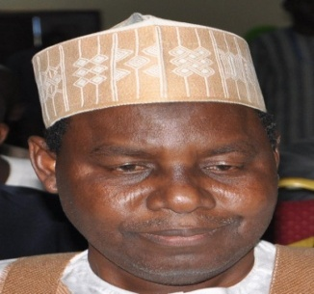
Baba Sali Song  Director, Department of Admin. & Supplies |  | Alh. Bello Kagara  Director, Department of Planning,  Research & Statistics |  | Alh. M. S. Dukku  Director, Department of  Finance & Accounts

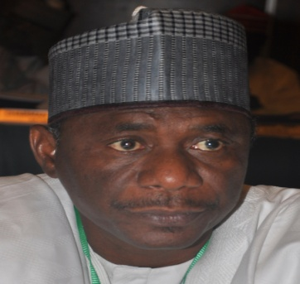 |  | 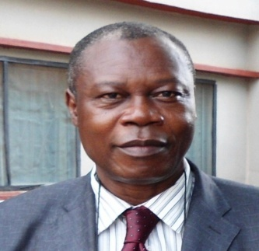 |  | 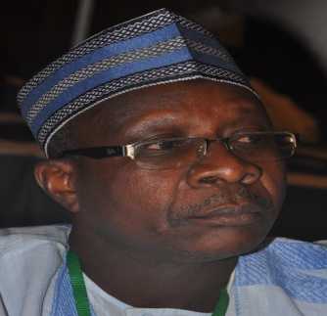
Alh. Aliyu Kardi  Director, Executive Secretary’s Office |  | Mr Pius Osaghae  Director, Department of Academic Services |  | Alh. Usman Aliyu Kaoje  Director, Department of Social Mobilization

UNIVERSAL BASIC EDUCATION COMMISSION

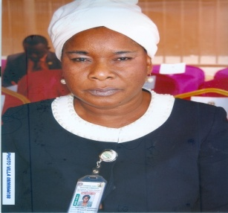 |  | 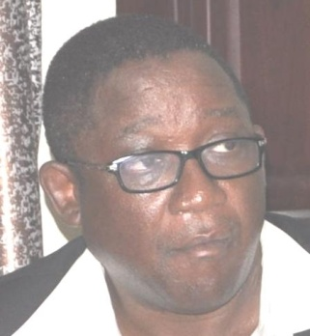 |  | 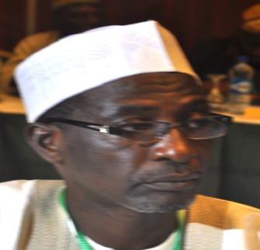
Dr. T. T. Onosode  Ag. Director, Department of Quality Assurance |  | Arc. M. M. Muftwang  Director, Department of Physical Planning |  | Alh Dauda Alhassan  Ag. Director, Department of Special Programmes

UNIVERSAL BASIC EDUCATION COMMISSION
ZONAL DIRECTORS

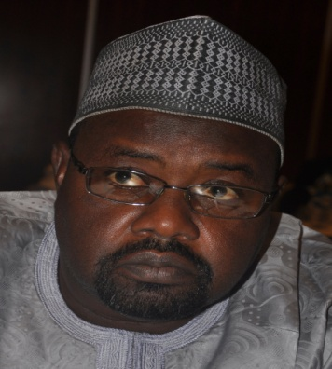 |  | 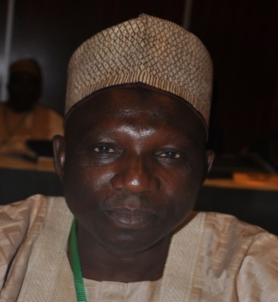
Alh. MansirIdris  Zonal Director, North-West |  | Alh. Jibo Abdullahi  Zonal Director, North-East
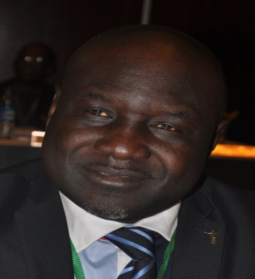 |  | 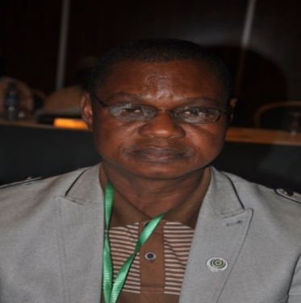
Bishop Edwin Jarumai  Zonal Director, North Central |  | Mr. Victor Madubuko  Acting Zonal Director, South-East
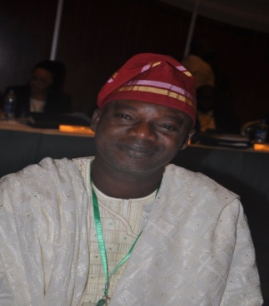 |  | 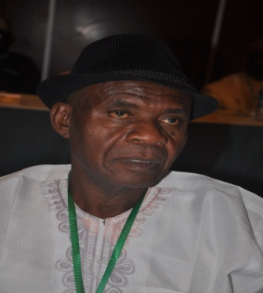
Mr. J. O. Toluju  Acting Zonal Director, South-West |  | Mr. Emeka Nderibe  Acting Zonal Director, South-South

2015 ANNUAL REPORT
INTRODUCTION
The Nigerian Government has made basic education one of its focal areas to be addressed with the coming of this new administration. The Millennium Development Goals (MDGs) metamorphosed into the Sustainable Development Goals (SDGs) and has one of its goals as ensuring inclusive and equitable quality education and promoting lifelong learning opportunities for all. In the light of this, the UBE Commission continues to work tirelessly to achieve effective implementation of basic education in Nigeria.
The Management, in its quest to provide direction and a systematic approach to UBE programme implementation, during the year, developed a 5-year Road Map (2015-2020) document, with the aim of addressing notable system challenges, entrenching strategic planning as a process and ensuring result-oriented implementation of the UBE programme at all levels.
In order to improve quality education and imbibe reading culture in basic education schools, the following instructional materials were procured and distributed:
- 2,220,000 copies of JSS 1-3 textbooks in Basic Science and Technology.
- 256,200 copies of Library Resource Materials for JSS.
- 518,000 copies of Social Studies, English and Mathematics for ECCDE.
Also, to improve quality of teaching and learning in schools, teachers and education managers at both State and Local Government levels, undertook capacity building trainings on various aspects relating to effective teaching and learning. The outcome these trainings are as follows:
- 30,426 teachers’ & 9,290 education managers.
- 27,000 teachers/trainers on SMASE training in 22 States and FCT.
- 168 Teachers & Proprietors of Model III Tsangaya schools on management of schools, implementation of curriculum and methodology in Minna, Niger State.
Additional school infrastructure and school facilities were provided in several schools across the six geo-political zones. These included:
- Construction of 4 Model I schools & 2 ICT Centres in Adamawa, Sokoto & Kaduna States,
- Procurement of 41,900 number of feeding/kitchen utensils for Tsangaya model schools,
- Provision 6,500 sets of school uniforms, for Tsangaya model schools.
In view of the need for more partnership and investment towards the development of basic education service delivery, the Commission took delivery of 2 project vehicles from the World Bank Office to support State Education Programme Investment Project (SEPIP). The Korean International Cooperation Agency (KOICA) donated Information Technology (IT) Equipments (Computers, Printers and Copier machines) to schools constructed by them in Gombe, Adamawa, Katsina and Kogi States and Project Monitoring Vehicles. Universal Learning Solutions (USL) provided over N2 billion worth of free teachers and pupils workbooks and trainings for 12,120 Primaries 1 & 2 teachers, 876 SUBEB/LGEA Officials. USL also provided 1,057,854 Primaries 1 & 2 Workbooks and 32,961 Teacher books provided.

OFFICE OF EXECUTIVE SECRETARY
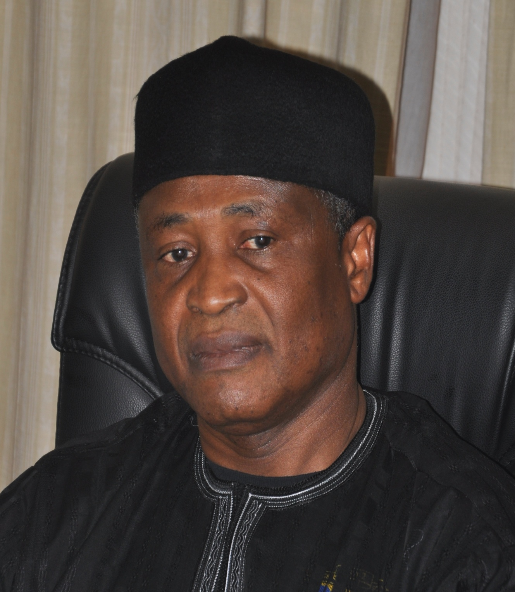
ALH. (DR.) DIKKO SULEIMAN
EXECUTIVE SECRETARY
Alhaji (Dr.) Dikko Suleiman was born in 1957 and hails from Danmusa Local Government Area of Katsina State. He holds the Grade Two Teacher’s Certificate (GR II), National Certificate in Education (NCE), Bachelor’s Degree in Education Art (B. A. Ed), Master’s Degree (M. Ed) in Developmental Psychology and a Ph.D. in Child Development.

Dr. Dikko is a prolific writer and has authored several professional educational books including Developmental Psychology; Human Learning, Psychology of Child Rearing; Psychology of Abnormal Personality; Beginning Psychology and Concise Guidance and Counseling Practices; and Fundamentals of Guidance and Counseling Practices, etc.
Arising from his educational pedigree, Dikko has served in many strategic educational and administrative capacities and has utilized his rich academic and professional background in contributing to the formulation and implementation of educational policies in Nigeria. As a teacher and administrator of outstanding repute, he has served as a member of the Standing Committee on Implementation of Public/Private Partnership in the Provision of Students Hostel Accommodation in FCE, Katsina; Staff Development Committee, FCE Katsina; Students Screening Committee, FCE Katsina and was Chairman, FCE Katsina Staff School Management Committee; Chairman, Primary School Management Committee; Dean, Students Affairs and Provost, Katsina State College of Education, etc. He was the Executive Chairman of Katsina State Universal Basic Education Board (SUBEB) prior to his appointment as Executive Secretary of UBEC in November, 2013.

His current tenure at UBEC has witnessed the innovation of result-oriented mechanisms for the implementation of the UBE programme in line with global best practices. Laying much emphasis on staff welfare and professionalism, he is working assiduously with his Management team towards repositioning the UBE Commission and making it more responsive to delivering the objectives of the UBE programme. His vision in this regard has led to uplifting the status of the Zonal Offices to directorates, creating two additional directorates at the UBEC Headquarters and improving the salary package of the Commissions’ workforce, amongst others. He has initiated sustainable partnerships with International Development Partners (IDPs) such as UNESCO, Japan International Cooperation Agency (JICA), Korea International Cooperation Agency (KOICA), British Council, The Commonwealth of Learning (COL), etc, in developing the basic education sub-sector.
Dr. Dikko is widely travelled and is a recipient of several National and International Awards. He is happily married and blessed with children.

DR. YAKUBU GAMBO
DEPUTY EXECUTIVE SECRETARY (SERVICES)
UNIVERSAL BASIC EDUCATION COMMISSION
Dr. Yakubu Gambo was born 15th June, 1960 in Talbushi, Kanam Local Government Area, Plateau State. A native of Jahr Chiefdom, Dr. Yakubu attended Central Primary School, Gyangayang from 1970 - 1977, Government Teachers’ College, Garkawa (1982) and graduated with a Teachers’ Grade II Certificate. He also obtained his Nigeria Certificate in Education from College of Education, Gindiri in 1987.  Dr. Gambo furthered his education in University of Jos and graduated with a B.Sc degree in Education (1997). His quest for knowledge led him to undertake a Master’s Degree in International Relations and Strategic Studies (2000). He also has a Doctor of Philosophy in Political Science from Bayero University, Kano (2010).  Prior to his appointment as Deputy Executive Secretary (Services) of Universal Basic Education Commission in 2013, Dr. Gambo has served in many committees, which amongst others include Committee of Elders Forum, Plateau State; Presidential Committee on COJA; National Political Reform Conference, Abuja and was Coordinator, Presidential Campaign Organisation. He also engages in writing and has published many books and articles both nationally and internationally.  He is a recipient of many prize awards and recognitions such as Best Local Government Administrator in Projects Implementation in Plateau State; Award of Excellence in Educational Planning, University of Jos and Best Agric Commissioner in Plateau State; amongst others.  Dr. Gambo enjoys reading and research. He is a farmer, politician and happily married with children. | Dr. Sharon ‘Rowo Oriero-Oviemuno was born in Lagos State and hails from Isoko South Local Government Area of Delta State. She attended Anglican Girls Grammar School also known as Adesuwa Grammar School Benin City (1977/78) after which she attended the College of Education, Benin City (1981/82) as the Pioneer Set. Dr. Sharon then furthered her studies in University of Benin and graduated with a B.Sc Geography & Regional Planning/Education (1985/86).  Dr. Sharon, in her pursuit of knowledge, went further to attain her Master’s Degree in Education from the University of Ibadan (1986/87), focusing on Personnel Management. This achievement led to her going for her PhD in the same University (2002/2003) where her research work focused on Personnel Management/Human Resources Management and Development/Gender Studies.  Her giant strides in the field of education resulted in her appointment by the former President Goodluck Ebele Jonathan as the Deputy Executive Secretary (Technical), Universal Basic Education Commission. She has previously worked as a Banker, Management Consultant, and served on different Federal Government Governing Boards including UBEC. She is a mobilizer and motivator of youths/children, women and men to mention but a few.  Dr. Sharon is a Chartered Manager and a Fellow of IPMD, a member of Nigerian Institute of Management and Institute of Policy Management Development. She has numerous awards attached to her and is happily married with children.

THE OFFICE OF THE EXECUTIVE SECRETARY
The Executive Secretary, as the Chief Executive and Accounting Officer of the Commission, is responsible for its day-to-day administration. He is assisted by two Deputy Executive Secretaries (Technical and Services) and is answerable to the Board and the Honourable Minister of Education. There are 8 Units in the Office of the Executive Secretary.
STRUCTURE
Fig. 1 shows the structuring of the Office of the Executive Secretary
Executive Secretary

Deputy Executive Secretary (Services)

Deputy Executive Secretary (Technical)

Federal Teachers Scheme (FTS) Unit
Almajirai Programme Unit

SERVICOM Unit

Legal Unit

Special Projects Unit

Procurement Unit

Internal Audit Unit

Public Relations & Protocol Unit

Fig. 1: Organogram of the Office of the Executive Secretary

FUNCTIONS
The functions of the Office of the Executive Secretary include among others:
- formulating and coordinating the execution of policy guidelines for the successful operation of the UBE Programme nationwide;
- ensuring the timely receipt of block grant from the Federal Government and allocating to States and other related Agencies implementing the UBE Programme in accordance with an approved formula;
- inquiring into and advising the Federal Government, through the Honourable Minister of Education, on the effective funding and orderly development of basic education in Nigeria;
- efficient collation and preparation of periodic master plans for a balanced and coordinated development of basic education in Nigeria;
- ensuring effective monitoring of Federal Government inputs into the implementation of basic education;
- presenting periodic progress reports on the implementation of the UBE Programme to Mr. President through the Honourable Minister of Education
- liaising with the Honourable Minister of Education on matters of implementation, funding and general management of the UBE Programme;
- liaising with the Presidency and National Assembly from time to time on the funding and implementation of the programme;
- sustaining cordial relationship and cooperation with SUBEBs, State Governments and other stakeholders;
- pursuing enrolment campaigns and programme implementation to achieve UBE’s set objectives and goals; and
- supervising activities in the Special Projects, Federal Teachers Scheme (FTS), Internal Audit, Legal, Public Relations/Protocol, Procurement, SERVICOM and Almajiri Education Programme Units.

STAFF DISPOSITION IN ES’ OFFICE
S/N | RANK/DESIGNATION | CONRAISS | NUMBER
 | Executive Secretary | Consolidated | 1
 | Deputy Executive Secretary (Technical) | Consolidated | 1
 | Deputy Executive Secretary (Services) | Consolidated | 1
 | Director | 15 | 1
 | SA to ES, National Coordinator (FTS), Deputy Director | 14 | 4
 | Asst. Director | 13 | 4
 | Chief Confidential Secretary, Chief Public Relations Officer, Chief Prog. Officer, Chief Internal Auditor | 12 | 4
 | Chief Data Processing Officer, Legal Adviser, Asst. Chief Protocol Officer, Asst. Chief (Procurement), Asst. Chief, Asst. Chief Internal Auditor, Asst. Chief Quality Assurance Officer | 12 | 7
 | Project Officer, Prin. Confidential Sec., Principal Legal Officer, Prin. Internal Auditor, Principal Quality Assurance Officer | 10 | 6
 | Senior Legal Officer, Senior Internal Auditor | 08 | 4
 | Admin Officer I, Legal Officer, Information Officer I, Computer Programmer, Quality Assurance Officer I | 08 | 7
 | Higher Executive Officer Protocol, Planning Officer II, Protocol Officer II, Prin. Officer, Information Officer II, Admin Officer II (Procurement), Auditor II, Confidential Secretary | 07 | 8
 | Asst. Executive Officer (Admin II), Asst. Executive Officer (Admin), Senior Clerical Officer I, Camera Man | 06 | 5
 | Clerical Officers | 03 | 2
TOTAL |  |  | 55

ACHIEVEMENTS
The Universal Basic Education Commission as usual, during the year under review, apart from sustaining the past achievements, continued to work out plans to ensure the effective implementation of UBE programme in Nigeria. The year 2015 recorded a lot of organized UBE activities and sustenance of collaboration between Federal/State Government Agencies and International Development Partners in the basic education sub-sector. The Commission recorded a lot of deliverables in 2015.
During the year under review, the Executive Secretary represented the Commission nationally and internationally; made remarks, presented papers and delivered addresses on various topics related to the implementation of UBE programme at different fora. These included the following:
- The national Flag-Off Ceremony of the Distribution of Instructional Materials for Public Basic Education Schools in Nigeria, held in Katsina State in March, 2015.
- Implication of NCE Teacher Education Restructure for Primary Education: A Paper Presented on the Occasion of the Silver Jubilee Celebration of the National Commission for Colleges of Education (NCCE), 2015.
- The Opening of the Training Programme for Quality Assurance Officers by Ekiti State Universal Basic Education Board, in Ado-Ekiti, Ekiti State, on Monday, 20th April, 2015.
- Goodwill Message at a One-Day Annual Review Meeting of All Registrars/Chief Executive Officers of States and FCT Examination Bodies on Harmonization and Standardization of Basic Education Certificate Examination (BECE), on Tuesday, 21st April, 2015.
- 5-Day Training Workshop for UBEC Staff on the Monitoring, Evaluation and Quality Assurance of Teacher Professional Development (TPD) – Phase I, at Hamdala Hotel, Kaduna, from 18th to 22nd May, 2015.
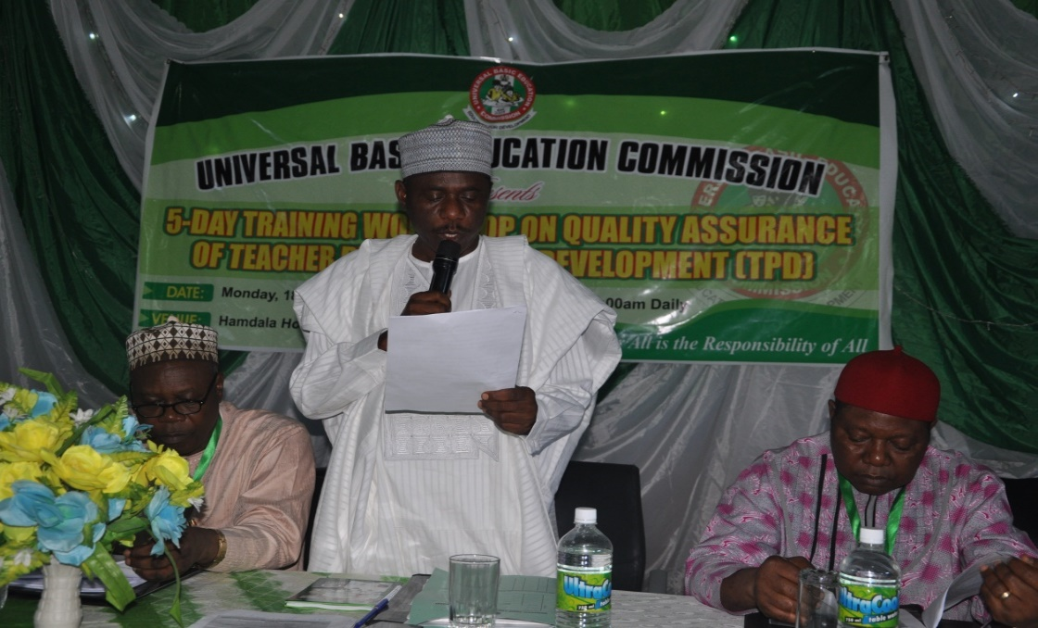
Alh. Aliyu Kardi, Director (ES Office) delivering the ES Speech at the Workshop

- 5-Day First Level Training of Almajiri Schools State Desk Officers and LGEAs Focal Persons on School Based Management Committees (SBMCs), held from 25th to 29th May, 2015, at Havista Hotel, Abuja.
- Opening of the Workshop for Directors, Desk Officers, LGEA Supervisors and Training Institutions on the Implementation of Teacher Professional Development (TPD) held at Parkview Hotel, Abuja, on the 8th to 12th and 15th to 19th June, 2015.
- Opening of the Workshop on Vetting, Serialization and Sorting of Test Items for the Development of an Item Bank for Basic Education in Nigeria, held at NUT Endwell Conference Hotel, Kaduna, Kaduna State, from 29thJune, 2015 – 5th July, 2015.
- Opening ceremony of a Training Workshop Programme for SUBEB SERVICOM Desk Officers, held at Abuja on 22nd July, 2015.
- One-Day Meeting of UBEC Management with Zonal Directors on Schedule of Duties, at the Conference Hall, UBEC Headquarters, Abuja, on the 21st July, 2015.
- Goodwill Message at the Flag-Off/Earth Breaking of the Construction of Classrooms for Selected Primary Schools in Oyo State by the Japan International Cooperation Agency (JICA), on Wednesday, 12th August, 2015.
- Position Paper on Home Grown School Feeding& Health Programme (HGSF&HP) in Nigeria, in August 2015.
- Critical Issues in Nigeria’s Educational System: Stakeholders’ Perspective with Focus on Basic Education, a Paper Presented at the National Institute for Policy and Strategic Studies, Kuru, Jos, Nigeria – Senior Executive Course (Sec) No. 37, 2015, on August 24, 2015.
- Brief on Universal Basic Education, presented to Participants of Senior Executive Course (SEC) No. 37, NIPSS 2015 when on a Visit to UBEC, on Thursday, 27th August, 2015.
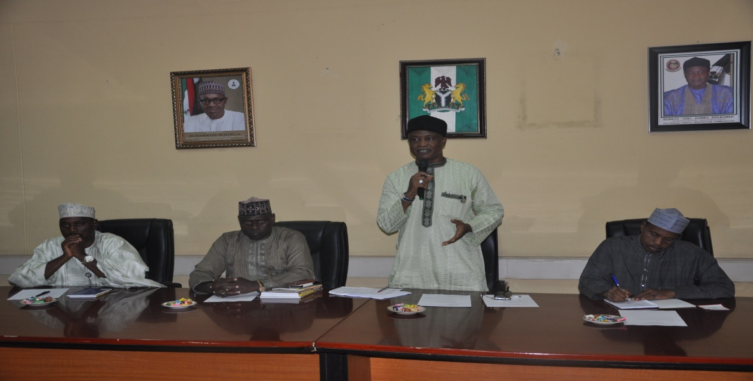
The ES giving a Speech during the visit of Senior Executive Course (SEC) No. 37, NIPSS 2015 to UBEC
- Goodwill Message Presented at the Seminar/Workshop on: Bringing Back the Old Glory in Public Schools, organised by Kogi SUBEB on Wednesday, 26th August, 2015.
- Position Paper on the Rebuilding of Basic Education in Post-Boko Haram Insurgency in the North East States of Adamawa, Borno and Yobe States, Presented toThe President and Commander-in-Chief of the Armed Forces of the Federal Republic of Nigeria, in August 2015.
- Courtesy Visit of National Association of Nigerian Colleges of Education Students (NANCES), on August 31, 2015.
- Flag-Off Ceremony for the Distribution of Plastic Desks and Chairs to Schools, held in Oshogbo, Osun State, on Tuesday, 8th September, 2015.
- Computerized Election Process as a Panacea for Electoral Fraud and Corruption in Nigeria, being a Keynote Address at a Workshop on Optimized ICT as a Panacea for Electoral Fraud and Corruption in Nigeria, Organized by The Civil Society Union of Nigeria, in Abuja, on Tuesday, 22nd September, 2015.
- The Universal Basic Education (UBE) Programme and its Flagship Interventions for Addressing the School Dropout Syndrome in Nigeria: A Position Paper/Information Brochure presented at the 2015 International School Dropout Prevention Summit, Washington DC, United States of America, on September 9 – 11, 2015.
- Inauguration of UBEC, IPSAS Implementation Committee, held in UBEC Conference Hall, on October 7, 2015.
- Presentation of the UBE 5-Year (2015-2020) Road Map to UBEC, held at UBEC Headquarters, Abuja on Monday, 19th October, 2015.
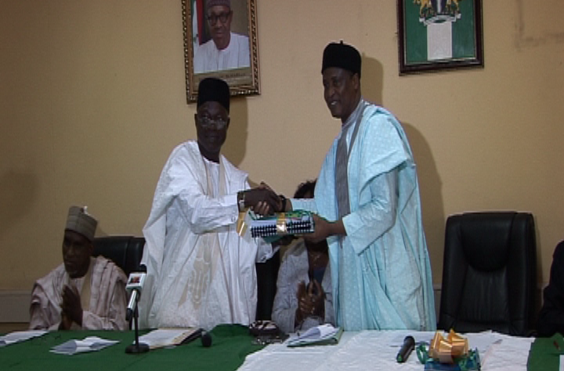
The ES receiving the Roadmap from the Chairman of the Committee, Prof U.T. Muhammad
- Meeting of UBEC Officials with the Private Providers of Special Education held at Education Resource Centre (ERC) at Wuse Zone 7, Abuja on Thursday, October 29, 2015.
- 5-Day Training of Managers and Teachers of Model Tsangaya Schools, held in Nasfah Hotel, Minna, Niger State, in November 2015.
- Brief on the Activities of the Universal Basic Education Commission (UBEC), presented to the Honourable Ministers of Education, in November 2015.
- Practical Solutions for Sustainable Schools Energy and Water at the Nigerian Schools Energy and Water 2015 Seminar, Exhibition and Awards, held at the International Conference Centre, Abuja, from 7th to 9th December, 2015.
- Opening ceremony of the 14th Quarterly Meeting of UBEC Management with Executive Chairmen of SUBEBs from 7th to 10th December, 2015 at Sheraton Hotel, Abuja.
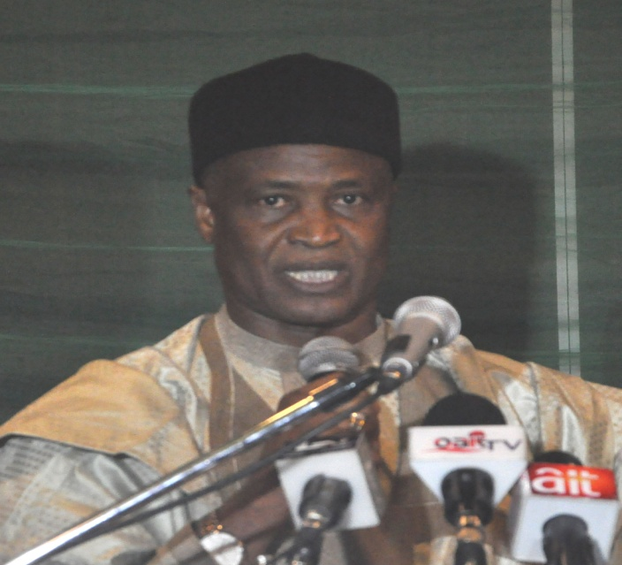
The ES presenting his speech at the 14th Quarterly
UBEC/SUBEB Meeting.

- 2015 Budget Performance as at 2nd December, 2015, presented to the Senate Committee on Education (Basic and Secondary), in December 2015.
- Brief on Universal Basic Education Commission (2011-2015), presented to the Honourable Minister of Education, in December, 2015.
- Occasion of the Handing Over of Information Technology (IT) Equipment and Project Monitoring Vehicles by the Chief Representative of the Korean International Cooperation Agency (KOICA), held on 31st December, 2015 at UBEC Headquarters, Abuja.
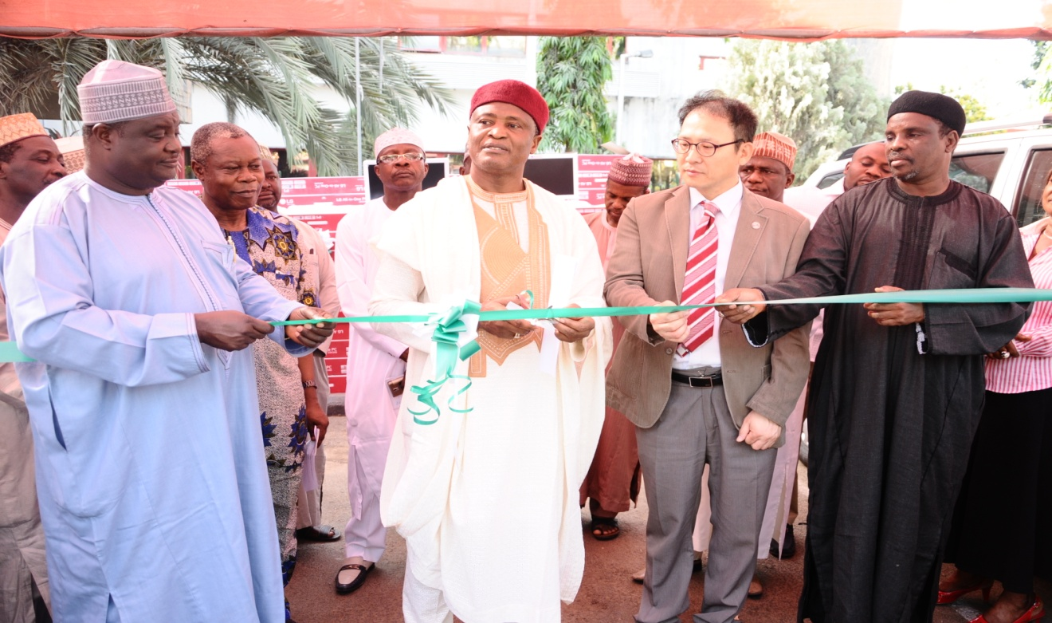
The ES cutting the tape at the handing over of Information Technology (IT) Equipment and Project Monitoring Vehicles by the Chief Representative of the Korean International Cooperation Agency (KOICA)

- “The Universal Basic Education (UBE) Programme in Nigeria: Progress, Challenges, Lessons Learnt and Impact on Socio-economic Transformation of Nigeria”, presented at the Millennium Development Goals and The Post-2015 Agenda, Abuja.
- “Effects of Self-Regulation Training on Senior Secondary School Students’ Academic Motivation and Self-Efficacy in Katsina Metropolis of Katsina State” 2015.
- The Functions of Universal Basic Education Commission at the Meeting of UBEC Team with Jolly Phonics and Universal Learning Solution in the UK in December, 2015.
On international representation, the Chief Executive attended some engagements which included the following:
- 2015 International School Dropout Prevention Summit, Washington DC, United States of America, on September 9 – 11, 2015.
- Conference on the Millennium Development Goals and The Post-2015 Agenda, Abuja.
- 38th Session of the UNESCO General Conference, UNESCO Headquarters, Paris, on the 3rd to 18th November, 2015.
- A Study Tour organized by Jolly Phonics and Universal Learning Solution in the UK, in December 2015.

MERIT AWARDS
Some of the Awards and Recognitions that were received during the year 2015 included:
- Most Ethically Responsible Head of Federal MDAs in Nigeria 2014/2015 for Innovative and Ethical Stewardship.
- National Leadership Award for Overall Best Federal Government Agency Manager in Nigeria by National Leadership Hall of Fame.
- Distinguished Merit Award for Excellence - “Achievers International Golden Pillar Grand Commander of Peace and Security Lifetime Achievement Award” by Baseline Global Ventures.
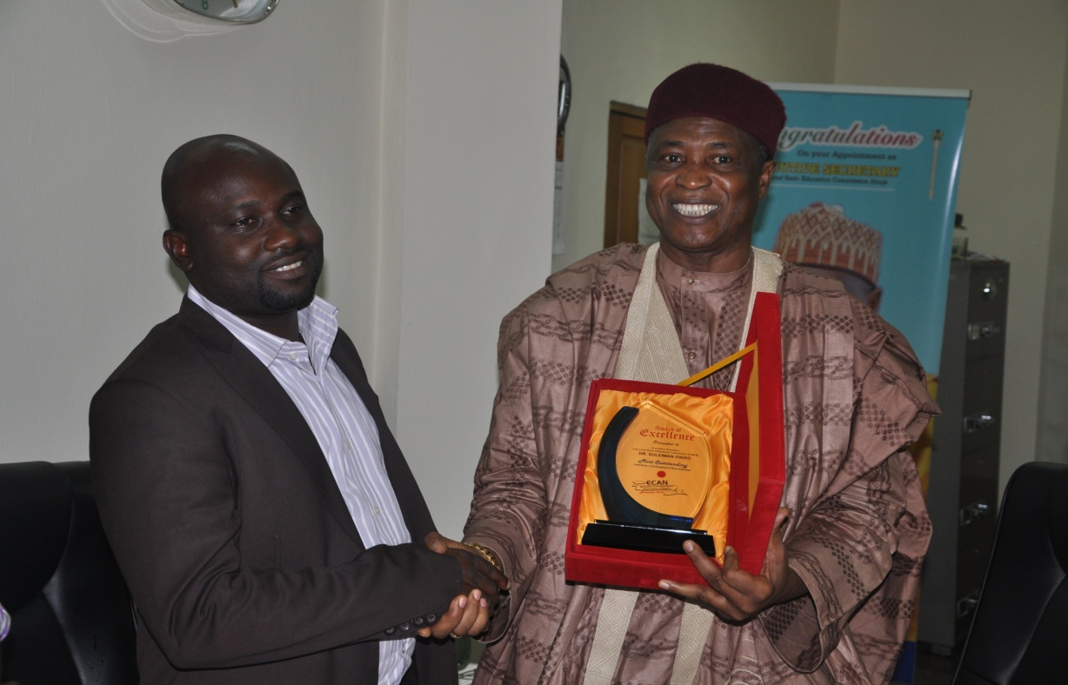
The Executive Secretary receiving an award from Education Correspondents
when they paid him a Courtesy Visit

- Distinguished Merit Award for Excellence as “Best Continental Distinguished Pan-African Best Executive Secretary of Universal Basic Education Board in Nigeria” by Baseline Global Ventures.
- Award of Excellence for “Contributions to Human Resources Development in Nigeria” by National Assoc. of Katsina State Students, ABU, Zaria (NAKATSS).
- Exemplary Leadership Award of Excellence as a “Distinguished Icon of Good Governance and National Development” by Arewa Youth Parliament.
- African Leader of Integrity Merit Award for “Educational Management & Development towards the Development of Nigeria, African Continent and the Entire World” by Integrity International.
- Merit Award in Recognition of “Outstanding and Patriotic Service to Humanity” by IACDI (Intercommunity Awareness for Change and Development Initiative.
- Award for “Outstanding Contributions to the Growth and Development of Nigeria”, presented by Prestige Exclusive Magazine.
- Recognition as “Icon of Integrity in Education Sector” awarded by National Association of Nigerian Colleges of Education Students (NANCES).
- Certificate of Membership of National Leadership Hall of Fame.
- Certificate in Recognition of Outstanding Contribution towards the Growth and Development of Sautus Sunnah International Comprehensive Secondary School, Katsina.
THE UNITS
The 8 Units in the Office of the Executive Secretary report directly to the Executive Secretary through the Director, Executive Secretary Office and the Special Assistant to the Executive Secretary.
1. INTERNAL AUDIT UNIT
The Internal Audit Unit is currently headed by a Deputy Director and is assisted by an Assistant Director and a Chief Internal Auditor in the day-to-day running of the Unit.
The Unit had a total of Fifteen (15) Staff at both Headquarters and Zonal Offices as follows:
Table 2: Staff Disposition in Internal Audit Unit
S/N | RANK | CONRAISS | NUMBER
1. | Deputy Director | 14 | 1
2. | Assistant Director | 13 | 1
3. | Chief Internal Auditor | 12 | 3
4. | Asst. Chief Int. Auditor | 11 | 2
5. | Principal Internal Auditor | 10 | 3
6. | Senior Internal Auditor | 09 | 1
7. | Auditor I | 08 | 2
8. | Auditor II | 07 | 1
9. | Confidential Secretary | 07 | 1
TOTAL |  |  | 15

FUNCTIONS
The Internal Audit, as a managerial control, functions by measuring and evaluating the effectiveness and efficiency of the internal control system of any organization.
Its mandate as enshrined in Financial Regulations (FR) 1701-1706 (ii) states, “The Accounting Officer of a Ministry or Extra-Ministerial Office and other arms of government shall ensure that an Internal Audit Unit is established to provide a complete and continuous audit of the accounts and records of revenue and expenditure, assets, allocated and un-allocated stores (where applicable) with a view to promoting transparency and accountability in the system”.

Functionally, the Internal Audit Unit liaises with the Department of Finance and Accounts on professional matters by working in close concert to ensure that the mandate of the Commission as enshrined in the enabling act is realized.

In line with the Financial Regulations therefore, the Internal Audit performs the following functions.
- Reports directly to the Accounting Officer for a detailed audit of the accounts and records of the organization and the examination of the system and procedures in force.
- Submits and reports to the Accounting Officer detailed Audit of Programme and the progress of the audit.
- Pre-audits all payment vouchers before payments are effected.
- Ensures compliance with Financial Regulations and other extant rules as they relate to the operations and activities of the organization.
- Issues Special Reports (where necessary) on apparent weaknesses in the accounting procedure, irregularity in the accounting process, any apparent in-attention to the reports of the Auditor-General or to earlier internal audit reports issued by him;
- Verifies Assets and Liabilities of the organization in order to ensure that organizational assets are secured while liabilities are properly incurred;
- Vets Staff claims, payrolls, pension and gratuities and other third party claims;
- Monitors fund disbursements to State Universal Basic Education Boards in the 36 states of the Federation and FCT in compliance with Section 9(b) of UBE Act, 2004;
- Verifies the procurement, supply and delivery of instructional materials to States and end-users;
- Monitors intervention projects in Teacher Professional Development, Good Performance, Almajiri, Library, Girl-Child and Boy-Child education projects across the states of the Federation and FCT;
- Monitors capital projects embarked upon by states and FCT using Matching Grant funds and;
- Performs any other function(s) as may be directed by the Executive Secretary from time to time.

ACCOMPLISHED ACTIVITIES
- Pre-payment Audit. This done on a daily basis before payments were effected.
- Status Audit on construction of Almajiri, All-Girls’Schools and e-Library projects for the year 2014. Status Audit was conducted on only All-Girls’ Schools projects
- Review of Year 2012-2013 UBEC Accounts and Operations. Activity conducted and reports sent to the Executive Secretary and Director, Finance and Accounts.
- Performance Audit on 2013 Constituency projects. It was accomplished 100%.
- Training, Workshops, Seminars and Conferences.
- Staffs were sent for workshops, seminars, Mandatory Continuing Professional Development and Annual Conference of ANAN.
- The Unit presented two (2) different papers at UBEC Training workshop held at Hamdala Hotel, Kaduna and Parkview Hotel, Abuja for UBEC staff.
- Served as Desk Officers in SUBEB Teacher Training on Financial Disbursements of TPD funds.
- Verification of the supply and delivery of Library, Junior Girls and Almajiri furniture and Equipment in the benefitting schools.
- Participated in the 22nd & 23rd Financial Monitoring of FGN-UBE Intervention funds to the 36 states and FCT.

ON-GOING ACTIVITIES
- Harmonization of Audit Review report on the year 2014 UBEC Accounts and Operations.
- Verification of the supplies and delivery of JSS Textbooks, furniture and equipment to benefitting schools across the 36 states and FCT.

FUTURE ACTIVITIES
- Submission of the year 2014 Audit Review of UBEC Accounts and Operations.
- Audit Review of the year 2015 UBEC Accounts and Operations.
- Status Audit on construction of 2014-2015 Almajiri, Library, Girl-child, Vocational and Rehabilitation projects.
- Performance Audit of the 2012-2014 Special Education projects nationwide.
- Compliance Audit of the year 2014 Teacher Professional Development funds in the 36 states and FCT.
- Audit monitoring of UBEC Zonal/Sub-Zonal and State Offices.
- 24th - 27th Financial Monitoring of FGN-UBE Intervention funds in the 36 States and FCT.
- Verification of the supply and delivery of office furniture and equipment to Almajiri, Junior-Girls and e-Library in selected schools.

CONSTRAINTS/CHALLENGES
The following activities could not be carried out within the year under review.
- Limited budgetary provisions for Status Audit of all intervention projects and other statutory activities of the Unit.

2. PUBLIC RELATIONS/PROTOCOL UNIT
The Public Relations/Protocol Unit is headed by a Chief Public Relations Officer (CPRO). He works closely with the Director in the Executive Secretary’s Office, other Heads of Departments and relevant Units of the Commission in the discharge of designated Public Relations/Protocol responsibilities.
The Unit had 8 staff as at December 31, 2015.
Table 3: Public Relations/Protocol Unit’s Staff Disposition
S/N | RANK | CONRAISS | NUMBER
1 | Chief Public Relations Officer | 12 | 1
2 | Asst. Chief Protocol Officer | 11 | 1
3 | Information Officer I | 08 | 1
4 | Information/ Protocol Officers II | 07 | 2
6 | Exe. Officer (Protocol) | 06 | 1
7 | Camera Man | 05 | 1
8 | Corps Member | NYSC | 1
TOTAL |  |  | 8

FUNCTIONS
The Public Relations/Protocol Unit is responsible for developing and implementing public enlightenment and corporate communication strategies and activities for UBEC. The unit seeks to build and sustain a positive image for the Commission as well as reinvigorate public trust and confidence in UBEC’s capacity to lead and mobilize Federal, State and LGA agencies for the implementation of basic education programmes in the country.
The major functions of the Unit include among others:
- Managing the public image of the Commission and maintaining a cordial relationship with the public through timely press releases on activities of the Commission.
- Enhancing improved and constant liaison between the Commission and its various collaborating partners and stakeholders.
- Maintaining constant public information on the activities of the Commission through the production of informative publicity materials for UBEC stakeholders.
- Planning and coordinating the logistics of travel and boarding arrangements (local and international) for UBEC officials and collaborating stakeholders involved in UBEC activities.
- Monitoring and tracking UBE-related information, publicity and related media items in all media.
- Moderating and anchoring briefings, meetings and courtesy calls to the Commission.
ACCOMPLISHED TASKS/ACTIVITIES
The Public Relations Unit in the period under review successfully executed the following media-related and protocol tasks/activities.
- Provided on and off-site media coverage for major UBEC internal and external events including:
- Flag-off of UBE 2014/2015 instructional materials’ distribution in Katsina State.
- Flag-off of the distribution of UBE Instructional Materials to States.
- 14th Quarterly Meeting of UBEC Management with Chairmen of SUBEBs.
- Monitored and tracked news stories, documentaries, and feature articles of and on the Commission in the news media.
- Compiled and provided direction for the production of critical UBEC informative and advocacy materials, e.g. Key Features of the UBE Programme.
- Coordinated various print and online advertorials, announcements and publicity of UBEC events.
- Ensured smooth logistics, operations and arrangements for UBEC events and activities.
- Facilitated visa processing, documentation and other arrangements for hitch-free local and international travels and boarding for UBEC staff on assignment to Iran, France, USA, UK, Kenya, etc.
- Moderated and anchored all UBEC formal events including:
- UBEC events, meetings and interview sessions with designated media;
- Internal Departmental briefings;
- Various engagements of UBEC professional Departments with SUBEB Directors and Desk Officers at various destinations across the country;
- Advocacy visits to major UBE stakeholders at the national and state levels;
- Coordinated courtesy calls to UBEC and on UBEC Executive Secretary by major government functionaries, UBE stakeholders, Advocacy groups, Media correspondents, International Development Partners, etc.
- Provided still and motion (pictures and video materials) documentation and reference materials for major UBEC events.
- Effectively managed the public relations profile and image of the UBE Commission through regular press releases, interviews between UBEC Executive Secretary and key media organs, press briefings, etc.

ACHIEVEMENTS
Through the above listed tasks/activities, the unit succeeded in:
- Maintaining a modest UBE media presence in Nigeria’s public domain.
- Creating a robust UBEC/Stakeholders’ sensitive and people friendly atmosphere for addressing and responding to negative public perception and reportage of the UBE programme.
- Broadening access to improved reportage of the UBE programme.
- Innovating improved mechanisms for responding to emerging issues in UBE programme implementation through factual dissemination of information on strategic UBEC interventions, engaging online media and specialized print media platforms.
- Providing and sustaining a vibrant protocol service that ensured smooth logistics arrangement for all UBEC activities as well as travel and boarding arrangements for designated staff.
- Maintaining and sustaining constant information and public enlightenment on Federal Government’s intervention through UBEC in basic education delivery.

CONSTRAINTS/CHALLENGES
The Unit was constrained in the exercise of its mandates and set targets by the following factors:
- The hiccups associated with the transition period.
- Low budgetary provision and funding for media-related activities and increasing cost of media production, broadcast and media-related activities.

ON-GOING ACTIVITIES
- Production of UBEC Newsletter.
- Collating of materials for future documentaries on the electronic media.
- Production of informative materials and publicity booklets on the Basic Education Sub-sector.

FUTURE ACTIVITIES
Going forward, the Unit intends to pursue a more vigorous public relations framework that seeks to integrate contemporary and creative mechanisms for publicizing the modest achievements of UBEC and creating a robust platform for mobilizing stakeholder support for UBE programme activities. Along this line:
- A public relations strategy and action plan has been developed for 2016 with specific budgets for key items.
- Public Relations functionaries are being mobilized to offer improved professional services in the coming year.
- The liaison and network with media service providers is being improved towards ensuring that impediments to effective media linkages are removed for the attainment of optimum impact in UBE communication and public relations efforts.

The performance of the Public Relations/Protocol Unit in 2015 was significantly slowed down by the slow/gradual process of articulating the structure of governance and social service delivery in a new democratic dispensation. Notwithstanding, the modest achievements recorded and lessons learnt would further propel or prompt timely actions towards delivering better communications, public relations and protocol services in the future.
Importantly, the unit envisages that UBEC and other basic education service delivery structures at State and LGA level will accord the right priority and commitment to public relations and protocol as a critical management function as well as a fundamental factor in mobilizing and harnessing resources for efficient UBE delivery.

3. PROCUREMENT UNIT
The office is headed by the Head of Procurement, who is supervised by the Special Assistant to the Executive Secretary. The Head of Procurement is assisted by 4 other Procurement Officers who undertake activities relating to Goods, Works and Services.
Table 4: Staff Disposition in Procurement Unit
S/N | RANK | CONRAISS | NUMBER
1. | Assistant Director | 13 | 1
2. | Assistant Chief Procurement Officer | 11 | 2
3. | Procurement Officer II | 07 | 1
4. | Clerical Officer | 03 | 1
TOTAL |  |  | 5

FUNCTIONS
The Procurement Unit is a service unit in the Office of the Executive Secretary. Its primary functions and responsibilities are to conduct the process for procurement of goods, works and services. The functions of the Unit are as listed below:
- Preparing needs analysis.
- Preparing procurement plans.
- Advertising/Soliciting for Tenders or Proposals.
- Conducting market surveys.
- Evaluating proposals.
- Recommending awards to the Tender’s Board.
- Monitoring procurement performance.
- Advising the Executive Secretary on issues of procurement.
- Any other duties that may be assigned by the Executive Secretary or the Tender’s Board.
ACCOMPLISHED ACTIVITIES
Procurement Unit successfully executed the underlisted activities
- Procurement of various furniture and equipment for the Commission’s Headquarters, State and Zonal Offices.
- Procurement of various sizes of tyres for vehicles of the Commission, State and Zonal Offices.
- Procurement of various items, construction and renovation of classrooms under 2015 Constituency Projects nationwide.
- Procurement of various furniture and ICT items for Unity Colleges, Junior Girls’ Model Secondary Schools.
ON-GOING ACTIVITIES
- Construction of various blocks of classrooms, offices and V.I.P toilets, renovation of blocks of classrooms in various LGAs in selected states of the federation under the Intervention Projects.
- Construction of 52 Junior Girls’ Model Secondary Schools in selected states of the country for 2014.
- Procurement and installation of computers and accessories for Almajiri schools in Gombe and Sokoto States.
- Corrective works for the completed 62 libraries.
FUTURE ACTIVITIES.
All procurement-related activities in the future will be undertaken as they become due.
ACHIEVEMENTS
- For the period under review, the unit recorded some major achievements in the areas of procurement of goods, works and services. The activities which were successfully concluded and on-going.
- Payments for all completed projects have been made. For on-going projects, payments are made based on delivery and terms of payment. There are no payment constraints.
CONSTRAINTS/CHALLENGES
The unit is faced with the challenge of store space to keep documents and inadequate office space for staff.
The unit is resolved to ensure that all procurement activities are carried out in compliance with the 2007 Procurement Act. This will ensure that quality goods, works and services are procured and delivered on time.

4. SPECIAL PROJECTS UNIT
The Special Projects Unit is the main entry point and clearing house of all International Development Partners and Donor Agencies intervening in basic education programmes. It is headed by an Assistant Director who works closely with the Heads of Departments and their relevant Technical Officers in performing the functions of the unit. He is assisted by 3 other project staff.
Table 5: Staff Disposition in Special Projects Unit
S/N | RANK | CONRAISS | NUMBER
1. | Assistant Director | 13 | 1
2. | Principal Confidential Secretary | 10 | 1
3. | Senior Project Officer | 09 | 1
4. | Project Officer | 07 | 1
Total |  |  | 4

FUNCTIONS
The main functions of the unit are:
- coordinating the implementation of the UBE activities in collaboration with multi and bilateral agencies, and
- liaising with Donor Agencies, Non-Governmental Organizations and other Development Partners on support for basic education in Nigeria. These are in keeping with the provisions of UBE Act, 2004, Part II, Sections (j) and (r)
- coordinating and providing support to technical officers at both UBEC and SUBEBs to facilitate the achievement of projects’ targets.
- initiating new projects or support areas of collaboration with International Development Partners.
- arranging, coordinating and facilitating High Level Donor Coordination Meeting in the area of basic education.

ACCOMPLISHED ACTIVITIES
The Universal Basic Education Commission has been able to collaborate with some major International Development Partners in providing support for the development of Basic Education in Nigeria. They are:
- Japan International Cooperation Agency (JICA).
JICA supports the provision of additional classrooms through its Project for the Construction of Additional Classrooms in Niger, Plateau, Kaduna and Kano States and is currently working in Oyo State.

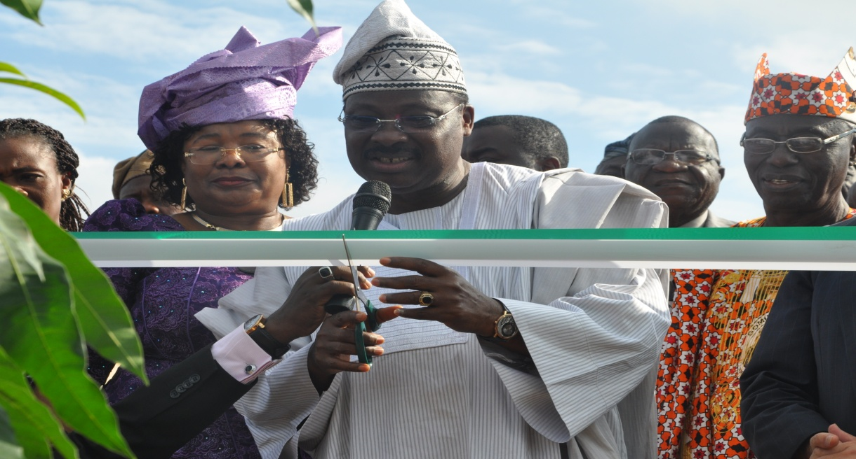
The Executive Governor Oyo State, Mr, Abiola Ajimobi cutting the tape while the Deputy Executive Secretary, Dr Sharon Oriero-Oveimuno and other
with dignitaries watch on.

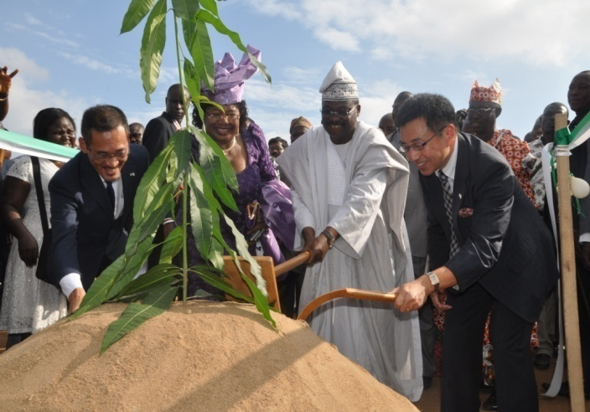 | 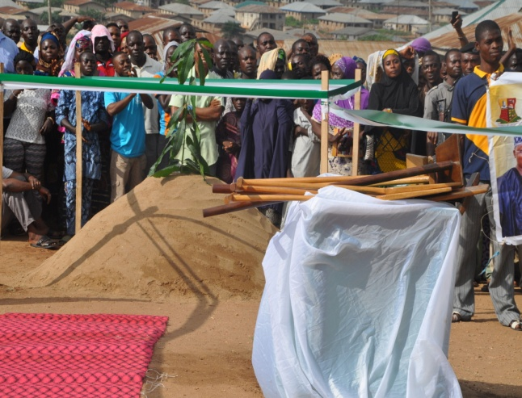
The Executive Governor Oyo State, Mr, Abiola Ajimobi and Deputy Executive Secretary (Technical), Dr Sharon Oriero-Oveimuno with dignitaries at the
Ground Breaking Ceremony in Oyo State

The Agency also built the capacity of primary school teachers under the project for the Strengthening of Mathematics and Science Education (SMASE) and provided managerial training for policy makers and managers of education in the country.

- Korea International Cooperation Agency (KOICA).
This agency supports the provision of additional classrooms and building of new schools. It also develops the capacity of management staff, teachers and administrators of primary schools. It has operated in Kogi, Katsina, Adamawa and Gombe States and is currently working in the FCT. Many educational policymakers, managers, administrators and teachers were trained in various aspects of educational concern in Seoul, South Korea. There is an ongoing plan to train additional policymakers, project managers and school teachers under the FCT project. It is also supporting the provision of ICT equipment in Gombe and Adamawa States. Currently, (December, 2015), KOICA has approved the procurement of about 200 all-in-one computers for the four schools in Adamawa and Gombe States.

- China Economic and Commercial Office
The Economic and Commercial Office of the Chinese Embassy assisted UBEC in building comprehensive primary schools in Kaduna, Katsina, Ogun and FCT. Negotiation is ongoing for new projects. The office has also been supporting the capacity building of teachers and school administrators at both UBEC and SUBEB levels.
- British Council
The British Council, through its Teaching Knowledge Test (TKT) project, is building the capacity of primary school teachers in methodologies of teaching English Language. The first phase of the project has elapsed since 2012. Now, a new project is being discussed.

- The World Bank:
- The World Bank has been a long time partner and is currently supporting the State Education Programme Investment Project in Nigeria. This is an innovation project being piloted in four states: Anambra, Bauchi, Edo and Ekiti states. Under this project, funds are disbursed to states after they achieved and accomplished some pre-determined performance/disbursement indicators called Disbursement Linked Indicators (DLIs). Thus, this is a result-based financing project. UBEC as a statutory agency charged with the responsibility of coordinating Basic Education in Nigeria has a major responsibility in this project. Therefore, the institutional arrangement for the SEPI project designated UBEC as a Technical Assistance provider to the implementing states. UBEC is also the main Monitoring and Evaluation outfit for the project.
- Also, under the World Bank supervision, the Global Partnership for Education (GPE) is supporting a GPE project which aims at assisting Nigeria to achieve EFA goals through increased access and improved quality to basic education. The GPE Project is at its final take-off stage since the Financing Agreement has been signed and ratified by the Federal Ministry of Finance in November 2015. The project would be implemented in the five states of Katsina, Kano, Kaduna, Jigawa and Sokoto. The major areas of focus in the project are:-
- Increasing girl-child enrolment and retention through conditional cash transfers,
- Strengthening SBMC and
- TPD, especially on classroom management.
- Islamic Development Bank (IDB)
Discussions and bilateral negotiations are ongoing with the Islamic Development Bank which approached UBEC with a view to supporting a pilot project on Bilingual Education in Niger, Gombe and Adamawa states, focusing on the Almajiris. The project’s main areas of focus are: building a boarding school with hostel and dining facilities, provision of textbooks with bilingual content, teacher training, monitoring and evaluation.

- UNICEF
Preliminary discussion with UNICEF is ongoing for collaboration in Islamiyyah and Quranic Education. There are, however, patches of support in other departments by UNICEF especially Social Mobilization and Academic Services departments.

- Jolly Phonics
The Jolly Phonics Project is a project that introduces phonetics teaching methods that enable unlettered children to learn to read and write in the shortest period of time ever recorded in the history of Basic Education in Nigeria.
The project is partially financed by Chris Jolly, the founder of the Jolly Learning Project. Since inception, the foundation, in collaboration with its technical partners, Universal Learning Solutions (USL), has recorded the following achievements:
- Provision of over £6,000,000 (i.e. over N2 billion) worth of free teachers’ and pupils’ workbooks and trainings.
- 12,120 Primaries 1 & 2 teachers trained.
- 876 SUBEB/LGEA officials trained.
- 1,057,854 Primaries 1 & 2 Workbooks provided.
- 32,961 Teacher books provided.
In continuation of our collaboration, therefore, UBEC’s key officers were invited to the UK to discuss further on the partnership. The discussion was aimed at providing UBEC with deeper understanding of the Jolly Phonics implementation strategies, challenges and best practices. With this development, UBEC is at the planning stage of scaling up the project to cover all states of the federation.
ACHIEVEMENTS
The achievements of the Unit in the year under review are:
- Coordinated the scaling up of the SMASE training to cover all 22 States and FCT where over 27,000 teachers/trainers were trained.
- Coordinated the successful completion of National INSET for all 36 Non-pilot States and FCT in collaboration with JICA, FME and NTI.
- Conducted additional sensitization visits to most of the SMASE non-pilot states in collaboration with FME and NTI.
- Continued to coordinate the JICA-Oyo Project under which the Government of Japan has already disbursed funds totaling Y1,277,000,000 Japanese yen which is about N1.8b into the project account domiciled in Tokyo, Japan and construction work has since commenced in April, 2015. Currently, the project is at 60% completion stage.
- Coordinated and participated in KOICA missions on the construction of a Comprehensive Model School which comprises kindergarten, primary and Junior Secondary Schools in the FCT. The project agreement has been signed while the project consultant has been engaged by KOICA. Preparatory to the take-off of the project, four UBEC officers participated in the Stakeholders’ workshop and training in Korea at the invitation of KOICA.
- Participated in three World Bank Missions to Anambra, Bauchi and Ekiti under the World Bank supported State Education Programme Investment Project (SEPIP).
- The Executive Secretary led a team of key officers to visit Jolly Phonics Head Office in the UK to discuss further on the partnership. The visit provided opportunity to conduct school visits and hold meetings with Educational Administrators in the UK aimed at providing UBEC with deeper understanding of the Jolly Phonics implementation strategies, challenges and best practices. The visit was from 22nd to 28th November, 2015. While on this trip, the Executive Secretary held sessions with the Nigerian High Commission and the UK Minister for Schools who is a very strong advocate of Phonics in the UK.
- Solicited the support of the World Bank which led to the procurement of 2 project vehicles worth over N20,000,000.00 under the World Bank supported SEPIP Project.
- Participated in a 5-Day Leadership Workshop on Nigerian Partnership for Education Project (NIPEP) organized by the World Bank held at Barcelona Hotel, 23 Blantyre Crescent, Off Ademola Adetokunbo Crescent, Wuse II, Abuja from Monday, 7th to Friday, 11th September, 2015.
- Developed instruments and organized workshop for the Critique of Monitoring and Evaluation Instruments for State Education Programme Investment Project (SEPIP): Disbursement-Linked Initiatives (DLIs) held at Quarter House Hotels, Kaduna on August 17 – 21, 2015.
- Attended Flag-off/Earth Breaking Ceremony organized by Oyo State Government for the Phase III construction of classrooms for some selected Primary Schools in the State by JICA at the L.E.A. Primary School, Okelola, Atiba, on Wednesday, August 12, 2015.
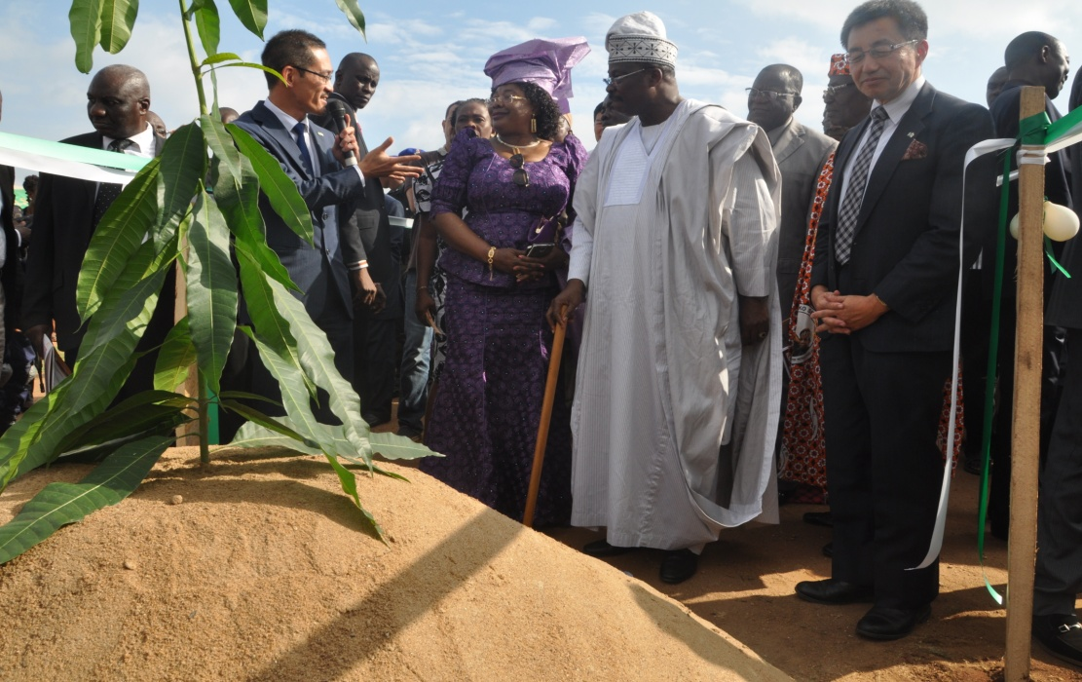
The Executive Governor of Oyo State, His Excellency Abiola Ajimobi and the Deputy Executive
Secretary (Technical) Dr. Sharon Oriero-Oveimuno with representatives of JICA at the
Ground Breaking Ceremony at the L.E.A. Primary School, Okelola, Atiba

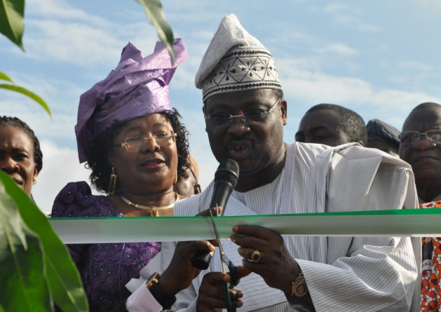 | 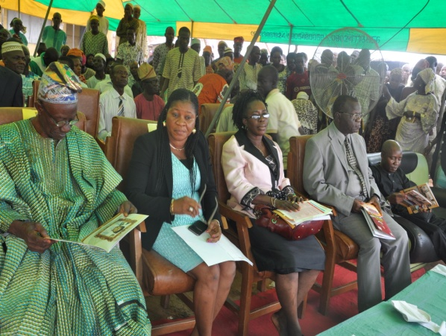
Executive Governor Abiola Ajimobi cutting the tap at the Ground breaking ceremony | Cross section of dignatories at the ceremony

- Coordinated the donation by Korean International Cooperation Agency (KOICA) of Information Technology (IT) Equipment (Computers, Printers and Copier machines) for use in some of the schools constructed by KOICA in Gombe, Adamawa, Katsina and Kogi States and Project Monitoring Vehicles. The delivery ceremony took place at the UBEC Headquarters on Thursday, December 31, 2015.

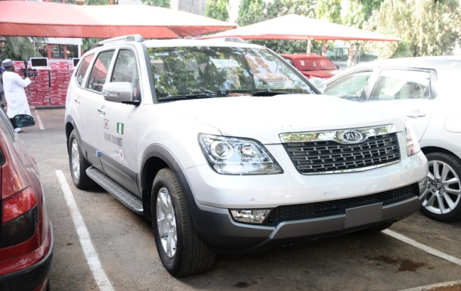
Project Monitoring Vehicles donated by Korean International Cooperation Agency (KOICA)

CONSTRAINTS/CHALLENGES
- Difficulty in reaching out to Islamic Development Bank on project follow-up discussion.
- Limited avenues and poor mobility logistics on reaching IDPs for collaboration dialogue that may lead to proposal writing.
- Limited office space/accommodation.
- Budgetary provision for adequate project monitoring (counterpart funding).

FUTURE ACTIVITIES
- Establishing more linkages with related Ministries and Departments such as FME, NPC, FMF, Immigration, Customs, Nigeria Ports Authority, etc., for smoother coordination and implementation of IDPs supported programmes and projects.
- Opening up dialogue with other IDPs such as USAID, Canadian International Cooperation Agency (CIDA) and the Emirate International Cooperation Agency.
- Discussion and dialogue with Multi-national Corporations such as Samsung, LG and Microsoft Corporation for areas of collaboration in basic education.
- Regular meetings with IDPs on collaboration in the basic education sub-sector.

5. LEGAL UNIT
The Legal Unit is headed by the Legal Adviser who is assisted by 5 other Legal Officers.
Table 6: Staff Disposition in the Legal Unit
S/N | RANK | CONRAISS | NUMBER
1 | Assistant Chief Legal Adviser/Legal Adviser | 11 | 1
2 | Principal legal Officer | 10 | 1
3 | Senior Legal Officers | 09 | 3
4 | Legal Officer 1 | 08 | 1
TOTAL |  |  | 6

FUNCTIONS
The Legal Unit is mandated to interpret laws and instruments entered into/executed by the Commission and in the event of any litigation represent the Commission in courts through external solicitors. Its principal functions are:
- Proffering legal advice to the Commission;
- Liaising with appropriate departments and consultant(s) on contract/project matters; and
- Drafting and executing legal instruments.
However, with the impact of the Commission’s activities being felt nationwide, the unit’s role has widened to include:
- Proffering legal advice to the State Universal Basic Education Boards whenever the need arises;
- Liaising with Banks on the confirmation of Contractors’ Advance Payment Guarantees;
- Alternative dispute resolution and other controversies without resulting to litigation; and
- Compilation and computation of Insurance premiums of the Commission’s assets.

ACCOMPLISHED ACTIVITIES
In the year 2015, the Commission was engaged in three main areas of activities.
- Cases
There were Commission had 5 cases pending in various courts. They were:
- Registered Trustee of African Initiative For Education Development vs. Universal Basic Education Commission (Civil);
- Deljatt Services Ltd vs. UBEC; and
- Public & Private Development Centre/GTE vs. UBEC &1or.
- Legal Documentation/Instruments
Documentation of contracts for:
- construction of Junior Girls’ Model Schools Phase III, supply of furniture to those schools and construction of ICT centres;
- construction of Almajiri Schools, expansion of some already existing schools and supply of furniture in various states of the federation;
- construction of Special Intervention/construction and rehabilitation of dilapidated schools and supply of furniture to those schools;
- independent monitors and leasing of properties for UBEC Zonal and State Offices; and
- Documentation of 2015 constituency projects.
- Insurance
The unit compiled the Commission’s assets for the 2015/2016 insurance year. Based on this list of assets, the Commission insured its assets through Brokers for the period of 1 year.
ACHIEVEMENTS
- Successfully perfected legal instruments for:
- 2015 Constituency projects;
- Construction of additional Junior Girls Model Schools Phase III;
- Construction of additional and expansion of existing Almajiri Schools,
- Construction, renovation/rehabilitation and supply of furniture and equipment under the Special Intervention Scheme;
- Supply of ICT equipment to Junior Girls’ Model Schools and
- Supply of Science and Technical Equipment to Federal Unity and Technical Colleges.
- Successfully averted court action resulting from allegations of fraud leveled against a contractor by Divine Links Integrated Ltd; and
- Designed a databank of all contracts showing the state, contractor and exact location of projects.
CONSTRAINTS
Delay in information dissemination. Staff of the unit have to follow up with departments for any additional information required on Action files. This usually takes time which delays prompt output of work.

ON-GOING ACTIVITIES
- Documenting and perfecting instruments entered into between UBEC and contractors;
- Liaising with the Commission’s external solicitors on cases involving UBEC;
- Conciliation Meetings with some non-governmental/civil organizations who have threatened Court action on ways to resolve issues without recourse to the courts; and
- Review of UBE Act.

FUTURE ACTIVITIES
- Continue to advise the Commission and the SUBEBs (when the need arises) on legal matters;
- Documentation of all contracts entered into by the Commission;
- Amicable dispute resolution between contractors and the Commission;
- Attend Court sittings and watch briefs on behalf of the Commission; and
- Regular meetings with dis-satisfied contractors on ways to settle issues without recourse to the courts.

6. SERVICOM UNIT
The unit consists of a total of Three (3) Staff namely an Assistant Director and Two (2) Senior Legal Officers.
STAFF DISPOSITION
Table 7: Staff Disposition in the Legal Unit
S/N | RANK | CONRAISS | NUMBER
1 | Assistant Director | 13 | 1
2 | Senior Legal Officers | 09 | 3
TOTAL |  |  | 4

FUNCTIONS
The basic functions of the SERVICOM Unit include but are not limited to:
- Liaise between the Commission and the Federal Ministry of Education on SERVICOM matters.
- Representation of the Commission in the Ministerial SERVICOM Unit quarterly meetings.
- Monitor and Update activities of State and Zonal offices on Service delivery.
- Formulate, implement and review the Commission’s Service Charter.
- Process reports from State and Zonal Offices on the response from stakeholders on UBEC Service delivery.
ACTIVITIES
- Training Workshops for SERVICOM Unit staff and SUBEB SERVICOM staff.
- Monitor and evaluate the implementation of SERVICOM ideals at the UBEC Zonal offices and SUBEBs.
- Training Workshop for UBEC staff on SERVICOM ideals.
- Servicing of SERVICOM Committee Meetings.
- Hosting of Second quarter Ministerial SERVICOM Committee meeting.
ACHIEVEMENTS
- A training workshop for SUBEB SERVICOM desk officers and UBEC Zonal Directors on SERVICOM and effective service delivery in the UBE Programme which held in the Commission.
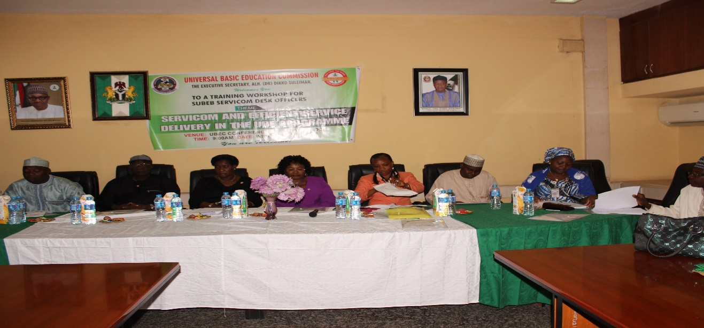
UBEC Management Staff and the Acting National Coordinator SERVICOM
in the Presidency, Mrs Nnenna Akajemeli at the workshop

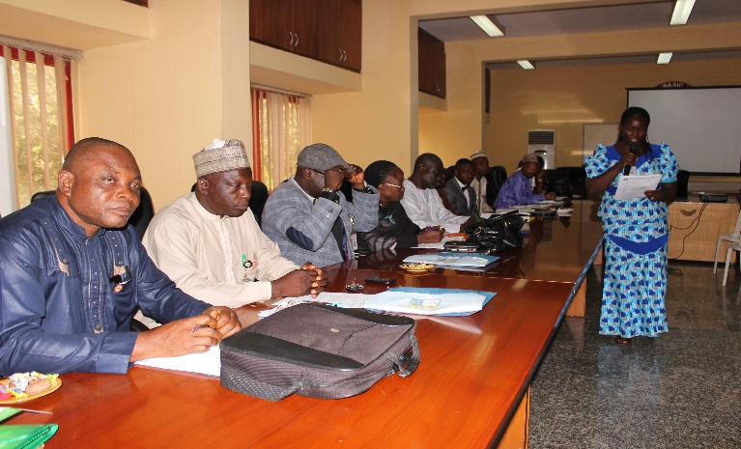 |  | 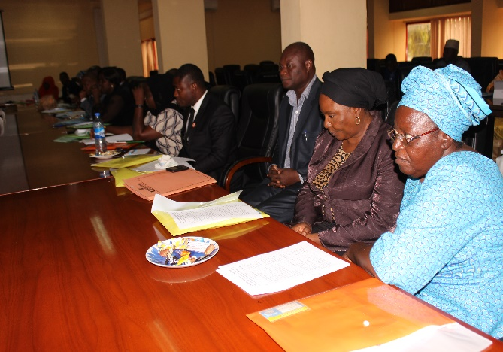
Cross section of Zonal Directors at the workshop |  | Participants at the workshop
- Representation of the Commission at the 4th quarter Ministerial SERVICOM Committee meeting organized by Federal Ministry of Education which was held in Minna.
CONSTRAINTS
- Inadequate/lack of funds to implement the Unit’s activities.
- Lack of training for SERVICOM Staff.
ON-GOING ACTIVITIES
The functions of the Unit as highlighted above are being monitored for effective implementation on a continuous basis.
FUTURE ACTIVITIES
- Follow-up monitoring of the SUBEBs, LGEAs, and Schools to ensure the implementation of SERVICOM Unit Establishment at the State Level.
- Quarterly Networking Seminar with all SUBEBs SERVICOM Desk Officers.
- Quarterly Training of UBEC SERVICOM Unit staff by SERVICOM Institute.
- Training of UBEC members of staff on SERVICOM ideals.
- Review and forwarding of Commission’s Service Charter to the SERVICOM Office (presidency) for review.
- Hosting of SERVICOM Units meeting in all the departments, and agencies in Federal Ministry of Education.

7. TSANGAYA EDUCATION PROGRAMME UNIT
The Tsangaya Education Programme is one of the initiatives of the Federal Government which is to address the problems of out-of-school children. Its specific objectives are to:
- provide access and equity to Basic Education for all Almajiri school age children.
- discourage and gradually eliminate itinerancy and begging of Almajiri in the country.
- support the emergence of an enabling environment that could facilitate the effective integration of Islamic disciplines into the basic education programme.
The Tsangaya Education Programme Unit is headed by a Chief Programme Officer and it has three (3) officials.
Table 8: Staff Disposition in the Tsangaya Education Programme Unit
S/N | RANK | CONRAISS | NUMBER
1. | Chief Programme Officer | 12 | 1
2. | Admin Officer I | 08 | 1
3. | Computer Prog. Officer | 08 | 1
TOTAL |  |  | 3

FUNCTIONS
The Unit carries out the following functions.
- Implement all decisions of the Universal Basic Education Commission Board and management on Tsangaya Education Programme.
- Initiateplanand programme for implementation of Tsangaya Education Programme.
- Coordinate the activities of SUBEBs that are related to implementation ofTsangaya Education Programme
- Collect, collate and report on status of Tsangaya Model Schools to UBEC Management

ACHIEVEMENTS
- Support for 31 selected Islamiyyah schools under Model III form of intervention in Kebbi, Sokoto, Kaduna, Jigawa, Katsina, Kano, Zamfara, Adamawa, Borno, Yobe, Gombe, Taraba, Kwara, Niger, Plateau, Kogi, Ondo, Ogun and Oyo.

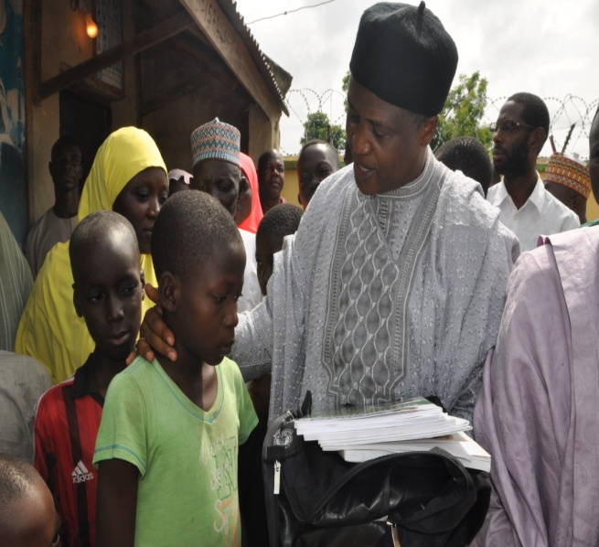 | 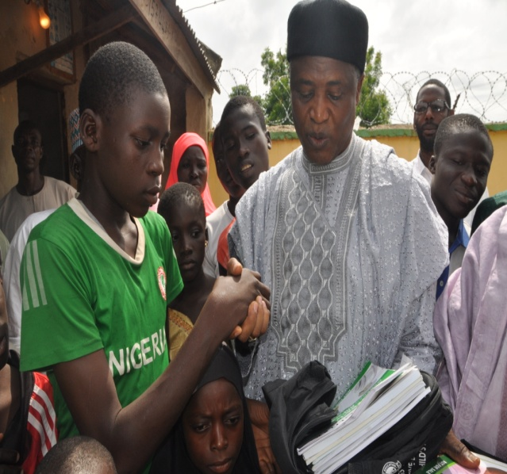
The Executive Secretary, Alh. Dr. Dikko Suleiman presenting textbooks to
pupils of Almajiri Model I School, Paiko, Niger State

- Training of 168 teachers and proprietors of Model III Tsangaya schools, management of schools, implementation of curriculum and methodology in Minna, Niger State.
- Monitoring and Needs Assessment of Tsangaya Education Programme nationwide in 34 states and the FCT.
- Construction of 4 Model I schools and 2 ICT Centres in Adamawa, Sokoto and Kaduna states.
- Procurement of 41,900 number of feeding/kitchen utensils for Tsangaya Model Schools as support to state governments.
- Procurement of 6,500 sets of school uniform for Tsangaya Model Schools as support to State governments.
- Mobilization and sensitization of stakeholders in the North-west and North-east.

CONSTRAINTS
In the process of implementing the Tsangaya Education Programme, the following serious challenges were encountered:
- Non-adoption and replication of the programme by the states.
- Failure of states to recruit and deploy teachers to these schools by the states.
- Non-payment of teachers’ salaries.
- Lack of appropriate mechanism for the enrolment of Almajiri into schools by States and Local Governments.
- Non-inclusion of feeding as a retention strategy by the States and Local Governments.
- Failure to integrate Alarammas/Mallams/Proprietors into the programme.
- Inadequate provision for maintenance of facilities.
- Ineffective management which could have a negative effect on the sustainability of these schools.

ON-GOING ACTIVITIES
- Construction of 4 Model I Schools and 2 ICT Centres in Adamawa, Sokoto and Kaduna states.
- 31 selected Islamiyyah schools under Model III intervention in Kebbi, Sokoto, Kaduna, Jigawa, Katsina, Kano, Zamfara, Adamawa, Borno, Yobe, Gombe, Taraba, Kwara, Niger, Plateau, Kogi, Ondo, Ogun and Oyo states.
FUTURE ACTIVITIES
- Translation of Almajiri Education Textbooks and Teachers’ Guides (Mathematics, Basic Science, Social Studies and Teachers’ Guides) into English Language.
- Production of additional textbooks
- Procurement of school Records, Registers for Tsangaya schools
- Construction of model Tsangaya Education Programme
- Training of teachers of model Tsangaya Education schools
- Support grants for Model III schools.

8. FEDERAL TEACHERS’ SCHEME
The Federal Teachers’ Scheme (FTS) is one of the Federal Government intervention programmes aimed at achieving the goal of the Universal Basic Education programme. Established in 2006, FTS serves as a strategy for improving the quality of education delivery through supply of qualified teachers.
The Federal Teachers’ Scheme is headed by a National Coordinator who is assisted by 6 other staff deployed from other departments in the Commission.
FUNCTIONS
The functions of the Federal Teachers’ Scheme Unit include the following:
  - conduct of the selection process of enlistment of candidates into the scheme;
  - deployment of selected teachers to States;
  - maintenance of accurate database on the Scheme;
  - monitoring the performance of serving teachers and generating reports for Management consideration;
  - preparation of monthly list of eligible participants for payment;
  - coordinating other activities relating to the scheme such as induction/orientation training, capacity building and physical verification of serving teachers; and
  - liaising with the State Universal Basic Education Boards on matters affecting the implementation of the scheme.
Table 9: Staff Strength in FTS Unit
S/N | Designation | CONRAISS | Number
1. | Deputy Director | 14 | 1
2. | Principal Quality Assurance Officer | 10 | 1
3. | Principal Assistant Quality Assurance Officer | 10 | 1
4. | Senior Quality Assurance Officer | 09 | 1
5. | Quality Assurance Officer I | 08 | 1
 | TOTAL |  | 5

ACTIVITIES
The unit performed the following activities during the reporting year:
- Conduct of a nationwide verification exercise for data update.
- Resolution of complaints relating to non-receipt of allowance by participants.
- Hosting of 2015 Meeting of FTS Unit with State FTS Desk Officers.
ACHIEVEMENTS
- Successful conduct of a Nationwide Verification exercise in January, 2015, during which 10,956 teachers were visited. The report of the exercise showed that despite the backlog of unpaid allowances for upwards of three months, 94.2% of the enlisted teachers remained at their duty posts. The exercise also revealed that 64.1% of the teachers visited were working in schools located in rural areas.
- Regular Data Update: Throughout the year, the Unit continuously updated its data on the scheme, with the monthly returns submitted by the State Universal Basic Education Boards.
- Up-to-Date Payment of Allowance: In spite of the initial hitches created by delay in the release of funds, the Commission was able to bring up to date the payment of participants’ allowances (November, 2015).
- Successful Exiting of 2013/2015 set from the Scheme: The 2013/2015 set of teachers enlisted into the Scheme successfully completed the two-year service and exited on November 30, 2015. This brings to 120,000 the total number of teachers that have been enlisted into the scheme.
8.0 CONSTRAINTS
The main challenge that the Scheme faced in 2015 was related to delay in the release of funds. This affected the scheme in the following ways:
- the Commission could not pay participants as at when due;
- the Commission could not conduct any monitoring exercise due to late release of funds. By the time funds were available, the serving teachers were about completing their two-year service.
THE FUTURE OF THE FEDERAL TEACHERS’ SCHEME
The Federal Government intervention in teacher supply to states for the implementation of the Universal Basic Education programme will remain an imperative for some time to come. This is because the quality and adequacy of available number of teachers are crucial to quality basic education delivery, and to the attainment of the Sustainable Development Goal 4 which targets quality education.
With States still being confronted with shortage of teachers, especially at the basic education level, and with declining resources, the Federal Government’s assistance to States will continue to be required to fill existing gaps in teacher availability and teacher quality.
The above notwithstanding, the implementation of the 2016 Federal Government Budget as proposed will determine the nature of activities to be conducted under the Federal Teachers’ Scheme, and indeed, the future of the scheme. The Federal Government has proposed to employ, train and deploy 500,000 teachers to teach in basic education schools.
If this proposal is fully implemented and the teachers are employed on permanent basis, the challenge of shortage of teachers at the basic education level would have been addressed adequately and, consequently, an ad hoc programme that FTS is will no longer be relevant. However, in the event that the implementation of the new scheme (the recruitment of 500,000 teachers) is assigned to the Universal Basic Education Commission, it would demand a redesign of the implementation structure and strategies.

THE DEPARTMENTS OF THE COMMISSION
There are 8 Departments in the Commission. The reports of the various Departments catalogued the Commission’s major activities, achievements and constraints in the year under review. They also charted the way forward for basic education delivery to the Nigerian child.

1. DEPARTMENT OF ACADEMIC SERVICES
The Department of Academic Services is headed by a Director who is assisted by 1 Deputy Director and 1 Assistant Director. It had Twenty-One (21) staff in the period under review.
The Director, Department of Academic Services was born on 31st August, 1956. He graduated with Bachelor of Education in 1980 and a Masters of Education in 1982 from University of Jos. He began his career as Assistant Lecturer I at the College of Education, Gindiri where he rose to the rank of Senior Lecturer. He served in various capacities including the pioneer Head of the Department of Integrated Science Education. He was also involved in the development of new curricula for the NCE Programme of the College.  He proceeded to the erstwhile National Primary Education Commission (NPEC) in 1990 where he also served as Zonal Coordinator, Bauchi Zone (Bauchi, Plateau and Yobe States) and later as Desk Officer, North-West Region. With the dissolution of NPEC; he served in the then Special Programme Unit of the Federal Ministry of Education that was responsible for maintaining standards and implementation of the World Bank Project.  The establishment of Universal Basic Education Commission in 2004 saw him serving in Department of Teacher Training and Curriculum Development. He later served as Zonal Coordinator, South-South, Deputy Director, Quality Assurance in 2003 from where he was deployed to Department of Academic Services in 2009.  He has served as Member or Secretary of various Committees including UBEC’s National Education Roadmap Implementation Committee, UBEC Technical Committees on Quality Assurance, Evaluation, Research, Teacher Training, Curriculum, etc. He is also the representative in EDOREN’s Steering Committee on the Evaluation of Teacher Development in Nigeria. | 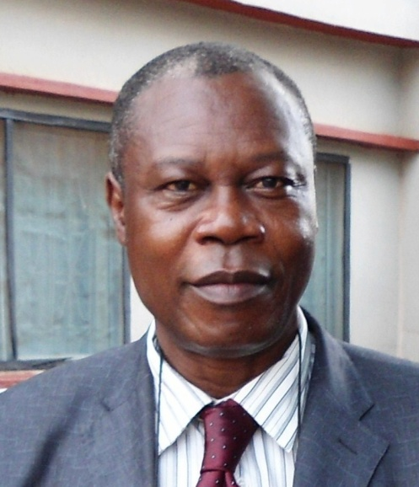
Pius O. Osaghae.
Director, Department of Academic Services
He had attended over 50 national and international conferences, workshops, and seminars as participant or resource person in many areas that include among others, Design and Implementation of Monitoring and Evaluation Systems, Assessment, Curriculum, Inspection and Supervision, Pedagogy, Teacher Education, Project Management, Anti-Corruption, Transparency and Accountability, etc.
He has also contributed to various national and international reports, monographs and training manuals on STM and basic education. He has received various commendations for exemplary services among which is Nigerians in Diaspora Organization – Germany’s Leadership Service Award 2015 for Excellence and Dedication to Educational Development.
He is a member of the Science Teachers Association of Nigeria (STAN), a Fellow of Microfinance Management Institute of Nigeria (FMFMI). His hobbies are reading and use of IT in basic education. He is married with three children.

STRUCTURE
The Department comprises 3 Units as shown in fig. 2.
Academic Services Department

Teacher Professional Development Unit

Education Support Services Unit

Academic Planning Unit

Guidance and Counselling
Library Services
Sports Development and Co-curricular Activities
JCCE/
NCE
Instructional Materials
Curriculum (ECCDE, Primary and JSS).

Fig. 2: Structure of the Department of Academic Services

Table 9: Staff Strength in the Department of Academic Services
S/N | DESIGNATION | CONRAISS | NUMBER
1. | Director | 15 | 1
2. | Deputy Director | 14 | 1
3. | Assistant Director | 13 | 1
4. | Chief Academic Planning Officer | 12 | 1
5. | Assistant Chief Academic Planning Officer | 11 | 2
6. | Principal Academic Planning Officer | 10 | 2
7. | Senior Academic Planning Officer | 09 | 1
8 | Librarian 1 | 08
9. | Academic Planning Officer 1 | 08 | 2
10. | Academic Planning Officer 11 | 07 | 1
11. | Higher Assistant Academic Planning Officer | 07 | 2
12. | Confidential Secretary | 07 | 1
13. | Higher Data Processing Officer | 07 | 1
14. | Driver | 05 | 1
TOTAL |  |  | 21

FUNCTIONS
The Department of Academic Services is vested with the responsibility of coordinating curriculum development, provision of instructional materials, library development, guidance and counseling, sports and quiz activities, other co-curricular activities and Teacher Professional Development in the UBE Commission. It thus performs the following functions:
- Promoting physical education activities, Guidance and Counseling services, sports and quiz activities in schools and other co-curricular activities;
- Coordinating and drawing up of guidelines on the utilization of the Federal Government Intervention Funds by States in the provision of instructional materials and teacher professional development;
- Stimulating the provision and coordination of functional libraries and classroom collections for all UBE target groups for the enhancement of learning-to-learn skills and a reading habit for life-long literacy;
- Serving as an observatory of events in the basic education sub-sector for reporting on early warning signs of deterioration as well as a means of proposing strategies for quick remediation;
- Stimulating and sensitizing the states to their responsibilities in the provision of quality Early Childhood Care Development and Education (ECCDE); and
- Serving as desk for participation in Joint Consultative Committee on Education (JCCE) and National Council on Education (NCE) meetings.

ACTIVITIES
- Developed Guidance and Counseling Training Manual for UBE Paracounsellors.
- Organized health and productivity at work talk for UBEC Management and staff.
- Distribution of textbooks in the core subject of Basic Science and Technology, Library Resource Materials and instructional materials on Social Studies, English and Mathematics for ECCDE.
- Coordinated and monitored the conduct of 2014 Teacher Professional Development Programme in all the 36 States and FCT to ensure adherence to work plan. The underlisted trainings were conducted during the year under review.
- Cluster Trainings;
- Strengthening Mathematics and Science Education (SMASE);
- Education Support Services Programme in Nigeria (ESSPIN);
- Teaching Knowledge Test (TKT);
- Jolly Phonics;
- Information and Communications Technology(ICT);
- Special/Inclusive Education;
- Curriculum;
- Northern Education Initiative (NEI);
- Early Childhood Curriculum Development (ECCD);
- Training on School Management;
- Guidance and Counselling (G&C) Training;
- Quality Assurance (QA) Training; and
- Training of SUBEB Directors and Desk Officers-in-charge of Teacher Professional Development and representatives of Training Institutions on implementation of Capacity Building Programmes for education managers and teachers.
ACHIEVEMENTS
The following are the achievements recorded by the Academic Planning Unit:
- Facilitated the training of UBEC staff on Quality Assurance of TPD Trainings.

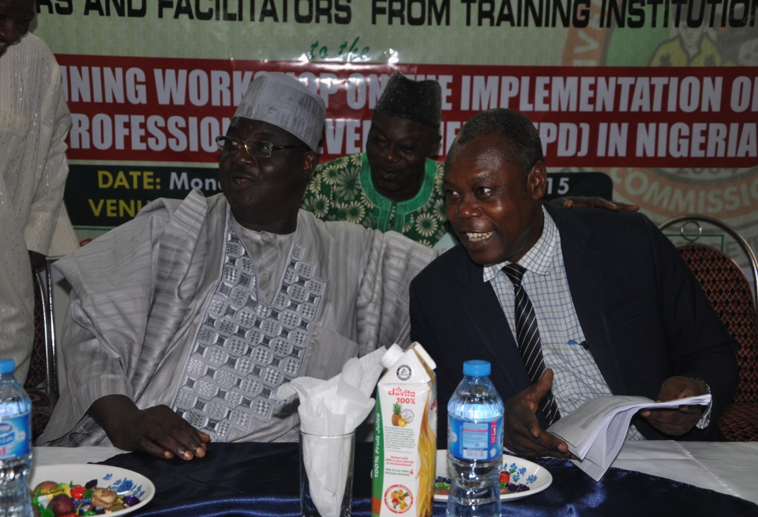
The Deputy Executive Secretary (Services) Dr Yakubu Gambo and Director
Academic Services, Mr. Pius Osaghae at the meeting

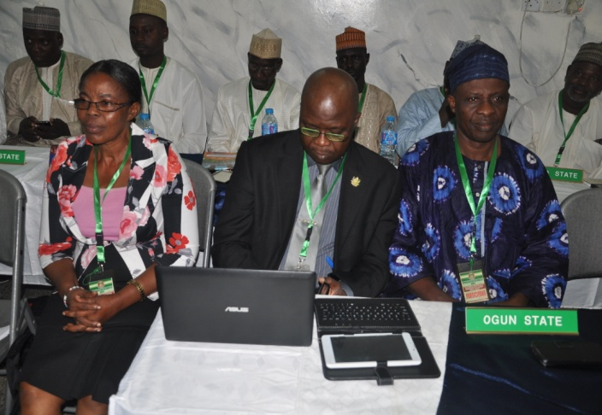 | 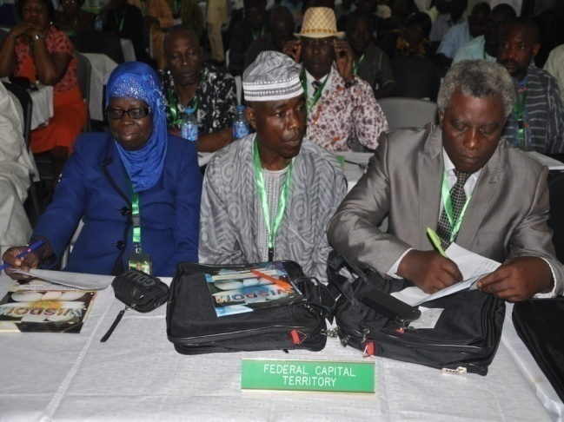
Some of the SUBEB Directors present at the workshop

- Facilitated the training of UBEC staff on Quality Assurance of TPD Trainings.
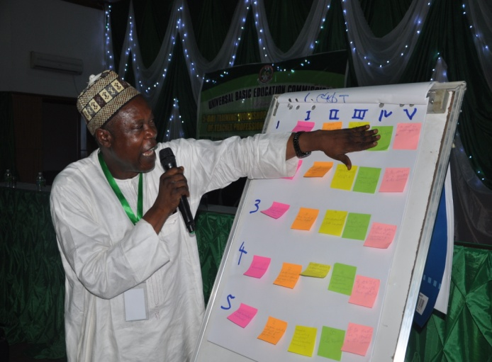 | 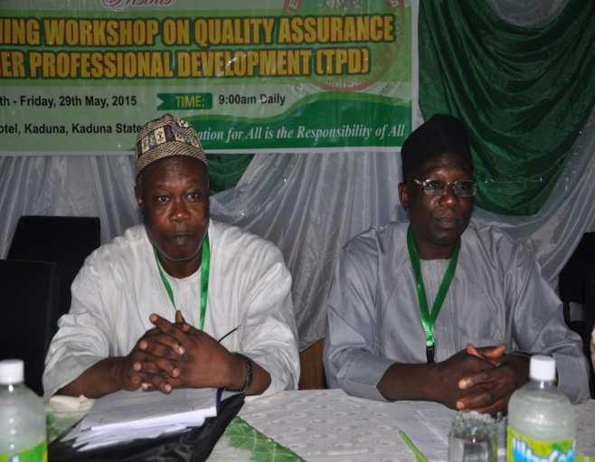
Mr Pius Osaghae, Director, Academic Services Department making a presentation | Members of Management at the workshop
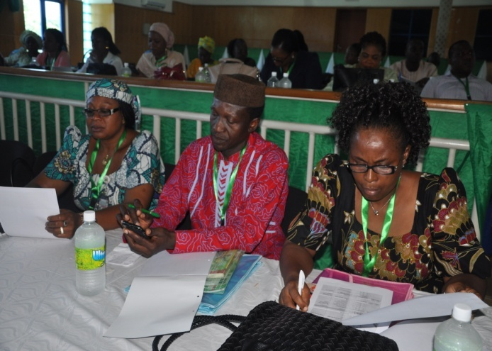 | 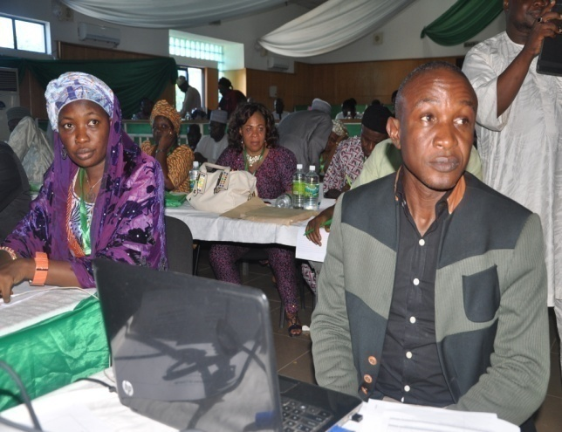
Cross-section of staff that participated in trained at the Workshop
- Distributed:
- 2,220,000 copies of JSS 1 – 3 textbooks in the core subject of Basic Science and Technology. The books have impacted positively on teaching and learning in Primary and Junior Secondary Schools across the States.
- 256,200 copies of Library Resource Materials to JSS to improve reading culture in the schools.
- 518,000 copies of instructional materials on Social Studies, English and Mathematics were also procured for ECCDE.
- Generated data for the establishment of Community Based Early Childhood Care and Education (CBECCE) Centres and focus Intervention by UNICEF in the 13 states and the FCT.
- A total of 39,716 participants comprising 30,426 teachers and 9,290 education managers benefitted from the 2014 trainings.
- Supported the conduct of the President’s Schools Debate of Nigeria (PSDN) 55th Independence Debate Activities.
- Created a new newspaper index proforma and exhibited UBEC Materials at the Annual Basic Education Conference in Abuja.
- Developed Guidance and Counseling Training Manual for UBE Paracounsellors.
- Supported the conduct of the President’s Schools Debate of Nigeria (PSDN) 55th Independence Debate Activities.
- Organized health and productivity at work talk for UBEC Management and staff.

CONSTRAINTS/CHALLENGES
Some of the major challenges that the Department faced included:
- Non-adherence to the guidelines on distribution of textbooks based on needs of the school by the States.
- Lack of fund to support implementation of sports and physical and health education activities in UBE schools.
- Inadequate data on school libraries.
- Delay in the release of intervention funds for the conduct of TPD;
- Sole reliance on FGN-UBE Funds for TPD by most of the States;
- Large number of unqualified teachers, teachers with low competence and teachers not adequately prepared for basic education during pre-service training;
- Poor quality of trainings conducted by some of the States;
- Poor or inadequate follow-up trainings, monitoring, evaluation and impact assessment of training by states; and
- Inadequate in-house capacity to manage trainings in many States especially in the area of monitoring, follow-up and provision of support to trainees in order to facilitate their putting to practice skills learnt in the Cluster sessions as well as monitoring the progress of each trainee.

ON-GOING ACTIVITIES
- Printing of Guidance and Counseling Manual for training of UBE Paracounsellors.
- Organizing training workshops and seminars for SUBEB Directors and Desk Officers in-charge of sports in the States.
- Analysis and harmonization of the 2014 TPD Trainings.
- Preparation for the conduct of 2015 TPD trainings.

FUTURE ACTIVITIES
- Meeting with Desk Officers in-charge of instructional materials in the 36 states and FCT. This will enable the Commission to share its report on the verification exercise on the availability and utilization of textbooks in the states. It will also be a forum to proffer solutions to challenges in the Federal Government’s Free Textbook Initiative.
- Distribution of the Guidance and Counselling Training Manual to the end users.
- Training workshop for Guidance and Counselling Desk Officers in the 36 SUBEBs and FCT UBEB.
- Scale-up of Advocacy Visits for the establishment of Community Based Early Childcare Centres (CBECC) to 24 states that were not involved in the UBE/UNICEF visits.
- Sensitization Meeting for policymakers and administrators on the implementation of the One-year Compulsory Pre-primary Education Community-Based Early Childhood Education.
- Sensitization of states in the implementation of Sports and Physical and Health Education activities in the UBE schools.
- Coordination of the conduct of 2015 Teacher Professional Development.
- Meeting of UBEC Management with Directors and Desk Officers-in-charge of TPD from SUBEBs.
- Meeting of UBEC Management with Representatives of Training Institutions.
- Analysis of the Action Plans to ensure adherence to the guidelines for TPD.
- Disbursement of funds to states for the conduct of the 2015 trainings.
- Monitoring of the 2015 TPD trainings.

2. DEPARTMENT OF ADMINISTRATION AND SUPPLIES
The Department of Administration and Supplies is a service department that assists the Executive Secretary in the daily/routine administration of the Commission. It is headed by a Director.

Baba Sali Song was born in Song, Adamawa State, in April, 1956. He attended University of Maiduguri and graduated with B.Sc Sociology and Anthropology in 1982. After the National Service, he took up appointment with the defunct Gongola State College of Education in Jalingo. After 7 years with the College, he joined the defunct Nigerian Students Loans Board and served from 1989-2002, after which he transferred his service to UBE Commission. He is presently the Director in-charge of Administration and Supplies. | 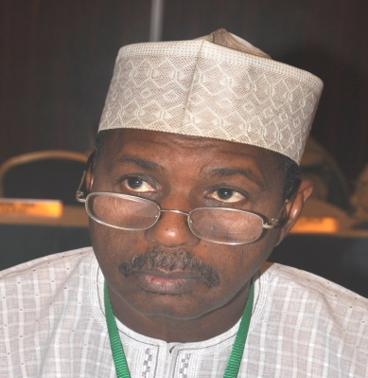  Baba Sali Song  Director, Dept of Administration & Supplies

The department has four units as indicated in fig. 3.
Department of Administration and Supplies

Maintenance and Services Unit

Stores and Supplies Unit

Establishment Unit

Training and Welfare Unit

Fig. 3: The structure of Department of Administration and Supplies
Table 10: Staff Disposition in Department of Administration and Supplies
S/N | DESIGNATION | CONRAISS | NUMBER
1. | Director | 15 | 1
2. | Deputy Director | 14 | 2
3. | Assistant Director | 13 | 3
4. | Principal Admin Officer | 10 | 1
5. | Senior Admin Officer | 9 | 2
6. | Principal Conf. Sec I | 9 | 1
7. | Principal Exec. Officer (Admin) | 9 | 4
8. | Principal Conf. Sec II | 9 | 1
9. | Senior Exec. Officer (Admin) | 8 | 1
10. | Admin Officer I | 8 | 8
11. | Senior Conf. Sec I | 8 | 1
12. | Admin Officer II | 7 | 5
13. | Conf. Sec II | 7 | 1
14. | Chief Driver Mech. | 6 | 4
15. | Chief Clerical Officer | 6 | 1
16. | Works Superintendent | 6 | 1
17. | Senior Driver Mech. | 5 | 2
18. | Asst. Works Superintendent | 5 | 1
19. | Motor Driver/Mech. | 2 | 2
TOTAL |  |  | 42

FUNCTIONS ACTIVITIES
- Advising Management on general administration, establishment and personnel matters.
- Providing secretarial services to the UBEC Management Committee;
- Provides secretarial services to the Governing Board and its Committees;
- Evolving and coordinating training and manpower development policy for the Commission.
- Interpreting and implementing the Commission’s policies as they affect staff welfare such as health/medical care, housing, transport, etc.
- Liaising with the Establishment Department of the Office of the Head of Service of the Federation for the participation of Clerical Staff in the Combined Promotion and Confirmation (COMPRO) Examination.
- Keeping records of all applications for employment, requests for transfer of service, secondments and contract appointments.
- Providing secretarial services to the Board of Trustees for the Commission’s Staff Pension Scheme as well as handling matters relating to terminal leave and pensions.
- Handling insurance matters.
- Providing and coordinating security for UBEC assets.
- Ensuring the cleanliness of offices and office environment through supervision of the cleaners;
- Ensuring the procurement and sustained provision of utility services like telephones, water, electricity, postal/mailings, etc.
- Beautification of office environment.
- Remittance of staff pension contributions to their Retirement Savings Accounts (RSAs).
- Verification of supplies of office furniture and equipment to schools nationwide.
- Processing and coordinating the supply of office furniture and equipment to Departments in the Headquarters, Zonal and State Offices.
- Payment of liquid and solid waste disposal bill- Abuja Environment Protection Board.
- Identifying training needs and drawing annual programme for UBEC staff.
- Processing requests for Seminars, Conferences and Workshops for both local and international.
- Proposing annual welfare programmes for UBEC.
- Liaising with Federal Mortgage Bank of Nigeria (FMBN) on National Housing Fund (NHF) Deductions/Remittances.
- Liaising with the Health Management Organization (HMO) of the National Health Insurance Scheme (NHIS) on health facility matters, etc.

ACCOMPLISHED ACTIVITIES
The Department conducted the underlisted activities during the period under review.
- Conducted the 2015 Pensioners’ Verification exercise.
- Paid Monthly Pension up to date.
- Remitted Staff Pension Contributions to their Retirement Savings Accounts (RSAs) on a monthly basis.
- Assisted retiring staff to enroll at the National Pension Commission (PenCom) for prompt payment of retirement benefits.
- Approval given to eleven (11) staff to proceed on long-term training.
- Serviced and maintained 110 Air-Conditioners.
- Renewed rent for State/Zonal Offices.
- Processed Office furniture and equipment needs for Headquarters, Zonal and State Offices.

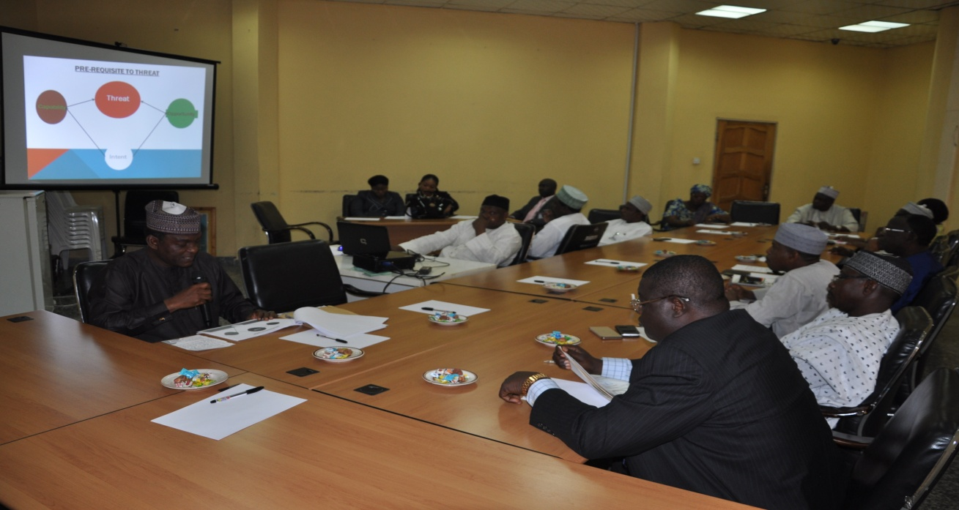
Management Staff of the Commission at a Security Awareness Training given to
UBEC Staff by the Directorate of State Service

- Facilitated the re-introduction and maintenance of UBEC Staff Housing Scheme through Private/Public Partnership on owner-occupier basis in line with Federal Government policy on housing for civil servants.
- Assisted in revamping the hitherto ineffective access to National Health Insurance Scheme healthcare facilities by staff and family members and re-engagement of a new Health Maintenance Organization (HMO) to replace the old one.
- Assisted in facilitating the commencement of yearly merit award to deserving UBEC staff.
- Assisted in facilitation/sustenance of yearly implementation of approved payment of the Rent Supplement policy in place of the hitherto Rent Advance system.
- Collaborated with the Department of Finance to ensure the statutory monthly deductions/remittances from staff salaries and forwarded to FMBN as contributions for the National Housing Fund (NHF).
- Facilitated the refunds of NHF contributions to staff on retirement.
- Facilitated provision of financial relief to staff in cases of emergencies and loss of staff or loved ones.
- Assisted in facilitating the approval of the review of Staff Conditions of Service to incorporate new staff welfare packages.

CONSTRAINTS/CHALLENGES
- Inadequate funds to carry out scheduled trainings.
- Delay in the release of funds for maintenance works.
- High cost of maintenance works and spare parts.
- Unavailability of genuine spare parts and materials in the market.
- Occasional inadequate budgetary allocation, lack of approval to review FGN-UBE CRF formula and absence of yet to be ratified reviewed Staff Conditions of Service.
- Regular interruption of power supply from AEDC leading to high cost of alternative power supply (diesel).

ON-GOING ACTIVITIES
- Compilation of list of officers who are due for confirmation of appointment.
- Preparation for the conduct of senior staff promotion for the years 2014/2015.
- Preparation for the conduct of 2013/2014 junior staff promotion.
- Long-term training for 11 staff.
- Needs assessment of Zonal/State Offices for 2016.
- Needs assessment for maintenance and servicing of all Office Equipment.
- Collaborating with Welfare Committee to establish a sustainable Staff Housing Scheme through establishing an internal revolving housing loan policy.
- Partnering with the Welfare Committee towards establishing Public/Private Partnership with reputable Estate Developers.
- Facilitating registration of/changes for staff towards better access to NHIS facilities.
- Provision of special assistance to staff as financial relief for emergencies such as fire, burglary, death of relations, etc.
- Following-up on staff timely compliance with Code of Conduct declaration of assets requirement.
- Collaborating with Welfare Committee on the provision of a well-equipped and conducive staff canteen.

FUTURE ACTIVITIES
- Compilation of list of senior staff due for 2016 promotion exercise.
- Conduct of 2015/2016 junior staff promotion.
- Construction of permanent Car/Vehicle Parking lots.
- Overhauling of fire prevention facilities at Head Office Complex.
- Procurement of new project monitoring vehicles.
- Working towards a revolving loan scheme or direct Public/Private partnership with Estate Developers for a sustainable UBEC Staff Housing.
- Closely collaborating to strengthen the performance of Health Management Organization to maximize access and benefits of the National Health Insurance Scheme.
- Ensuring that all retired UBEC staff obtain full refund from FMBN of their unutilized contributions as well as those of deceased staff through their next of kin.

3. DEPARTMENT OF FINANCE AND ACCOUNTS

The Department of Finance and Accounts is headed by a Director and assisted by 4 Deputy Directors and two (2) Assistant Directors.
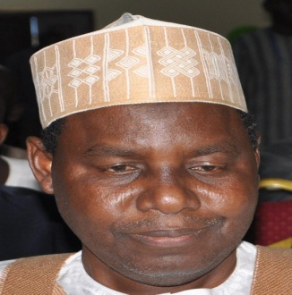

Alhaji Mohammed Sambo Dukku.
Director, Finance & Accounts
Alh. Dukku, who is happily married and blessed with children, can therefore, be referred to as a fulfilled career Public Servant.
Alh. Mohammed Sambo Dukku was born on 14th January, 1959 in Dukku, Gombe State. He graduated from Bayero University Kano with a B.Sc. Accounting in 1986. He had his National Youth Service with the Nigerian Television Authority (NTA), Ibadan, where he was employed as Accountant II, thereafter.

Alh. Dukku rose to the post of Principal Accountant from 1987 - 1995 before joining the defunct National Primary Education Commission in 1995. He is a member of Institute of Chartered Accountants of Nigeria (ICAN) and possesses Master’s of Business Administration, MBA (2010) from Ahmadu Bello University, Zaria. Alh. Dukku is a seasoned Accountant who held various positions within the Commission’s service such as Head of State Accounts (1995), Chief Accountant (2001), Assistant Director (2005) and Deputy Director (2009).

The Department consists of 4 Units as contained in Fig. 4.
The Department of Finance and Accounts
Final Accounts Unit
Funds and Budget Unit
State Accounts Unit

Expenditure Control Unit

Fig. 4: Structure of the Department of Finance and Accounts
In addition to the 4 Units, the Department supervises the financial activities of the Federal Teachers’ Scheme Unit. The structuring of the Department is as shown in Table 12.
Table 12: Staff Disposition in the Department of Finance and Accounts
S/N | DESIGNATION | CONRAISS | NUMBER
1. | Director | 15 | 1
2. | Deputy Director | 14 | 4
3. | Assistant Director | 13 | 2
4. | Chief Accountant/Chief Executive Officer (Accounts)/Chief Conf. Secretary | 12 | 6
5. | Asst. Chief Accountant | 11 | 2
6. | Principal Accountant/Principal Executive Officer(Accounts) | 10 | 12
7. | Senior Accountant/Senior Executive Officer (Accounts) /Prin. Conf. Secretary I | 09 | 9
8. | Accountant I/Senior Executive Officer (Accounts) | 08 | 20
9. | Accountant 11/Higher Executive Officer (Accounts)/Finance Assistant I | 07 | 7
10. | Executive Officer (Accounts)/Finance Assistant II | 06 | 8
TOTAL |  |  | 73
FUNCTIONS
The Department of Finance and Accounts performs functions such as:
- Disbursing the FGN–UBE Intervention Funds to states and other providers of Basic Education;
- Conducting Quarterly Financial Monitoring of the FGN–UBE Intervention Funds;
- Advising the Federal Government, through the Federal Ministry of Education, on the funding of Basic Education in Nigeria;
- Preparing and presenting Financial Progress Reports on the Implementation of the UBE Programme to Mr. President through the Honourable Minister of Education;
- Managing Local and International Donor Agencies’ Grants;
- Liaising with other relevant bodies, such as Federal Ministry of Finance, Federal Ministry of Education, Office of the Accountant-General of the Federation, Office of the Auditor-General of the Federation, National Assembly, the Presidency, Tertiary Education Trust Fund, etc., on matters relating to the funding of UBE Commission;
- Preparing of the Commission’s Annual Budget and Cash Flow Analysis;
- Determining the basis of allocating funds to states and other UBE Implementing Agencies;
- Preparing and presenting the Commission’s Annual Financial Statements.
- Keeping the Commission’s financial records;
- Providing other financial advisory services to the Commission on Taxation, Investment, and Foreign Exchange Management, etc.; and
- Processing and payment of monthly staff salaries, emoluments and other financial entitlements as well as allowances to Federal Teachers’ Scheme participants.
ACCOMPLISHED ACTIVITIES
The Department carried out the underlisted activities during the period under review.
- Disbursed N19,020,365,538.41 UBE Matching grants to 16 States and FCT as contained in Table 12.
Table 13: State by State Disbursement of Matching Grants
S/N | STATE | PERIOD | AMOUNT  (N)
1. | Anambra | 1st - 4th Qtrs, 2014 | 952,297,297.30
2. | Borno | 1st - 4th Qtrs, 2014 | 1,209,997,296.71
3. | Delta | 1st - 4th Qtrs, 2013 | 1,030,797,297.30
4. | Ebonyi | 3rd & 4th Qtrs, 2010, 1st - 4th Qtrs, 2011, 2012, 2013 & 2014 | 4,000,000,000.00
5. | Gombe | 4th Qtr, 2014 | 259,155,405.41
6. | Imo | 1st - 4th Qtrs, 2014 | 952,297,297.30
7. | Jigawa | 3rd & 4th Qtrs, | 604,328,940.64
8. | Kaduna | 1st - 4th Qtrs, 2014 | 952,297,297.30
9. | Kano | 4th Qtr, 2014 | 259,155,405.41
10. | Katsina | 4th Qtr, 2013, 1st - 4th Qtrs, 2014 | 1,209,199,997.71
11. | Kebbi | 1st - 4th Qtrs, 2013, 2014 & 2015 | 2,716,180,180.11
12. | Kogi | 1st - 4th Qtrs, 2011, 2012, 2013 & 2014 | 2,836,031,308.52
13. | Lagos | 1st - 4th Qtrs, 2014 | 952,297,297.30
14. | Osun | 4th Qtr, 2011, 4th Qtr, 2013 | 189,354,604.00
15. | Sokoto | 4th Qtr, 2014 | 259,155,405.41
16. | Taraba | 4th Qtr, 2014 | 179,797,297.30
17. | FCT-Abuja | 4th Qtr, 2011 | 458,023,210.69
TOTAL |  |  | 19,020,365,538.41
- Disbursed N734,42,482.82 Special Education fund to 18 States and FCT and to duly registered Non-Governmental Organizations (NGOs) that provide free special education to the public. Table 14 contains the details.
Table 14: State by State Disbursement of Special Education fund
S/N | STATE | PERIOD | AMOUNT  (N)
1. | Abia | 2014 | 24,459,459.46
2. | Akwa Ibom | 2014 | 24,459,459.46
3. | Anambra | 2013 - 2014 | 48,918,918.92
4. | Benue | 2014 | 24,459,459.46
5. | Delta | 2014 | 24,459,459.46
6. | Ebonyi | 2014 | 24,459,459.46
7. | Gombe | 2014 | 24,459,459.46
8. | Imo | 2013 | 75,291,686.46
9. | Jigawa | 2013 - 2014 | 51,409,459.46
10. | Kaduna | 2014 | 10,000,000.00
11. | Kogi | 2012 - 2014 | 75,291,686.46
12. | Niger | 2013 | 26,950,000.00
13. | Ondo | 2011 - 2013 | 75,291,686.46
14. | Oyo | 2011 & 2012 | 48,312,991.00
15. | Plateau | 2014 | 24,459,459.46
16. | Rivers | 2014 | 24,459,459.46
17. | Sokoto | 2014 | 24,459,459.46
18. | Zamfara | 2013 - 2014 | 51,409,459.46
19. | FCT-Abuja | 2013 & 2014 | 51,409,459.46
TOTAL |  |  | 734,420,482.82

- Disbursed/utilized the sum of N8,344,450,270.59 Educational Imbalance Fund to 35 states and FCT on Almajiri Education, Boy-Child and Girl-Child Education.
- Disbursed/utilized the sum of N7,014,040,683.14 as Good Performance Fund Award for the construction of e-Libraries in Federal Government Colleges.
- Utilized the sum ofN8,870,608,964.40 Instructional Materials Fund to procure science equipment for JSS, textbooks in core subjects and library resource materials.
- Disbursed the sum of N2,978,500,000.00 as 2014 Teacher Professional Development Fund for training of teachers and education managers in the 35 States and FCT at N80, 500,000.00 per state with the exception of Akwa Ibom State which had at N161,000,000.00.

Table 15: State by State Disbursement of 2014 TPD Fund
S/N | STATE | PERIOD | AMOUNT  (N)
1. | Abia | 2014 2nd Tranche | 80,500,000.00
2. | Adamawa | 2014 2nd Tranche | 80,500,000.00
3. | Akwa Ibom | 2014 1st & 2nd Tranches | 161,000,000.00
4. | Anambra | 2014 2nd Tranche | 80,500,000.00
5. | Bauchi | 2014 2nd Tranche | 80,500,000.00
6. | Bayelsa | 2014 2nd Tranche | 80,500,000.00
7. | Benue | 2014 2nd Tranche | 80,500,000.00
8. | Borno | 2014 2nd Tranche | 80,500,000.00
9. | Cross River | 2014 2nd Tranche | 80,500,000.00
10. | Delta | 2014 2nd Tranche | 80,500,000.00
11. | Ebonyi | 2014 2nd Tranche | 80,500,000.00
12. | Edo | 2014 2nd Tranche | 80,500,000.00
13. | Ekiti | - | -
14. | Enugu | 2014 2nd Tranche | 80,500,000.00
15. | Gombe | 2014 2nd Tranche | 80,500,000.00
16. | Imo | 2014 2nd Tranche | 80,500,000.00
17. | Jigawa | 2014 2nd Tranche | 80,500,000.00
18. | Kaduna | 2014 2nd Tranche | 80,500,000.00
19. | Kano | 2014 2nd Tranche | 80,500,000.00
20. | Katsina | 2014 2nd Tranche | 80,500,000.00
21. | Kebbi | 2014 2nd Tranche | 80,500,000.00
22. | Kogi | 2014 2nd Tranche | 80,500,000.00
23. | Kwara | 2014 2nd Tranche | 80,500,000.00
24. | Lagos | 2014 2nd Tranche | 80,500,000.00
25. | Nasarawa | 2014 2nd Tranche | 80,500,000.00
26. | Niger | 2014 2nd Tranche | 80,500,000.00
27. | Ogun | 2014 2nd Tranche | 80,500,000.00
28. | Ondo | 2014 2nd Tranche | 80,500,000.00
29. | Osun | 2014 2nd Tranche | 80,500,000.00
30. | Oyo | 2014 2nd Tranche | 80,500,000.00
31. | Plateau | 2014 2nd Tranche | 80,500,000.00
32. | Rivers | 2014 2nd Tranche | 80,500,000.00
33. | Sokoto | 2014 2nd Tranche | 80,500,000.00
34. | Taraba | 2014 2nd Tranche | 80,500,000.00
35. | Yobe | 2014 2nd Tranche | 80,500,000.00
36. | Zamfara | 2014 2nd Tranche | 80,500,000.00
37. | FCT-Abuja | 2014 2nd Tranche | 80,500,000.00
TOTAL |  |  | 2,978,500,000.00

- Conducted 22nd and 23rd Financial Monitoring of the FGN-UBE Intervention Funds in all the 36 states of the federation and the FCT.
- Secured the release of the 2015 appropriation for the MDGs/DRG funds totaling N4,213,624.00 for Federal Teachers’ Scheme, National Programme on Almajiri Education and Constituency Project.
- Received the sum of N68,380,000,000.00 being 2% Consolidated Revenue Fund for 2015.
- Conducted Training Workshop for UBEC/SUBEBs Directors of Finance and their Accounts staff on implementation of IPSAS.

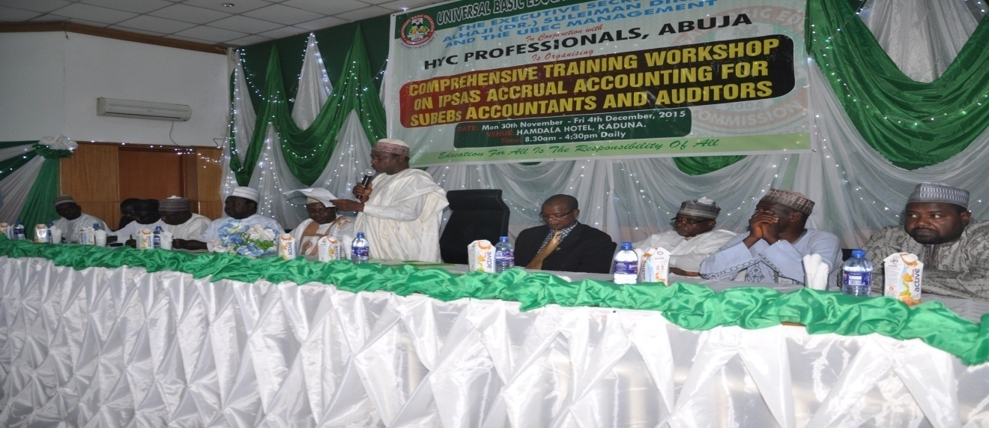
Dignatories present at the workshop for UBEC/SUBEBs Directors of Finance and
their Accounts staff on implementation of IPSAS held in Kaduna

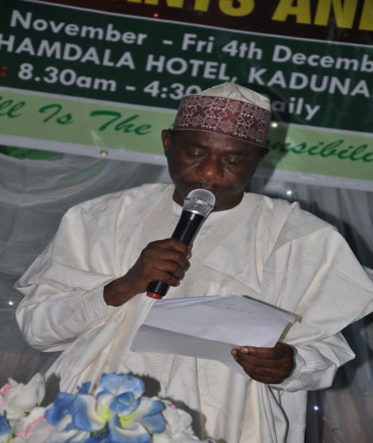 | 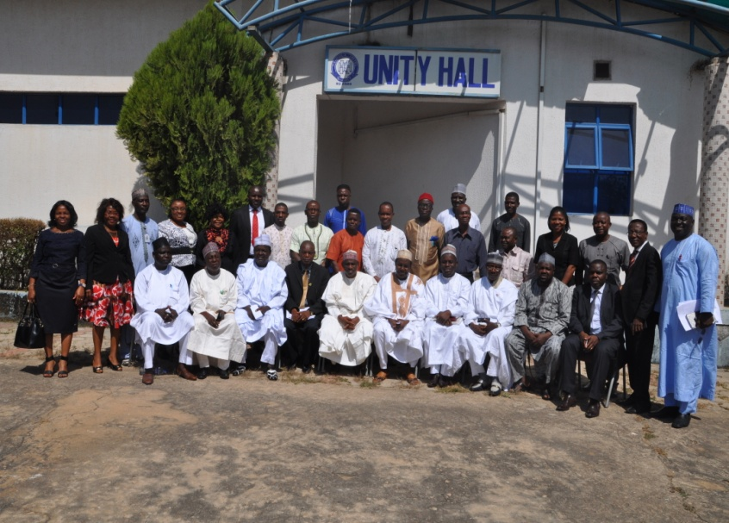
Alh Aliyu Kardi, Director (ES Office) reading the ES address at the meeting | Group photograph of participants at the workshop
ON-GOING ACTIVITIES
- 2016 Budget Preparation and Defense before the National Assembly.
- Updating the new Accounting Manual.
- Adoption of Public Sector Accounting Standard (IPSAS).
CONSTRAINTS/CHALLENGES
- The dwindling FGN revenue due to the fall in crude oil price below benchmark which reduces the funds allocated to the Commission and hence limits the activities of the commission, thereby affecting the attainment of UBE goals.
- Non-regular release of constituency projects funds which causes delay in project completion. There is also the danger of having abandoned projects. It also increases the cost of the projects through variation and delays payment to contractors.
- Inadequate office accommodation.
- Slow utilization of the FGN-UBE Intervention Funds by SUBEBs.
- Lack of political will by some State Governments to access the FG-UBE Matching Grants.
- High turnover rate of SUBEBs Accounting Personnel.
- Delay in submission of Financial Returns by SUBEBs.
- Low level of budgetary allocation to Basic Education by States and Local Governments.
- Exit of Tertiary Education Trust Fund (TETFUND) in funding basic education.
- Inadequate monitoring of FTS participants by SUBEBs and LGEAs which are the beneficiaries.
- Inadequate working equipment like computers.
FUTURE ACTIVITIES
- Developing, printing and distribution of the new Accounting Manual.
- Training of UBEC/SUBEB staff on the new Accounting Manual.
- Development of procedural manual.
- Audit of the 2014/2015 FG-UBE Intervention Funds and MDG Funds.
- Full implementation of IPSAS.

CONCLUSION
The Finance and Accounts Department has been able to respond to many challenges based on the support of Management. This has resulted in new and efficient ways of performing our functions. Data on disbursement of FGN-UBE Intervention Fund is posted on the UBEC website for public knowledge in line with Mr. President’s change agenda of Transparency, Accountability and Transformation; this has reduced the feedback time in responding to reports by individuals and organizations for information on FGN-UBE Intervention Funds.

4. THE DEPARTMENT OF PHYSICAL PLANNING
The Department of Physical Planning was created in 2014. It is headed by a Director who is assisted by 1 Deputy Director.
Arch. Molkat M. Mutfwang was born on 1st November, 1957 in Ampang-West, Mangu Local Government Area of Plateau State. He studied Architecture at the Ahmadu Bello University, Zaria and graduated with a B.Sc (1980) and M.Sc in Architecture in 1982. He did his National Youth Service in Kaduna State after which he worked with the Ministry of Works and Housing, Plateau State before returning to Ahmadu Bello University, Zaria as Lecturer II in 1984.  He joined the National Primary Education Commission (NPEC) as Assistant Chief Architect in Kaduna in 1989 and rose to the rank of Chief Architect in 1994 and became a Deputy Director in UBEC in 1999. | Arch. M.M. Mutfwang  Director, Department of Physical Planning  He is a seasoned Architect that has been engaged in various projects and continues to give his quota to the development of the nation.

It has three (3) Units and they are as shown in Fig. 5.
The Department of Physical Planning

Architecture
Quantity Surveying
Engineering
Fig. 5: Organogram of the Department of Physical Planning
Table 16: Staff Disposition in the Department of Physical Planning
S/NO | Designation | CONRAISS | Number
1. | Director | 15 | 1
2. | Deputy Director | 14 | 1
3. | Chief Tech. /Civil Engineer | 12 | 2
4. | Assist. Chief Building/Data Officer | 11 | 2
5. | Prin. Conf. Secretary | 10 | 1
6. | Civil Engineer I/Senior Technical Officer (QS)/ Architect I/Electrical Engineer I/Senior Technical Officer (Arch)/Architect I/Senior Architect/Building Officer I | 08 | 11
7. | Higher Technical Officer (QS)/Civil Engineers/ Agric Engineer/Higher Technical Officer E/E/ Civil Engineer II/Planning Officer II/Engineer II/Architect II | 07 | 11
TOTAL |  |  | 29

FUNCTIONS
The mandate of the Department is to ensure the provision of qualitative and user-friendly infrastructural facilities in public schools by the states, FCT, donor agencies and Federal Government. The major functions of the Department include:
- participating in the monitoring of approved UBEC/SUBEB executed projects.
- producing designs for FGN Direct Intervention Projects.
- supervising and monitoring of FGN Direct Intervention Projects.
- participating in the preparation of short, medium and long-term budgets for the Commission.
- carrying out market surveys for basic construction materials with a view to updating cost norms for Basic Education infrastructural projects across the whole country and to set cost specific benchmarks for each SUBEB.
- participating in the monitoring of Special Education Projects and donor agencies’ projects.
- attending to major maintenance of UBEC building facilities.
- acting as consultants on the projects of donor agencies such as JICA, KOICA, etc.
- coordinating the activities of consultants for intervention projects engaged by the Commission.
- creating and updating the database for UBEC/SUBEBs projects in terms of approved proposals and confirmed deliverables.
ACCOMPLISHED ACTIVITIES
The department recorded the following achievements in the year under review:
- Assessment and vetting of SUBEB Action Plans.
The Department undertook the assessment and vetting of the infrastructural component of the Action Plans submitted by SUBEBs. This aspect of work covers both the matching grant and Special Education Funds.
- Monitoring of SUBEB projects.
The Department participated in the monitoring of approved and executed projects for various SUBEBs for both the matching grants and Special Education Funds within the year. It also coordinated the mop-up monitoring in states and FCT for projects executed with 2011, 2012, 2013 and 2014 intervention funds. This is with a view to updating the database of the Commission in terms of deliverables.
- Supervision and Monitoring of FGN Direct Intervention Projects through Resident Supervision.
- The FGN Direct Intervention Projects e.g. Junior Girls’ Model Secondary Schools, Almajiri Model Schools, Vocational Schools, e-Library Complexes and Special Renovation.
- The Department participated in and coordinated the monitoring of MDG constituency projects across the country.
ON-GOING ACTIVITIES
The Department is presently supervising the construction of:
- Almajiri School projects.
- Junior Girls’ Model Secondary Schools.
- E-Library projects in Unity Schools
- Special Renovation Projects.
- Vocational schools.
- 2015 MDG Projects nationwide.
- Rectification of Defects for E-Library Projects awarded in 2011.

FUTURE ACTIVITIES
The Department will:
- organize workshops for SUBEBs to review the Minimum Standard Guidelines for infrastructural development;
- organize workshop for SUBEBs Technical officers on the preparation of Action Plans and project monitoring;
- strengthen its mechanism for project monitoring and supervision to enhance quality and timely delivery of projects;
- embark on capacity building for newly employed UBEC Technical Officers through attendance of local and overseas training;
- source for cheaper building materials, in conjunction with states, to reduce the cost of infrastructural facilities;
- develop a maintenance plan for the infrastructural projects in States.
CHALLENGES
- Lack of project vehicles to visit project sites in order to provide effective supervision.
- Lack of capacity training for newly employed Technical Officers.

CONCLUSION
In spite of the challenges mentioned above, the Department with the support of other Departments and Management of the Commission was able to record the above achievements and it is the hope of the Department to record more achievements in the years to come.

5. DEPARTMENT OF PLANNING, RESEARCH AND STATISTICS
The Department of Planning, Research and Statistics is headed by a Director who is assisted by 1 Deputy Director.
Malam Bello Kagara was born on 22nd November, 1960 at Kagara in Kafur Local Government, Katsina State. He attended Galama Primary School, Mahuta (1967-1973), Kufena College, Wusasa, Zaria (1973-1975), the famous Katsina Teachers’ College (1975-1979), College of Education, Kafanchan, (1980-1983), Ahmadu Bello University (1987-1990 and 1993-1994). Kagara holds the Teacher Grade II Certificate (1979), NCE (1983), B..A. Ed. (English) (1990).  He is an alumnus of the prestigious Harvard University, Boston, USA, where he obtained a certificate in Improving Quality in Education System. He has attended several international trainings on Project Planning, Management, Procurement, Policy and Strategic Planning, Educational Planning and Administration, Financing and Modernizing Public Sector Organizations, etc. Kagara is a seasoned  administrator traversing primary school administration as Head-Master, Local Government Councilor for Education and Health and later Council Secretary, Malumfashi and Kafur Local Governments Katsina State, and Head of Planning, Research and Statistics at Katsina State Transport Authority from where he joined the services of the then National Primary Education Commission (NPEC) (now UBEC) as Principal Project Officer World Bank Department in 1994. | 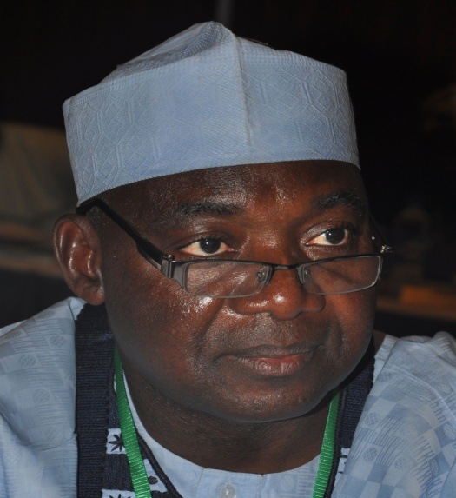  Mallam Bello Kagara  Director, Planning, Research and Statistics  He was the Personal Assistant to the Interim Administrator NPEC in1996, Project Coordinator, World Bank Special Project and Deputy Director, (Special Projects) under the Executive Secretary’s Office. His service as the Project Coordinator of the Special Projects brought fame to the Commission and has to his credit the successful implementation of the Second World Bank-Supported Primary Education Project (PEP II) (2002-2005) and bringing in many International Development Partners (IDPs) such as JICA, USAID, KOICA, and CHINA Commercial Office, etc, within the ambit of the Commission’s Partnership activities.  An accomplished administrator, Bello Kagara is happily married and blessed with children.
He has since then rose through the ranks to become Director, Planning Research and Statistics in September, 2014 to date.
The Department consists of four (4) Units and they are as shown in Fig. 6.
The Department of Planning, Research and Statistics

EMIS and Statistics Unit

Information and Communication (ICT) Unit
Strategic Planning Unit
Research and Publications Unit

Fig. 6: Organogram of the Department of Planning, Research and Statistics

Table 17: Staff Disposition in the Department of Planning, Research and
Statistics
S/N | DESIGNATION | CONRAISS | NUMBER
1. | Director | 15 | 1
2. | Deputy Director | 14 | 1
3. | Assistant Director | 13 | 1
4. | Chief Statistician | 12 | 1
5. | Asst. Chief Research Officer/Assistant Chief Programme Analyst/ Assistant Chief Statistical Officer | 11 | 4
6. | Principal Programme Analyst/Principal Statistical Officer/Principal Research Officer/Principal Planning Officer | 10 | 4
7. | Planning Officer 1/Senior Statistical Officer/Statistician I/Program Analyst I/ Research Officer 1 | 08 | 12
8. | Planning Officer II/ Statistician II | 07 | 12
9. | NYSC | NA | 1
TOTAL |  |  | 37

FUNCTIONS OF THE DEPARTMENT
The basic functions of the Computer Unit include but are not limited to:
- Advising the Management on acquisition, maintenance, utilization and update of ICT facilities in the Commission.
- Coordinating and management of the Basic Education Databank through collection, collation, processing, analysis and dissemination of basic education data and statistics.
- Providing accurate, timely and reliable statistical information relating to basic education for management, stakeholders in basic education, researchers and other end-users;
- Monitoring the implementation of Action Plans and Budget;
- Management of the Commission’s websites and ICT needs.
- Serving as a link between collaborating agencies and other stakeholders on ICT development, data management and other related issues.
- Organizing and initiating computer literacy training to all users of Information and Communications Technology (ICT).
- Designing and developing data collecting instruments for UBE field activities that require data generation;
- Setting standards, monitoring the progress and providing technical support on the development of EMIS at UBEC, SUBEB, LGEA and school levels;
- Coordinating the development of UBEC Action, Strategic and Rolling Plans;
- Monitoring the implementation of SUBEBs’ Action Plans and Budget;
- Developing Key Performance Indicators – KPIs from approved Action Plans for UBE and SUBEBs and reporting same to stakeholders.
- Organizing quarterly In-house Seminars for UBEC staff;
- Managing research and development components of assisted projects by International Development Partners - IDPs;
- Coordinating action research in identified areas of basic education;
- Serving as Secretariat for Inter-departmental Committee on Research; and serving as technical Partners on special research assignments.

ACCOMPLISHED ACTIVITIES
- Managed the Commission’s computer systems and network.
- Updated the Commission’s website.
- Developed Verification Software for instructional materials’ supply to schools.
- Integrated all Departments and Units into one networking family.
- Routine systems troubleshooting, repairs, crimping of internet cables for connectivity, Operating Systems, utilities and Application package installation.
- Updated Basic Education Database for 2012 – 2014.
- Identified Data Inconsistencies and Discrepancies in SUBEBs data returns
- Produced Manuscript on Digest of Basic Education Statistics 2010-2014 ready for publication.
- Exchanged professional, technical expertise and best practices in data organization and Management with SUBEBs through interactive engagement during the mop-up exercise.
- Successfully disseminated Basic Education data to stakeholders and other end-users.
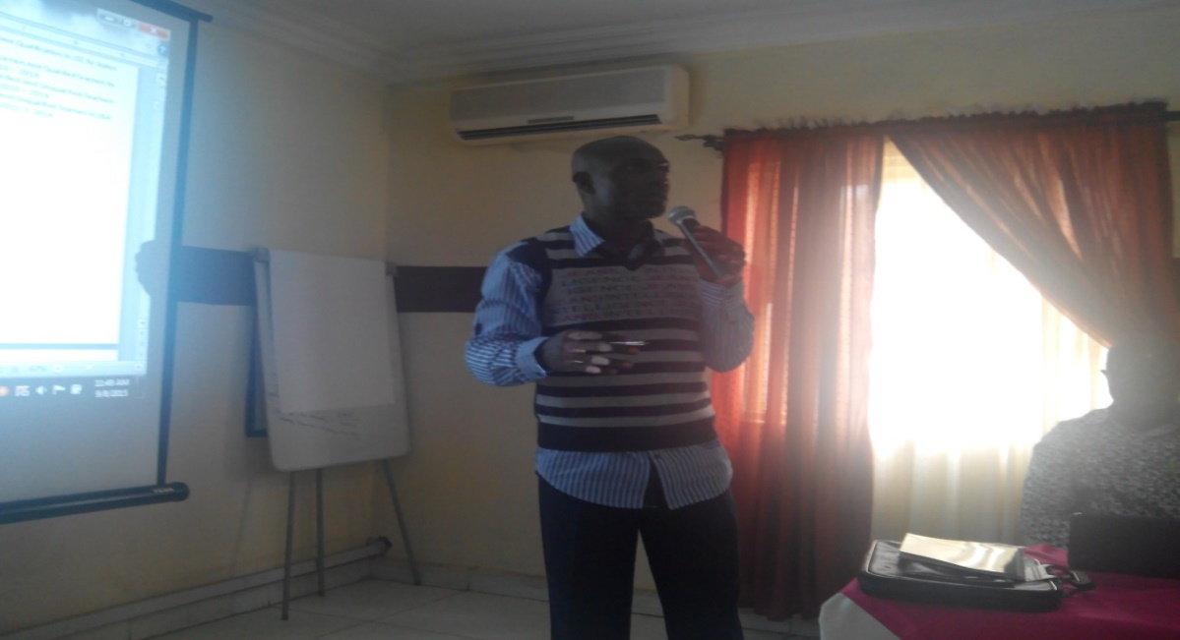
Mr. Akpannossom Udoh, HOU-EMIS leading the Technical Session at a workshop for the
production of manuscript on Digest of Basic Education Statistics 2010-2014

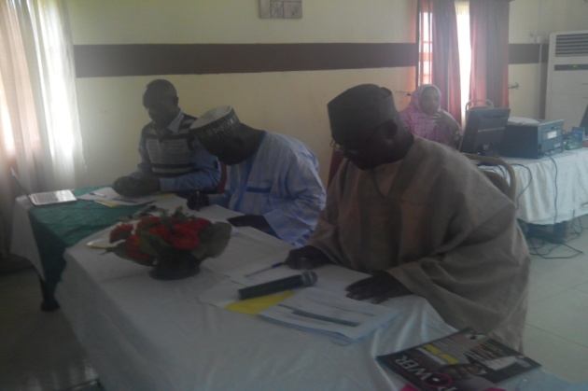 | 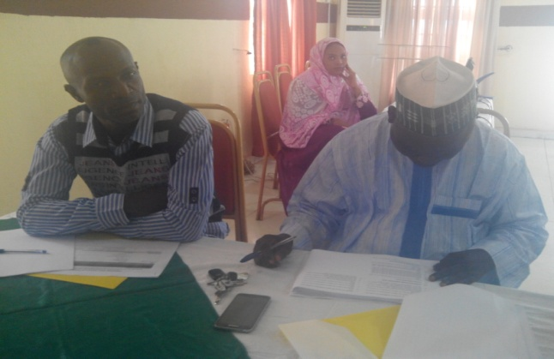
The Director working with other members of staff at the workshop

- Executed basic education focused surveys, programmes and projects in collaboration with some MDAs such as FM0E, NPoPC, NBS and IDPs (UNICEF, USAID and World Bank). These include: Out-of-school children (OOSC), Child Based Community Care (CBCC), Early Child Care Education (ECCDE), 2015 Nigeria Education Data Survey (NEDS) and State Education Programme Investment Project (SEPIP).
- Analysed report on the discrepancies and data inconsistencies in SUBEB data returns and their attendant consequences in basic education management.
- Conducted In-house seminar on Office Procedure and Ethics.
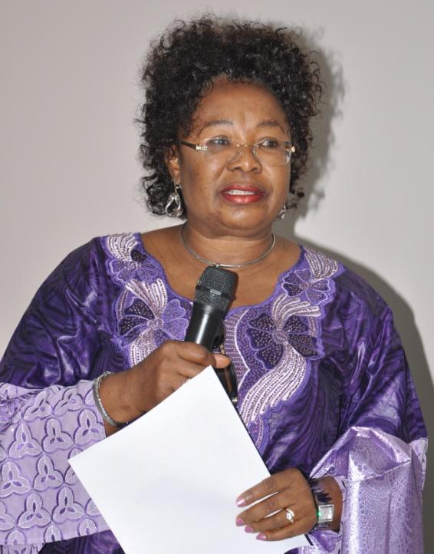 | 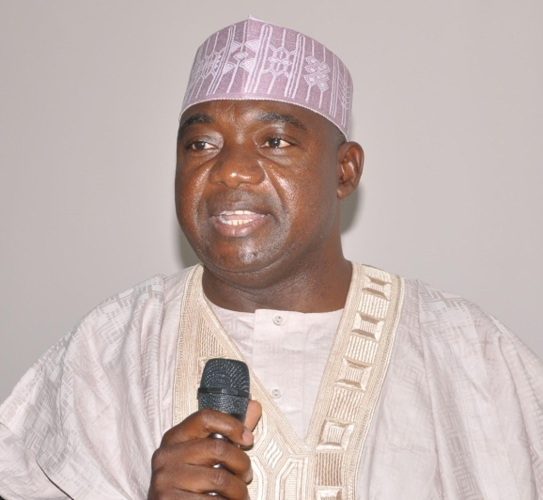
Dr. Sharon ‘Rowo Oriero-Oviemuno (DES-T) reading the Opening Address on behalf of the Executive Secretary | Alh. Bello Kagara, DPRS welcoming staff to  the In-House Seminar
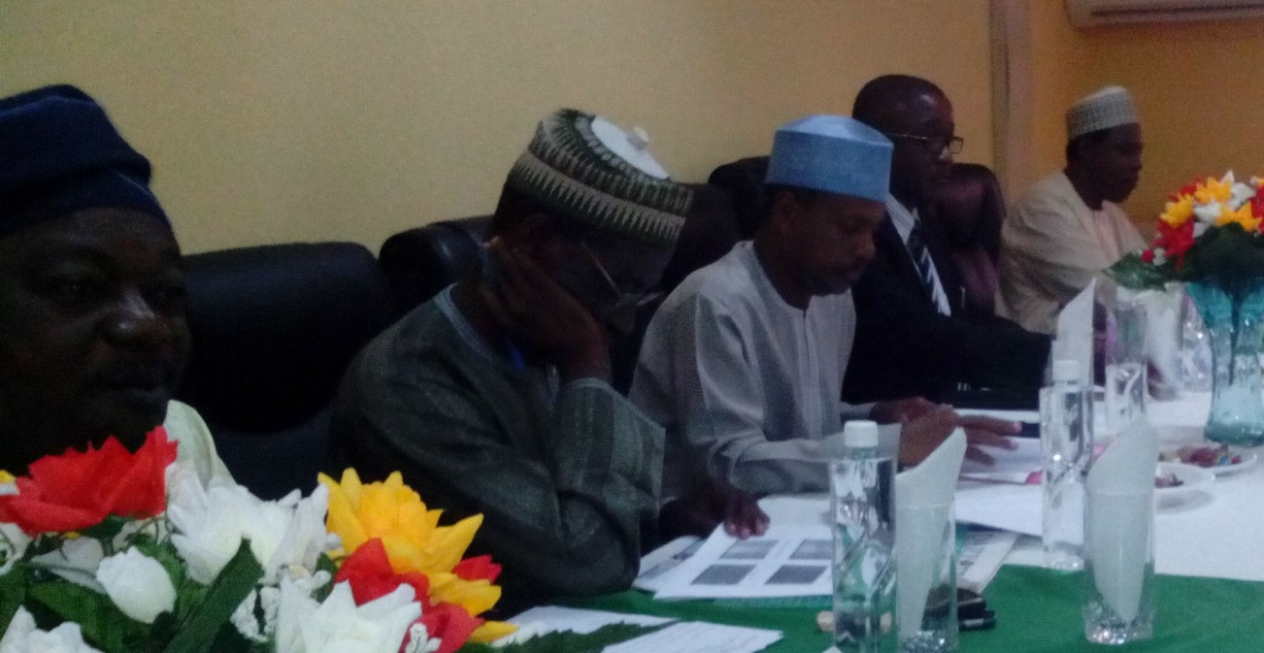

Members of management present at the seminar

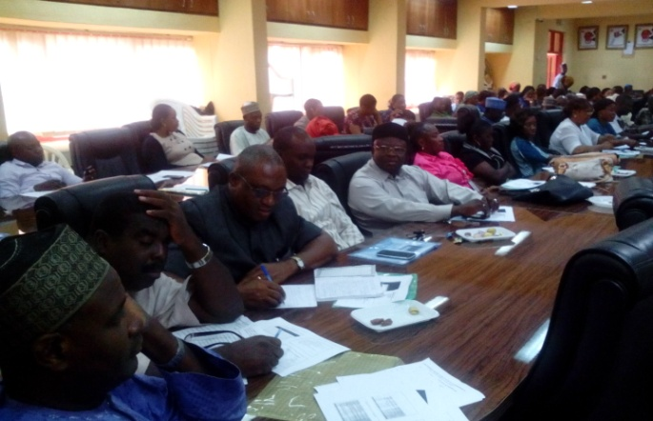 | 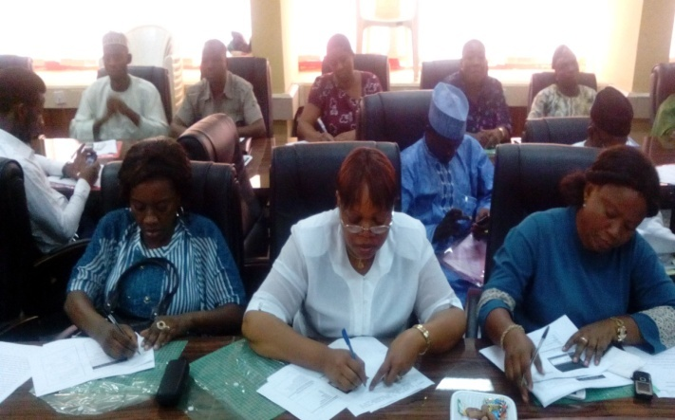
Cross section of staff at the seminar

- Collated, reviewed and edited 2015 Annual Report.
- Collated, reviewed and edited papers for publication in the UBE Forum and the Basic Educationist magazine.
- Conducted the 2nd edition of Forum of Directors in-charge of Strategic Planning in UBEC and SUBEBs in December, 2015.
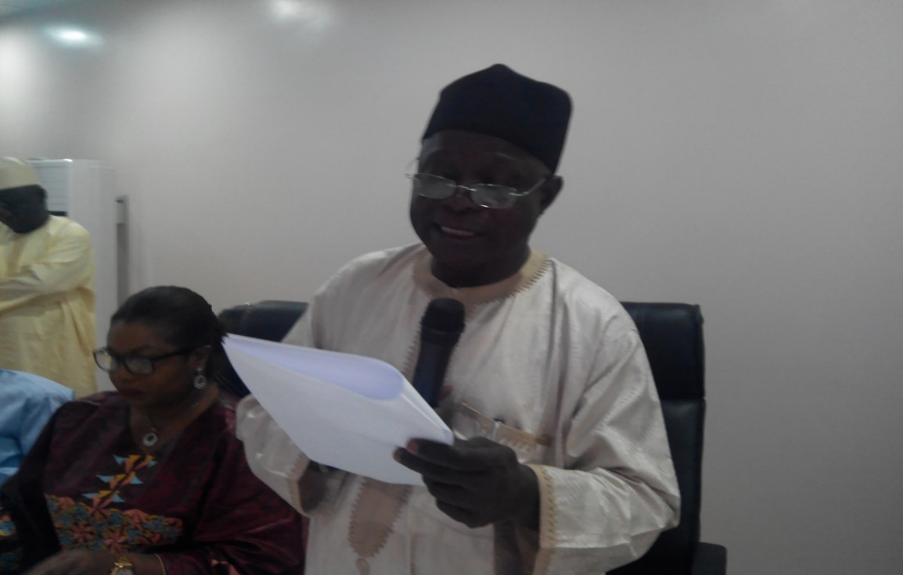
Prof U. T. Muhammad, the representative of the ES delivering an address at the meeting
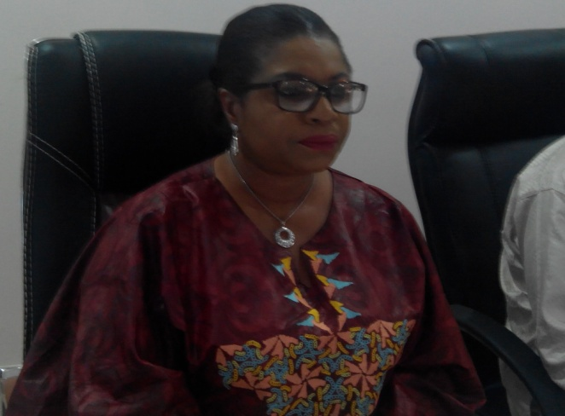 | 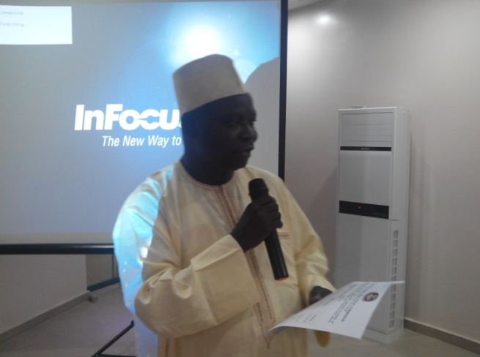
Dr. Rosemary Nwangwu of UNICEF, one of  the Resource Persons at the meeting | Mal. Imam Aliyu Shaaba, Deputy Director, Strategic Planning making a comment during the meeting
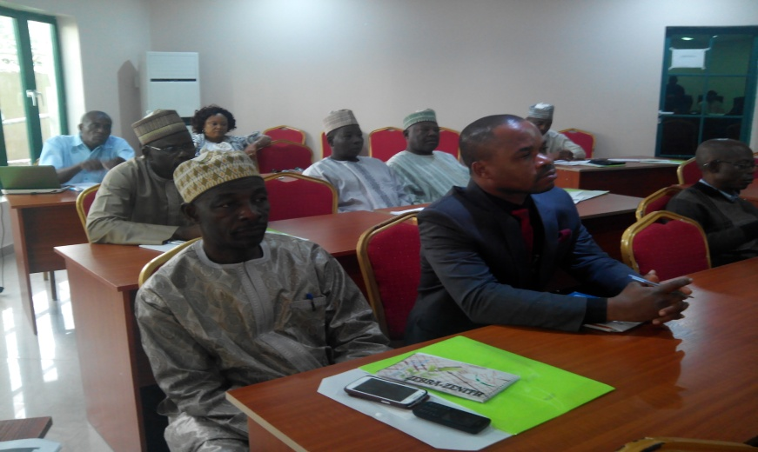
Participants at the meeting listening to one of the papers
presented with rapt attention

- Established a line of collaboration with ESSPIN and UNICEF to assist UBEC and SUBEBs in the development of States’ Education Sector and Strategic Plans, through a consultative meeting in November, 2015.
- Represented the Commission in an FME/UNICEF SESP/MTSS Review Meeting in November, 2015 at Akwanga, Nasarawa State.

- Development of Staff Salary Software and Instructional Materials’ supplies to schools.
- Verification of e-Library ICT equipment in Unity Schools, Junior Girls’ Model Schools and Almajiri Schools across the country.
- Routine maintenance and update of UBEC website.
- Routine systems troubleshooting, repairs, crimping of internet cables for connectivity, Operating Systems, utilities and Application Package installation.
- Member of UBEC IPSA Implementation Committee.
- Mopping-up of the 2012/2013and 2013/2014 basic education data from SUBEBs.
- Data processing, analysis, and reporting of the 2012/2013and 2013/2014basic education.
- Carried out a Technical Workshop on the analyses of the 2010 - 2014 basic education data and Production of Manuscript for the UBE Digest of Statistics 2010 – 2014.
- Harmonization of data emanating from UBEC departments through the formation of UBEC Data Committee.
- Constant interaction with states on EMIS Development at SUBEBs, LGEAs and schools.
- Continuous dissemination of Basic Education data to stakeholders and other end-users.
- Collaboration with the National Population Commission on the 2015 Nigeria Education Data Survey (NEDS).

CONSTRAINTS/CHALLENGES
- Lack of budgetary provisions for EMIS development at UBEC, SUBEBs, LGEAs and schools.
- Low commitment by UBEC and SUBEB Management on EMIS development at all Basic Education management tiers.
- Falsification and politicization of basic education data by SUBEBs.
- Lack of established Management Information System along Basic Education management and administrative set-up: UBEC – SUBEB – LGEA – Schools.
- Inadequate planning of statistics development over the short, medium and long term.
- Non-availability of a common or uniform Basic Education Management Information System (BEMIS) tools such as School Tool, EMIS Toolbox, School Mapping software, Cloud Computing, etc.
- Inability of Management to provide the necessary grounds for more sustained actions toward the full implementation of EMIS policy in Basic education Management and operations.
- Inadequate funding, policy formulation and implementation machinery.
- Inadequate provision of an ICT Budget.
- Provision of modern equipment to meet the emerging ICT trends.
- Lack of capacity building for staff of the department.
- Lack of budgetary allocation for research activities.
- Omission of unit’s personnel in the interactive meetings of SUBEBs on Action Plan;
- Difficulties in the development of Action and Rolling Plans due to falsified and incomplete data returns;
- Inadequate collaborations between units/departments in the Commission, to ensure proper implementation of strategic and operational plans culture.

ON-GOING ACTIVITIES
- Routine systems troubleshooting, repairs, crimping of internet cables for connectivity, Operating Systems, utilities and Application Package installation.
- Completion of School Mapping Project.
- Member of UBEC IPSA Implementation Committee.
- Routine updating of the Commission’s website.
- Verification of e-Library ICT equipment in Unity Schools, Junior Girls’ Model Schools and Almajiri Schools across the country.
- Production of UBE Statistical Digest 2010-2014.
- Harmonization of UBEC Departmental Data/Data Departmental Support Services.
- Collation and analysis of the 2014/2015 and 2015/2016 basic education data returns from SUBEB.
- Continual dissemination of basic education data to stakeholders and other end-users.

FUTURE ACTIVITIES
- Meeting with Directors of PRS from States Ministry of Education and SUBEBs on synergy of Basic Education data collection.
- Development of Basic Education Management Information System in the basic education management sub-sector.
- Development and Production of Training Manual on EMIS for the continuous capacity building of EMIS personnel and data managers in basic education.
- Capacity building for UBEC EMIS staff in Modern Statistical Application Packages (MSAP).
- Capacity building of UBEC Headquarters staff in Basic Education Key Performance Indicators (KPI).
- 2014/2015 basic education data collation, analysis, report writing and production.
- Verification of status and functionality of EMIS facilities and monitoring of EMIS development at SUBEBs.
- Production and publication of the 2015 Annual Report.
- Production of the UBE Forum and the Basic Educationist magazine.
- Conduct of quarterly In-house seminars.
- Collation of 2016 Annual Report.
- Publication of papers for UBE Forum and the Basic Educationist magazine.
- Migrating the Current Website to .gov.ng domain.
- Provision of Local Area Network (LAN) and Internet Connectivity to the Zonal Offices, State Office and State Universal Basic Education Board (SUBEB).
- Developing e-Instrument for the different departments.
- Moving towards paperless office.
- Making e-library work (checking the functionality of the e-library facilities supplied).
- To organize and conduct the bi-annual meetings of the Forum of UBEC and SUBEBs’ Directors in-charge of Strategic Planning in 2016.
- To collaborate with consultants, IDPs (like UNICEF and ESSPIN) and other stakeholders in the development of Education Sector Plans for all the SUBEBs and UBEC.
- A Bi-Annual monitoring to ascertain the extent of implementation of SESOP/ESP by SUBEBs in all the states of the federation will be carried out.
- To develop a national basic education strategic plan in line with UBEC Road Map.
- To carry out a critique on the Draft Plan on development of National Basic Education Road Map.
- To publish and disseminate the final document on National Basic Education Strategic Plan in line with UBEC Road Map.
- Workshop on how UBEC Departments will key into the intervention of the Commission via SESOP/ESP implementation in the states.
- Provision of technical support in the sector plan development in the states.

6. DEPARTMENT OF QUALITY ASSURANCE
The Department of Quality Assurance is one of the eight Departments of the Commission. It is currently being headed by an Acting Director who is assisted by 2 Deputy Directors.
Dr. Tokunbo Tserun Onosode was born on 17th October, 1960. She attended the University of Ife, Ile-Ife, Osun State. She graduated with a Bachelor of Arts in English in 1986 and Masters’/Ph.D degrees in Educational Evaluation from the University of Ibadan, Oyo State in 1991/2004. She took up teaching appointment with the Lagos State Government after the National Youth Service in 1987. She later joined the Federal Civil Service in 1998 as Education Officer VIII where she was deployed to the defunct National Educational Technology Centre (NETC), Kaduna.  She was later redeployed to the Special Programme Unit of the Federal Ministry of Education, Kaduna which metamorphosed into the erstwhile National Primary Education Commission. She served as Monitoring Officer in Benin and Ibadan Zonal Offices at different times. She later served as the State Coordinator of Edo State Office of the Universal Basic Education Commission from 2006 – 2011 before she was transferred to the Headquarters. She is | 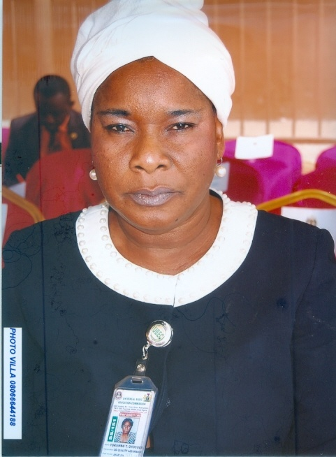
Tokunbo Tserun Onosode
Ag. Director, Dept of Quality Assurance
 | skilled in Programme Evaluation, Research Design and Development of Inventory on Basic Education Standards with special interest in Teaching and Learning at the Basic Education Level. She is presently Acting Director of the Department of Quality Assurance.
The department has three Units and oversees the Zonal and State offices as indicated in Fig. 1. Each Unit is headed by an officer of the rank of Deputy Director (Quality Assurance).
Zonal/State Offices and
FCT Sub-Zonal Office Unit

Zonal Office Matters
Unit
Monitoring and
Evaluation Unit
Assessment Unit
QA Department

Fig. 7: The Structure of the Department of Quality Assurance

FUNCTIONS
The Department of Quality Assurance is charged with the responsibility of ensuring high quality basic education through appropriate quality assurance mechanisms as well as prescribing, monitoring, evaluating and maintaining minimum standards, especially in the area of teaching and learning, to Nigerian children. The main tasks of the department are to prescribe and maintain minimum standards, monitor, appraise and evaluate the UBE programme through the following mechanisms:
- Quality Assurance - appraising school effectiveness and efficiency; appraising teaching and learning and quality of provisions in schools;
- Prescribing, monitoring and maintaining minimum standards in basic education provisions;
- Assessment of learning achievements at the Basic Education level in Nigeria (e.g. National Assessment of Learning Achievements in Basic Education - NALABE) - determining the normative indices for evaluating learners’ performance;
- Development and application of the Unified National Continuous Assessment Programme (UNCAP) in Nigeria at the Basic Education level;
- Coordinating the activities of the 6 Zonal Offices, FCT Sub-Zonal Office, and 30 State Offices;
- Liaising with other UBEC departments in the development of appropriate instruments for the purpose of evaluating their field activities;
- Supporting various Development Partners in the monitoring of assisted programmes and projects in Basic Education institutions;
- Serving as the Secretariat of the Quarterly meeting of UBEC Management with the Executive Chairmen of SUBEBs and
- Carrying out any assignment that may be directed by the Executive Secretary and/or Management.
THE UBEC’S ZONAL AND STATE OFFICES
While the Zonal Offices are headed by Directors, the State Offices/FCT Sub-Zonal Office is headed by Officers of the cadre of Assistant Director or not less than Principal Quality Assurance Officer. The locations of the Zonal offices and the States that they cover are contained in Table 1.
STAFF DISPOSITION
The staff position and the total number of staff in the Department are as follows:

Table 18: Staff Disposition at the Headquarters
S/N | STAFF POSITION | CONRAISS | Number
1. | Ag. Director | 14 | 1
2. | Deputy Director | 14 | 2
3. | Chief Quality Assurance Officer | 12 | 1
4. | Chief Confidential Secretary | 12 | 1
5. | Principal Quality Assurance Officer | 10 | 2
6. | Senior Quality Assurance Officer | 09 | 2
7. | Prin. Data Processing Assistant IV | 09 | 1
8. | Confidential Secretary II | 09 | 1
9. | Quality Assurance Officer I | 08 | 3
10. | Quality Assurance Officer II | 07 | 2
11. | Driver | 06 | 1
TOTAL |  |  | 17

Table 19: Staff Disposition at the Zonal and State Offices

Table 19a: Staff Disposition at the North Central Zonal Office and State Offices
A. | North Central Zonal Office
S/N | DESIGNATIONS | CONRAISS |  | DEPARTMENT
1. | Zonal Director | 15 |  | Quality Assurance
2. | Asst. Chief. Tech. Officer | 11 |  | Social Mobilization
3. | Principal Accountant | 10 |  | Finance & Accounts
4. | Principal Admin Officer | 10 |  | Admin. & Supplies
5. | Principal Admin Officer | 10 |  | Admin. & Supplies
6. | Principal Tech Officer | 10 |  | Physical Planning
7. | Senior Tech Officer | 09 |  | Physical Planning
8. | Civil Engineer I | 08 |  | Physical Planning
9. | Quality Assurance Officer I | 08 |  | Quality Assurance
10. | Internal Auditor I | 08 |  | Audit
11. | Academic Planning Officer I | 08 |  | Academic Services
12. | Civil Engineer I | 08 |  | Physical Planning
13. | Legal Officer I | 08 |  | Legal Unit
14. | Confidential Secretary II | 06 |  | Admin. & Supplies
15. | Driver-Mechanic | 04 |  | Admin. & Supplies
B. | Benue State Office
1. | Ag. State Coordinator |  | 10 |  | Quality Assurance
2. | Prin. Confidential Secretary II |  | 09 |  | Admin & Supplies
3. | Accountant II |  | 08 |  | Finance & Accounts
4. | Quality Assurance Officer II |  | 07 |  | Quality Assurance
5. | Higher Executive Officer (Admin) |  | 07 |  | Admin & Supply
6. | Quality Assurance Officer II |  | 07 |  | Quality Assurance
7. | Quality Assurance Officer II |  | 07 |  | Quality Assurance
8. | Accountant II |  | 07 |  | Finance & Accounts
9. | Chief Motor Driver/Mech. |  | 06 |  | Admin & Supplies
10. | Chief Clerical Officer (Accts) |  | 06 |  | Finance & Accounts
11. | Assistant Executive Officer |  | 05 |  | Admin & Supplies
C. | Kwara State Office
1. | State Coordinator |  | 13 |  | Quality Assurance
2. | Quality Assurance Officer I |  | 08 |  | Quality Assurance
3. | Higher Executive Officer (Admin.) |  | 08 |  | Admin. & Supplies
4. | Quality Assurance Officer II |  | 07 |  | Quality Assurance
5. | Admin Officer II |  | 07 |  | Admin. & Supplies
6. | Executive Officer Admin |  | 05 |  | Admin. & Supplies
7. | Motor Driver |  | 02 |  | Admin. & Supplies
D. | Nasarawa State Office
1. | Ag. State Coordinator |  | 10 |  | Quality Assurance
2. | Prin. Executive Officer II (Admin) |  | 09 |  | Admin. & Supplies
3. | Social Mobilization Officer I |  | 08 |  | Social Mobilization
4. | Accountant II |  | 07 |  | Finance &Account
5. | Admin Officer II |  | 07 |  | Admin. & Supplies
E. | Niger State Office
1. | Ag. State Coordinator |  | 12 |  | Quality Assurance
2. | Quality Assurance Officer I |  | 08 |  | Quality Assurance
3. | Snr. Executive Officer (Admin) |  | 08 |  | Admin & Supplies
4. | Quality Assurance Officer I |  | 08 |  | Quality Assurance
5. | Higher Executive Officer Acct. II |  | 07 |  | Finance & Accounts
6. | Academic Planning Officer II |  | 07 |  | Academic Services
7. | Planning Officer II |  | 07 |  | Planning, Research & Statistics
8. | Social Mobilization Officer II |  | 07 |  | Social Mobilization
9. | Quality Assurance Officer II |  | 07 |  | Quality Assurance
F. | Plateau State Office
1. | Ag. State Coordinator |  | 11 |  | Quality Assurance
2. | Prin. Data Processing Officer |  | 11 |  | Planning, Research & Statistics
3. | Snr. Quality Assurance Officer |  | 09 |  | Quality Assurance
4. | Senior Admin. Officer |  | 09 |  | Admin & Supplies
5. | Planning Officer I |  | 08 |  | Planning, Research & Statistics
6. | Quality Assurance Officer I |  | 08 |  | Quality Assurance
7. | Quality Assurance Officer II |  | 07 |  | Quality Assurance
8. | Quality Assurance Officer II |  | 07 |  | Quality Assurance
9. | Accountant II |  | 07 |  | Finance & Accounts
10. | Planning Officer II |  | 07 |  | Planning, Research & Statistics
G. | FCT Sub-Zonal Office
1. | Coordinator |  | 13 |  | Quality Assurance
2. | Chief Internal Auditor |  | 12 |  | Finance & Accounts
3. | Asst. Chief Executive Off. (Accts) |  | 11 |  | Finance & Accounts
4. | Asst. Chief Academic Planning Officer. |  | 11 |  | Academic Services
5. | Prin. Executive Officer (Fin.) |  | 10 |  | Finance & Accounts
6. | Principal Admin Officer |  | 10 |  | Admin & Supplies
7. | Prin. Executive Officer (Admin) |  | 09 |  | Admin & Supplies
8. | Prin. Executive Officer (Soc. Mob.) |  | 09 |  | Social Mobilization
9. | Admin Officer I |  | 08 |  | Admin & Supplies
10. | Admin Officer I |  | 08 |  | Admin & Supplies
11. | Legal Officer I |  | 08 |  | Legal Unit
12. | Academic Planning Officer I |  | 08 |  | Academic Services
13. | Admin Officer I |  | 08 |  | Admin & Supplies
14. | Admin Officer II |  | 07 |  | Admin & Supplies
15. | Social Mobilization Officer II |  | 07 |  | Social Mobilization
16. | Admin Officer II |  | 07 |  | Admin & Supplies
17. | Academic Planning Officer II |  | 07 |  | Academic Services
18. | Social Mobilization Officer II |  | 07 |  | Social Mobilization
19. | Planning Officer II |  | 07 |  | Planning, Research & Statistics
20. | Social Mobilization Officer II |  | 07 |  | Social Mobilization
21. | Social Mobilization Officer II |  | 07 |  | Social Mobilization
22. | Confidential Secretary |  | 06 |  | Admin & Supplies
23. | Driver |  | 02 |  | Admin & Supplies

Table 19b: Staff Disposition at the North East Zonal Office and State Offices
A. | North-East Zonal Office
S/N | DESIGNATIONS | CONRAISS | DEPARTMENT
1. | Director | 15 | Quality Assurance
2. | Chief Accountant | 12 | Finance & Accounts
3. | Asst. Chief Auditor | 11 | Finance & Accounts
4. | Asst. Chief Building Officer | 11 | Physical Planning
5. | Principal Admin. Officer | 10 | Admin & Supplies
6. | Electrical Engr. I | 08 | Physical Planning
7. | Programmer Analyst I | 08 | Planning, Research & Statistics
8. | Building Engr. I | 08 | Physical Planning
9. | Quantity Surveyor | 08 | Physical Planning
10. | Legal I | 08 | Legal Unit
11. | Admin. Officer I | 08 | Admin & Supplies
12. | Social Mobilization Officer II | 07 | Social Mobilization
13. | Quality Assurance Officer II | 07 | Quality Assurance
14. | Planning Officer II | 07 | Planning, Research & Statistics
15. | Architect II | 07 | Physical Planning
16. | Snr. Driver I | 06 | Admin & Supplies
B. | Adamawa State Office
1. | Ag. State Coordinator | 10 | Quality Assurance
2. | Principal Accountant | 10 | Finance & Accounts
3. | Prin. Quality Assurance Officer | 10 | Quality Assurance
4. | Snr. Quality Assurance Officer | 09 | Quality Assurance
5. | Engr II | 07 | Physical Planning
6. | Planning Officer II | 07 | Planning, Research & Statistics
7. | Exec. Officer (Admin.) | 06 | Admin & Supplies
8. | Exec. Officer (Admin.) | 06 | Admin & Supplies
9. | Snr. Driver/Mech | 05 | Admin & Supplies
C. | Borno State Office
1. | Ag. State Coordinator | 11 | Quality Assurance
2. | Asst. Chief Admin. Officer | 11 | Admin & Supplies
3. | Snr. Quality Assurance Officer | 09 | Quality Assurance
4. | Admin. Officer | 08 | Admin & Supplies
5. | Quality Assurance Officer II | 07 | Quality Assurance
6. | Confidential Secretary | 07 | Admin & Supplies
D. | Gombe State Office
1. | State Coordinator | 14 | Quality Assurance
2. | Prin. Executive Officer (Accounts) | 10 | Finance & Accounts
3. | Admin Officer I | 08 | Admin & Supplies
4. | Social Mobilization Officer I | 08 | Social Mobilization
5. | Quality Assurance Officer II | 07 | Quality Assurance
6. | Asst. Quality Assurance Officer II | 06 | Quality Assurance
7. | Confidential Secretary III | 05 | Admin & Supplies
8. | Driver | 02 | Admin & Supplies
E. | Taraba State Office
1. | State Coordinator | 13 | Quality Assurance
2. | Admin Officer II | 07 | Admin & Supplies
3. | Quality Assurance Officer II | 07 | Quality Assurance
4. | Accountant II | 07 | Finance & Accounts
5. | Snr. Mobilization Officer II | 07 | Social Mobilization
6. | Executive Officer Admin | 06 | Admin & Supplies
F | Yobe State Office: Staff yet to be posted to the office

Table 19c: Staff Disposition at the North West Zonal Office and State Offices
A. | North-West Zonal Office
S/N | DESIGNATIONS | CONRAISS | DEPARTMENT
1. | Director | 16 | Quality Assurance
2. | Chief Accountant | 12 | Finance & Accounts
3. | Asst. Chief Admin. Officer | 11 | Admin & Supplies
4. | Chief Tech. Officer (Arc.) | 12 | Physical Planning
5. | Principal Accountant | 10 | Finance & Accounts
6. | Senior Legal Officer | 09 | Legal Unit
7. | Chief Typist | 08 | Admin & Supplies
8. | Architect I | 08 | Physical Planning
9. | Architect I | 08 | Physical Planning
10. | Prin. Admin. Officer II | 08 | Admin & Supplies
11. | Quality Assurance Officer I | 08 | Quality Assurance
12. | Civil Engineer II | 08 | Physical Planning
13. | Building Officer I | 08 | Physical Planning
14. | Social Mobilization Officer I | 08 | Social Mobilization
15. | Planning Officer I | 08 | Physical Planning
16. | Social Mobilization Officer II | 07 | Social Mobilization
17. | Statistician II | 07 | Planning, Research & Statistics
18. | Planning Officer II | 07 | Planning, Research & Statistics
19. | Academic Planning Officer II | 07 | Academic Services
20. | Higher Executive Officer (Admin.) | 07 | Admin & Supplies
21. | Civil Engineer II | 07 | Physical Planning
22. | Civil Engineer II | 07 | Physical Planning
23. | Town Planning Officer II | 07 | Planning, Research & Statistics
24. | Academic Planning Officer II | 07 | Academic Services
25. | Quality Assurance Officer II | 07 | Quality Assurance
26. | Chief Driver Mechanic | 06 | Admin & Supplies
27. | Driver | 03 | Admin & Supplies
B. | Jigawa State Office
1. | State Coordinator | 13 | Quality Assurance
2. | Snr. Quality Assurance Officer | 09 | Quality Assurance
3. | Admin. Officer I | 08 | Admin & Supplies
4. | Snr. Executive Officer (Accounts) | 08 | Finance & Accounts
5. | Academic Planning Officer II | 07 | Academic Services
6. | Quality Assurance Officer II | 07 | Quality Assurance
C. | Kano State Office
1. | Ag. State Coordinator | 11 | Quality Assurance
2. | Prin. Social Mobilization Officer | 10 | Social Mobilization
3. | Principal Accountant | 10 | Finance & Accounts
4. | Senior Admin Officer 1 | 09 | Admin & Supplies
5. | Quality Assurance Officer I | 08 | Quality Assurance
6. | Administrative Officer II | 07 | Admin & Supplies
7. | Social Mobilization Officer II | 07 | Social Mobilization
8. | Social Mobilization Officer II | 07 | Social Mobilization
9. | Chief Driver/Mechanic | 06 | Admin & Supplies
10. | Senior Executive Officer | 06 | Admin & Supplies
11. | Confidential Secretary III | 05 | Admin & Supplies
12. | Clerical Officer I | 04 | Admin & Supplies
D. | Katsina State Office
1. | Ag. State Coordinator | 14 | Quality Assurance
2. | Prin. Planning Officer | 10 | Planning, Research & Statistics
3. | Prin. Confidential Secretary | 10 | Admin & Supplies
4. | Higher Executive Officer (Admin) II | 07 | Admin & Supplies
5. | Quality Assurance Officer II | 07 | Quality Assurance
6. | Admin. Officer II | 07 | Admin & Supplies
7. | Snr. Data Processing Asst. I | 05 | Academic Services
8. | Driver | 02 | Admin & Supplies
9. | Clerical Asst.(Admin) | 02 | Admin & Supplies
E. | Kebbi State Office: Staff are yet to be posted to the office
F | Sokoto State Office
1. | State Coordinator | 13 | Quality Assurance
2. | Prin. Executive Officer (Admin.) | 10 | Admin & Supplies
3. | Academic Planning Officer I | 08 | Academic Services
4. | Quality Assurance Officer II | 07 | Quality Assurance
5. | Accountant II | 07 | Finance & Accounts
6. | Quality Assurance Officer II | 07 | Quality Assurance
7. | Quality Assurance Officer II | 07 | Quality Assurance
8. | Chief Driver/Mech. | 06 | Admin & Supplies
G | Zamfara State Office
1. | Ag. State Coordinator | 11 | Quality Assurance
2. | Senior Admin. Officer | 09 | Admin & Supplies
3. | Admin. Officer | 07 | Admin & Supplies
4. | Snr. Executive Officer (Accounts) | 08 | Finance & Accounts
5. | Quality Assurance Officer | 07 | Quality Assurance
6. | Statistician II | 07 | Physical Planning
7. | Planning Officer II | 07 | Planning, Research & Statistics

Table 19d: Staff Disposition at the South East Zonal Office and State Offices
A. | South-East Zonal Office
S/N | DESIGNATIONS | CONRAISS | DEPARTMENT
1. | Ag. Zonal Coordinator | 13 | Quality Assurance
2. | Chief Confidential Secretary | 12 | Admin & Supplies
3. | Asst Chief Internal Auditor | 11 | Finance & Accounts
4. | Principal Accountant | 10 | Finance & Accounts
5. | Legal Officer | 07 | Legal Unit
6. | Legal Officer | 07 | Legal Unit
7. | Academic Planning Officer | 07 | Academic Services
8. | Engineer | 07 | Physical Planning
9. | Engineer | 07 | Physical Planning
10. | Higher Executive Officer (Admin) | 07 | Admin & Supplies
11. | Chief Driver/Mechanic | 06 | Admin & Supplies
12. | Finance Assistant | 04 | Finance & Accounts
B. | Abia State Office
1. | Ag. State Coordinator | 11 | Quality Assurance
2. | Quality Assurance Officer I | 08 | Quality Assurance
3. | Academic Planning Officer | 07 | Academic Services
4. | Executive Officer (Accounts) | 06 | Admin & Supplies
C. | Anambra State Office
1. | Quality Assurance Officer I | 08 | Quality Assurance
2. | Academic Planning Officer | 07 | Academic Services
3. | Executive Officer (Accounts) | 06 | Admin & Supplies
D. | Ebonyi State Office
1. | Ag State Coordinator | 09 | Quality Assurance
2. | Accountant I | 08 | Finance & Accounts
3. | Admin Officer | 07 | Admin & Supplies
4. | Confidential Secretary III | 05 | Admin & Supplies
5. | Senior Driver | 03 | Admin & Supplies
E. | Enugu State Office
1. | Ag. State Coordinator | 11 | Quality Assurance
2. | Accountant | 10 | Finance & Accounts
3. | Snr. Quality Assurance Officer | 09 | Quality Assurance
4. | Snr. Quality Assurance Officer | 09 | Quality Assurance
5. | Admin Officer | 07 | Admin & Supplies
6. | Accountant | 07 | Finance & Accounts
7. | Academic Planning Officer | 07 | Academic Services
8. | Chief Driver/Mechanic | 06 | Admin & Supplies
9. | Chief Clerical officer (Accts) | 06 | Admin & Supplies
10. | Confidential Secretary II | 06 | Admin & Supplies

Table 19e: Staff Disposition at the South South Zonal Office and State Offices
A. | South-South Zonal Office
S/N | DESIGNATIONS | CONRAISS | DEPARTMENT
1. | Ag. Zonal Coordinator | 11 | Quality Assurance
2. | Principal Internal Auditor | 10 | Finance & Accounts
3. | Principal Accountant | 10 | Quality Assurance
4. | Quality Assurance Officer II | 07 | Quality Assurance
5. | Admin. Officer II | 07 | Admin & Supplies
6. | Accountant II | 07 | Finance & Accounts
7. | Executive Officer (Admin.) | 06 | Admin & Supplies
8. | Chief Driver/Mech. | 06 | Admin & Supplies
9. | Confidential Secretary III | 05 | Admin & Supplies
B. | Bayelsa State Office
1. | Ag. State Coordinator | 11 | Quality Assurance
2. | Prin Confidential Secretary II | 09 | Admin & Supplies
3. | Accountant I | 08 | Finance & Accounts
4. | Quality Assurance Officer II | 07 | Quality Assurance
5. | Academic Planning Officer II | 07 | Academic Services
6. | Senior Driver/ Mechanic | 04 | Admin & Supplies
C. | Cross River State Office
1. | Ag. State Coordinator | 11 | Quality Assurance
2. | Quality assurance I | 08 | Quality Assurance
3. | Accountant I | 08 | Finance & Accounts
4. | Admin. Officer II | 07 | Admin & Supplies
5. | Academic Planning Officer II | 07 | Academic Services
6. | Confidential Secretary II | 06 | Admin & Supplies
7. | Driver | 03 | Admin & Supplies
D. | Delta State Office
1. | Snr. Quality Assurance Officer | 09 | Quality Assurance
2. | Academic Planning Officer I | 08 | Academic Services
3. | Admin. Officer I | 08 | Admin & Supplies
4. | Accountant II | 07 | Finance & Accounts
5. | Social Mobilization Officer II | 07 | Social Mobilization
 | Driver/ Mechanic | 02 | Admin & Supplies
E. | Edo State Office
1. | Ag. State Coordinator | 11 | Quality Assurance
2. | Prin Confidential Secretary | 10 | Admin & Supplies
3. | Snr. Quality Assurance Officer | 09 | Quality Assurance
4. | Academic Planning | 08 | Academic Services
5. | Executive Officer Account | 06 | Admin & Supplies
6. | Chief Driver Mech. | 06 | Admin & Supplies
F. | Rivers State Office
1. | Principal Executive Officer II | 09 | Admin & Supplies
2. | Snr. Quality Assurance Officer | 09 | Quality Assurance
3. | Accountant I | 08 | Finance & Accounts
4. | Social Mobilization Officer I | 08 | Social Mobilization
5. | Administrative Officer II | 07 | Admin & Supplies
6. | Administrative Officer II | 07 | Admin & Supplies

Table 19f: Staff Disposition at the South West Zonal Office and State Offices
A. | South-West Zonal Office
S/N | DESIGNATIONS | CONRAISS | DEPARTMENT
1. | Ag. Zonal Director | 14 | Quality Assurance
2. | Senior Admin Officer | 09 | Admin & Supplies
3. | Accountant II | 09 | Finance & Accounts
4. | Quality Assurance Officer I | 08 | Quality Assurance
5. | Snr. Exec. Officer (Audit) | 08 | Finance & Accounts
6. | Planning Officer II | 07 | Planning, Research & Statistics
7. | Chief Driver/Mech. | 06 | Admin & Supplies
8. | Confidential Sec. III | 05 | Admin & Supplies
B. | Ekiti State Office
1. | Ag. State Coordinator | 10 | Quality Assurance
2. | Snr. Quality Assurance Officer | 09 | Quality Assurance
3. | Higher Executive Officer (Acct.) | 07 | Finance & Accounts
4. | Quality Assurance Officer II | 07 | Quality Assurance
5. | Quality Assurance Officer II | 07 | Quality Assurance
6. | Academic Planning Officer II | 07 | Academic Services
7. | Chief Driver | 06 | Admin. & Supplies
8. | Confidential Secretary III | 05 | Admin. & Supplies
C. | Lagos State Office
1. | State Coordinator | 13 | Quality Assurance
2. | Chief Typist | 08 | Admin. & Supplies
3. | Accountant I | 08 | Finance & Accounts
4. | Social Mobilization Officer II | 07 | Social Mobilization
5. | Quality Assurance Officer II | 07 | Quality Assurance
6. | Admin Officer II | 07 | Admin. & Supplies
7. | Admin Officer II | 07 | Admin. & Supplies
8. | Chief Driver/Mechanic | 06 | Admin. & Supplies
D. | Ondo State Office
1. | Ag. State Coordinator | 12 | Quality Assurance
2. | Prin. Executive Officer (Accounts) | 10 | Finance & Accounts
3. | Quality Assurance Officer I | 08 | Quality Assurance
4. | Admin Officer I | 08 | Admin & Supplies
E. | Osun State Office
1. | Ag. State Coordinator | 11 | Quality Assurance
2. | Asst. Chief Conf. Secretary | 11 | Admin. & Supplies
3. | Quality Assurance Officer I | 08 | Quality Assurance
4. | Quality Assurance Officer I | 08 | Quality Assurance
5. | Accountant | 07 | Finance & Accounts
F. | Oyo State Office
1. | Ag. State Coordinator | 10 | Quality Assurance
2. | Asst. Chief Conf. Secretary | 12 | Admin & Supplies
3. | Principal Conf. Secretary | 10 | Admin & Supplies
4. | Snr. Quality Assurance Officer | 09 | Quality Assurance
5. | Admin. Officer II | 07 | Admin & Supplies
6. | Quality Assurance Officer II | 07 | Quality Assurance
7. | Driver/Mechanic | 03 | Admin & Supplies

ACCOMPLISHED ACTIVITIES
The Department of Quality Assurance covered and accomplished the activities stated below.
- A 5-day workshop for cleaning and editing of selected items for National Assessment of Learning Achievements in Basic Education (NALABE) and item bank for Basic Education in Nigeria.
- Conducted Trial-testing of test items for NALABE in seven (7) states covering 6 geo-political zones.
- Conducted Quality Assurance in Basic Education Institutions.
- Facilitated capacity building of Quality Assurance Officers in SUBEBs.
- Hosted the 14th Quality Meeting of UBEC Management with the Executive Chairmen of SUBEBs in the Federal Capital Territory, Abuja.
- Harmonized the 2015 School Calendar.
- Harmonized the Quarterly Administrative Reports from 1st to 4th Quarter of 2015.
- Facilitated the payment of running cost to State Offices cleared by Final Accounts from 1st to 4th quarter of 2015.

ACHIEVEMENTS
Some of the major achievements of the department include the following:
- Two hundred and fifty thousand (250,000) and more test items were selected in each of the four core subjects: English Language, Mathematics, Social Studies and Basic Science.
- Trial-testing of the test items was successfully conducted in six (6) states selected from the 6 geo-political zones and the FCT.
- Quality assured 401 ECD centres, 690 primary schools and 164 junior secondary schools for 3rd term 2014/2015 and 1st term 2015/2016 sessions. The schools covered were mainly in the rural areas.
- Conducted training for 2,734 Quality Assurance Officers of SUBEB and LGEAs in 35 states.
- The 14th Quarterly Meeting of UBEC Management with SUBEBs Chairmen was successfully conducted.
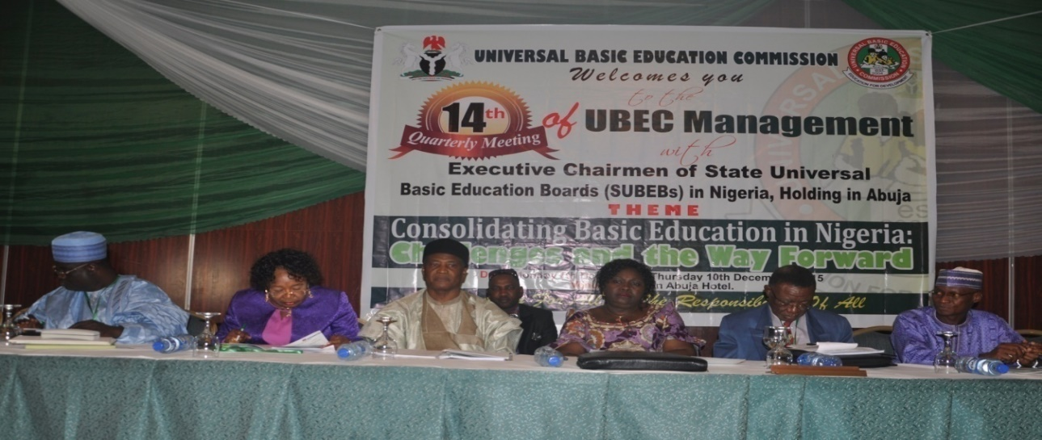
The Representative of the Honourable Minister of Education, Mal Adamu Adamu, with Management during the Opening Ceremony of the 14th UBEC Management/SUBEB Chairmen Meeting
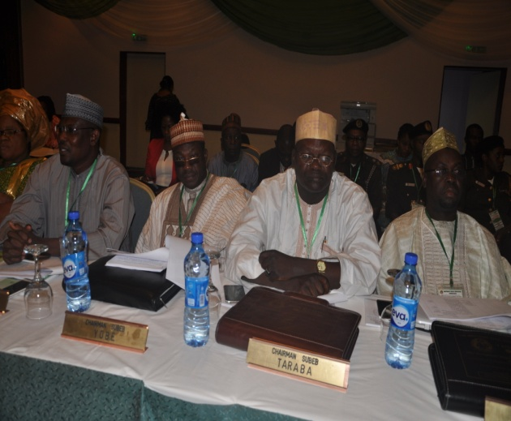 | 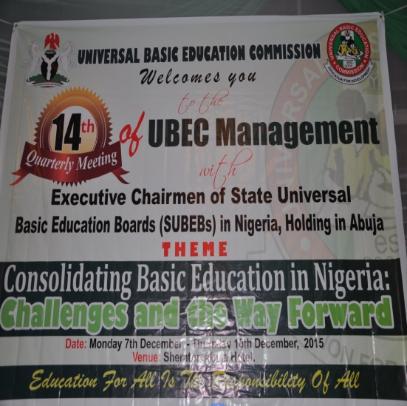
Cross-section of Chairmen at the meeting | The banner of the meeting
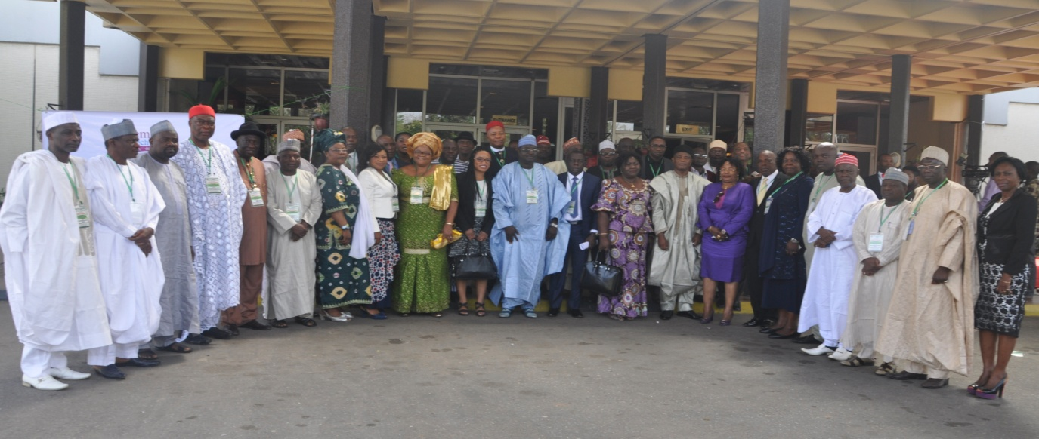
The Management and Chairmen in a group photograph

ON-GOING ACTIVITIES
The following activities are currently being carried out by the department:
- Editorial work on SUBEB Reports to the 9th, 10th, 11th and 12th Quarterly Meetings of UBEC Management with Executive Chairmen of SUBEBs, preparatory to their printing.
- Memorandum to UBEC Management on the relevance of quality assurance reports in the implementation of the UBE Programme.
- Memorandum to UBEC Management on Minimum Standards for Quality Assurance Departments in SUBEBs.
- Editorial work on the Minutes of the 14th Quarterly Meeting of UBEC Management with the Executive Chairmen of SUBEBs held in Abuja.
- Preparation for the 15th Quarterly meeting of UBEC Management with the Executive Chairmen of SUBEBs to be held in Yenagoa, Bayelsa State.
- Training of SUBEB and LGEA Quality Assurance Officers on the conduct of Quality Assurance in Basic Education Institutions in Nigeria for 2015 TPD Funds.

FUTURE PLANS
The department plans to conduct the following activities:
- Regular conduct of termly quality assurance of basic education institutions and follow-up monitoring of the previous Quality Assurance.
- Printing of hard copies of test items.
- Conduct of National Assessment of Learning Achievement in Basic Education (NALABE).
CONSTRAINTS/CHALLENGES
The challenges that the department encountered in the implementation of quality assurance activities included, among other things:
- Inadequate number of trained Quality Assurance Officers at SUBEB and LGEA levels.
- Inadequate time to effectively conduct quality assurance in schools due to paucity of funds at the UBEC, SUBEB and LGEA levels.
- Inadequate monitoring vehicles in most SUBEBs and LGEAs.
- The capacity of SUBEB and LGEA Officers has not been adequately enhanced in the implementation of the Unified National Continuous Assessment Programme (UNCAP).
- Non-implementation of recommendations contained in quality assurance reports by stakeholders (UBEC, SUBEBs, LGEAs, Schools and other stakeholders).
- Need to increase the frequency of visits to schools in order to ensure that all schools are visited within the 4-year cycle as stipulated in the Minimum Standards document.
- Need to have the full complement of Quality Assurance Officers in all the Zonal and State Offices.

CONCLUSION
The department noted all its achievements which it duly ascribed to the tremendous support/assistance received from the Management. It, therefore, looks forward to a more exciting 2016 with the hope of impacting positively on the implementation of all UBE Programme activities.

7. THE DEPARTMENT OF SOCIAL MOBILIZATION
The Department of the Department of Social Mobilization is headed by a Director and assisted by 2 Deputy Directors and two (1) Assistant Directors.
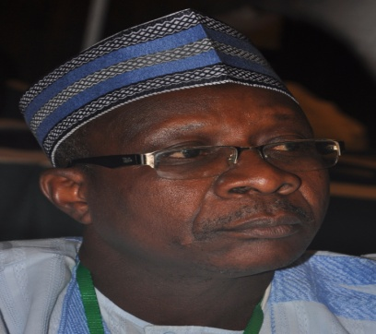
Alh Usman Aliyu Kaoje.
Director, Department of Social Mobilisation

Alhaji Kaoje is a seasoned Administrator and a Fellow of the Institute of Industrialist and Corporate Administrators.
Alh. Usman Aliyu Kaoje was born on the 23rd November, 1958 in Kaoje town of Bagudo Local Government Area in Kebbi State. He attended LEA Primary School in Koaje town, Gwadabawa Secondary School and proceeded to Usman Danfodio University, Sokoto, where he obtained a B.Sc Degree in Political Science in 1982.
Alhaji Kaoje started his civil service career as an Assistant Secretary in 1983 with Sokoto State Government. By 1995, he joined the services of the defunct National Primary Education Commission as an Assistant Chief Administrative officer and rose to the rank of a Deputy Director Admin by the year 2006. On 1st September 2014, he was appointed the Director of Social Mobilization of the Commission.

The department has two (2) Units and six (6) Sections. They are shown in Fig. 8.
The Department of Social Mobilization

Social Mobilization Unit
Community Development and Empowerment Unit

Advocacy Section
Campaigns and Promotion Section
Production and Media Relations Section
Production and Media Relations Section
Donor intervention/Partnerships Section
Self Help Project/Special Needs Education Section

Fig. 8: The Structure of the Department of Social Mobilization

The department is presently manned by a staff strength shown in Table 20 below.
Table 20: Staff Disposition in the the Department of Social Mobilization
S/N | DESIGNATION | CONRAISS | Number
1 | Director | 15 | 1
2 | Deputy Director | 14 | 2
3 | Asst. Chief Social Mobilization Officer | 11 | 1
4 | Principal Social Mobilization Officer | 10 | 1
5 | Principal Confidential Secretary | 10 | 1
6 | Social Mobilization Officer I | 08 | 5
7 | Social Mobilization Officer II | 07 | 5
8 | Senior Driver | 07 | 1
Total |  |  | 17

FUNCTIONS OF THE DEPARTMENT
The roles of the Department of Social Mobilization, UBEC, include among other things, carrying out mass mobilization, advocacy and sensitization of the general public, building partnerships with stakeholders in the Basic Education Sub-sector as well as disseminating various activities of the UBE Programme to the general public for increased awareness, community empowerment/ownership and participation in order to achieve the overall objectives of the compulsory, free universal basic education in Nigeria. The specific functions are:
- Initiating Social Mobilization policies and programmes especially as they relate to:
- Advocacy, sensitization and mobilization for successful basic education delivery.
- Community empowerment through Self-Help projects and mobilization to promote enrolment, improvement and ownership of the UBE programme.
- Orientating the stakeholders on their duties, obligations and responsibilities as wards, custodians, implementers and facilitators of the UBE Programme and for proper understanding of its policies.
- Initiating contacts and programmes towards broadening the network of partnerships with CSOs and other stakeholders at the grassroots, as well as other resources in providing for, participating in the execution, monitoring and evaluating of all basic education delivery processes.
- Promoting new sets of attitude and culture for the attainment of the goals and objectives of the UBE programme as well as promoting the spirit of dignity of labour, honesty and commitment to qualitative basic education attainment.
- Encouraging formal and non-formal education through public enlightenment activities, production of publications, etc.
- Liaising with other UBEC professional Departments and other Government Agencies for effective mobilization on the implementation of all Basic Education-related programmes, e.g. Girl-Child Education, Education of Street Children and other Disadvantaged groups and Home-Grown School Feeding and Health Programme, etc.
- Liaising with agencies such as NTI, NERDC, NBTE, NETC, NCCE, NABTEB, FMI, ADNF, etc., local and international organizations and NGOs in the design, production and distribution of public enlightenment and relevant information on UBE Programme.
- Promoting the establishment of popular Community-Based Organizations such as School Based Management Committees (SBMCs) that will enhance the implementation of the UBE Programme.
- Initiating and implementing programmes such as HIV/AIDS awareness campaign and capacity building for States, LGAs and communities/schools.

ACCOMPLISHED ACTIVITES
- The Department conducted the 4th level training (Mentoring and monitoring) to strengthen the capacity of SBMC members with a view to make the Committee functional in their schools using the domesticated SBMC policy guidelines of their states. Staff of the Commission who were trained have cascaded same to relevant SBMC members in all the States which the SBMCs have used the knowledge acquired to conduct their monitoring and mentoring in all the schools.
- SUBEBs have monitored the SBMCs in all the basic education schools using mentoring method instead of the conventional monitoring. This has helped the SBMCs to improve their activities particularly, in the areas of sourcing for funds, development of School Development Plan (SDP), retention and completion.
- UBEC in collaboration with Education Sector Support Programme in Nigeria (ESSPIN) drew out a plan for the successful conduct of the second edition of the National Stakeholders’ Conference on Community Participation in School Governance. The conference which is in fulfilment of the Commission’s pledge to make it an annual event was also expected to appraise the activities of the SBM across the federation for the period under review.
- Special Education Unit conducted a Mid-term monitoring of 2013 projects executed by the private providers that benefitted in the 2013 disbursement arrangement.
- A final monitoring of 2013 projects executed by the private providers that benefitted in the 2013 disbursement was also conducted by the Special Education Unit.
- The Special Education Unit verified the submission from private providers seeking support from 2014 special needs intervention fund.
- A meeting with selected beneficiaries of 2014 special needs intervention fund was held with the Special Education Unit in Abuja.
- Funds for the beneficiaries of 2014 special needs intervention fund has been approved and disbursed to commence implementation of approved projects.
- A mid-term monitoring of 2014 projects executed by the private providers that benefitted in the 2015 disbursement was carried out by the Unit and Department.
- Second tranche funds (final payments) to qualified 2014 private providers of Special Needs Education were disbursed in the course of the year.

ON-GOING ACTIVITIES
- Understudying the pilot testing of school feed programme in selected nomadic schools in Kebbi and Sokoto States by the National Commission for Nomadic Education in collaboration with UNICEF.
- A review is been conducted on UBE community initiated self-help programme in line with whole School development approach.
- The Department is yet to introduce the construction of a Proto- Type classroom blocks toilet and other infrastructure of the Self-Help project.
- An increase in the Intervention/Support funds from 1 million to 7 million naira per school for the Self-Help project.
- Monitoring of special education projects undertaken by the SUBEB
- The Production and Media Unit intends to expand the scope of UBE mobilization/enlightenment through collaborations with other news media for the broadcast and dissemination of UBE messages.
- A replication of ongoing broadcast/enlightenment programmes at state level will be carried out
- Continuous production of light print enlightenment materials; posters, fliers, etc showcasing the Department’s activities.
- Conduct of second phase of 4th Level training for Desk Officers and CSOs (the CGPs) to provide follow-up monitoring and mentoring support to SBMCs (by Master Trainers)
- Continuation of Mentoring and monitoring of SBMCs
- Review, document and scale-up (by UBEC, states/SUBEBs)
- Further collaboration with ESSPIN and UNICEF on School Based Management (SBM)
- Printing of 2011 Community Accountability Transparency Initiative CATI document
- Compilation, printing and distribution of 2012 - 2015 CATI documents
- The HIV/AIDS Unit under the Department intends to disseminate the Guidelines for HIV/AIDS Peer Clubs
- A proposed capacity building for SUBEB officials in the use of the guidelines for HIV/AIDS Peer Clubs.
- The Department aims at developing an Action Plan and strategies for systematic establishment of the Peer Clubs in the school.
- A continuous sensitization and mobilization for the prevention of HIV/AIDS in schools.

CONSTRAINTS
- In spite of all efforts at sensitizing the SUBEBs on the need to access funds, there is still low draw-down of UBE Intervention Fund by some of them. The affected States are lagging behind in providing necessary facilities needed to create conducive environment for teaching and learning.
- Inadequate fund to carry out some departmental activities at the right time.
- Inability of SUBEBs to augment the fund provided by UBEC to carry out activities in the flowchart of the School Based Management Committees (SBMCs).

THE DEPARTMENT OF SPECIAL PROGRAMMES
The Department of Special Programmes was created in the year 2014 with a mandate to coordinate and implement all Special Programmes in the Commission. The Department is headed by a Director who is assisted by 1 Deputy Director.
Alhaji Dauda Alhassan was born on the 6th April, 1957 in Dutsen-wai town of Kabau LGA in Kaduna State. He attended LEA Primary School Dutsen-wai from 1965-1971, later gained admission into Arabic Teachers Collage Katsina, for his Teachers Grade II Certificate from 1972-1976.  He started his teaching career as a classroom Teacher and rose to the position of Head Teacher and later as Schools Supervisor.  In 1979, he gained admission into College of Education, Kafanchan, where he graduated as an N.C.E holder in 1982, specializing in Physical and Health Education (P.H.E). After his NYSC in 1983, he joined Kaduna State Civil Service under the Ministry of Education and was posted to teach in one of the Secondary Schools in the state. After his NYSC in 1983, he joined Kaduna State Civil Service under the Ministry of Education and was posted to teach in one of the Secondary Schools in the state.  In 1985, he went for his B.Ed (Physical and Health Education) course in Ahmadu Bello University, Zaria through in service training secured from Kaduna State Ministry of Education. After completion of his course, he continued with his teaching career where he rose to the position of Vice-Principal between 1988 and 1989. | 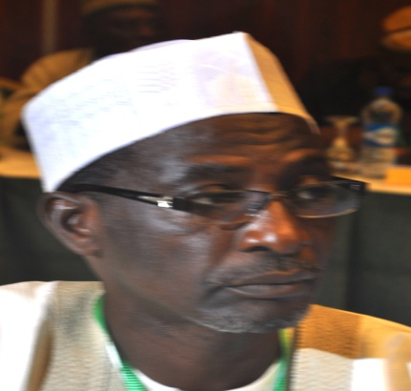  Alhaji Dauda Alhassan  Director, Department of Special Programmes
In November, 1989 he was employed as Senior Monitoring Officer by the defunct National Primary Education Commission (NPEC) now UBEC. He worked in Ibadan, Ilorin, Sokoto, Kano, Uyo, Makurdi, Jos and Gombe State Offices, to mention but a few. He was posted to UBEC Headquarters as Deputy Director, Social Mobilization in 2010, a position on which he remained until 2013, when he was made the Ag. Director, Social Mobilization from 2013 - 2014.

Later in 2014, he was posted to the Executive Secretary’s Office as Deputy Director (E.S Office). In July, 2015, he was posted to the Special Programmes Department of the Commission as the Ag. Director.

The Department is presently handling the Girl-Child education, Boy-Child education and the activities of Education Sector Support Programme in Nigeria (ESSPIN). These are the three (3) Units of the Department.
The Department of Special Programmes

Girl-Child Education
ESSPIN
Matters
Boy-Child Education

Fig. 8: The Structure of the Department of Special Programmes

The structuring of the Department is as shown in Table 21.
Table 21: Staff Disposition in the the Department of Social Mobilization
S/N | DESIGNATION | CONRAISS | NUMBER
1. | Ag. Director | 15 | 1
2. | Deputy Director | 14 | 1
3. | Asst. Chief Programme Officer | 12 | 1
4. | Principal Quality Assurance Officer | 11 | 1
5. | Principal Confidential Secretary | 11 | 1
6. | Quality Assurance Officer I | 08 | 1
7. | Programme Officer 1 | 08 | 1
8. | Academic Planning Officer I | 08 | 1
9. | Planning Officer I | 08 | 1
10. | Programme Officer II | 07 | 1
11 | Chief Driver/Mechanic | 06 | 1
Total |  |  | 11
FUNCTIONS
The Department performs the following functions:
- Provision of access and equity for the Girl-Child and Boy-Child education through effective collaboration with relevant UBEC Departments and other Government Agencies to provide unfettered access of basic education to out-of-school children.
- Formulating policy direction and activities that are geared towards reducing gender disparity in access and completion ratios and gradual elimination of gender disparity in Basic Education.
- Effective collaboration with relevant departments, national and international agencies to create appropriate opportunities for socialization and behavioural molding along culturally acceptable norms and tradition.
- Liaising with relevant Departments to set robust monitoring and evaluation standards to enhance learning achievements of both the Boy-Child and Girl-Child education in the country.
- Organising seminars/workshops with relevant stakeholders on the effective implementation of the Boy-Child and Girl-Child education.
- Coordinating the activities and programmes provided by ESSPIN with the relevant departments in the Commission.
- Disseminating activities related to the Boy-Child and Girl-Child education programmes of the Commission to relevant stakeholders.
- Monitoring the implementation of the Boy-Child and Girl-Child Education Programmes.
- Documentation of achievements recorded in the implementation of the Boy-Child and Girl-Child Education Programme for publication.
ACCOMPLISHED ACTIVITIES
The major activities accomplished by the department centred mainly on the construction of Junior Girls’ Schools across the country and vocational centres for the boy-child in the South-South and South-East Geo-Political zones for the period under review. The total number of Junior Girls’ Schools and Boy-Child Vocational Centres are eighty three (83). The breakdown is as follows:
- Award of contracts for the construction of Sixty six (66) Model Junior Girls’ Schools located in 31 States and the FCT. The States are: Adamawa, Akwa Ibom, Bauchi, Bayelsa, Benue, Cross River, Delta, Edo, Ekiti, Gombe, Jigawa, Kaduna, Kano, Katsina, Kebbi, Kogi, Kwara, Lagos, Nasarawa, Niger, Ogun, Ondo, Osun, Oyo, Plateau, Rivers, Sokoto, Taraba, Yobe, Zamfara.
- Award of contracts for the construction of 17 Boy-Child Vocational Centres located in 11 States has been awarded. The States are Abia, Akwa Ibom, Anambra, Bayelsa, Edo, Cross River, Delta, Ebonyi, Enugu, Rivers and Imo.

ACHIEVEMENTS
- Development of a realistic and functional framework for the Boy-Child integration process.
- Development of a framework for the All-Girls School Initiative with Action Plan for interventions and support to the initiative in the UBE Programme.
- Development of an Action Plan for key activities under the integration programme.
- Development of a concept paper on “All-Girls School Initiative”.
- Twenty-two (22) Junior Girls’ Schools have been completed.
- Setting up of Technical Working Committee for “All-Girls School Initiative” with the aim of providing expert advice and developing strategies for the advancement of the cause of the girl-child.
- Contracts for the construction of additional Twenty-one (21) model schools have been awarded and the contractors are in the process of mobilizing their equipment to different sites.
- One Vocational Centre at Umouru village, Aguata Local Government in Anambra State have been completed and handed over to the SUBEB for utilization.
CONSTRAINTS/CHALLENGES
- Wrong perception of the integration process and low information dissemination among states are fundamental challenges to the ongoing process.
- Some SUBEBs are not putting sufficient effort in mobilizing the public for the smooth commencement and sustenance of the Girl-Child and Boy-Child programmes.
- Inability of States to replicate the Girl-Child and Boy-Child schools at their own level.
- Inability of States to deploy adequate and qualified teachers into the Model Girls’ Schools.
- Cultural practice and poverty of most communities tend to hinder the Girl-Child education.

ON-GOING ACTIVITIES
- Construction works on Forty-four (44) Model Junior Girls’ Schools are ongoing.
- Construction works on Sixteen (16) Boy-child vocational centres located in 10 states are ongoing.

FUTURE ACTIVITIES
- Completion of ongoing construction of Boy-Child and Girl-Child Education Schools.
- Handing over of the completed Boy-Child and Girl-Child Schools.
- Monitoring the full commencement of academic activities in the completed Schools.
- Monitoring the utilization of the facilities for the Boy-child vocational centres and Junior Girls’ Secondary Schools.
- Organising seminars/workshops for relevant stakeholders on the effective implementation of the Boy-Child and Girl-Child education.
- Mass Mobilization, Sensitization, Advocacy and general public enlightenment for stakeholders to key into the education of the Boy-Child and Girl-Child in the country.
- Capacity building training on inclusive education.

CONCLUSION
As one of the newly established Departments of the Commission, a lot of activities as outlined above were successfully carried out despite the challenges the department is facing particularly the responses from SUBEBs which are the end-users of the available resources provided by the Commission.

